Chapter 21: The opium analgesics

Type: multiple choice question
Title: Chapter 21 Question 01
01) The following structure is an important medicine.

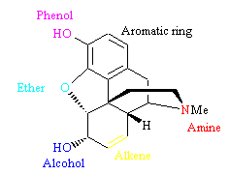
What is its major clinical use?
Feedback: The structure is morphine. Morphine remains one of the most effective analgesics in medicine.
Page reference: 618
a. An anti-ulcer agent
b. A cardiovascular agent
*c. An analgesic
d. An anti-asthmatic agent

Type: multiple choice question
Title: Chapter 21 Question 02
02) Morphine is an important analgesic.

What interactions are involved in binding the alkene group of morphine to the target binding site?
Feedback: Analogues lacking the alkene group have a similar level of activity to the parent compound, demonstrating that the alkene is not an essential group for activity.
Page reference: 620
a. Ionic interactions
b. Hydrogen bonding interactions
c. Van der Waals binding interactions
*d. The group has no binding role

Type: multiple choice question
Title: Chapter 21 Question 03
03) Morphine is an important analgesic.

What interactions are involved in binding the aromatic ring of morphine to the target binding site?
Feedback: An aromatic ring cannot form ionic or hydrogen bond interactions. It interacts with the binding site through van der Waals interactions.
Page reference: 622
a. Ionic interactions
b. Hydrogen bonding interactions
*c. Van der Waals binding interactions
d. The group has no binding role

Type: multiple choice question
Title: Chapter 21 Question 04
04) Morphine is an important analgesic.

What interactions are involved in binding the ether group of morphine to the target binding site?
Feedback: Analogues lacking the ether group have similar activity to the parent compound and so this group is not an important binding group.
Page reference: 621
a. Ionic interactions
b. Hydrogen bonding interactions
c. Van der Waals binding interactions
*d. The group has no binding role

Type: multiple choice question
Title: Chapter 21 Question 05
05) Morphine is an important analgesic.

What interactions are involved in binding the amine group of morphine to the target binding site?
Feedback: The amine group is a weak base which exists as an equilibrium between the free base and the protonated, ionised form. The latter is important to binding interactions.
Page reference: 622
*a. Ionic interactions
b. Hydrogen bonding interactions
c. Van der Waals binding interactions
d. The group has no binding role

Type: multiple choice question
Title: Chapter 21 Question 06
06) Morphine is an important analgesic.

What interactions are involved in binding the alcohol group of morphine to the target binding site?
Feedback: Analogues lacking the alcohol group show similar activity to the parent compound illustrating that the group is not essential to activity.
Page reference: 619-620
a. Ionic interactions
b. Hydrogen bonding interactions
c. Van der Waals binding interactions
*d. The group has no binding role

Type: multiple choice question
Title: Chapter 21 Question 07
07) Morphine is an important analgesic.

Which is the most serious short term side effect morphine?
Feedback: An overdose of morphine can suppress the respiratory centre in the central nervous system leading to cessation of breathing and death.
Page reference: 618-619
a. Tolerance and depression
b. Constipation
*c. Depression of the respiratory centre
d. Pupil constriction

Type: multiple choice question
Title: Chapter 21 Question 08
08) Morphine is an important analgesic.

Which of morphine's side effects can be used to advantage in another aspect of medicine?
Feedback: Morphine and its analogues can be used in the treatment of diarrhoea.
Page reference: 619
a. Tolerance and depression
*b. Constipation
c. Depression of the respiratory centre
d. Pupil constriction

Type: multiple choice question
Title: Chapter 21 Question 09
09) The following structure is used as an analgesic.

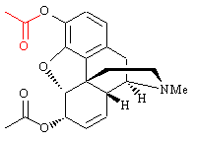
What is the name of the structure?
Feedback: Diamorphine is the diacetyl derivative of morphine. Codeine is a derivative of morphine where the phenol group is methylated. Thebaine is a natural product that is related in structure to morphine.
Page reference: 620
*a. Diamorphine
b. Morphine
c. Codeine
d. Thebaine

Type: multiple choice question
Title: Chapter 21 Question 10
10) Diamorphine is used as an analgesic.

Which of the following statements is false?
Feedback: Diamorphine is a prodrug which is converted to morphine in the brain. The acetyl group in red is hydrolysed by esterases to reveal the phenol group - an important binding group. Diamorphine produces a stronger analgesic effect than morphine. This is because it can cross the blood brain barrier more easily and lead to higher levels of morphine in the brain.
The acetyl masks an important binding group and has to be hydrolysed before the drug is active.
Page reference: 620
a. The structure is a stronger analgesic than morphine.
b. The structure acts as a prodrug.
c. The structure is converted to morphine in the brain.
*d. The coloured acetyl group is an important binding group.

Type: multiple choice question
Title: Chapter 21 Question 11
11) The following structure is more active than morphine as an analgesic.

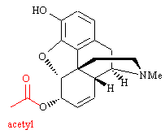
This structure is more active than morphine. What is the principle reason for this?
Feedback: The extra acetyl group masks a polar alcohol group such that the drug can cross the blood brain barrier more easily. Once in the brain, it can interact immediately with analgesic receptors since the important phenol group is free.
There is no extra binding region for a group of this sort. A polar group is masked, but the drug interacts with receptors on the surface of the cells and does not need to cross cell membranes to reach its target. The phenol is the major site for metabolic conjugation, not the alcohol. Therefore, masking the alcohol does little to reduce metabolism and excretion.
Page reference: 620
a. The extra acetyl group interacts with an extra binding region within the binding site by acting as a hydrogen bonding acceptor.
*b. The extra acetyl group masks a polar group allowing the structure to cross the blood brain barrier more efficiently.
c. The extra acetyl group masks a polar group allowing the structure to cross cell membranes more efficiently.
d. The extra acetyl group masks an alcohol group which would otherwise undergo a phase II metabolic conjugation reaction leading to rapid excretion of the drug.

Type: multiple choice question
Title: Chapter 21 Question 12
12) The N-phenethyl analogue of morphine has an analgesic activity which is 14 times greater than that of morphine. What is the principle reason for this?

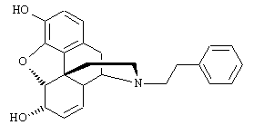
Feedback: The aromatic ring interacts with an extra hydrophobic binding region by van der Waals interactions. This is the main reason for the increased activity although the increased hydrophobicity should also increase the levels of drug crossing the blood brain barrier. Aromatic rings are hydrophobic and will not interact well with hydrophilic binding regions. The major metabolic reaction for opiates is a phase II conjugation reaction carried out on the phenol group.
Page reference: 623-624
a. the aromatic ring of the phenethyl group interacts with an extra hydrophilic region of the binding site
*b. the aromatic ring of the phenethyl group interacts with an extra hydrophobic region of the binding site
c. the phenethyl group increases the hydrophobicity of the molecule allowing a greater percentage to cross the blood brain barrier
d. the phenethyl group acts as a steric shield to protect the amine group from drug metabolism

Type: matching question
Title: Chapter 21 - Question 13
13) The following synthetic route can be used to prepare N-alkylated analogues of morphine.

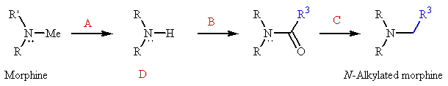
What reagents are used in step A , step B and step C
Feedback: Vinyloxycarbonyl chloride in methanol is a mild reagent that demethylates the tertiary amine of morphine to form a scondary amine. Reaction with an acid chloride acylates the secondary amine to give a tertiary amide. Reduction with Lithium aluminium hydride reduces the amide to an amine.
Page reference: 623
a. Step A = Vinyloxycarbonyl chloride and methanol
b. Step B = An acid chloride
c. Step C = Lithium aluminium hydride

Type: multiple choice question
Title: Chapter 21 Question 14
14) The following synthetic route can be used to prepare N-alkylated analogues of morphine.

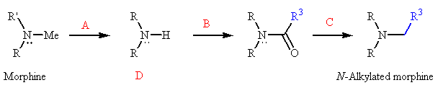

What is the name of structure D?
Feedback: Normorphine is the name of the compound. The prefix 'nor' is often used to indicate the absence of a methyl group from the parent compound. Noradrenaline is another example of this terminology. The names given in the other options are fictitious.
Page reference: 623
a. Desmorphine
b. Demethylmorphine
*c. Normorphine
d. Isomorphine

Type: multiple choice question
Title: Chapter 21 Question 15
15) The N-phenethyl analogue of morphine is known as a semi-synthetic product. What does this mean?
Feedback: Many natural products are complex in nature making a full synthesis of analogues impractical. Instead, it is easier to synthesise analogues from the natural lead compound itself, or from a related natural product or from an intermediate derived from either source. Such syntheses are defined as semi-synthetic since the synthesis relies on a starting material obtained from a natural source.
Page reference: 623
a. The synthesis involved a starting material representing half of the structure, and constructing the remaining half on that scaffold.
b. The synthesis involved synthesising two halves of the molecule separately then joining them together.
c. Half of the synthesis involved synthetic reagents while the other half involved enzymes.
*d. It was synthesised from a natural product.

Type: multiple choice question
Title: Chapter 21 Question 16
16) The following structure is the N-allyl analogue of morphine.

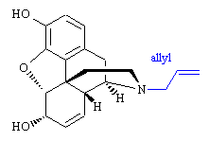
What is it called?
Feedback: Nalorphine is the N-allyl analogue of morphine. Naloxone also has an N-allyl group, but there is a ketone at the 6-position rather than an alcohol. Naltrexone contains an N-cyclopropylmethylene group, a ketone at position 6 and an alcohol at position 14. Nalbuphine has an N-cyclobutylmethylene group plus an alcohol at position 14.
Page reference: 624
a. Naltrexone
b. Naloxone
*c. Nalorphine
d. Nalbuphine

Type: multiple choice question
Title: Chapter 21 Question 17
17) The following structure (nalorphine) is the N-allyl analogue of morphine.

What sort of property does this molecule have?
Feedback: The opiates interact with receptors. Opiates such as morphine act as agonists, but the presence of an N-allyl group results in antagonist properties.
Page reference: 624
a. It is an agonist
*b. It is an antagonist
c. It is an enzyme inhibitor
d. It is an inverse agonist

Type: multiple choice question
Title: Chapter 21 Question 18
18) The following structure is an analgesic which is five times more active than morphine.

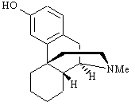
What is the name of the structure?
Feedback: The other structures named all belong to the same group of compounds as levorphanol.
Page reference: 626
*a. Levorphanol
b. N-methylmorphinan
c. Levallorphan
d. Dextrorphan

Type: multiple choice question
Title: Chapter 21 Question 19
19) Levorphanol is an analgesic which is five times more active than morphine.

What drug design strategy has been used in developing this structure from the lead compound morphine?
Feedback: The ring containing the ether group has been removed from the morphine structure, as have non-essential functional groups. Therefore, this is a simplification.
Page reference: 626
*a. Simplification
b. Rigidification
c. Extension
d. Substituent variation

Type: multiple choice question
Title: Chapter 21 Question 20
20) Levorphanol is an analgesic which is five times more active than morphine.

What happens when the N-methyl group is replaced with an N-phenethyl group (NCH2CH2Ph)?
Feedback: The extra aromatic ring interacts with an extra hydrophobic binding region in the binding site by means of van der Waals interactions. This leads to an increase in agonist activity.
Page reference: 626
*a. There is an increase in activity
b. There is a decrease in activity
c. There is a loss of all activity
d. The compound becomes an antagonist

Type: multiple choice question
Title: Chapter 21 Question 21
21) The following agent has similar analgesic activity to morphine.

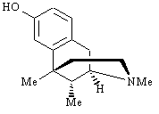
What is it called?
Feedback: The other structures names belong to the same group of compounds as metazocine.
Page reference: 627
*a. Metazocine
b. Bremazocine
c. Phenazocine
d. Pentazocine

Type: multiple choice question
Title: Chapter 21 Question 22
22) Metazocine has similar analgesic activity to morphine.

To which group of compounds does this structure belong?
Feedback: Benzomorphans lack two of the rings originally present in morphine. Morphinans are structures lacking one of the rings originally present in morphine. 4-Phenylpiperidines are simpler structures lacking three of the rings present in morphine. Enkephalins are endogenous pentapeptides that are produced in the brain.
Page reference: 627
*a. Benzomorphans
b. 4-phenylpiperidines
c. Morphinans
d. Enkephalins

Type: multiple choice question
Title: Chapter 21 Question 23
23) Identify the following compound:

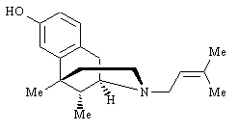
Feedback: Pentazocine is a useful long term analgesic with a low risk of addiction. The other structures named belong to the same group of compounds - the benzomorphans. Metazocine is the parent compound having an N-methyl group. Phenazocine has an N-phenethyl substituent. The structure of bremazocine is shown in fig 21.16.
Page reference: 627
a. Metazocine
b. Bremazocine
c. Phenazocine
*d. Pentazocine

Type: multiple choice question
Title: Chapter 21 Question 24
24) The following agent has been used as an analgesic during child labour.

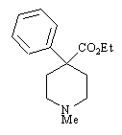
What is it called?
Feedback: Ketobemidone and pethidine belong to the same class of compounds. Metazocine is a benzomorphan. Fentanyl is a piperidine derivative.
Page reference: 628
a. Ketobemidone
b. Metazocine
c. Fentanyl
*d. Pethidine

Type: multiple choice question
Title: Chapter 21 Question 25
25) The following agent has been used as an analgesic during child labour.

To which class of compounds does this structure belong?
Feedback: The structure is called pethidine and is an example of a group of compounds called the 4-phenylpiperidines.The 4-phenylpiperidines contain two of the rings originally present in morphine. Benzomorphans and morphinans are more complex structures containing more rings. Enkephalins are endogenous pentapeptides produced in the brain.
Page reference: 627-628
a. Benzomorphans
*b. 4-phenylpiperidines
c. Morphinans
d. Enkephalins

Type: multiple choice question
Title: Chapter 21 Question 26
26) Pethidine has been used as an analgesic during child labour.

Which of the following statements is true regarding the above structure?
Feedback: The N-substituents that lead to antagonism or increased activity in more complex opiates such as the morphine analogues, the morphinans and the benzomorphans, do not have these effects in the 4-phenylpiperidine series. This indicates that the 4-phenylpiperidines are binding to the binding site in a different manner.
Page reference: 628-629
a. Replacing the N-methyl group with an N-allyl group results in an antagonist.
b. Replacing the N-methyl group with an N-allyl group results in a partial agonist.
c. Replacing the N-methyl group with an N-phenethyl group increases activity.
*d. The molecule has a different binding mode with the receptor binding site compared to morphine.

Type: multiple choice question
Title: Chapter 21 Question 27
27) The following structure was synthesised in Germany during the second world war as an analgesic. What is it called?

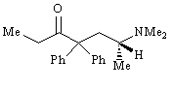
Feedback: Etorphine is a complex structure belonging to a group of compounds known as the oripavines. Pethidine and ketobemidone are examples of 4-phenylpiperidines.
Page reference: 629
a. Etorphine
b. Pethidine
*c. Methadone
d. Ketobemidone

Type: multiple choice question
Title: Chapter 21 Question 28
28) The following molecule is used in veterinary medicine.

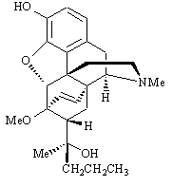
What is it called?
Feedback: Buprenorphine, etorphine and diprenorphine are all examples of a group of compounds called the oripavines. Buprenorphine is used as an analgesic in medicine. Etorphine is used as a sedative in veterinary medicine and diprenorphine is used as an antidote to etorphine. They are synthesised from the natural product thebaine.
Page reference: 630-631
a. Buprenorphine
*b. Etorphine
c. Diprenorphine
d. Thebaine

Type: multiple choice question
Title: Chapter 21 Question 29
29) Etorphine is used in veterinary medicine.

To which class of compounds does the above structure belong
Feedback: Benzomorphans are structures lacking two of the rings originally present in morphine. Endorphins are polypeptide structures and endomorphins are tetrapeptides.
Page reference: 629-630
a. Benzomorphans
b. Endorphins
*c. Oripavines
d. Endomorphins

Type: matching question
Title: Chapter 21 - Question 30
30) The following synthetic route is used to produce compounds such as etorphine.
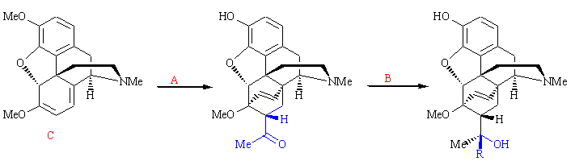
What are the reagents A and B?
Feedback: Reaction of thebaine with methyl vinyl ketone results ina Diels Alder reaction which produces an extra six membered ring. The product also has a ketone group which can undergo reaction with Grignard reagents.
Page reference: 630
a. Grignard reagent = Methyl vinyl ketone
b. Alkyl halide = Grignard reagent

Type: multiple choice question
Title: Chapter 21 Question 31
31) The following synthetic route is used to produce compounds such as etorphine.

What is the name of the reaction in step A?
Feedback: A Diels-Alder reaction is a concerted reaction between a diene and a dienophile to produce a six membered cyclohexene ring. Thebaine contains the diene group and the methyl vinyl ketone is the dienophile.
Page reference: 630
*a. Diels Alder reaction
b. Claisen condensation
c. Grignard reaction
d. Michael addition

Type: multiple choice question
Title: Chapter 21 Question 32
32) The following synthetic route is used to produce compounds such as etorphine

What is the name of the starting material?
Feedback: Thebaine contains a diene functional group in the 'bottom' ring. This allows the molecule to undergo a Diels Alder reaction. None of the other structures named have this functional group.
Page reference: 630
a. Codeine
b. Morphine
c. 3,6-diacetylmorphine
*d. Thebaine

Type: multiple choice question
Title: Chapter 21 Question 33
33) The following synthetic route is used to produce compounds such as etorphine

How is the starting material obtained?
Feedback: Thebaine can be extracted from opium along with codeine and morphine.
Page reference: 630
*a. It is extracted from opium
b. It is synthesised from morphine
c. It is synthesised from simple starting materials
d. It is extracted from cell cultures

Type: multiple choice question
Title: Chapter 21 Question 34
34) The following synthetic route is used to produce compounds such as etorphine.

The starting material has no analgesic activity. Which of the following explanations is the most likely reason for this?
Feedback: The phenol group is an essential part of the analgesic pharmacophore. It is masked in thebaine and so the molecule is inactive. The alkene and the alcohol groups are not part of the pharmacophore and so the masking or absence of these groups does not explain the lack of activity. The principle reason for inactivity is the masked phenol group.
Page reference: 630
a. The alcohol group is masked as an ether and cannot act as a binding group.
*b. The phenol group is masked as an ether and cannot act as a binding group.
c. The alkene group present in morphine is no longer present as a binding group.
d. The diene group distorts the molecule such that it does not fit the binding site.

Type: multiple choice question
Title: Chapter 21 Question 35
35) What pharmacophore is shared by the opiate analgesics?
Feedback: The charged nitrogen interacts with the binding site by ionic bonding. The phenol interacts by hydrogen bonding. The aromatic ring interacts by van der Waals interactions.
Page reference: 632
*a. A charged nitrogen, a phenol and an aromatic ring
b. A charged nitrogen, an alcohol and an aromatic ring
c. A charged nitrogen, a phenol, an aromatic ring and an ethylene hydrocarbon bridge
d. A charged nitrogen, a phenol, an aromatic ring and an N-methyl substituent

Type: multiple choice question
Title: Chapter 21 Question 36
36) What sort of receptor is the μ receptor?
Feedback: The μ receptor controls a potassium ion channel. The κ receptor controls a calcium ion channel. The δ receptor is a G_{i}-protein-linked receptor.
Page reference: 638
a. Calcium ion channel
b. Gi-protein linked receptor
*c. Potassium ion channel
d. Gs-protein linked receptor

Type: multiple choice question
Title: Chapter 21 Question 37
37) What sort of receptor is the κ receptor?
Feedback: The μ receptor controls a potassium ion channel. The  receptor controls a calcium ion channel. The δ receptor is a G_{i}-protein-linked receptor.
Page reference: 639
*a. Calcium ion channel
b. Gi -protein linked receptor
c. Potassium ion channel
d. Gs-protein linked receptor

Type: multiple choice question
Title: Chapter 21 Question 38
38) What sort of receptor is the δ receptor?
Feedback: The μ receptor controls a potassium ion channel. The κ receptor controls a calcium ion channel. The δ receptor is a G_{i}-protein-linked receptor.
Page reference: 639
a. Calcium ion channel
*b. Gi -protein linked receptor
c. Potassium ion channel
d. Gs-protein linked receptor

Type: multiple choice question
Title: Chapter 21 Question 39
39) Which of the following receptors is considered the safest?
Feedback: The κreceptor has the least serious side effects. The μ receptor has the most serious side effects. The σ receptor produces hallucinogenic effects and no analgesic effects.
Page reference: 633
a. μ
*b. κ
c. δ
d. σ

Type: multiple choice question
Title: Chapter 21 Question 40
40) Which of the following describes the properties of nalorphine?
Feedback: Nalorphine is a safer analgesic than morphine since it acts as an agonist at the κ receptor and as an antagonist at the μ receptor. The κ receptor has less serious side effects associated with it than the μ receptor.
Page reference: 633
a. It is an agonist at the μ  receptor and the κ receptor.
b. It is an antagonist at the μ  receptor and the κ receptor.
*c. It is an antagonist at the μ  receptor and an agonist at the κ receptor.
d. It is an antagonist at the κ  receptor and an agonist at the μ receptor.

Type: multiple choice question
Title: Chapter 21 Question 41
41) Which of the following describes the properties of buprenorphine?
Feedback: Buprenorphine is a safer analgesic than might be expected for a partial agonist of the μ receptor. This is related to the rate at which the drug binds and dissociates from the binding site.
Page reference: 634
a. It is an agonist at the μ  receptor, the κ receptor and the δ receptor.
b. It is an antagonist at the μ  receptor, the κ receptor and the δ receptor.
*c. It is an antagonist at the μ  receptor and the κ receptor, and a partial agonist at the μ receptor.
d. It is an antagonist at the  receptor and the  receptor, and a partial agonist at the κ receptor.

Type: multiple choice question
Title: Chapter 21 Question 42
42) What properties would you expect from the following structures?

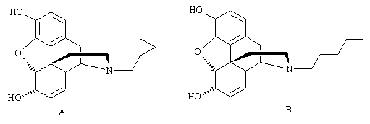

Feedback: Structure A has a cyclopropylmethylene substituent which can interact with the hydrophobic antagonist region close to the ionic binding region. Structure B has a hydrophobic alkene group at the end of a lengthy alkyl chain. It is more likely to bind to the agonist binding region than the antagonist binding region since the former region is further from the ionic binding region. Therefore, this compound should act as an agonist.
Page reference: 634-636
a. Both structures would be agonists
b. Both structures would be antagonists
c. Structure A would be an agonist and structure B would be an antagonist
*d. Structure A would be an antagonist and structure B would be an agonist

Type: multiple choice question
Title: Chapter 21 Question 43
43) Consider the following analgesic.

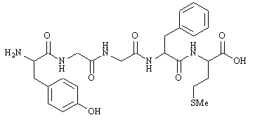
Identify the structure
Feedback: Met enkephalin is a pentapeptide containing the amino acids Tyr, Gly, Gly, Phe and Met. Leu-enkephalin has the same structure except that leucine replaces methionine. Endorphin is a larger polypeptide with analgesic properties. Tyr-enkephalin is not an endogenous compound.
Page reference: 636
a. Endorphin
*b. Met-enkephalin
c. Leu-enkephalin
d. Tyr-enkephalin

Type: multiple choice question
Title: Chapter 21 Question 44
44) Consider the following analgesic.

The above structure is a pentapeptide. Which one?
Feedback: The structure is Met enkephalin. The enkephalins are pentapeptides. The tyrosine residue at the N-terminal end is crucial to activity and must be present. The methionine residue is at the C-terminal end of the pentapeptide.
Page reference: 636
*a. H-Tyr-Gly-Gly-Phe-Met-OH
b. H-Tyr-Gly-Gly-Phe-Cys-OH
c. H-Phe-Gly-Gly-Phe-Met-OH
d. H-Phe-Gly-Gly-Phe-Cys-OH

Type: multiple choice question
Title: Chapter 21 Question 45
45) Consider the following analgesic, Met-enkephalin:

Which amino acid in the above structure is crucial to activity?
Feedback: The tyrosine is thought to have the same phenol and amine groups that are present in morphine.
Page reference: 636-637
*a. Tyrosine
b. Glycine
c. Phenylalanine
d. Cysteine

Type: multiple choice question
Title: Chapter 21 Question 46
46) Consider the following analgesic, Met-enkephalin:

Which peptide bond in the above structure is susceptible to enzymatic hydrolysis?
Feedback: The peptide bond between tyrosine and glycine is susceptible to enzymatic hydrolysis. Various enkephalin analogues have been made to try and prevent this hydrolysis – for example replacing glycine with an unnatural amino acid.
Page reference: 637
a. gly-gly
b. phe-gly
*c. tyr-gly
d. phe-met

Type: multiple choice question
Title: Chapter 21 Question 47
47) Consider the following analgesic, Met-enkephalin:

Which of the following strategies have been tried to design metabolically stable analogues of the above structure?
Feedback: All the strategies have been tried, but it is important to retain L-tyrosine since this contains important binding groups.
Page reference: 637
a. N-methylation of the peptide bond.
b. Introduction of a D-amino acid.
c. Introduction of an unnatural amino acid.
*d. All of the strategies have been tried.

Type: multiple choice question
Title: Chapter 21 Question48
48) Consider the following analgesic, Met-enkephalin:

Which receptor is predominantly activated by this structure?
Feedback: The δ receptor is a G_{i}-protein-linked receptor.
Page reference: 637
a. μ
b. κ
*c. δ
d. σ

Type: multiple choice question
Title: Chapter 21 Question 49
49) Consider the following analgesic, Met-enkephalin:

What compound has been used as an enzyme inhibitor to reduce the level of enkephalin hydrolysis?
Feedback: Thiorphan inhibits peptidase enzymes, resulting in a longer lifetime for enkephalins and enkephalin analogues.
Pro-opiomelanocortin is a protein precursor for endorphins and enkephalins. Phencyclidine is a drug of abuse that is thought to interact with σ-receptors. γ-Aminobutyric acid is a neurotransmitter in the brain.
Page reference: 637
a. Pro-opiomelanocortin
b. Phencyclidine
*c. Thiorphan
d. γ-aminobutyric acid

Type: multiple choice question
Title: Chapter 21 Question 50
50) What is the name for the recently discovered tetrapeptides which have analgesic activity?
Feedback: Enkephalins are pentapeptides with analgesic activity. Endorphins and dynorphins are larger polypeptides with analgesic activity. Endomorphins are tetrapeptides with analgesic activity.
Page reference: 637
a. Enkephalins
b. Endorphins
c. Dynorphins
*d. Endomorphins

Type: multiple choice question
Title: Chapter 21 Question 51
51) What is the source of opium?
Feedback: Poppy seed capsules are scored with a knife. The opium gum oozes out and is collected.
Page reference: 616
a. Poppy leaves
b. Poppy stalks
c. Poppy roots
*d. Poppy seed capsules

Type: multiple choice question
Title: Chapter 21 Question 52
52) How many asymmetric centres are present in morphine?

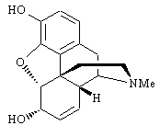
Feedback: The asymmetric centres are represented by red stars below

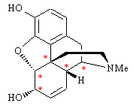

Page reference: 622
a. 2
b. 3
c. 4
*d. 5

Type: multiple choice question
Title: Chapter 21 Question 53
53) How is morphine currently obtained?
Feedback: Morphine is extracted directly from opium. It is too complex to synthesise economically from simple starting materials.
Page reference: 618
a. By a semi-synthetic method involving a natural product as starting material
b. By a full synthesis from simple starting materials
*c. By extraction of the natural source
d. By harvesting bacteria

Type: multiple choice question
Title: Chapter 21 Question 54
54) The quaternary methiodide salt of morphine has no analgesic activity when injected into the blood supply, but it is active when injected directly into the brain. Explain these results.
Feedback: Since the salt has a permanent positive charge, it cannot cross the blood brain barrier, and so it shows no activity when injected into the blood supply. When it is injected directly into the brain, it can bind to analgesic receptors since it has the necessary positive charge for an ionic interaction.
Page reference: 620
a. The salt is rapidly metabolised in the blood supply before it has the chance to reach the brain
b. The salt is rapidly excreted in the blood supply before it has a chance to reach the brain
*c. The salt is unable to cross the blood brain barrier
d. The salt is metabolised to an active compound by enzymes which are only present in the brain

Type: multiple choice question
Title: Chapter 21 Question 55
55) Morphine has a tertiary amine group. Which of the following intermolecular interactions is not possible for this group?
Feedback: A tertiary amine group is a polar group and does not form van der Waals interactions. When the tertiary amine is not ionised, it can act as a hydrogen bond acceptor. When it is protonated and ionised, it can interact by ionic interactions. It can also interact as a hydrogen bond donor. It cannot act as a hydrogen bond acceptor since the nitrogen is charged.
Page reference: 190-191
a. Hydrogen bonding as a hydrogen bond acceptor
b. Hydrogen bonding as a hydrogen bond donor
c. Ionic interactions
*d. Van der Waals interactions

Type: multiple choice question
Title: Chapter 21 Question 56
56) Morphine has a tertiary amine group. Which of the following interactions is chiefly involved when the tertiary amine group of morphine interacts with an analgesic receptor?
Feedback: The tertiary amine group is protonated and ionised when it binds to the analgesic binding site, making ionic interactions the most important interaction since this will be the strongest interaction. However, it is possible that the group could also be acting as a hydrogen bond donor.
Page reference: 622
a. Hydrogen bonding as a hydrogen bond acceptor
b. Hydrogen bonding as a hydrogen bond donor
*c. Ionic interactions
d. Van der Waals interactions

Type: multiple choice question
Title: Chapter 21 Question 57
57) From which starting material is heroin synthesised?
Feedback: Heroin is the diacetyl derivative of morphine.
Page reference: 620
a. Thebaine
b. Codeine
*c. Morphine
d. Normorphine

Type: multiple choice question
Title: Chapter 21 Question 58
58) What reagent is used in the synthesis of heroin from morphine?
Feedback: The ease with which heroin can be produced from morphine means that supplies of morphine have to be kept secure and closely monitored.
Page reference: 620
a. Acetic acid
b. Iodomethane
c. Vinyloxycarbonyl chloride
*d. Acetic anhydride

Type: multiple choice question
Title: Chapter 21 Question 59
59) Heroin acts as a prodrug. Which molecule is formed from it?
Feedback: The ester groups of heroin are hydrolysed in the brain by esterase enzymes to give morphine.
Page reference: 620
a. Thebaine
b. Codeine
*c. Morphine
d. Normorphine

Type: multiple choice question
Title: Chapter 21 Question 60
60) What drug strategy is involved in the development of morphinans and benzomorphans from morphine?
Feedback: These compounds have been developed by removing excess rings and functional groups.
Page reference: 626-627
a. Rigidification
*b. Simplification
c. Extension
d. Substituent variation

Type: multiple choice question
Title: Chapter 21 Question 61
61) State what happens when an N-methyl group is replaced with an N-phenethyl group in morphine analogues, morphinans and benzomorphans.
Feedback: The aromatic ring that has been added interacts with an extra hydrophobic region by van der Waals interactions.
Page reference: 624, 626-627
*a. Analgesic activity increases
b. Analgesic activity decreases
c. Analgesic activity is lost completely
d. The structure becomes an antagonist at some or all of the analgesic receptors

Type: multiple choice question
Title: Chapter 21 Question 62
62) Activity increases when an N-methyl group is replaced with an N-phenethyl group in morphine analogues, morphinans or benzomorphans. What drug design strategy is involved?
Feedback: A new binding group has been added to the molecule which interacts with a binding region not used by the original molecule, and so this is an extension strategy.
Page reference: 623-624
a. Rigidification
b. Simplification
*c. Extension
d. Substituent variation

Type: multiple choice question
Title: Chapter 21 Question 63
63) State what happens when an N-methyl group is replaced with an N-allyl group in morphine analogues, morphinans and benzomorphans.
Feedback: The N-allyl group is hydrophobic and can bind to a hydrophobic binding region that cannot be reached by the N-methyl group of the parent compounds. Binding to this extra binding region results in antagonist activity.
Page reference: 624-625
a. Analgesic activity increases
b. Analgesic activity decreases
c. Analgesic activity is lost completely
*d. The structure becomes an antagonist at some or all of the analgesic receptors

Type: matching question
Title: Chapter 21 – Question 64
64) Identify the following agents.

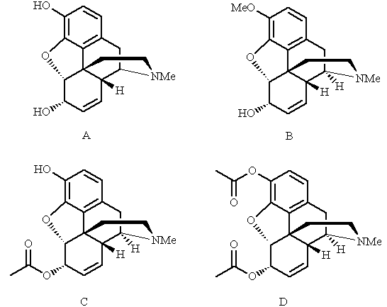
Feedback: Morphine is the main active principle of opium. Codeine is an analogue of morphine where the phenol group is methylated. 6-Acetylmorphine is an analogue of morphine where the alcohol group at position 6 is acetylated. Diamorphine is an analogue of morphine where both the phenol and alcohol functions are acetylated.
Page reference: 618-620
a. Codeine = B
b. Diamorphine = D
c. 6-acetylmorphine = C
d. Morphine = A

Type: multiple choice question
Title: Chapter 21 - Question 65
65) The following structure is morphine

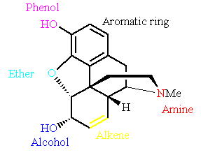

Which of the following groups interacts with the binding site by hydrogen bonding alone?
Feedback: The phenol group is capable of acting as a hydrogen bond donor or a hydrogen bond acceptor. Analogues lacking the phenol group have significantly lower activity.
Page reference: 619-622
a. Aromatic ring
b. Alcohol
c. Amine
*d. Phenol

Type: multiple choice question
Title: Chapter 21 - Question 66
66) The following structure is morphine

Which of the following groups interacts with the binding site by van der Waals interactions?
Feedback: The aromatic ring is a non-polar functional group which can interact by van der Waals interactions. The other groups are polar groups which can interact by hydrogen bonding. The amine can be protonated and charged allowing it to interact by ionic interactions.
Page reference: 619-622
*a. Aromatic ring
b. Alcohol
c. Amine
d. Phenol

Type: multiple choice question
Title: Chapter 21 - Question 67
67) The following structure is morphine

Which of the following groups interacts with the binding site by ionic interactions?
Feedback: The amine group is a weak base which exists as an equilibrium between the free base and the protonated, ionised form. The latter is important to binding interactions.
Page reference: 619-622
a. Aromatic ring
b. Alcohol
*c. Amine
d. Phenol

Type: multiple choice question
Title: Chapter 21 - Question 68
68) Codeine is used as an analgesic.

Which of the following statements is false?
Feedback: Codeine acts as a prodrug and is converted to morphine by enzymes in the liver which remove the coloured methyl group. This reveals an important phenol binding group. It is a weaker analgesic than morphine since only 20% of it is converted to morphine.
Page reference: 619
a. The structure is a weaker analgesic than morphine
b. The structure acts as a prodrug
c. The structure is converted to morphine in the liver
*d. The coloured methyl group is an important binding group

Type: multiple choice question
Title: Chapter 21 - Question 69
69) Diamorphine is used as an analgesic.

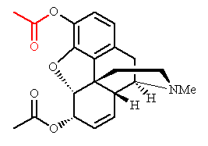
Which of the following statements is false?
Feedback: Diamorphine is a prodrug which is converted to morphine in the brain. The acetyl group in red is hydrolysed by esterases to reveal the phenol group: an important binding group. Diamorphine produces a stronger analgesic effect than morphine. This is because it can cross the blood brain barrier more easily and lead to higher levels of morphine in the brain. The acetyl masks an important binding group and has to be hydrolysed before the drug is active.
Page reference: 620
a. The structure is a stronger analgesic than morphine.
b. The structure acts as a prodrug.
*c. The structure is converted to codeine in the brain.
d. The coloured acetyl group is not an important binding group.

Type: multiple choice question
Title: Chapter 21 - Question 70
70) Which of the following statements is true?

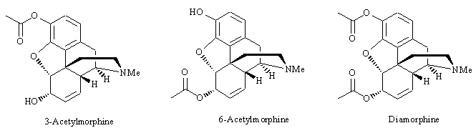
Feedback: 3-Acetylmorphine should be less active than 6-acetylmorphine. Both structures should cross the blood brain barrier equally well since each has a polar group masked by an acetyl group. However, esterases have to remove the acetyl group of 3-acetylmorphine before it can be active, whereas 6-acetylmorphine is inherently active since the phenol group is free.
3-Acetylmorphine should be less active than diamorphine. The latter structure has two polar groups masked by acetyl groups and should be able to cross the blood brain barrier more effectively leading to higher brain concentrations of the drug. Both agents are likely to be similarly activated by esterases, but the diamorphine should be more effective since it is present at higher levels.
Page reference: 619-620
a. 3-acetylmorphine should be more active than 6-acetylmorphine since the alcohol group is free to bind
*b. 3-acetylmorphine should be less active than 6-acetylmorphine since the phenol group is masked
c. 3-acetylmorphine should be more active than diamorphine since it should cross the blood brain barrier more easily
d. 3-acetylmorphine should be less active than diamorphine since it lacks an acetyl group at the 6-position which is important for binding

Type: multiple choice question
Title: Chapter 21 - Question 71
71) The N-phenethyl analogue of morphine is an example of a structure that has been synthesised from morphine itself, morphine being a natural product. What term is used for a synthetic compound obtained in this way?
Feedback: Many natural products are complex in nature making a full synthesis of analogues impractical. Instead, it is easier to synthesise analogues from the natural lead compound itself, or from a related natural product or from an intermediate derived from either source. Such syntheses are defined as semi-synthetic since the synthesis relies on a starting material obtained from a natural source.
Page reference: 622-623
a. Partial synthetic compound
b. Analogous synthetic compound
c. Natural synthetic compound
*d. Semi-synthetic compound

Type: matching question
Title: Chapter 21 - Question 72
72) Name the following structures:

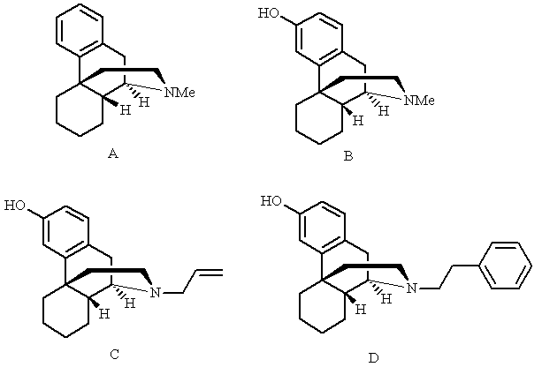

Feedback: All four structures are examples of a group of compounds called the morphinans
Page reference: 626
a. Levorphanol = Structure B
b. N-methylmorphinan = Structure A
c. N-phenethyllevorphanol = Structure D
d. Levallorphan = Structure C

Type: multiple choice question
Title: Chapter 21 - Question 73
73) To which class of compounds do the following structures belong?

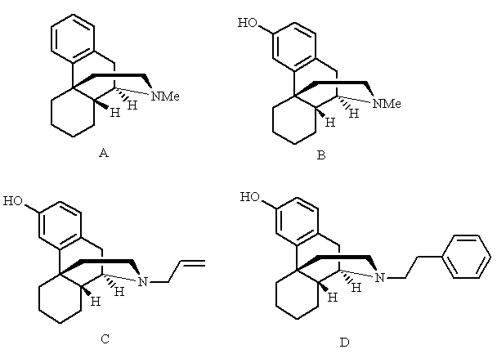

Feedback: Morphinans lack the ring containing the ether oxygen. Benzomorphans and 4-phenylpiperidines are simpler structures with fewer rings. Enkephalins are endogenous pentapeptides that are produced in the brain. The structures shown (A-D) are N-methylmorphinan, levorphanol, levallorphan, and N-phenethyllevorphanol respectively.
Page reference: 626
a. Benzomorphans
b. 4-phenylpiperidines
*c. Morphinans
d. Enkephalins

Type: multiple choice question
Title: Chapter 21 - Question 74
74) Which of the following structures is an opiate antagonist?

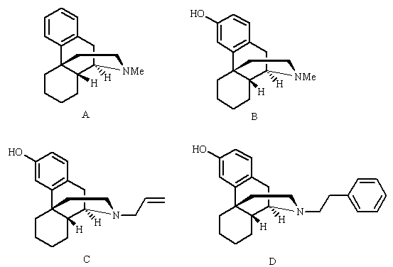
Feedback: The structures shown (A-D) are N-methylmorphinan, levorphanol, levallorphan, and N-phenethyllevorphanol respectively. The presence of an N-Allyl or N-cyclopropyl substituent on an opiate structure is known to change it from an agonist into an antagonist.
Page reference: 626
a. Structure A
b. Structure B
*c. Structure C
d. Structure D

Type: multiple choice question
Title: Chapter 21 - Question 75
75) Which of the following structures has the greatest analgesic activity?

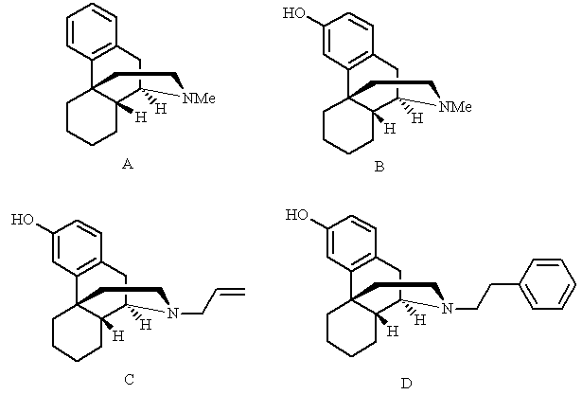
Feedback: The structures shown (A-D) are N-methylmorphinan, levorphanol, levallorphan, and N-phenethyllevorphanol respectively. Levallorphan is an antagonist and not an agonist. N-methylmorphinan is the weakest agonist since it lacks the important phenol group. N-phenethyllevorphanol is the strongest agonist. The extra aromatic ring interacts with an extra hydrophobic binding region in the binding site by means of van der Waals interactions. This leads to an increase in agonist activity.
Page reference: 626
a. Structure A
b. Structure B
c. Structure C
*d. Structure D

Type: multiple choice question
Title: Chapter 21 - Question 76
76) Which of the following structures has the weakest analgesic activity?

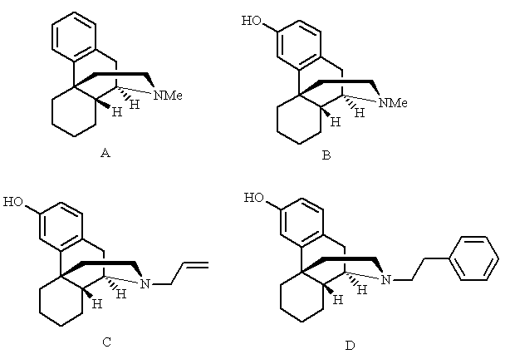
Feedback: The structures shown (A-D) are N-methylmorphinan, levorphanol, levallorphan, and N-phenethyllevorphanol respectively. Levallorphan is an antagonist and not an agonist. N-methylmorphinan is the weakest agonist since it lacks the important phenol group. N-phenethyllevorphanol is the strongest agonist. The extra aromatic ring interacts with an extra hydrophobic binding region in the binding site by means of van der Waals interactions. This leads to an increase in agonist activity.
Page reference: 626
*a. Structure A
b. Structure B
c. Structure C
d. Structure D

Type: matching question
Title: Chapter 21 - Question 77
77) Identify the following structures:

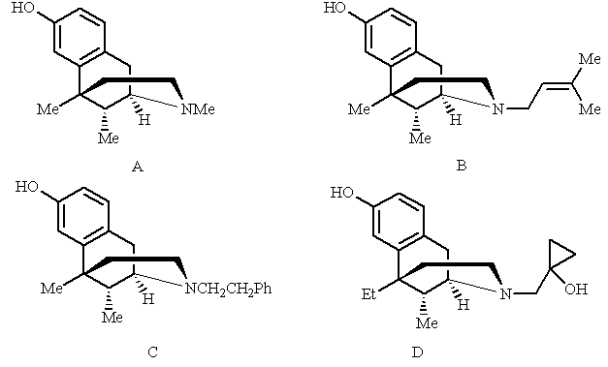

Feedback: All four of these structures are examples of a group of compounds called the benzomorphans.
Page reference: 627
a. Bremazocine = Structure D
b. Phenazocine = Structure C
c. Pentazocine = Structure B
d. Metazocine = Structure A

Type: matching question
Title: Chapter 21 - Question 78
78) To which group of compounds do the following structures belong?

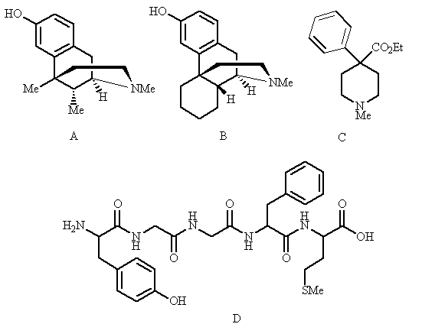
Feedback: Benzomorphans lack two of the rings originally present in morphine. Morphinans are structures lacking one of the rings originally present in morphine. 4-Phenylpiperidines are simpler structures lacking three of the rings present in morphine. Enkephalins are endogenous pentapeptides that are produced in the brain.
The structures (A-D) are metazocine, levorphanol, pethidine and met-enkephalin respectively.
Page reference: 626-629, 636-637
a. Benzomorphans = Structure A
b. 4-phenylpiperidines = Structure C
c. Enkephalins = Structure D
d. Morphinans = Structure B

Type: multiple choice question
Title: Chapter 21 - Question 79
79) The following compounds are all benzomorphans. Which is the parent structure of the four shown?

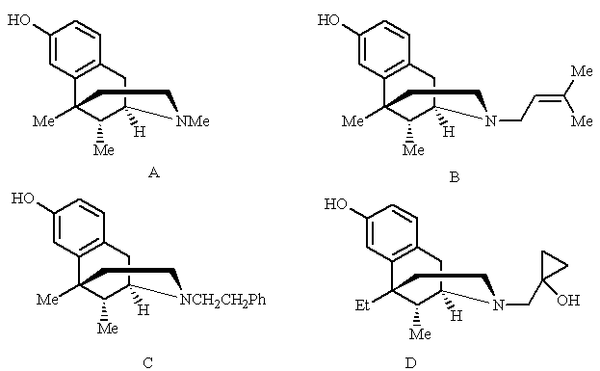
Feedback: The structures shown (A-D) are metazocine, pentazocine, phenazocine and bremazocine. Pentazocine is a useful long term analgesic with a low risk of addiction. Metazocine is the parent compound having an N-methyl group.
Page reference: 627
*a. Structure A
b. Structure B
c. Structure C
d. Structure D

Type: multiple choice question
Title: Chapter 21 - Question 80
80) Which of the following structures is a useful long term analgesic with a low risk of addiction?

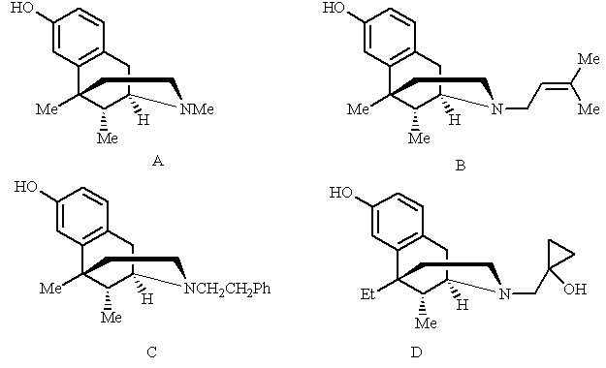
Feedback: The structures shown (A-D) are metazocine, pentazocine, phenazocine and bremazocine. Pentazocine is a useful long term analgesic with a low risk of addiction. Metazocine is the parent compound having an N-methyl group.
Page reference: 627
a. Structure A
*b. Structure B
c. Structure C
d. Structure D

Type: multiple choice question
Title: Chapter 21 - Question 81
81) Which of the following structures is thought to have a different binding mode in analgesic binding sites when compared with the other three?

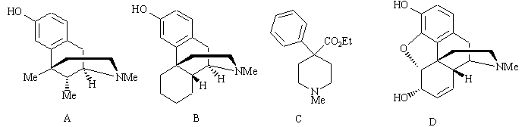
Feedback: The structures (A-D) are metazocine, levorphanol, pethidine and morphine respectively.
The N-substituents that lead to antagonism or increased activity in more complex opiates such as structures A, B and D do not have these effects in the 4-phenylpiperidine series. This indicates that 4-phenylpiperidines such as structure C are binding to the binding site in a different manner.
Page reference: 627-629
a. Structure A
b. Structure B
*c. Structure C
d. Structure D

Type: multiple choice question
Title: Chapter 21 - Question 82
82) Methadone was synthesised in Germany during the second world war as an analgesic. Which of the following statements is false?

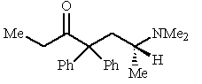
Feedback: Methadone is comparable in activity to morphine.
Page reference: 629
*a. It is 5 times more active than morphine.
b. It is used as a substitute for heroin to wean addicts off the latter drug.
c. It contains an asymmetric centre with one enantiomer being more active than the other.
d. It is orally active.

Type: matching question
Title: Chapter 21 - Question 83
83) Identify the following molecules:

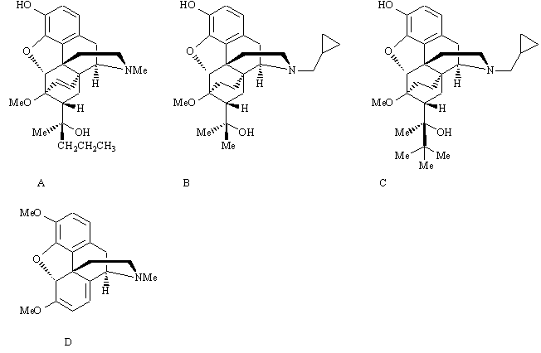
Feedback: Buprenorphine, etorphine and diprenorphine are all examples of a group of compounds called the oripavines. Buprenorphine is used as an analgesic in medicine. Etorphine is used as a sedative in veterinary medicine and diprenorphine is used as an antidote to etorphine. They are synthesised from the natural product thebaine.
Page reference: 629-632
a. Buprenorphine = Structure C
b. Etorphine = Structure A
c. Diprenorphine = Structure B
d. Thebaine = Structure D

Type: matching question
Title: Chapter 21 - Question 84
84) What are the following molecules used for?

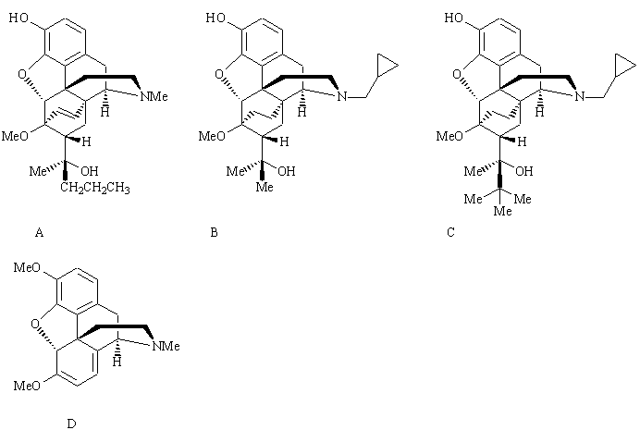
Feedback: The structures (A-D) are etorphine, diprenorphine, buprenorphine and thebaine respectively. Buprenorphine, etorphine and diprenorphine are all examples of a group of compounds called the oripavines. Buprenorphine is used as an analgesic in medicine. Etorphine is used as a sedative in veterinary medicine and diprenorphine is used as an antidote to etorphine. They are synthesised from the natural product thebaine.
Page reference: 629-632
a. An analgesic in human medicine = Structure C
b. The starting material for the synthesis of oripavines = Structure D
c. A powerful sedative in veterinary medicine = Structure A
d. An antidote to etorphine = Structure B

Type: multiple choice question
Title: Chapter 21 - Question 85
85) Which of the following structures is an oripavine?

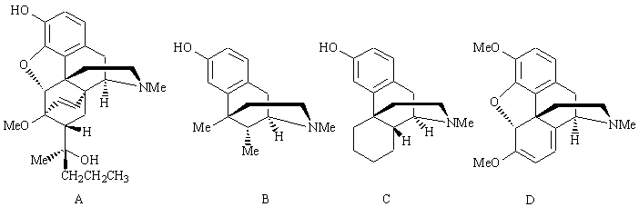
Feedback: Structure A is etorphine which is an example of an oripavine. the oher structures (B-D) are metazocine, levorphanol and thebaine respectively.
Page reference: 629-632
*a. Structure A
b. Structure B
c. Structure C
d. Structure D

Type: multiple choice question
Title: Chapter 21 - Question 86
86) Buprenorphine is used clinically as an analgesic.

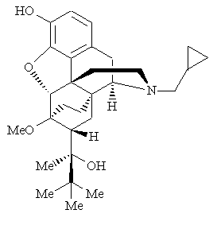
Which of the following statements is false?
Feedback: Buprenorphine is slow to bind to analgesic receptors, and slow to depart. Less buprenorphine is required to interact with a certain number of analgesic receptors than morphine, and so lower doses can attain the same level of analgesia. However, the agent cannot reach the same maximum levels of analgesia as morphine and so it is less useful for severe pain.
Buprenorphine has some side effects although they are less serious than those of morphine. It cannot be taken orally and has to be injected.
Page reference: 631-632
a. It is 100 times more active than morphine as an agonist
b. It is 4 times more active than nalorphine as an antagonist
c. There is a low risk of respiratory depression
*d. It is quick to bind to analgesic receptors, but slow to depart

Type: multiple choice question
Title: Chapter 21 - Question 87
87) Which of the following is an analgesic receptor that controls a potassium ion channel?
Feedback: The κ receptor controls a calcium ion channel. The δ receptor initiates a signal transduction process involving the suppression of cyclic AMP levels. The μ receptor controls a potassium ion channel. The σ receptor is not an analgesic receptor and is responsible for hallucinogenic side effects associated with some opiate analgesics.
Page reference: 638-639
a. κ receptor
b. δ receptor
*c. μ receptor
d. σ receptor

Type: multiple choice question
Title: Chapter 21 - Question 88
88) Which of the following is an analgesic receptor that controls a calcium ion channel?
Feedback: The κ receptor controls a calcium ion channel. The δ receptor initiates a signal transduction process involving the suppression of cyclic AMP levels. The μ receptor controls a potassium ion channel. The σ receptor is not an analgesic receptor and is responsible for hallucinogenic side effects associated with some opiate analgesics.
Page reference: 638-639
*a. κ receptor
b. δ receptor
c. μ receptor
d. σ receptor

Type: multiple choice question
Title: Chapter 21 - Question 89
89) Which of the following is an analgesic receptor that initiates a signal transduction process leading to the suppression of cyclic AMP levels?
Feedback: The κ receptor controls a calcium ion channel. The δ receptor initiates a signal transduction process involving the suppression of cyclic AMP levels. The μ receptor controls a potassium ion channel. The σ receptor is not an analgesic receptor and is responsible for hallucinogenic side effects associated with some opiate analgesics.
Page reference: 638-639
a. κ receptor
*b. δ receptor
c. μ receptor
d. σ receptor

Type: multiple choice question
Title: Chapter 21 - Question 90
90) Consider the following analgesic:

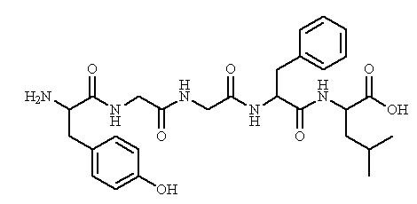
Identify the structure
Feedback: Leu enkephalin is a pentapeptide containing the amino acids Tyr, Gly, Gly, Phe and Leu. Met-enkephalin has the same structure except that methionine replaces leucine. Endorphin is a larger polypeptide with analgesic properties. Tyr-enkephalin is not an endogenous compound.
Page reference: 636-637
a. Endorphin
b. Met-enkephalin
*c. Leu-enkephalin
d. Tyr-enkephalin

Type: multiple choice question
Title: Chapter 21 - Question 91
91) Consider the following analgesic.

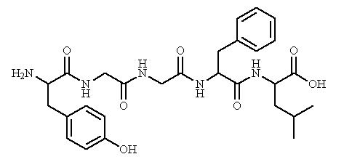
What is the source of this structure?
Feedback: The structure is Leu enkephalin which is a pentapeptide containing the amino acids Tyr, Gly, Gly, Phe and Leu.
Page reference: 636-637
a. Opium
b. Frog
*c. An endogenous compound present in the body
d. Snake venom

Type: multiple choice question
Title: Chapter 21 - Question 92
92) Consider the following analgesic.

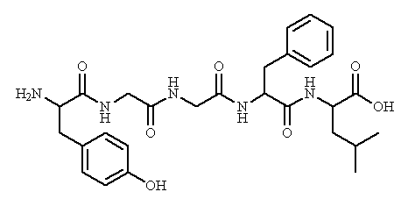
The above structure is a pentapeptide. Which one?
Feedback: The structure is Leu enkephalin which is a pentapeptide containing the amino acids Tyr, Gly, Gly, Phe and Leu.
Page reference: 636-637
a. H-Tyr-Gly-Gly-Phe-Met-OH
*b. H-Tyr-Gly-Gly-Phe-Leu-OH
c. H-Phe-Gly-Gly-Phe-Met-OH
d. H-Phe-Gly-Gly-Phe-Cys-OH

Type: multiple choice question
Title: Chapter 21 - Question 93
93) Consider the following analgesic - Leu-enkephalin

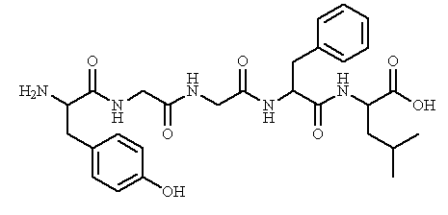

Which amino acid in the above structure is crucial to activity?

Feedback: The tyrosine is thought to have the same phenol and amine groups that are present in morphine.
Page reference: 636-637
*a. Tyrosine
b. Glycine
c. Phenylalanine
d. Cysteine

Type: multiple choice question
Title: Chapter 21 - Question 94
94) Consider the following analgesic - Leu-enkephalin

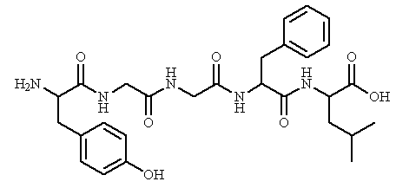
Which peptide bond in the above structure is susceptible to enzymatic hydrolysis?
Feedback: The bond between tyrosine and glycine is susceptible to enzymatic hydrolysis. Analogues aimed at stabilising this link have been prepared. For example, glycine has been replaced with an unnatural amino acid with the aim of making the bond unrecognisable to the hydrolytic enzyme.
Page reference: 636-637
a. gly-gly
b. phe-gly
*c. tyr-gly
d. phe-met

Type: multiple choice question
Title: Chapter 21 - Question 95
95) Consider the following analgesic - Leu-enkephalin

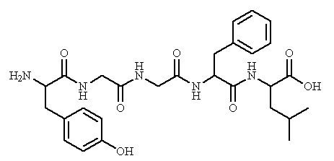
Which of the following strategies have been tried to design metabolically stable analogues of the above structure?

Feedback: All the above strategies have been tried, but it is important to retain L-tyrosine since this contains important binding groups
Page reference: 636-637
a. N-methylation of the peptide bond
b. Introduction of a D-amino acid
c. Introduction of an unnatural amino acid
*d. All of the answers are correct

Type: multiple choice question
Title: Chapter 21 - Question 96
96) Consider the following analgesic - Leu-enkephalin

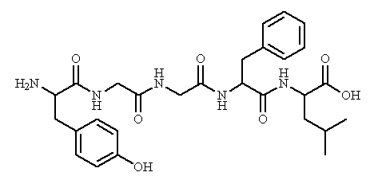
Which receptor is predominantly activated by this structure?

Feedback: The δ receptor is predominantly activated by Leu-enkephalin. The receptor is an example of a G_{i}-protein linked receptor.
Page reference: 636-637
a. μ
b. κ
*c. δ
d. σ

Type: multiple choice question
Title: Chapter 21 - Question 97
97) Consider the following analgesic - Leu-enkephalin

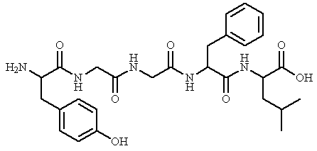
What compound has been used as an enzyme inhibitor to reduce the level of enkephalin hydrolysis?
Feedback: Thiorphan inhibits peptidase enzymes, resulting in a longer lifetime for enkephalins and enkephalin analogues.
Pro-opiomelanocortin is a protein precursor for endorphins and enkephalins. Phencyclidine is a drug of abuse that is thought to interact with σ-receptors. γ−Aminobutyric acid is a neurotransmitter in the brain.
Page reference: 636-637
a. Pro-opiomelanocortin
b. Phencyclidine
*c. Thiorphan
d. γ-aminobutyric acid

Type: multiple choice question
Title: Chapter 21 - Question 98
98) Morphine has been described as an active principle derived from opium. What is meant by the term active principle?
Feedback: An active principle is the chemical which is chiefly responsible for the biological activity of a natural extract.
Page reference: 618
a. It is the structure which is used as the benchmark for all opiate analgesics.
*b. It is the compound chiefly responsible for the biological activity observed for opium.
c. It provides the starting point for the design of novel analgesics.
d. It establishes that analgesic receptors exist.

Type: multiple choice question
Title: Chapter 21 - Question 99
99) Which of the following structures is synthesised when morphine is treated with acetic anhydride?

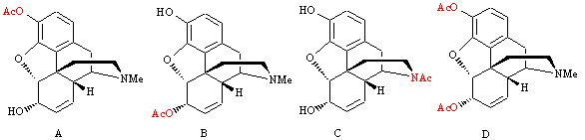
Feedback: The phenol and alcohol groups of morphine are both acetylated to give diamorphine or heroin.
Page reference: 620
a. Structure A
b. Structure B
c. Structure C
*d. Structure D

