Chapter 20: The adrenergic nervous system

Type: multiple choice question
Title: Chapter 20 Question 01
01) What are the two main types of adrenergic receptor?
Feedback: The two main types of adrenergic receptors are the α and β adrenoceptors. The muscarinic and nicotinic receptors are the two main types of cholinergic receptors. A receptors are adenosine receptors. Numerals such as 1 and 2 are used to indicate receptor subtypes such as the α 1-adrenoceptor.
Page reference: 594
a. Muscarinic and nicotinic
b. 1 and 2
*c. α and β
d. A1 and A2

Type: multiple choice question
Title: Chapter 20 Question 02
02) What kind of receptors are the adrenergic receptors?
Feedback: The adrenergic receptors bind G-proteins when they are activated and split the G-protein into an α-subunit and a β,γ-dimer. These in turn trigger signal transduction pathways.
Page reference: 594
*a. G-protein coupled receptors
b. Kinase linked receptors
c. Intracellular receptors
d. Ion channels

Type: multiple choice question
Title: Chapter 20 Question 03
03) What G-protein is activated by α -adrenoceptors?
Feedback: There are various types of G-proteins which trigger different signal transduction processes. The Go protein is activated by α -adrenoceptors.
Page reference: 594
a. Gs
b. Gi
*c. Go
d. Gq

Type: multiple choice question
Title: Chapter 20 Question 04
04) What G-protein is activated by α -adrenoceptors?
Feedback: There are various types of G-proteins which trigger different signal transduction processes. The Gs protein is activated by α -adrenoceptors.
Page reference: 594
*a. Gs
b. Gi
c. Go
d. Gq

Type: multiple choice question
Title: Chapter 20 Question 05
05) How many subtypes of the α -adrenoceptor are there?
Feedback: The subtypes are the α-adrenoceptor and α₂-adrenoceptor. There are also three subtypes of each of these (α 1A, α 1B, α 1C, α 2A, α 2B, α 2C)
Page reference: 594
*a. 2
b. 3
c. 4
d. 5

Type: multiple choice question
Title: Chapter 20 Question 06
06) How many subtypes of the β -adrenoceptor are there?
Feedback: The subtypes are the β-adrenoceptor, β₂-adrenoceptor and β₃-adrenoceptor.
Page reference: 594
a. 2
*b. 3
c. 4
d. 5

Type: multiple choice question
Title: Chapter 20 Question 07
07) What is the physiological effect resulting from activation of β adrenoceptors in heart muscle?
Feedback: The predominant adrenergic receptor in cardiac muscle is the β adrenoceptor, compared to bronchial smooth muscle where the predominant adrenergic receptor is the β2 adrenoceptor
Page reference: 594
a. Muscle contraction leading to decreased heart rate and force
*b. Muscle contraction leading to increased heart rate and force
c. Muscle relaxation leading to decreased heart rate and force
d. Muscle relaxation leading to increased heart rate and force

Type: multiple choice question
Title: Chapter 20 Question 08
08) What is the predominant β -adrenoceptor in bronchial smooth muscle?

Feedback: The β 1-adrenoceptor is predominant in heart muscle. The β 2-adrenoceptor is the predominant type of -adrenoceptor in bronchial smooth muscle, arteriole smooth muscle, veins, the liver, gastrointestinal tract smooth muscle and kidney. The β 3-adrenoceptor is predominant in fat cells. The β 4-adrenoceptor does not exist.
Page reference: 594
a. β 1adrenoceptor
*b.β2 adrenoceptor
c. β 3adrenoceptor
d. β 4adrenoceptor

Type: multiple choice question
Title: Chapter 20 Question 09
09) What is the physiological effect resulting from activation of β2 adrenoceptors in bronchial smooth muscle?
Feedback: Activation of β2 adrenoceptors in bronchial smooth muscle results in muscle relaxation, leading to opening of the airways. Therefore, adrenergic agonists are useful agents in the treatment of asthma.
Page reference: 594
a. Muscle contraction leading to closure of the airways
b. Muscle relaxation leading to closure of the airways
c. Muscle contraction leading to opening of the airways
*d. Muscle relaxation leading to opening of the airways

Type: multiple choice question
Title: Chapter 20 Question 10
10) What is the physiological effect resulting from activation of β3 adrenoceptors in fat cells?
Feedback: Activation of β3 adrenoceptors in fat cells leads to the activation of enzymes which catalyse the breakdown of fat. Consequently, agonists of these receptors are potential medications for the treatment of obesity.
Page reference: 594
*a. Activation of enzymes leading to fat breakdown
b. Deactivation of enzymes leading to fat breakdown
c. Activation of enzymes leading to fat synthesis
d. Deactivation of enzymes leading to fat synthesis

Type: multiple choice question
Title: Chapter 20 Question 11
11) What is the predominant adrenoceptor in the smooth muscle of arterioles supplying blood to the skeletal muscles?
Feedback: The β 1-adrenoceptor is predominant in heart muscle. The β 2-adrenoceptor is the predominant type of β -adrenoceptor in bronchial smooth muscle, arteriole smooth muscle, veins, the liver, gastrointestinal tract smooth muscle and kidney. The α 1-adrenoceptor is predominant in bronchial smooth muscle and the liver along with β 2-adrenoceptors. The α 2-adrenoceptor is predominant in gastrointestinal tract smooth muscle along with β 2-adrenoceptors and α 1-adrenoceptors.
Page reference: 594-595
a. α adrenoceptor
b. α 2adrenoceptor
c. β1adrenoceptor
*d. β 2adrenoceptor

Type: multiple choice question
Title: Chapter 20 Question 12
12) What is the physiological effect resulting from activation of β 2adrenoceptors in the smooth muscle of arterioles suppling blood to the skeletal muscles?
Feedback: As the smooth muscles of arterioles relax, the blood vessels dilate, increasing the blood supply to skeletal muscles.
Page reference: 594-595
a. Smooth muscle contraction leading to hypertension
b. Smooth muscle relaxation leading to hypotension
c. Smooth muscle contraction leading to decreased blood supply to skeletal muscles
*d. Smooth muscle relaxation leading to increased blood supply to skeletal muscles

Type: matching question
Title: Chapter 20 - Question 13
13) The following diagram shows the biosynthetic pathway to adrenaline.

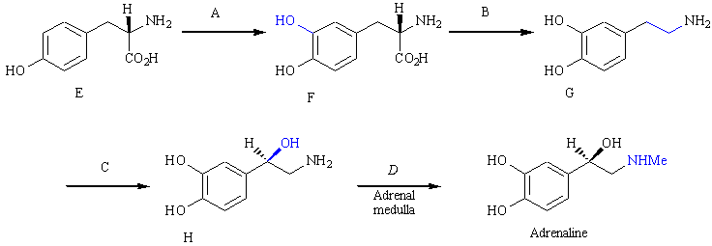
What are the enzymes A-D?
Feedback: Tyrosine hydroxylase catalyses the oxidation of the aromatic ring present in tyrosine to introduce a second phenol group and the formation of levodopa. Dopa decarboxylase catalyses the decarboxylation of levodopa to produce dopamine. Dopamine β -hydroxylase catalyses the oxidation of dopamine in order to introduce an alcohol function leading to the formation of noradrenaline. N-Methyl transferase introduces a methyl group onto the nitrogen atom of noradrenaline
Page reference: 595-596
a. A = Tyrosine hydroxylase
b. B = Dopa decarboxylase
c. C = Dopamine β -hydroxylase
d. D = N-methyl transferase

Type: matching question
Title: Chapter 20 - Question 14
14) The following diagram shows the biosynthetic pathway to adrenaline.

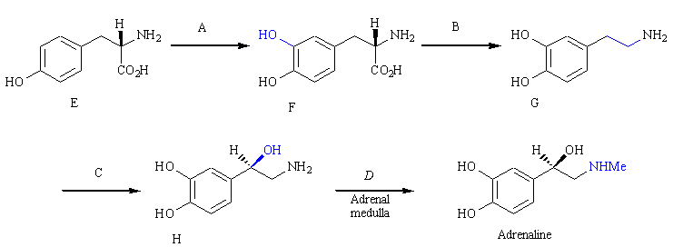
What are the names of the compounds E-H?
Feedback: Tyrosine hydroxylase catalyses the oxidation of the aromatic ring present in tyrosine to introduce a second phenol group and the formation of levodopa. Dopa decarboxylase catalyses the decarboxylation of levodopa to produce dopamine. Dopamine β -hydroxylase catalyses the oxidation of dopamine in order to introduce an alcohol function leading to the formation of noradrenaline. N-Methyl transferase introduces a methyl group onto the nitrogen atom of noradrenaline.
Page reference: 595-596
a. E = L-tyrosine
b. F = Levodopa
c. G = Dopamine
d. H = Noradrenaline

Type: multiple choice question
Title: Chapter 20 Question 15
15) Identify the enzyme that is responsible for catalysing the following metabolic reaction.

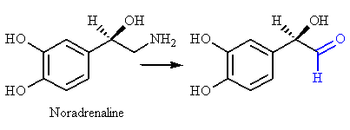

Feedback: Monoamine oxidase catalyses the oxidation of a primary amino group to an aldehyde. Catechol O-methyltransferase catalyses the methylation of one of the catechol phenol groups to a methyl ether.
The other two enzymes do not exist.
Page reference: 595-596
a. Monoamine O-methyltransferase
*b. Monoamine oxidase
c. Catechol O-methyltransferase
d. Catechol oxidase

Type: multiple choice question
Title: Chapter 20 Question 16
16) How is noradrenaline removed from a nerve synapse once it has served its function as a chemical messenger?
Feedback: Carrier proteins in the presynaptic nerve transport noradrenaline back into the nerve such that it can be taken up in vesicles. It is then ready to be released again when the nerve becomes active.
Page reference: 597
a. It is metabolised by enzymes present on the outer surface of nerve membranes.
*b. It is transported into the presynaptic nerve by carrier proteins.
c. It is transported into the postsynaptic nerve by carrier proteins.
d. It diffuses out of the synapse and enters the blood vessels to be taken to the kidneys.

Type: multiple choice question
Title: Chapter 20 Question 17
17) Which of the following agents has a controlling influence on the release of noradrenaline from adrenergic nerves?
Feedback: Prostaglandins, acetylcholine and noradrenaline itself all inhibit the release of noradrenaline from presynaptic nerves. Each of these chemical messengers interacts with a receptor on the pre-synaptic nerve that is specific for that chemical messenger.
Page reference: 597-598
a. Prostaglandins
b. Acetylcholine
c. Noradrenaline
*d. All of the answer are correct

Type: matching question
Title: Chapter 20 - Question 18
18) The structure shown below is adrenaline. What sort of binding interactions do the following functional groups have with the binding site of the adrenergic receptor; i) the phenols ii) the aromatic ring iii) the alcohol and iv) the quaternary nitrogen atom?

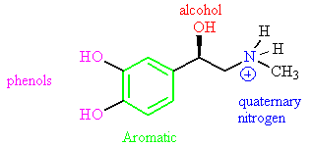
Feedback: The phenol groups and the alcohol group act as hydrogen bond donors. The aromatic ring interacts through van der Waals interactions. The quaternary nitrogen interacts through ionic interactions.
Page reference: 599
a. i = Hydrogen bond donor (1)
b. ii = Van der Waals interactions
c. iii = Hydrogen bond donor (2)
d. iv = Ionic interactions

Type: multiple choice question
Title: Chapter 20 Question 19
19) The following structure was found to have an 800 fold increase in agonist activity when the blue coloured group was added. What drug design strategy is illustrated here?

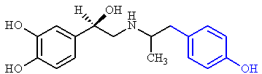
Feedback: The extra phenol is capable of interacting with an extra binding region by means of hydrogen bonding, and so this illustrates the strategy of extension - adding extra groups to find extra binding regions within the binding site.
Page reference: 601
*a. Extension
b. Rigidification
c. Substituent variation
d. Conformational blocking

Type: matching question
Title: Chapter 20 - Question 20
20) The following synthetic route has been used to prepare SALBUTAMOL. What are the reagents A – D?

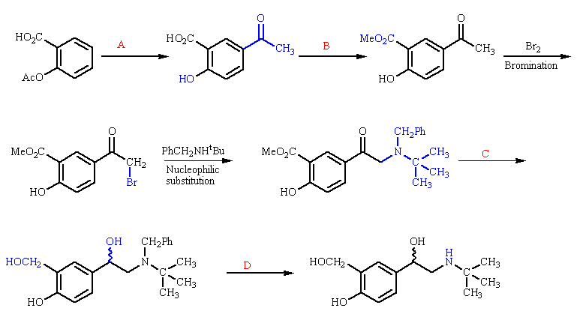
Feedback: Aluminium chloride and nitrobenzene are used to carry out a Fries rearrangement to produce a keto acid from aspirin. Methanol and hydrochloric acid are used to carry out an esterification with the hydrochloric acid acting as an acid catalyst. Litium aluminium hydride is a reducing agent which converts the ketone present in the structure to an alchohol. Tetrahydrofuran is present as solvent. A hydrogenolysis reaction is carried out using hydrogen gas in the presence of a palladium/charcoal catalyst.
Page reference: 603
a. A = Aluminium trichloride and nitrobenzene
b. B = Methanol and hydrochloric acid
c. C = Lithium aluminium hydride and tetrahydrofuran
d. D = Hydrogen gas over a palladium charcoal catalyst

Type: multiple choice question
Title: Chapter 20 Question 21
21) The following structure (salmeterol) has twice the potency of salbutamol, and an extended action of 12 hours.

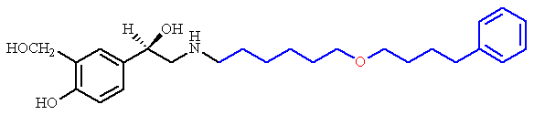
What role does the red coloured oxygen play?
Feedback: It does increase the polarity of the molecule but the group was not introduced in order to increase polarity for its own sake, but to introduce a hydrogen bond acceptor. There is no evidence to indicate that a methylene group at that position is overly susceptible to metabolism. It is impossible for an ether to act as a hydrogen bond donor.
Page reference: 604
a. It increases the polarity of the molecule.
b. It acts as an isostere for a methylene group that is susceptible to metabolism.
*c. It acts as a hydrogen bond acceptor to an extra hydrogen bonding region in the binding site.
d. It acts as a hydrogen bond donor to an extra hydrogen bonding region in the binding site.

Type: multiple choice question
Title: Chapter 20 Question 22
22) The following structure (salmeterol) has twice the potency of salbutamol, and an extended action of 12 hours.

What was the principle reason for including the blue coloured regions of the molecule?
Feedback: The principle reason for adding the extended alkyl chain and aromatic ring is that they increase the hydrophobicity of the molecule such that it binds more strongly and for longer periods to lipophilic tissue in the vicinity of adrenoceptors.. However, it is possible that these groups also interact with hydrophobic binding regions in the binding site of the receptor.
Page reference: 604
a. They interact with hydrophobic binding regions in the binding site.
b. The alkyl chain acts as a flexible arm positioning the aromatic ring correctly such that it can interact with an extra hydrophobic region by van der Waals interactions.
c. They increase the hydrophobicity of the molecule such that it is less solvated.
*d. They increase the hydrophobicity of the molecule such that it binds more strongly and for longer periods to lipophilic tissue in the vicinity of adrenoceptors.

Type: multiple choice question
Title: Chapter 20 Question 23
23) The following diagram illustrates some of the compounds that were involved in the development of an important clinical agent.

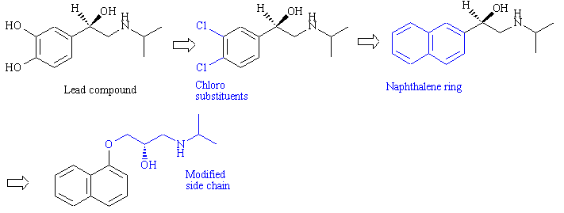
What sort of agent is it?
Feedback: The agent is propranolol. Propranolol was first introduced for the treatment of angina but is now more commonly used for the treatment of hypertension.
Page reference: 606-607
a. Anti-asthmatic agent
*b. Cardiovascular agent
c. Analgesic
d. Anti-ulcer agent

Type: multiple choice question
Title: Chapter 20 Question 24
24) The following diagram illustrates some of the compounds that were involved in the development of an important clinical agent.

What role does the clinical agent play?
Feedback: The agent is propranolol Propranolol acts as an antagonist of the -adrenoceptors present in heart muscle. This inhibits the force and frequency of heart muscle contractions and relieves the symptoms of angina.
Page reference: 606-607
a. An agonist at α -adrenoceptors
b. An antagonist at α-adrenoceptors
c. An agonist at β –adrenoceptors
*d. An antagonist at β -adrenoceptors

Type: multiple choice question
Title: Chapter 20 Question 25
25) The following diagram illustrates some of the compounds that were involved in the development of the important clinical agent - propranolol.

What effect does the replacement of phenol groups with chloro groups have?
Feedback: A partial agonist still activates its receptor, but not to the same extent as a full agonist.
Page reference: 606
a. It makes the agent an agonist
b. It makes the agent an antagonist
*c. It makes the agent a partial agonist
d. It makes the agent inactive

Type: multiple choice question
Title: Chapter 20 Question 26
26) The following diagram illustrates some of the compounds that were involved in the development of the important clinical agent - propranolol.

What effect does modification of the side chain have in the final structure?
Feedback: Modification of the side chain makes the agent an antagonist. It binds to the receptor but fails to activate it.
Page reference: 606-607
a. It makes the agent an agonist
*b. It makes the agent an antagonist
c. It makes the agent a partial agonist
d. It makes the agent inactive

Type: multiple choice question
Title: Chapter 20 Question 27
27) The diagram below indicates propranolol.

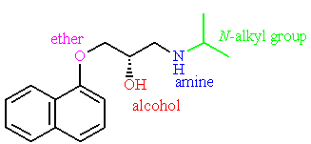

How does substitution on the side chain affect activity?

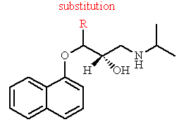
Feedback: Substitution on the side chain decreases activity. This may be due to bad steric interactions which make te molecule a poorer 'fit' for the binding site.
Page reference: 607
a. It increases activity.
*b. It decreases activity.
c. It has no effect.
d. It is impossible to predict.

Type: multiple choice question
Title: Chapter 20 Question 28
28) Practolol is a second generation β-blocker with selectivity for β ₂-adrenoceptors over β ₁-adrenoceptors.

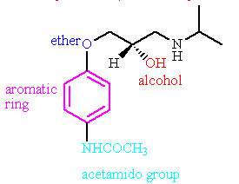

Which feature of the molecule is responsible for this advantage?
Feedback: The acetamido group is capable of forming an extra binding interaction with the β 1-adreonceptor.
Page reference: 609
a. The aromatic ring
*b. The acetamido group at the para-position of the aromatic ring
c. The ether
d. The alcohol

Type: multiple choice question
Title: Chapter 20 Question 29
29) Practolol is a second generation β -blocker with selectivity for β ₁-adrenoceptors over β ₂-adrenoceptors due to the presence of an acetamido group at the para position of the aromatic ring.

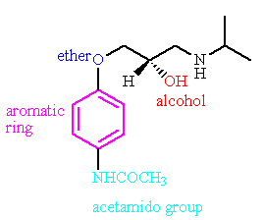

What extra binding interaction results from the presence of this group?
Feedback: The acetamido grup can form an extra hydrogen bond interaction where the oxygen of the acetamido group acts as a hydrogen bond acceptor.
Page reference: 609
a. An ionic interaction
b. Van der Waals interactions
*c. A hydrogen bonding interaction
d. A dipole-dipole interaction

Type: multiple choice question
Title: Chapter 20 Question 30
30) The following structure is a prodrug used in the treatment of shock.

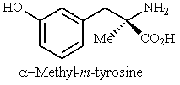

What structure is formed in the body from α-methyl-m-tyrosine?
Feedback: α -Methylnoradrenaline is a false transmitter that is formed from the prodrug α -methyldopa. Metaraminol is a false neurotransmitter formed from the prodrug α -methyl-m-tyrosine.
Page reference: 611
a. α -methylnoradrenaline
b. α -methyladrenaline
*c. Metaraminol
d. α -methyldopa

Type: multiple choice question
Title: Chapter 20 Question 31
31) The following structure is a prodrug used in the treatment of shock. It is converted in the body to metaraminol which is the active agent

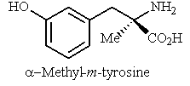

What function does the active agent serve?
Feedback: Metaraminol is a false transmitter which is taken up into vesicles and released like the natural neurotransmitter. However, it is less effective at activating adrenergic receptors, and so it down regulates the adrenergic system.
Page reference: 611
a. It is an adrenergic antagonist
*b. It is a false transmitter
c. It is an enzyme inhibitor
d. It inhibits noradrenaline uptake by the presynaptic nerve

Type: multiple choice question
Title: Chapter 20 Question 32
32) What is the mode of action of the natural product reserpine?
Feedback: Reserpine binds to the carrier proteins responsible for transporting noradrenaline into the storage vesicles within the presynaptic nerve. This prevents the uptake of noradrenaline into storage vesicles.
Page reference: 611
a. Adrenergic antagonist
b. False transmitter
c. Enzyme inhibitor
*d. Carrier protein inhibitor

Type: multiple choice question
Title: Chapter 20 Question 33
33) What is the mode of action of guanethidine and bretylium?

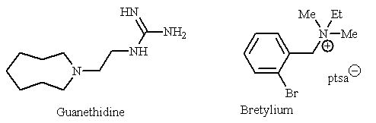
Feedback: These agents are taken up into storage vesicles and displace noradrenaline. They also prevent release of the vesicle's contents into the synaptic gap.
Page reference: 611-612
a. They are adrenergic antagonists
*b. They inhibit the release of noradrenaline from storage vesicles
c. They are enzyme inhibitors
d. They inhibit noradrenaline uptake into presynaptic nerves

Type: multiple choice question
Title: Chapter 20 Question 34
34) What is the mode of action of the tricyclic antidepressants?
Feedback: The tricyclic antidepressants inhibit the carrier proteins that transport noradrenaline from the synaptic gap back into the presynaptic nerve. Noradrenaline levels remain high in the synaptic gap leading to increased adrenergic activity.
Page reference: 612
a. They are adrenergic antagonists
b. They inhibit the release of noradrenaline from storage vesicles
c. They are enzyme inhibitors
*d. They inhibit noradrenaline uptake by presynaptic nerves

Type: multiple choice question
Title: Chapter 20 Question 35
35) What is the clinical use of monoamine oxidase inhibitors?
Feedback: These agents were used for the treatment of depression. They inhibit the metabolic enzyme monoamine oxidase and thus reduce the level at which catecholamines such as adrenaline and noradrenaline are metabolised. This results in an increase in adrenergic activity.
Page reference: 613
a. Treatment of asthma
b. Treatment of hypertension
*c. Treatment of depression
d. Treatment for obesity

Type: multiple choice question
Title: Chapter 20 Question 36
36) Which of the following is a monoamine oxidase inhibitor?
Feedback: Amphetamine and ephedrine are transported by the same carrier proteins that transport noradrenaline from the synaptic gap into the presynaptic nerves. Since they compete with noradrenaline for these carrier proteins, less noradrenaline is taken up from the synaptic gap, leading to increased levels of noradrenaline in the synaptic gap and increased adrenergic activity.
Cocaine binds to the carrier proteins responsible for the uptake of noradrenaline from the synaptic gap, also leading to increased levels of noradrenaline in the synaptic gap and increased adrenergic activity.
Phenelzine inhibits the metabolism of noradrenaline leading to increased levels of the neurotransmitter and increased adrenergic activity.
Page reference: 613
a. Amphetamine
b. Cocaine
c. Ephedrine
*d. Phenelzine

Type: multiple choice question
Title: Chapter 20 Question 37
37) Ripe cheese contains a chemical which results in severe headaches for people who are taking monoamine oxidase inhibitors (MAOI's).
What is the chemical in cheese responsible for this effect?
Feedback: Tyramine has a structure which is similar to noradrenaline. Too much tyramine can enhance the adrenergic system and lead to acute hypertension and severe headaches. This can occur if a patient is taking monoamine oxidase inhibitors.
Page reference: 614
a. Tyrosine
*b. Tyramine
c. Threonine
d. Tryptophan

Type: multiple choice question
Title: Chapter 20 Question 38
38) Ripe cheese contains a chemical which results in severe headaches for people who are taking monoamine oxidase inhibitors (MAOI's).
Why does this effect take place?
Feedback: Tyramine has a structure which is similar to noradrenaline. Too much tyramine can enhance the adrenergic system and lead to acute hypertension and severe headaches. This can occur if a patient is taking monoamine oxidase inhibitors since these inhibit the ennzymes which normally metabolise tyramine.
Page reference: 614
a. The MAOI and the chemical react with each other to produce a different compound which produces the symptoms.
*b. The MAOI inhibits the enzyme which normally metabolises the chemical and so there is a build up of the latter in the body. This produces the observed symptoms.
c. The MAOI inhibits the enzyme which normally metabolises the chemical, and so the chemical undergoes an alternative metabolic reaction to produce a different metabolite which is responsible for the symptoms.
d. The chemical binds to monoamine oxidase and blocks the MAOI from binding. Free MAOI produces the observed symptoms.

Type: multiple choice question
Title: Chapter 20 - Question 39
39) Which of the following is a natural chemical messenger for the adrenergic receptor?

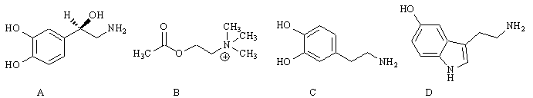

Feedback: Structure A is noradrenaline. This is the neurotransmitter that activates adrenergic receptors. The other compounds (B-D) are acetylcholine, dopamine and serotonin. These are neurotransmitters which have their own receptors.
Page reference: 593, 595
*a. Structure A
b. Structure B
c. Structure C
d. Structure D

Type: multiple choice question
Title: Chapter 20 - Question 40
40) Which of the following is a natural chemical messenger for the adrenergic receptor?

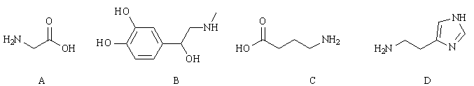

Feedback: Structure B is adrenaline. It is released by the adrenal medulla and travels round the body like a hormone to activate adrenergic receptors. The other structures are glycine (A), γ-aminobutyric acid (C) and histamine (D). Glycine and γ-aminobutyric acid are neurotransmitters that have their own receptors in the brain. Histamine is a chemical released by cells and which acts like a local hormone, interacting with its own receptors on nearby cells.
Page reference: 593, 595
a. Structure A
*b. Structure B
c. Structure C
d. Structure D

Type: multiple choice question
Title: Chapter 20 - Question 41
41) Which of the following statements is true regarding the signal transduction resulting from activation of the αadrenoceptor ?
Feedback: The α adrenoceptor triggers the release of inositol triphosphate and diacylglycerol while the α2adrenoceptor inhibits the release of cyclic AMP.
Page reference: 594
a. Activation results in the opening of an ion channel
b. Activation results in the activation of a tyrosine kinase
*c. Activation result in the release of inositol triposphate and diacylglycerol
d. Activation results in the release of cyclic AMP

Type: multiple choice question
Title: Chapter 20 - Question 42
42) Which of the following statements is true regarding the signal transduction resulting from activation of the α2 adrenoceptor ?
Feedback: Adrenoceptors are all G-protein-coupled receptors but differ in the signal transduction process that results. Activiation of the α2 adrenoceptor leads to the release of inositol triphosphate and diacylglycerol
Page reference: 594
a. Activation results in the opening of an ion channel
b. Activation results in the activation of a tyrosine kinase
*c. Activation result in the release of inositol triposphate and diacylglycerol
*d. Activation results in the release of cyclic AMP

Type: multiple choice question
Title: Chapter 20 - Question 43
43) Which of the following has a predominance of β2adrenoceptors?
Feedback: The β 1-adrenoceptor is predominant in heart muscle. The β 2-adrenoceptor is the predominant type of β -adrenoceptor in bronchial smooth muscle, arteriole smooth muscle, veins, the liver, gastrointestinal tract smooth muscle and kidney. The β 3-adrenoceptor is predominant in fat cells. The β -adrenoceptors are predominant in arteriole smooth muscle where the arterioles are not supplying muscles.
Page reference: 594-595
a. Fat cells
b. Bronchial smooth muscle
*c. Heart muscle
d. Arteriole smooth muscle not supplying muscles

Type: multiple choice question
Title: Chapter 20 - Question 44
44) Which of the following has a predominance of β 2adrenoceptors?
Feedback: The β 1-adrenoceptor is predominant in heart muscle. The β 2-adrenoceptor is the predominant type of β -adrenoceptor in bronchial smooth muscle, arteriole smooth muscle, veins, the liver, gastrointestinal tract smooth muscle and kidney. The β 3-adrenoceptor is predominant in fat cells. The β -adrenoceptors are predominant in arteriole smooth muscle where the arterioles are not supplying muscles.
Page reference: 594-595
a. Fat cells
*b. Bronchial smooth muscle
c. Heart muscle
d. Arteriole smooth muscle not supplying muscles

Type: multiple choice question
Title: Chapter 20 - Question 45
45) Which of the following has a predominance of β 3adrenoceptors?
Feedback: The β 1-adrenoceptor is predominant in heart muscle. The β 2-adrenoceptor is the predominant type of β -adrenoceptor in bronchial smooth muscle, arteriole smooth muscle, veins, the liver, gastrointestinal tract smooth muscle and kidney. The β 3-adrenoceptor is predominant in fat cells. The β -adrenoceptors are predominant in arteriole smooth muscle where the arterioles are not supplying muscles.
Page reference: 594-595
*a. Fat cells
b. Bronchial smooth muscle
c. Heart muscle
d. Arteriole smooth muscle not supplying muscles

Type: multiple choice question
Title: Chapter 20 - Question 46
46) Which of the following has a predominance of α adrenoceptors?
Feedback: The β 1-adrenoceptor is predominant in heart muscle. The β 2-adrenoceptor is the predominant type of -adrenoceptor in bronchial smooth muscle, arteriole smooth muscle, veins, the liver, gastrointestinal tract smooth muscle and kidney. The β 3-adrenoceptor is predominant in fat cells. The α-adrenoceptors are predominant in arteriole smooth muscle where the arterioles are not supplying muscles.
Page reference: 594-595
a. Fat cells
b. Bronchial smooth muscle
c. Heart muscle
*d. Arteriole smooth muscle not supplying muscles

Type: multiple choice question
Title: Chapter 20 - Question 47
47) Which of the following adrenoceptors is the main target for anti-asthmatic drugs?
Feedback: Agonists of the β 2-adrenoceptors in bronchial smooth muscle result in smooth muscle relaxation and dilation of the airways to relieve asthma.
Page reference: 595
a. β -adrenoceptor
*b. β 2-adrenoceptor
c. β 3-adrenoceptor
d. α2 -adrenoceptor

Type: multiple choice question
Title: Chapter 20 - Question 48
48) Which of the following adrenoceptors is the main target for anti-hypertensive drugs?
Feedback: Antagonists of the β -adrenoceptors were originally designed as β -blockers to inhibit heart muscle contraction and force, and thus treat angina. However, they are more commonly used to treat hypertension (high blood pressure).
Page reference: 595
a. β -adrenoceptor
*b. β 2-adrenoceptor
c. β 3-adrenoceptor
d. α2 -adrenoceptor

Type: multiple choice question
Title: Chapter 20 - Question 49
49) Which of the following structures is a catecholamine?

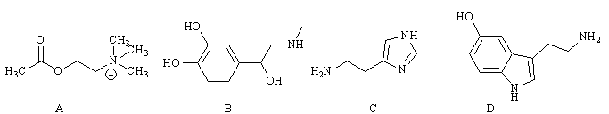
Feedback: Structure B is a catecholamine. The catecholamines all contain an aromatic ring with two neighbouring phenolic groups, as well as an alkyl chain bearing an amino group.
Structure B is adrenaline. This is a hormone that activates adrenergic receptors. The other compounds (A, C and D) are acetylcholine, dopamine and serotonin. These are neurotransmitters which have their own receptors.
Page reference: 595
a. Structure A
*b. Structure B
c. Structure C
d. Structure D

Type: multiple choice question
Title: Chapter 20 - Question 50
50) Which of the following statements is false regarding analogues of noradrenaline?
Feedback: The selectivity is the other way round with selectivity for β -receptors over α -receptors.
Page reference: 600
a. A naphthalene ring is good for selective β -antagonists.
*b. A bulky N-alkyl substituent introduces selectivity for α -receptors over β -receptors.
c. Removal of one of the catechol phenol groups leads to a drop in activity.
d. Addition of an α -methyl group increases selectivity for the α 2-adrenoceptor.

Type: multiple choice question
Title: Chapter 20 - Question 51
51) Which of the following statements about adrenaline is false?
Feedback: Adrenaline acts like a hormone when it is released in the body. It is not rapidly metabolised and has a reasonable life time. It also has a good activity. The disadvantage with adrenaline is that it activates all the adrenergic receptors that it reaches and shows no selectivity between different types and sub types. It is a useful medicine, especially in emergency situations of cardiac arrest or anaphylactic reactions
Page reference: 601
a. It acts like a hormone
*b. It is rapidly metabolised
c. It shows poor selectivity between different types of adrenoceptor
d. It is a useful medicine

Type: matching question
Title: Chapter 20 - Question 52
52) Identify the following structures.

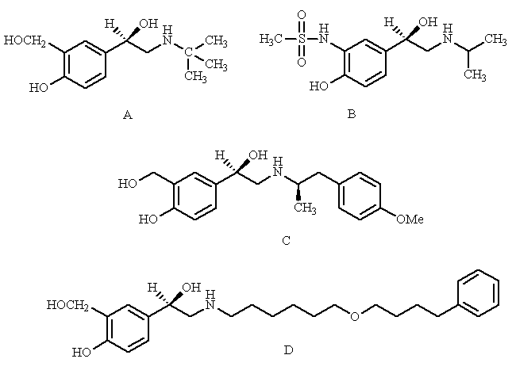
Feedback: The agents shown are all α 2-agonists which were either used or were considered as anti-asthmatic agents.
Page reference: 602-604
a. Salmefamol = Structure C
b. Salmeterol = Structure D
c. Salbutamol = Structure A
d. Soterenol = Structure B

Type: multiple choice question
Title: Chapter 20 - Question 53
53) Which of the following structures has never been used clinically?

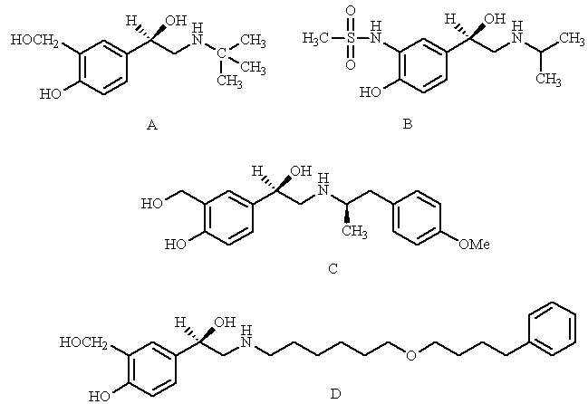
Feedback: Structure B is soterenol. It was never used because salbutamol (structure A) was discovered. The remaining two structures (C and D) are salmefamol and salmeterol which were designed to have longer activity than sulbutamol.
Page reference: 602-604
a. Structure A
*b. Structure B
c. Structure C
d. Structure D

Type: multiple choice question
Title: Chapter 20 - Question 54
54) What sort of agents are the following structures?

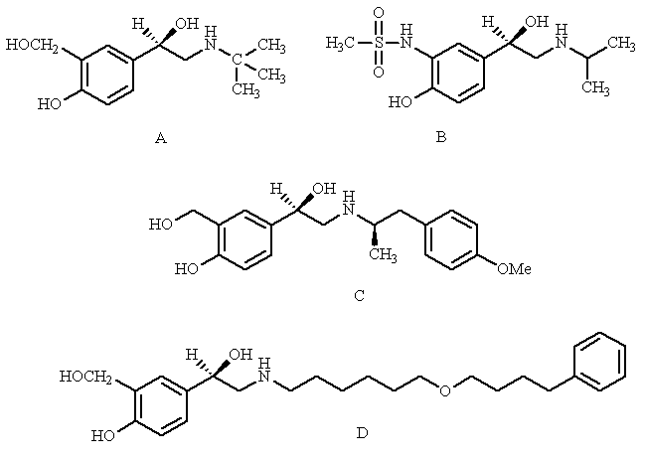
Feedback: Structures A-D are salbutamol, soterenol, salmefamol and salmeterol. Soterenol was never used because salbutamol was discovered. Salmefamol and salmeterol were designed to have longer activity than sulbutamol. They all act as agonists with selectivity for 2-adrenoceptors.
Page reference: 602-604
*a. -adrenoceptor agonists
b. -adrenoceptor antagonists
c. -adrenoceptor agonists
d. -adrenoceptor antagonists

Type: multiple choice question
Title: Chapter 20 - Question 55
55) What ailment were the following structures designed to treat?

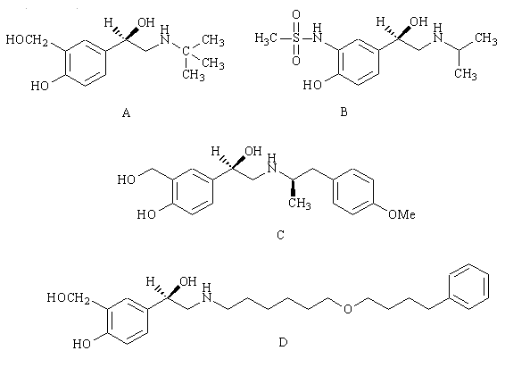

Feedback: Structures A-D are salbutamol, soterenol, salmefamol and salmeterol. Soterenol was never used because salbutamol was discovered. Salmefamol and salmeterol were designed to have longer activity than sulbutamol.
Page reference: 602-604
a. Hypertension
b. Pain
*c. Asthma
d. Angina

Type: multiple choice question
Title: Chapter 20 - Question 56
56) The following structure is the anti-asthmatic agent salbutamol. Which of the following groups is important in conferring selectivity for β -adrenoceptors?

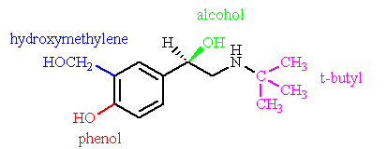
Feedback: The β-adrenoceptor has a larger hydrophobic pocket available to N-alkyl substituents than the α-adrenoceptor, and so bulky N-alkyl substituents confer selectivity for β-adrenoceptors.
Page reference: 602-604
a. The hydroxymethylene group
b. The phenol
c. The alcohol
*d. The tertiary butyl group

Type: multiple choice question
Title: Chapter 20 - Question 57
57) The following structure is the anti-asthmatic agent salbutamol. Which of the coloured groups interacts with a hydrophobic binding region in the adrenergic binding site?

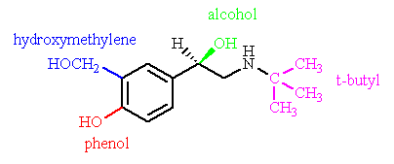
Feedback: The β-adrenoceptor has a larger hydrophobic pocket available to N-alkyl substituents than the α-adrenoceptor, and so bulky N-alkyl substituents confer selectivity for β-adrenoceptors by interacting with this pocket via van der Waals interactions.
Page reference: 602-604
a. The hydroxymethylene group
*b. The phenol
c. The alcohol
*d. The tertiary butyl group

Type: multiple choice question
Title: Chapter 20 - Question 58
58) The following structure is the anti-asthmatic agent salbutamol. Which of the following groups is important in conferring greater metabolic stability compared to noradrenaline?

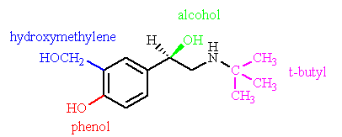
Feedback: The original phenol is metabolised to a methyl ether by the metabolic enzyme catechol O-methyltransferase. Shifting the OH group away from the aromatic ring by one bond makes it unrecognisable to the metabolic enzyme, but the group can still interact by hydrogen bonding with the receptor binding site.
Page reference: 602-604
*a. The hydroxymethylene group
b. The phenol
c. The alcohol
d. The tertiary butyl group

Type: matching question
Title: Chapter 20 - Question 59
59) Identify the following structures.

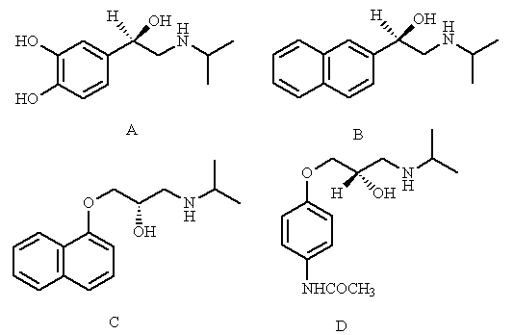
Feedback: The agents shown are examples of β-blockers. β-Blockers are used in cardiovascular medicine.
Page reference: 606-610
a. Pronethalol = Structure B
b. Propranolol = Structure C
c. Practolol = Structure D
d. Isoprenaline = Structure A

Type: multiple choice question
Title: Chapter 20 - Question 60
60) Which of the following structures is a partial agonist?

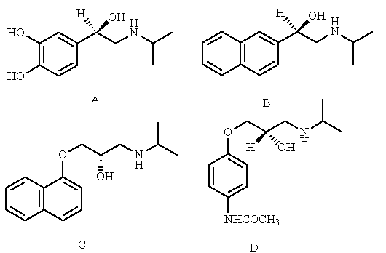
Feedback: The structures shown (A-D) are isoprenaline, pronethalol, propranolol and practolol. Isoprenaline is an adrenergic agonist. Pronethalol is a partial agonist. Practolol and propranolol are adrenergic antagonists.
Page reference: 606-610
a. Structure A
*b. Structure B
c. Structure C
d. Structure D

Type: multiple choice question
Title: Chapter 20 - Question 61
61) Which of the following structures is an adrenergic agonist?

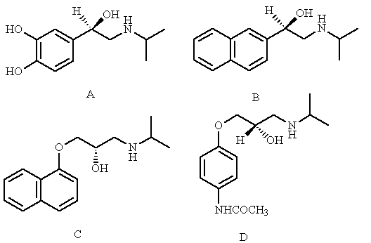

Feedback: The structures shown (A-D) are isoprenaline, pronethalol, propranolol and practolol. Isoprenaline is an adrenergic agonist. Pronethalol is a partial agonist. Practolol and propranolol are adrenergic antagonists.
Page reference: 606-610
*a. Structure A
b. Structure B
c. Structure C
d. Structure D

Type: multiple choice question
Title: Chapter 20 - Question 62
62) Which of the following structures was introduced as an adrenergic antagonist with selectivity for β1 adrenoceptros over β2 adrenoceptors?

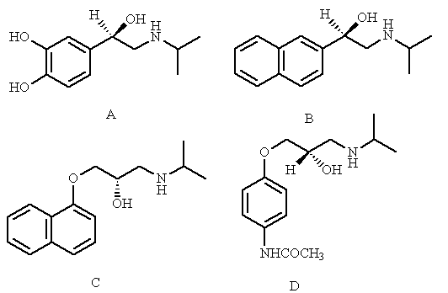
Feedback: The structures shown (A-D) are isoprenaline, pronethalol, propranolol and practolol. Isoprenaline is an adrenergic agonist. Pronethalol is a partial agonist. Practolol and propranolol are adrenergic antagonists. Practolol is selective for b1 adrenoceptors over b1 adrenoceptors and avoided the side effects of propranolol that were observed in asthmatic patients. Unfortunately, the drug had to be withdrawn due to rare but serious side effects.
Page reference: 606-610
a. Structure A
b. Structure B
c. Structure C
*d. Structure D

Type: multiple choice question
Title: Chapter 20 - Question 63
63) Propranolol is an important β-blocker.

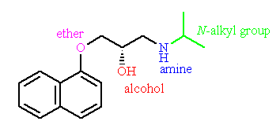

Which of the coloured groups indicated interacts with the adrenergic binding site by ionic bonding?
Feedback: The amine is protonated and interacts with the binding site by ionic interactions. The ether acts as a hydrogen bond acceptor. The alcohol can act both as a hydrogen bond donor and a hydrogen bond acceptor. The N-alkyl group interacts with a hydrophobic region by van der Waals interactions.
Page reference: 606-610
a. The ether
b. The alcohol
*c. The amine
d. The N-alkyl group

Type: multiple choice question
Title: Chapter 20 - Question 64
64) Propranolol is an important β-blocker.

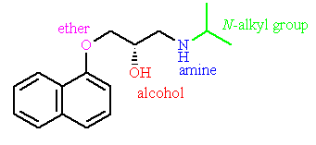

Which of the coloured groups indicated interacts with the adrenergic binding site by van der Waals interactions?

Feedback: The amine is protonated and interacts with the binding site by ionic interactions. The ether acts as a hydrogen bond acceptor. The alcohol can act both as a hydrogen bond donor and a hydrogen bond acceptor. The N-alkyl group interacts with a hydrophobic region by van der Waals interactions.
Page reference: 606-610
a. The ether
b. The alcohol
c. The amine
*d. The N-alkyl group

Type: multiple choice question
Title: Chapter 20 - Question 65
65) Propranolol is an important β-blocker.

Which of the coloured groups indicated interacts with the adrenergic binding site as a hydrogen bond acceptor?
Feedback: The amine is protonated and interacts with the binding site by ionic interactions. The ether acts as a hydrogen bond acceptor. The alcohol can act both as a hydrogen bond donor and a hydrogen bond acceptor. The N-alkyl group interacts with a hydrophobic region by van der Waals interactions.
Page reference: 606-610
*a. The ether
b. The alcohol
c. The amine
d. The N-alkyl group

Type: multiple choice question
Title: Chapter 20 – Question 66
66) Propranolol is an important β-blocker.

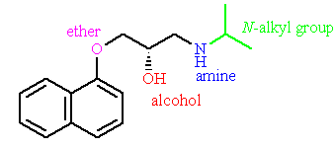

Which of the coloured groups indicated can interact with the adrenergic binding site as a hydrogen bond acceptor or a hydrogen bond donor?
Feedback: The amine is protonated and interacts with the binding site by ionic interactions. The ether acts as a hydrogen bond acceptor. The alcohol can act both as a hydrogen bond donor and a hydrogen bond acceptor. The N-alkyl group interacts with a hydrophobic region by van der Waals interactions.
Page reference: 606-610
a. The ether
*b. The alcohol
c. The amine
d. The N-alkyl group

Type: multiple choice question
Title: Chapter 20 - Question 67
67) What reagents could be used to synthesise timolol?

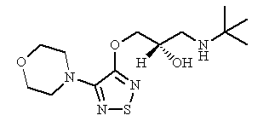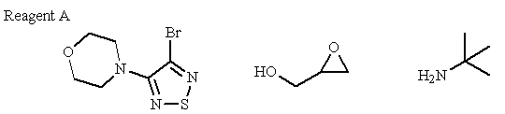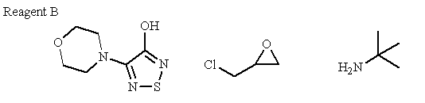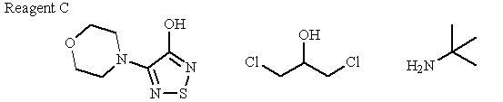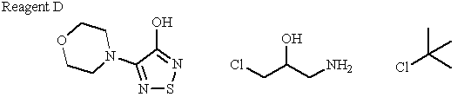
Feedback: The general synthesis for aryloxypropanolamines is shown below:

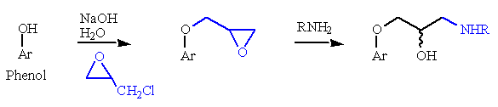
Therefore the 'building blocks' for timolol are as shown below:

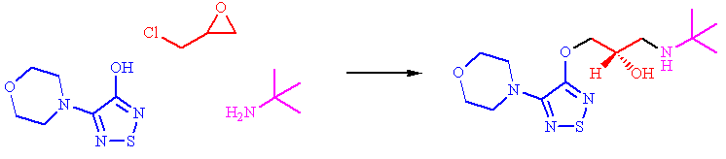

Page reference: 608
a. Reagent A
*b. Reagent B
c. Reagent C
d. Reagent D

Type: matching question
Title: Chapter 20 - Question 68
68) Identify the following agents:

[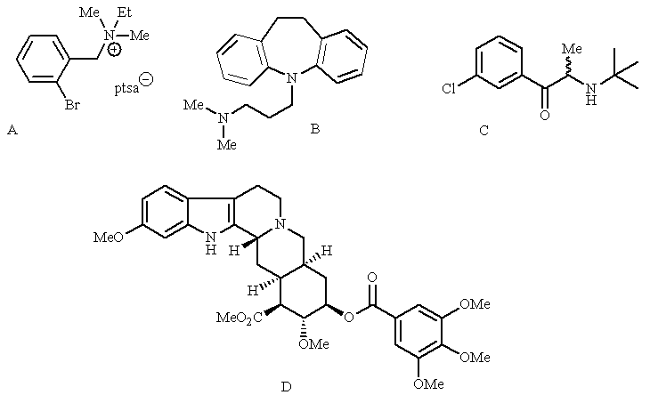

Feedback: The drugs shown have an effect on adrenergic transmission. Reserpine affects the uptake of noradrenailne into storage vesicles. Bretylium affects the release of noradrenaline from storage vesicles. Imipramine is a tricyclic antidepressant which inhibits noradrenaline reuptake in the central nervous system. Bupropion inhibits the reuptake of both noradrenaline and dopamine.
Page reference: 611-613
a. Reserpine = Structure A
b. Bretylium = Structure B
c. Imipramine = Structure C
d. Bupropion = Structure D

Type: multiple choice question
Title: Chapter 20 - Question 69
69) Which of the following agents acts as a carrier protein inhibitor?
Feedback: Reserpine binds to the carrier proteins responsible for transporting noradrenaline into the storage vesicles within the presynaptic nerve. This prevents the uptake of noradrenaline into storage vesicles.
Page reference: 611-613
a. Propranolol
b. Guanethidine
*c. Reserpine
d. Salbutamol

Type: multiple choice question
Title: Chapter 20 - Question 70
70) Which of the following agents inhibits the release of noradrenaline from storage vesicles?
Feedback: Guanethidine is taken up into storage vesicles and displaces noradrenaline. It also prevents release of the vesicle's contents into the synaptic gap.
Page reference: 611-613
a. Propranolol
*b. Guanethidine
c. Reserpine
d. Salbutamol

Type: multiple choice question
Title: Chapter 20 - Question 71
71) Which of the following agents inhibits the release of noradrenaline from storage vesicles?
Feedback: Desipramine is an example of a tricyclic antidepressant. The tricyclic antidepressants inhibit the carrier proteins that transport noradrenaline from the synaptic gap back into the presynaptic nerve. Noradrenaline levels remain high in the synaptic gap leading to increased adrenergic activity.
Page reference: 611-613
a. Propranolol
b. Guanethidine
*c. Desipramine
d. Salbutamol

Type: matching question
Title: Chapter 20 - Question 72
72) Identify the following structures

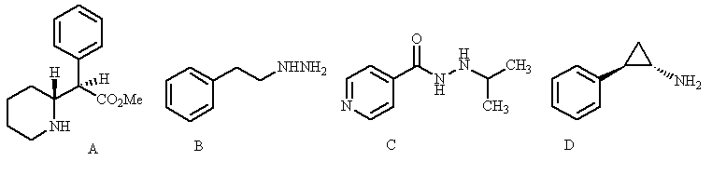

Feedback: Iproniazid, phenelzine and tranylcypromine are mooamine oxidase inhibitors. These agents were used for the treatment of depression. They inhibit the metabolic enzyme monoamine oxidase and thus reduce the level at which catecholamines such as adrenaline and noradrenaline are metabolised. This results in an increase in adrenergic activity.
Methylphenidate inhibits noradrenaline uptake and acts as a stimulant.
Page reference: 613-614
a. Iproniazid = Structure C
b. Methylphenidate = Structure A
c. Phenelzine = Structure B
d. Tranylcypromine = Structure D

Type: multiple choice question
Title: Chapter 20 - Question 73
73) Which of the following agents is not a monoamine oxidase inhibitor?

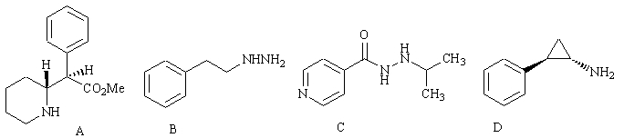

Feedback: Iproniazid, phenelzine and tranylcypromine are mooamine oxidase inhibitors. These agents were used for the treatment of depression. They inhibit the metabolic enzyme monoamine oxidase and thus reduce the level at which catecholamines such as adrenaline and noradrenaline are metabolised. This results in an increase in adrenergic activity.
Methylphenidate inhibits noradrenaline uptake and acts as a stimulant.
Page reference: 613-614
a. Iproniazid
*b. Methylphenidate
c. Phenelzine
d. Tranylcypromine

Type: multiple choice question
Title: Chapter 20 - Question 74
74) What is the mode of action of phenelzine?
Feedback: Phenelzine inhibits the metabolism of noradrenaline leading to increased levels of the neurotransmitter and increased adrenergic activity.
Page reference: 613-614
*a. Monoamine oxidase inhibitor
b. Inhibitor of noradrenaline uptake
c. Adrenergic agonist
d. Adrenergic antagonist

Type: multiple choice question
Title: Chapter 20 - Question 75
75) What is the mode of action of methylphenidate?
Feedback: Methylphenidate inhibits noradrenaline uptake and acts as a stimulant.
Page reference: 613-614
a. Monoamine oxidase inhibitor
*b. Inhibitor of noradrenaline uptake
c. Adrenergic agonist
d. Adrenergic antagonist

Type: multiple choice question
Title: Chapter 20 - Question 76
76) What side effect can affect patients taking monoamine oxidase inhibitors (MAOI's) if they eat ripe cheese?
Feedback: Severe headache can arise. Ripe cheese contains tyramine which is normally metabolised by monoamine oxidases. Inhibition of these enezymes allows tyramine levels to increase, resulting in the effects observed.
Page reference: 613-614
a. Dizziness
b. Nausea
*c. Severe headache
d. Constipation

