Chapter 19: Cholinergics, anticholingergics and anticholinesterases

Type: matching question
Title: Chapter 19 - Question 01
01) Consider the following diagram.

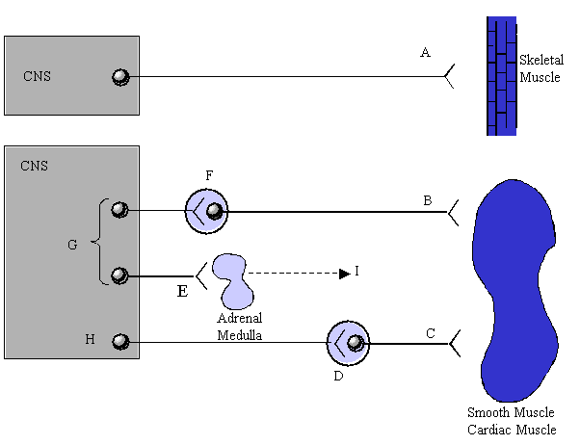
What receptors are present to receive the neurotransmitter released at the synapses A-F?
Feedback: Nerves innervating skeletal muscle release acetylcholine as the neurotransmitter and will interact with cholinergic receptors on skeletal muscle cells. There are two types of cholinergic receptor and skeletal muscle contains nicotinic cholinergic receptors rather than muscarinic receptors.
Smooth muscle and cardiac muscle also have cholinergic receptors, and these are muscarinic receptors and not nicotinic receptors. Nerves of the parasympathetic nervous system release acetylcholine.
Unlike skeletal muscle, smooth muscle and cardiac muscle also have adrenergic receptors which are activated by noradrenaline. Noradrenaline is released by nerves of the sympathetic nervous system and activation of adrenergic receptors will have the opposite effect on a target cell from the effect resulting from activation of a cholinergic receptor.
The neurotransmitter released in the synapses between different nerves or betwen a nerve and the adrenal medulla is acetylcholine and the receptor on the target cell is a nicotinic receptor.
Page reference: 560
a. A = Nicotinic receptor (1)
b. B = Adrenergic receptor
c. C = Muscarinic receptor
d. D = Nicotinic receptor (2)
e. E = Nicotinic receptor (3)
f. F = Nicotinic receptor (4)

Type: matching question
Title: Chapter 19 - Question 02
02) Consider the following diagram.

What are the names of the nervous systems indicated by G and H?
Feedback: Nerves of the sympathetic nervous system synapse quite soon after leaving the spinal cord using acetylcholine as a neurotransmitter. The 'recipient' nerves then travel to target organs and release noradrenaline as neurotransmitter. Nerves of the sympathetic nervous system are also responsible for triggering the release of adrenaline from the adrenal medulla.
Nerves of the parasympathetic nervous system travel some distance after leaving the spinal column before synapsing. The subsequent nerves then release acetylcholine at target cells.
Page reference: 560
a. G = Sympathetic
b. H = Parasympathetic

Type: multiple choice question
Title: Chapter 19 Question 03
03) Consider the following diagram.

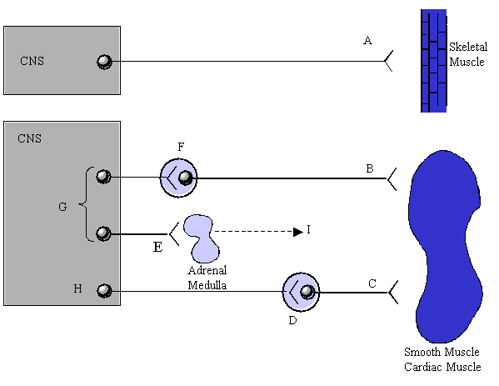
What is the name of the chemical messenger (I) released by the adrenal medulla?
Feedback: Adrenaline is released by the adrenal medulla and acts as a hormone. It travels round the body and activates adrenergic receptors. Noradrenaline, acetylcholine and dopamine are all neurotransmitters released by specific nerves.
Page reference: 560
a. Noradrenaline
b. Acetylcholine
*c. Adrenaline
d. Dopamine

Type: matching question
Title: Chapter 19 - Question 04
04) Identify the following chemical messengers

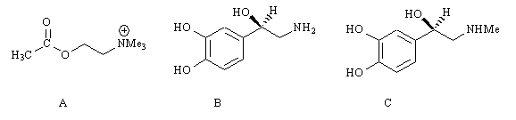

Feedback: Acetylcholine and noradrenaline are neurotransmitters released by nerves. Adrenaline is a hormone released by the adrenal medulla. Adrenaline and noradrenaline are very similar in structure and are classed as catecholamines. The term 'nor' is oten used to indicate that the structure no longer has a methyl group on a nitrogen atom. Thus noradrenaline has the same structure as adrenaline, but lacks the N-methyl group present on adrenaline.
Page reference: 560
a. A = Acetylcholine
b. B = Noradrenaline
c. C = Adrenaline

Type: multiple choice question
Title: Chapter 19 Question 05
05) What is the name of the enzyme responsible for the synthesis of acetylcholine?
Feedback: Acetylcholinesterase catalyses the breakdown of acetylcholine. Choline acetyltransferase catalyses its synthesis. The other two enzymes do not exist.
Page reference: 562
a. Acetylcholinesterase
*b. Choline acetyltransferase
c. Acetylcholine synthase
d. Acetylcholine ligase

Type: matching question
Title: Chapter 19 - Question 06
06) The following two compounds are natural products.

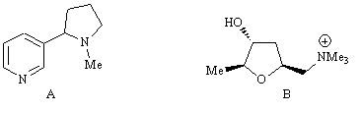
What are they called?
Feedback: Nicotine is present in tobacco and contains a pyridine ring linked toa pyrrolidine ring. Muscarine is the active principle of a poisonous mushroom and contains a tetrahydrofuran ring.
Page reference: 564
a. A = Nicotine
b. B = Muscarine

Type: multiple choice question
Title: Chapter 19 Question 07
07) The following two compounds are natural products.

What effect do these structures have on cholinergic receptors?
Feedback: Both these agents act as agonists at two different types of cholinergic receptor. Nicotine is an agonist for nicotinic receptors. Muscarine is an agonist for muscarinic receptors.
Page reference: 564-565
a. They are suicide substrates
b. They are antagonists
*c. They are agonists
d. They are allosteric modulators

Type: multiple choice question
Title: Chapter 19 Question 08
08) Which feature of acetylcholine interacts with the binding site of cholinergic receptors by ionic bonding?

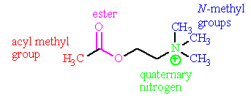
Feedback: The acyl methyl group fits a hydrophobic pocket and interacts by van der Waals interactions. The oxygen atoms of the ester serve as hydrogen bond acceptors to asparagine 617 in the binding site. The quaternary nitrogen has a positive charge and forms an ionic bond to aspartate 311. Two of the three N-methyl groups fit hydrophobic pockets and interact by van der Waals interactions.
Page reference: 566
a. The acyl methyl group
b. The ester
*c. The quaternary nitrogen
d. All three N-methyl groups

Type: multiple choice question
Title: Chapter 19 Question 09
09) Which feature of acetylcholine interacts with the binding site of cholinergic receptors by van der Waals interactions?

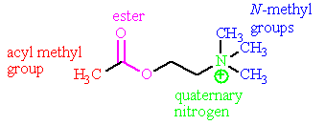
Feedback: The acyl methyl group fits a hydrophobic pocket and interacts by van der Waals interactions. The oxygen atoms of the ester serve as hydrogen bond acceptors to asparagine 617 in the binding site. The quaternary nitrogen has a positive charge and forms an ionic bond to aspartate 311.
Only two of the three N-methyl groups fit hydrophobic pockets and interact by van der Waals interactions.
Page reference: 566
*a. The acyl methyl group.
b. The ester.
c. The quaternary nitrogen.
d. All three N-methyl groups.

Type: multiple choice question
Title: Chapter 19 Question 10
10) What amino acid in the binding site of the cholinergic receptor is involved in an ionic interaction with acetylcholine?
Feedback: Aspartic acid 311 is ionised and is present in the binding site as a negatively charged aspartate ion.
Page reference: 566
a. Histidine
*b. Aspartic acid
c. Glutamic acid
d. Lysine

Type: multiple choice question
Title: Chapter 19 Question 11
11) What amino acid in the binding site of the cholinergic receptor is involved in a hydrogen bonding interaction with acetylcholine?
Feedback: Asparagine has a primary amide functional group on its side chain. This acts as a hydrogen bond donor to the ester of acetylcholine.
Page reference: 566
a. Serine
*b. Asparagine
c. Glutamine
d. Cysteine

Type: multiple choice question
Title: Chapter 19 Question 12
12) How many hydrophobic pockets in the cholinergic binding site are occupied by groups present on acetylcholine?
Feedback: There are three hydrophobic pockets. One accepts the acyl methyl group. The remaining two accept two of the three N-methyl groups.
Page reference: 566
a. 1
b. 2
*c. 3
d. 4

Type: multiple choice question
Title: Chapter 19 Question 13
13) Several aromatic amino acid residues present in the cholinergic binding site are thought to interact with acetylcholine by means of an induced dipole-dipole interaction. Which part of the acetylcholine is involved?
Feedback: The quaternary ammonium head group could be sandwiched between the heteroaromatic and aromatic rings of amino acids such as tryptophan and tyrosine, resulting in induced dipoles in the heteroaromatic or aromatic rings.
Page reference: 566
a. The acyl methyl group
b. The ester
c. The ethylene bridge
*d. The quaternary ammonium head group

Type: multiple choice question
Title: Chapter 19 Question 14
14) Which of the following statements is true regarding the use of acetylcholine as a drug?
Feedback: Acetylcholine is easily synthesised. The other options are false. Acetylcholine activates all cholinergic receptors and shows no selectivity. It is also susceptible to acid and enzymatic hydrolysis. It cannot survive the acids of the stomach and it is orally inactive. It is also quickly hydrolysed by enzymes in the blood supply.
Page reference: 563-565
*a. It is easily synthesised
b. It shows selectivity between the different types of cholinergic receptors
c. It is orally active
d. It is metabolically stable

Type: multiple choice question
Title: Chapter 19 Question 15
15) The following structure is a cholinergic agonist.

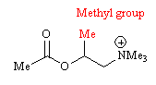
What is the purpose of the methyl group?
Feedback: The ester group is susceptible to acid and enzyme catalysed hydrolysis. The methyl group acts as a steric shield to incoming nucleophiles. The structure is called methacholine.
Page reference: 568-569
a. It acts as a metabolically susceptible group.
b. It interacts with a hydrophobic pocket in the binding site.
*c. It acts as a steric shield to protect the ester group.
d. It has an inductive effect on the neighbouring ester group.

Type: multiple choice question
Title: Chapter 19 Question 16
16) The following structure is a cholinergic agonist.

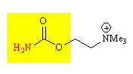
What is the structure called?
Feedback: Compared to acetylcholine, methacholine contains an extra methyl substituent on the 2-C chain linking the ester and quaternary ammononium groups. In contrast, carbachol has a urethane group instead of an ester while bethanechol has a urethane group and an extra methyl substituent.
Page reference: 568-569
a. Acetylcholine
*b. Carbachol
c. Methacholine
d. Bethanechol

Type: multiple choice question
Title: Chapter 19 Question 17
17) The following structure is a cholinergic agonist.

What is the name of the functional group in yellow?
Feedback: The general formula for an amide group is RCONR2. For an ester it is RCO2R. A urethane functional group has the general formula R2NCO2R. The urea is R2NCONR2 The structure is carbachol.
Page reference: 568-569
a. Amide
b. Ester
*c. Urethane
d. Urea

Type: multiple choice question
Title: Chapter 19 Question 18
18) What is the name of the cholinergic agonist which combines the steric strategy used to stabilise methacholine and the electronic strategy used to stabilise carbachol?
Feedback: Bethanechol contains a methyl steric shield at the same position as methacholine and a urethane functional group instead of an ester.
Page reference: 569
a. Acetylcholine
b. Carbachol
c. Methacholine
*d. Bethanechol

Type: multiple choice question
Title: Chapter 19 Question 19
19) Which of the following structures would you expect to be a stable cholinergic agonist?

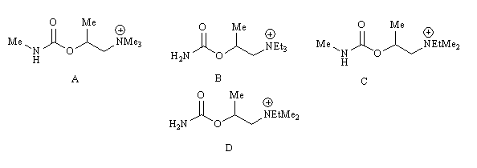
Feedback: All the structures shown have a methyl steric shield and a urethane functional group, so they would be expected to be stable to hydrolysis.
Structures A and C are unlikely to be active since the urethane nitrogen has a methyl substituent which is likely to be too large for the small hydrophobic pocket available.
Structure B will be inactive since the ethyl groups on the quaternary nitrogen are too large for the hydrophobic pockets available.
Structure D would be expected to be active. There is an ethyl group on the quaternary nitrogen atom, but the remaining two groups are methyl groups which can fit the hydrophobic pockets available.
Page reference: 568-569
a. Structure A
b. Structure B
c. Structure C
*d. Structure D

Type: multiple choice question
Title: Chapter 19 Question 20
20) Which of the following is a clinical use for a nicotinic agonist?
Feedback: Nicotinic agonists have been used for the treatment of myasthenia gravis. The other clinical uses described are relevant to muscarinic agonists and not nicotinic agonists.
Page reference: 570
*a. Treatment of myasthenia gravis
b. 'Switching on the gastrointestinal tract
c. 'Switching on the urinary tract
d. Decreasing heart muscle activity in certain heart defects

Type: multiple choice question
Title: Chapter 19 Question 21
21) The following structure is used as a muscarinic agonist.

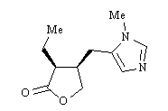
What is it called?
Feedback: All the agents stated are muscarinic agonists.
Page reference: 569-570
a. Oxotremorine
b. Muscarine
c. Arecoline
*d. Pilocarpine

Type: multiple choice question
Title: Chapter 19 Question 22
22) What are the products arising from the hydrolysis of acetylcholine?
Feedback:
Page reference: 562
a. Ethanoic acid and ethylamine
b. Methanoic acid and choline
*c. Ethanoic acid and choline
d. Ethanoic acid, ethanol and ammonia

Type: multiple choice question
Title: Chapter 19 Question 23
23) Which of the following is not an application for a muscarinic antagonist?
Feedback: Skeletal muscle cells have nicotinic receptors and so they are not affected by muscarinic antagonists.
Page reference: 570-571
a. Ophthalmic examinations
b. Shutting down the gastrointestinal and urinary tracts during surgery
c. Treatment of motion sickness
*d. Relaxation of skeletal muscle

Type: multiple choice question
Title: Chapter 19 Question 24
24) Which of the following is not a general characteristic of muscarinic antagonists?
Feedback: This is a requirement for nicotinic antagonists but not muscarinic antagonists. The other characteristics are valid.
Page reference: 572-573
a. The alkyl groups on nitrogen can be larger than methyl.
*b. Two positively charged centres are required at a specific distance apart.
c. Large branched acyl groups are good for activity.
d. The nitrogen can be tertiary or quaternary.

Type: multiple choice question
Title: Chapter 19 Question 25
25) Identify which of the following structural features is present in many muscarinic antagonists but not in muscarinic agonists.
Feedback: The ester, quaternary nitrogen and ethylene bridge are present in both muscarinic agonists and antagonists. The acyl group containing one or two aromatic rings is only present in muscarinic antagonists.
Page reference: 572
a. An ester
b. A quaternary nitrogen
*c. An acyl group containing one or two aromatic rings
d. An ethylene bridge between an ester and a quaternary nitrogen

Type: multiple choice question
Title: Chapter 19 Question 26
26) The following structure is a lead compound for a class of medicinally useful compounds.

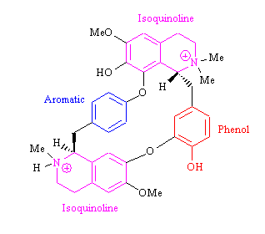
What is the name of the structure?
Feedback: Tubocurarine is the active principle of the natural extract curare. Tubocurarine was the lead compound leading to the synthetic agents suxamethonium and pancuronium.
Page reference: 575-576
*a. Tubocurarine
b. Curare
c. Suxamethonium
d. Pancuronium

Type: multiple choice question
Title: Chapter 19 Question 27
27) Tubocurarine is a lead compound for a class of medicinally useful compounds.

What was the source of the structure?
Feedback: Curare is the name of the plant extract from which tubocurarine is isolated.
Page reference: 575
a. A marine coral
b. A poison toadstool
*c. A plant
d. Snake venom

Type: multiple choice question
Title: Chapter 19 Question 28
28) Tubocurarine is a lead compound for a class of medicinally useful compounds.
What sort of activity does the above structure have?
Feedback: Skeletal muscle cells have nicotinic receptors. This agent acts as an antagonist and not an agonist.
Page reference: 575
a. Muscarinic agonist
b. Muscarinic antagonist
c. Nicotinic agonist
*d. Nicotinic antagonist

Type: multiple choice question
Title: Chapter 19 Question 29
29) Pancuronium is used as a neuromuscular blocker.

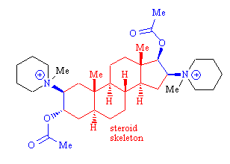
What is the role of the steroid skeleton?
Feedback: The crucial role of the steroid skeleton is to act as a spacer to ensure that the two quaternary nitrogen atoms are the correct distance apart.
The steroid structure is certainly hydrophobic but there is no advantage in the drug crossing cell membranes since the target is receptors present on the surface of cells. There may well be hyrophobic interactions occurring between the steroid structure and the receptor once the drug is bound, but these interactions are not the crucial factor behind the drug's activity.
The steroid structure may well be acting as a steric shield for the ester groups but again this is not the important factor relating to activity.
Page reference: 577
a. It is a hydrophobic group which allows the drug to cross cell membranes.
b. It interacts with hydrophobic regions of the cholinergic receptor.
*c. It acts as a spacer to ensure that the quaternary nitrogen atoms are the correct distance apart.
d. It acts as a steric shield to the ester groups.

Type: multiple choice question
Title: Chapter 19 Question 30
30) Pancuronium is used as a neuromuscular blocker.

What is the significance of the blue regions of the molecule?
Feedback: The acetylcholine moieties were incorporated to increase the recognition of the drug by the nicotinic receptor.
Page reference: 577
*a. They represent the skeleton of acetylcholine.
b. They are polar groups which increase water solubility.
c. They introduce a dipole moment to the molecule allowing correct alignment of binding groups when the molecule binds to the binding site.
d. They are prone to metabolism, thus limiting the lifetime of the drug.

Type: matching question
Title: Chapter 19 - Question 31
31) The following structures were introduced as neuromuscular blocking agents.

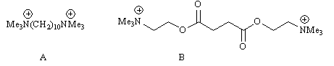
What are structures (A) and (B) called?
Feedback: Decamethonium and suxamethonium are simple acyclic neuromuscular blockers. Vecuronium is a neuromuscular blocker which contains a steroid skeleton as a spacer. Atracurium is a neuromuscular blocker whose structure is related to elements of tubocurarine and suxamethonium.
Page reference: 576-577
a. A = Decamethonium
b. B = Suxamethonium

Type: multiple choice question
Title: Chapter 19 Question 32
32) The following structures were introduced as neuromuscular blocking agents.

Structure B is derived from structure A and has two ester groups incorporated. What was the main reason for incorporating these groups?
Feedback: Structures A and B are decamethonium and suxamethonium respectively. Incorporation of ester groups was designed to reduce the lifetime of the drug since the esters are susceptible to enzymatic hydrolysis.
Page reference: 576-577
a. To enhance hydrogen bonding interactions with the binding site.
b. To increase the polarity of the drug.
c. To alter the conformation of the molecule.
*d. To reduce the lifetime of the drug.

Type: multiple choice question
Title: Chapter 19 Question 33
33) Atracurium is used intravenously as a neuromuscular blocker.

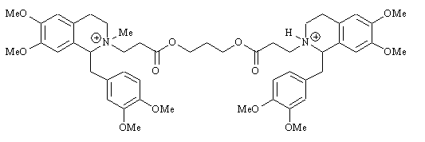

What two drugs were used as the basis for the design of this drug?
Feedback: The cyclic portions at either end are derived from tubocurarine while the chain containing the two ester groups is based on suxamethonium.
Page reference: 577-578
a. Tubocurarine and decamethonium
b. Vecuronium and suxamethonium
*c. Tubocurarine and suxamethonium
d. Atracurium and mivacurium

Type: multiple choice question
Title: Chapter 19 Question 34
34) Atracurium is used intravenously as a neuromuscular blocker.

Which feature is chiefly responsible for the drug's activity and its rapid chemical degradation?
Feedback: The presence of two quaternary nitrogen atoms at the correct distance apart is crucial for activity. In atracurium, the positively charged quaternary nitrogens are also crucial to the Hofmann elimination which deactivates the molecule.
Page reference: 577-578
a. The ester groups
*b. The positively charged nitrogens
c. The alkene
d. The isoquinoline rings

Type: multiple choice question
Title: Chapter 19 Question 35
35) Acetylcholine is inactivated by the enzyme acetylcholinesterase.
What is the reaction catalysed by this enzyme?
Feedback: The enzyme catalyses the hydrolysis of acetylcholine to ethanoic acid and choline.
Page reference: 562
*a. Ester hydrolysis
b. Reduction
c. Oxidation
d. N-demethylation

Type: multiple choice question
Title: Chapter 19 Question 36
36) Acetylcholine is inactivated by the enzyme acetylcholinesterase.
What amino acid in the active site forms an interaction with the quaternary nitrogen of acetylcholine?
Feedback: The aspartic acid is ionised as the aspartate ion. It forms an ionic bond with the quaternary ammonium group of acetylcholine.
Page reference: 581-582
a. Serine
b. Tyrosine
*c. Aspartic acid
d. Histidine

Type: multiple choice question
Title: Chapter 19 Question 37
37) Acetylcholine is inactivated by the enzyme acetylcholinesterase.
What amino acid in the active site forms an interaction with the ester group of acetylcholine?
Feedback: The phenolic group of tyrosine acts as a hydrogen bond donor to the ester group of acetylcholine.
Page reference: 581-582
a. Serine
*b. Tyrosine
c. Aspartic acid
d. Histidine

Type: multiple choice question
Title: Chapter 19 Question 38
38) Acetylcholine is inactivated by the enzyme acetylcholinesterase.
How many of the N-methyl groups interact with hydrophobic pockets within the active site?
Feedback: This is very similar to the binding site of the cholinergic receptor which has two hydrophobic pockets that can accomodate two of the three N-methyl groups.
Page reference: 581-582
a. 1
*b. 2
c. 3
d. 4

Type: multiple choice question
Title: Chapter 19 Question 39
39) Acetylcholine is inactivated by the enzyme acetylcholinesterase.
Which amino acid plays an important role as a nucleophile in the enzyme's mechanism of action?
Feedback: The hydroxyl group of serine acts as a nucleophile in the enzyme's mechanism of action.
Page reference: 581-582
a. Lysine
b. Histidine
*c. Serine
d. Threonine

Type: multiple choice question
Title: Chapter 19 Question 40
40) The following compound is a natural product which inhibits the acetylcholinesterase enzyme.

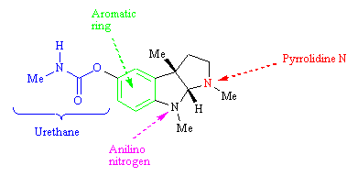
What was the natural source of this compound?
Feedback: The calabar bean was the natural source for physostigmine. The coca bush is the natural source for cocaine. Ourari is the natural source for curare and tubocurarine. Opium is the natural source for morphine, codeine and thebaine.
Page reference: 583
*a. Calabar bean
b. Coca bush
c. Ourari
d. Opium

Type: multiple choice question
Title: Chapter 19 Question 41
41) Physostigmine is a natural product which inhibits the acetylcholinesterase enzyme.

Which of the following groups is not important to the compound's activity?
Feedback: The urethane group is crucial to the drug's mechanism of action. The aromatic ring is thought to act as a good leaving group. The pyrrolidine nitrogen is ionised and mimics the quaternary ammonium group of acetylcholine. The anilino nitrogen is not crucial to activity.
Page reference: 584
a. The urethane group
b. The aromatic ring
*c. The anilino nitrogen
d. The pyrrolidine nitrogen

Type: multiple choice question
Title: Chapter 19 Question 42
42) Physostigmine is a natural product which inhibits the acetylcholinesterase enzyme.

Which portion of the molecule reacts with serine in the active site and produces a stable intermediate which resists hydrolysis?
Feedback: Serine acts as a nucleophile and interacts with the urethane group of physostigmine. A nucleophilic substitution reaction takes place on the urethane, resulting in carbamoylation of the serine residue.
Page reference: 584
*a. The urethane group
b. The aromatic ring
c. The anilino nitrogen
d. The pyrrolidine nitrogen

Type: multiple choice question
Title: Chapter 19 Question 43
43) Physostigmine is a natural product which inhibits the acetylcholinesterase enzyme. A portion of the molecule reacts with serine in the active site and produces a stable intermediate which resists hydrolysis.

Why does this intermediate resist hydrolysis?
Feedback: Since the carbonyl group is less reactive to nucleophiles, the urethane cannot be hydrolysed by water and so the moiety transferred from physostigmine remains bound to serine.
Page reference: 584-585
a. The moiety which is transferred acts as a steric shield and prevents water entering the active site.
b. The moiety which is transferred undergoes a further alkylation reaction with a lysine residue.
*c. The moiety which is transferred contains nitrogen which feeds electrons into the carbonyl group and makes it less reactive to nucleophiles.
d. The moiety which is transferred is hydrophobic and repels water.

Type: matching question
Title: Chapter 19 - Question 44
44) The following structures are analogues of physostigmine (C)

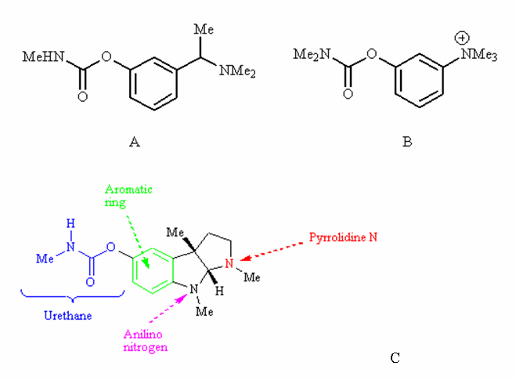
Name the structures A and B.
Feedback: Miotine and neostigmine are simplified analogues of physostigmine. Pyridostigmine is another simplified analogue of physostigmine.
Page reference: 585
a. A = Miotine
b. B = Neostigmine

Type: multiple choice question
Title: Chapter 19 Question 45
45) The following structures are analogues of of physostigmine (C)

What drug strategy has principally been used in the design of the above structures?
Feedback: The tricyclic system has been replaced with a single aromatic ring and so these are simplified analogues.
Page reference: 585
a. Rigidification
b. Conformational blocking
c. Extension
*d. Simplification

Type: multiple choice question
Title: Chapter 19 Question 46
46) The following structures are analogues of physostigmine (C)

Structure B is less susceptible to chemical hydrolysis than structure A. Which feature is responsible for this?
Feedback: The dimethylamino group hinders the two possible mechanisms of hydrolysis.
Page reference: 585
a. The urethane group
*b. The dimethylamino group
c. The aromatic ring
d. The quaternary ammonium ion

Type: multiple choice question
Title: Chapter 19 Question 47
47) The following structures are analogues of of physostigmine (C)

Structure B is less susceptible to chemical hydrolysis than structure A. Structure B is free of CNS side effects unlike structure A. Which feature is responsible for this?
Feedback: The quaternary ammonium ion has a permanent charge which means that neostigmine cannot cross the blood brain barrier. As a result, it is free from CNS side effects.
Page reference: 585
a. The urethane group
b. The dimethylamino group
c. The aromatic ring
*d. The quaternary ammonium ion

Type: multiple choice question
Title: Chapter 19 Question 48
48) The following structure inhibits the acetylcholinesterase enzyme.

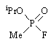
What sort of compound is it?
Feedback: The structure is sarin. This is a highly toxic nerve gas which was used in the terrorist attack on the Tokyo underground some years back.
Page reference: 587
a. An insecticide
*b. A nerve gas
c. A 'smart drug'
d. A treatment for glaucoma

Type: multiple choice question
Title: Chapter 19 Question 49
49) The nerve gas sarin inhibits the acetylcholinesterase enzyme.

Which amino acid is irreversibly phosphorylated by the above structure?
Feedback: The hydroxyl group of serine acts as a nucleophile and reacts with the nerve gas to become phosphorylated.
Page reference: 587
a. Threonine
b. Histidine
*c. Serine
d. Aspartic acid

Type: multiple choice question
Title: Chapter 19 Question 50
50) Ecothiopate is used in medicine.

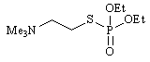
What is the agent used for clinically?
Feedback: Ecothiopate is an organophosphate which has been used to treat glaucoma and targets the acetylcholinesterase enzyme. Neuromuscular blockers and drugs used to treat myasthenia gravis target cholinergic receptors and not the acetylchoinesterase enzyme. Several drugs used in the treatment of Alzheimers disease target the acetylcholinesterase enzyme including organophosphates, but ecothiopate has not been used for this prupose.
Page reference: 587
a. Myasthenia gravis
b. Alzheimer's disease
*c. Glaucoma
d. Neuromuscular blockade

Type: multiple choice question
Title: Chapter 19 Question 51
51) Ecothiopate is used in medicine.

What is the main purpose of the quaternary ammonium ion?
Feedback: Since the structure binds more strongly to the active site, it can be administered in lower, safer doses.
Page reference: 587
*a. It mimics the quaternary ammonium group of acetylcholine resulting in stronger receptor binding
b. It increases water solubility
c. It acts as a steric shield to protect the molecule from metabolic enzymes
d. It prevents the molecule crossing the blood brain barrier

Type: multiple choice question
Title: Chapter 19 Question 52
52) Parathion had an important commercial use as an insecticide.

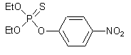
The above structure acts as a prodrug. What reaction is necessary to activate it?
Feedback: Enzymes capable of catalysing oxidative desulfurisation occur in insects and so the P=S bond is converted to a P=O bond. This activates the drug such that it can inhibit the acetylcholinesterase enzyme.
Page reference: 587-588
*a. Oxidative desulfurisation
b. Reductive desulfurisation
c. Hydrolysis of the thiophosphate
d. Reduction of the nitro group

Type: multiple choice question
Title: Chapter 19 Question 53
53) Parathion had an important commercial use as an insecticide.

Despite the relationship of the above structure to nerve gases, it is relatively safe to mammals. Why?
Feedback: Parathion is relatively harmless in mammals and is metabolised in a different way from the metabolic route in insects. If the compound was metabolised to the active agent in mammals it would be as fatal as the nerve gases.
Page reference: 588
a. Exposure to the drug is only likely to result in skin contact
b. The metabolic enzyme required to activate the drug is only present in target cells.
*c. The metabolic enzyme required to activate the drug is not present in mammals.
d. The activated drug is less toxic than the nerve gases.

Type: multiple choice question
Title: Chapter 19 Question 54
54) Pralidoxime is used as an antidote to nerve gases.

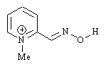
How does the agent reverse the effect of nerve gases?
Feedback: The drug has been designed to fit the portion of the active site that is not occupied by the nerve gas. Once bound, it acts as a nucleophile and displaces the phosphate group from serine. It does not intercept the nerve gas. Nor does it prevent the nerve gas accessing the active site. It does not act as a chemical messenger.
Page reference: 588-589
a. It reacts with the nerve gas and deactivates it before the latter reaches the enzyme active site.
b. It binds to the enzyme's active site and prevents the nerve gas from entering.
*c. It binds to the active site and acts as a nucleophile to displace a phosphate group from serine.
d. It acts a chemical messenger triggering the transcription of the gene that codes for the acetylcholinesterase enzyme.

Type: multiple choice question
Title: Chapter 19 Question 55
55) Pralidoxime is used as an antidote to nerve gases.

What role does the quaternary ammonium ion play in the above structure?
Feedback: The correct answer is that it mimis the quaternary nitrogen of acetylcholine and alows the drug to target the enzyme's active site more effectively.
The quaternary nitrogen may also increase water solubility and the charged group certainly prevents the molecule crossing the blood brain barrier but these are not the primary reasons for including it. Indeed, an inability to cross the blood brain barrier can be seen as a disadvantage since it cannot reach affected enzymes in the central nervous system.
There is no reason why the charged pyridine ring should make the molecule a more powerful nucleophile. If anything it should make it a poorer nucleophile.
Page reference: 588-589
a. It increases water solubility.
*b. It mimics the quaternary nitrogen of acetylcholine and targets the drug to the enzyme's active site.
c. It prevents the molecule crossing the blood brain barrier and prevents CNS side effects.
d. It activates the pyridine ring such that the molecule is a more powerful nucleophile.

Type: multiple choice question
Title: Chapter 19 Question 56
56) Pralidoxime is used as an antidote to nerve gases.

What role does the hydroxylamine group play?
Feedback: The hydroxylamine group acts as a nucleophilic group where the oxygen is the nucleophilic centre.
Page reference: 588-589
a. It increases water solubility.
b. It mimics the ester group of acetylcholine and targets it to the cholinergic binding site.
c. It prevents the molecule crossing the blood brain barrier and prevents CNS side effects..
*d. It acts as a nucleophilic group and displaces phosphate groups from alcoholic functions.

Type: multiple choice question
Title: Chapter 19 Question 57
57) The following drug (tacrine) has been used medicinally.

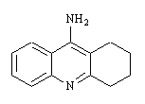
What sort of drug is it?
Feedback: The agent inhibits acetylcholinesterase such that acetylcholine survives longer in the brain and activates surviving cholinergic receptors surviving more strongly.
Page reference: 589-590
a. Cholinergic agonist
b. Cholinergic antagonist
*c. Acetylcholinesterase inhibitor
d. Choline transferase inhibitor

Type: multiple choice question
Title: Chapter 19- Question 58
58) What is an agonist?
Feedback: An agonist is an agent which binds to a receptor and activates it. An antagonist is an agent which binds to a receptor but does not activate it. By binding, it prevents the natural ligand from binding. A neurotransmitter is a chemical which is released from the end of a nerve and acts as a chemical messenger. It interacts with a receptor on the target cell for the nerve. A synapse is the small gap that exists between two nerves, or between one nerve and a target cell.
Page reference: 69
*a. It is an agent which binds to a receptor binding site and activates the receptor.
b. It is an agent which binds to a receptor binding site but does not activate it. By binding, it blocks the natural messenger from binding.
c. It is a chemical which is released from the end of a nerve and acts as a chemical messenger.
d. It is a small gap that exists between two nerves, or between one nerve and a target cell.

Type: multiple choice question
Title: Chapter 19- Question 59
59) What is a synapse?
Feedback: An agonist is an agent which binds to a receptor and activates it. An antagonist is an agent which binds to a receptor but does not activate it. By binding, it prevents the natural ligand from binding. A neurotransmitter is a chemical which is released from the end of a nerve and acts as a chemical messenger. It interacts with a receptor on the target cell for the nerve. A synapse is the small gap that exists between two nerves, or between one nerve and a target cell.
Page reference: 560-563
a. It is an agent which binds to a receptor binding site and activates the receptor .
b. It is an agent which binds to a receptor binding site but does not activate it. By binding, it blocks the natural messenger from binding.
c. It is a chemical which is released from the end of a nerve and acts as a chemical messenger.
*d. It is a small gap that exists between two nerves, or between one nerve and a target cell.

Type: multiple choice question
Title: Chapter 19- Question 60
60) What is a neurotransmitter?
Feedback: An agonist is an agent which binds to a receptor and activates it. An antagonist is an agent which binds to a receptor but does not activate it. By binding, it prevents the natural ligand from binding. A neurotransmitter is a chemical which is released from the end of a nerve and acts as a chemical messenger. It interacts with a receptor on the target cell for the nerve. A synapse is the small gap that exists between two nerves, or between one nerve and a target cell.
Page reference: 560-561
a. It is an agent which binds to a receptor binding site and activates the receptor.
b. It is an agent which binds to a receptor binding site but does not activate it. By binding, it blocks the natural messenger from binding.
*c. It is a chemical which is released from the end of a nerve and acts as a chemical messenger.
d. It is a small gap that exists between two nerves, or between one nerve and a target cell.

Type: multiple choice question
Title: Chapter 19- Question 61
61) What is an antagonist?
Feedback: An agonist is an agent which binds to a receptor and activates it. An antagonist is an agent which binds to a receptor but does not activate it. By binding, it prevents the natural ligand from binding. A neurotransmitter is a chemical which is released from the end of a nerve and acts as a chemical messenger. It interacts with a receptor on the target cell for the nerve. A synapse is the small gap that exists between two nerves, or between one nerve and a target cell.
Page reference: 69
a. It is an agent which binds to a receptor binding site and activates the receptor.
*b. It is an agent which binds to a receptor binding site but does not activate it. By binding, it blocks the natural messenger from binding.
c. It is a chemical which is released from the end of a nerve and acts as a chemical messenger.
d. It is a small gap that exists between two nerves, or between one nerve and a target cell.

Type: multiple choice question
Title: Chapter 19- Question 62
62) What sort of interaction does the ester of acetylcholine have with the binding site of cholinergic receptors?

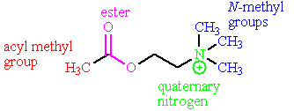

Feedback: The acyl methyl group fits a hydrophobic pocket and interacts by van der Waals interactions. The oxygen atoms of the ester serve as hydrogen bond acceptors to asparagine 617 in the binding site. The quaternary nitrogen has a positive charge and forms an ionic bond to aspartate 311. Two of the three N-methyl groups fit hydrophobic pockets and interact by van der Waals interactions.
Page reference: 565-567
a. Ionic interactions
*b. Hydrogen bonding as a hydrogen bond acceptor
c. Hydrogen bonding as a hydrogen bond donor
d. Van der Waals interactions

Type: multiple choice question
Title: Chapter 19- Question 63
63) What sort of interaction does the quaternary nitrogen of acetylcholine have with the binding site of cholinergic receptors?

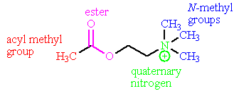
Feedback: The acyl methyl group fits a hydrophobic pocket and interacts by van der Waals interactions. The oxygen atoms of the ester serve as hydrogen bond acceptors to asparagine 617 in the binding site. The quaternary nitrogen has a positive charge and forms an ionic bond to aspartate 311. Two of the three N-methyl groups fit hydrophobic pockets and interact by van der Waals interactions.
Page reference: 565-567
*a. Ionic interactions
b. Hydrogen bonding as a hydrogen bond acceptor
c. Hydrogen bonding as a hydrogen bond donor
d. Van der Waals interactions

Type: multiple choice question
Title: Chapter 19- Question 64
64) What sort of interaction does the N-methyl groups of acetylcholine have with the binding site of cholinergic receptors?

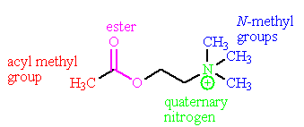
Feedback: The acyl methyl group fits a hydrophobic pocket and interacts by van der Waals interactions. The oxygen atoms of the ester serve as hydrogen bond acceptors to asparagine 617 in the binding site. The quaternary nitrogen has a positive charge and forms an ionic bond to aspartate 311. Two of the three N-methyl groups fit hydrophobic pockets and interact by van der Waals interactions.
Page reference: 565-567
a. Ionic interactions
b. Hydrogen bonding as a hydrogen bond acceptor
c. Hydrogen bonding as a hydrogen bond donor
*d. Van der Waals interactions

Type: multiple choice question
Title: Chapter 19- Question 65
65) What sort of interaction does aspartic acid 311 have with acetylcholine in the binding site of cholinergic receptors?
Feedback: Aspartic acid 311 is ionised and is present in the binding site as a negatively charged aspartate ion.
Page reference: 565-567
*a. Ionic
b. Van der Waals
c. Hydrogen bonding as a hydrogen bond acceptor
d. Hydrogen bonding as a hydrogen bond donor

Type: multiple choice question
Title: Chapter 19- Question 66
66) Which part of acetylcholine does Asp311 interact with in the cholinergic binding site?

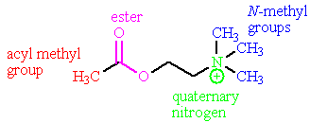
Feedback: Asp311 contains a negatively charged carboxylate group which can form an ionic interaction with the positively charged quaternary nitrogen.
Page reference: 565-567
a. The acyl methyl group
b. The ester
*c. The quaternary nitrogen
d. The N-methyl groups

Type: multiple choice question
Title: Chapter 19- Question 67
67) What sort of interaction does asparagine-617 have with acetylcholine in the binding site of cholinergic receptors?
Feedback: Asparagine has a primary amide functional group on its side chain. This acts as a hydrogen bond donor to the ester of acetylcholine.
Page reference: 565-567
a. Ionic
b. Van der Waals
c. Hydrogen bonding as a hydrogen bond acceptor
*d. Hydrogen bonding as a hydrogen bond donor

Type: multiple choice question
Title: Chapter 19- Question 68
68) Which part of acetylcholine does asparagine 617 interact with in the cholinergic binding site?

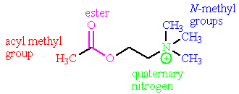

Feedback: Asparagine 617 interacts with the ester group by means of hydrogen bonding.
Page reference: 565-567
a. The acyl methyl group
*b. The ester
c. The quaternary nitrogen
d. The N-methyl groups

Type: multiple choice question
Title: Chapter 19- Question 69
69) Acetylcholine has 4 methyl groups. How many of these fit into hydrophobic pockets in the cholinergic binding site?

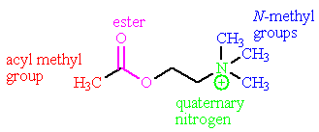
Feedback: There are three hydrophobic pockets. One accepts the acyl methyl group. The remaining two accept two of the three N-methyl groups.
Page reference: 565-567
a. 1
b. 2
*c. 3
d. 4

Type: multiple choice question
Title: Chapter 19- Question 70
70) Several aromatic amino acid residues present in the cholinergic binding site are thought to interact with the quaternary nitrogen of acetylcholine. What sort of interaction is involved?
Feedback: The quaternary ammonium head group could be sandwiched between the heteroaromatic and aromatic rings of amino acids such as tryptophan and tyrosine, resulting in induced dipoles in the heteroaromatic or aromatic rings.
Page reference: 565-567
a. Ionic
b. Van der Waals
*c. Hydrogen bonding as a hydrogen bond acceptor
d. Hydrogen bonding as a hydrogen bond donor

Type: multiple choice question
Title: Chapter 19- Question 71
71) Which of the following statements is true regarding the use of acetylcholine as a drug?
Feedback: Acetylcholine is easily synthesised. Acetylcholine activates all cholinergic receptors and shows no selectivity. It is also susceptible to acid and enzymatic hydrolysis. It cannot survive the acids of the stomach and it is orally inactive. It is also quickly hydrolysed by enzymes in the blood supply.
Page reference: 567568
a. It is hard to synthesise
b. It shows selectivity between the different types of cholinergic receptors
*c. It is not orally active
d. It is metabolically stable

Type: matching question
Title: Chapter 19 - Question 72
72) Identify the following structures

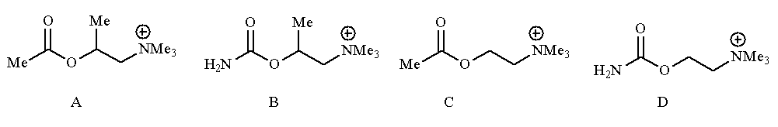

Feedback: Compared to acetylcholine, methacholine contains an extra methyl substituent on the 2-C chain linking the ester and quaternary ammononium groups. In contrast, carbachol has a urethane group instead of an ester while bethanechol has a urethane group and an extra methyl substituent.
Page reference: 565, 568-569
a. Acetylcholine = Structure C
b. Carbachol = Structure D
c. Methacholine = Structure A
d. Bethanechol = Structure B

Type: multiple choice question
Title: Chapter 19- Question 73
73) Which of the following structures is an endogenous compound?

Feedback: Structure C is the neurotransmitter acetylcholine. The other structures are synthetic agonists of acetylcholine.
Page reference: 565, 568-569
a. Structure A
b. Structure B
*c. Structure C
d. Structure D

Type: multiple choice question
Title: Chapter 19- Question 74
74) The following structure is the cholinergic agonist bethanechol. Which portion of the molecule is present as a steric shield?

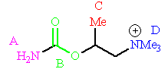

Feedback: The ester group is susceptible to acid and enzyme catalysed hydrolysis. The methyl group acts as a steric shield to incoming nucleophiles.
Page reference: 569
a. Group A
b. Group B
*c. Group C
d. Group D

Type: multiple choice question
Title: Chapter 19- Question 75
75) The following structure is the cholinergic agonist bethanechol. Which portion of the molecule stabilises the molecule by electronic factors?

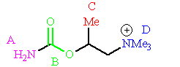

Feedback: The ester group is susceptible to acid and enzyme catalysed hydrolysis. The lone pair of the amino group interacts with the ester carbonyl group and lowers its reactivity to nucleophiles. The amino group is approximately the same size as the original methyl group and so it cannot act as a steric shield. It occupies the same hydrophobic pocket occupied by the methyl group, but is unable to interact by van der Waals interactions since it is a polar group.
Page reference: 569
*a. Group A
b. Group B
c. Group C
d. Group D

Type: multiple choice question
Title: Chapter 19- Question 76
76) Which of the following is not a clinical use for a muscarinic agonist?
Feedback: Muscarinic agonists can be used to 'switch on' the gastrointestinal and urinary tracts after surgery. They are not used to 'switch them off'.
Page reference: 569
a. Treatment of glaucoma
*b. 'Switching off' the urinary tract prior to surgery
c. 'Switching on' the gastrointestinal tract tract after surgery
d. Decreasing heart muscle activity in certain heart defects

Type: matching question
Title: Chapter 19 - Question 77
77) Identify the following agents.

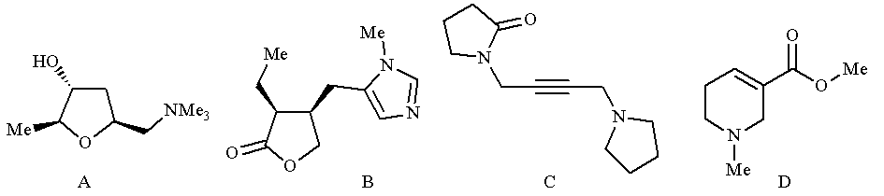

Feedback: All the agents stated are muscarinic agonists.
Page reference: 569-570
a. Oxotremorine = Agent C
b. Muscarine = Agent A
c. Arecoline = Agent D
d. Pilocarpine = Agent B

Type: multiple choice question
Title: Chapter 19- Question 78
78) Which of the following statements regarding pilocarpine is true?

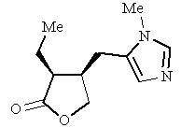

Feedback: Pilocarpine is a muscarinic agonist and is used in the treatment of glaucoma. The statement 'it is likely to be protonated when it interacts with the nicotinic receptor' is correct, except for the fact that it is the muscarinic receptor that is involved.
Page reference: 569-570
a. It is a nicotinic agonist.
b. It is used in the treatment of myasthenia gravis.
c. It is likely to be protonated when it interacts with the nicotinic receptor.
*d. It can adopt a conformation where the separation between nitrogen and oxygen is 4.4A.

Type: matching question
Title: Chapter 19 - Question 79
79) Identify the following structures

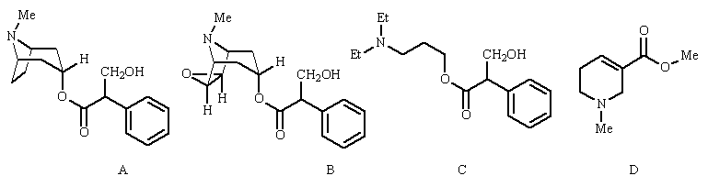

Feedback: Atropine, Hyoscine and amprotropine are muscarinic antagonists. Atropine and hyoscine are closely related structures derived from natural sources. Amprotropine is a synthetic structure which was developed as a simplified analogue of these natural products. Arecoline is a synthetic compound which acts as a muscarinic agonist and is not related to the previous three compounds.
Page reference: 570-572
a. Hyoscine = Structure B
b. Arecoline = Structure D
c. Atropine = Structure A
d. Amprotropine = Structure C

Type: multiple choice question
Title: Chapter 19- Question 80
80) Which of the following structures is not a muscarinic antagonist?

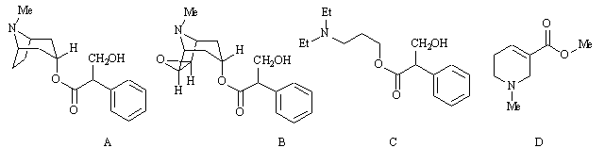
Feedback: Structures A-C are atropine, hysocine and amprotropine, all of which are muscarinic antagonists. Structure D is arecoline which is a muscarinic agonist.
Page reference: 570-572
a. Structure A
b. Structure B
c. Structure C
*d. Structure D

Type: multiple choice question
Title: Chapter 19- Question 81
81) Which of the following structures is a simplified analogue of atropine?

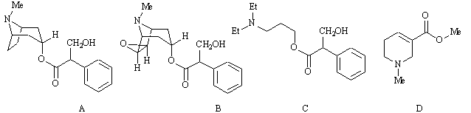
Feedback: Structures A-D are atropine, hysocine, amprotropine and arecoline. Structures A-C are muscarinic antagonists while arecoline is a muscarinic agonist. Amptotropine is a simplified analogue of atropine.
Page reference: 570-572
a. Structure A
b. Structure B
*c. Structure C
d. Structure D

Type: matching question
Title: Chapter 19 - Question 82
82) Identify the following structures

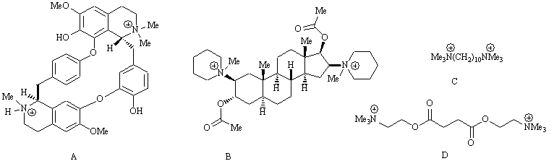
Feedback: Tubocurarine is a natural product which is the lead compound for neuromuscular blockers. Decamethonium and suxamethonium are highly simplified analogues containing the two quaternary centres that are crucial for activity, separated by a suitable linear chain of atoms. Suxamethonium contains ester groups within this chain to limit its duration of action. Pancuronium is a synthetic agent where a steroid skeleton is used as a suitable spacer between the quaternary centres.
Page reference: 575-577
a. Decamethonium = Structure C
b. Tubocurarine = Structure A
c. Suxamethonium = Structure D
d. Pancuronium = Structure B

Type: multiple choice question
Title: Chapter 19- Question 83
83) What sort are the following structures used for clinically?

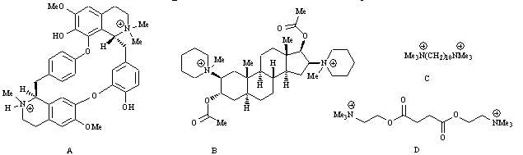

Feedback: The agents A-D are tubocurarine, pancuronium, decamethonium and suxamethonium. They are all nicotinic antagonists which are used as neuromuscular blockers.
Page reference: 575-577
a. Cardiovascular medicine
*b. Neuromuscular blockers
c. Anti-asthmatics
d. Analgesics

Type: multiple choice question
Title: Chapter 19- Question 84
84) The following structure is tubocurarine. Which of the following statements is false?

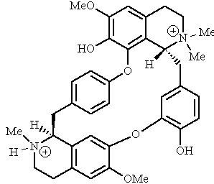
Feedback: The distance between the two quaternary nitrogens is not sufficiently large to allow to molecule to span the istance between two cholinergic binding sites. Instead, it is thought that one of the quaternary nitrogens binds to a cholinergic binding site while the other binds to a nearby cysteine residue.
Page reference: 575-576
a. The distance between the two positively charged nitrogens is 1.15nm.
b. Two positively charged nitrogens is crucial for nicotinic antagonism.
*c. The two positively charged nitrogens allow the molecule to span between two different cholinergic binding sites.
d. Tubocurarine has been used as a neuromuscular blocker.

Type: multiple choice question
Title: Chapter 19- Question 85
85) The following structures are used as neuromuscular blockers.

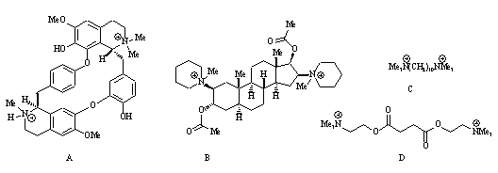
Which of the above structures contains a steroid skeleton as a spacer?
Feedback: Structure B is pancuronium. the steroid skeleton allows the quaternary nitrogens to the proper distance apart for a nicotinic antagonist.
Page reference: 577
a. Structure A
*b. Structure B
c. Structure C
d. Structure D

Type: matching question
Title: Chapter 19 - Question 86
86) Identify the following structures.

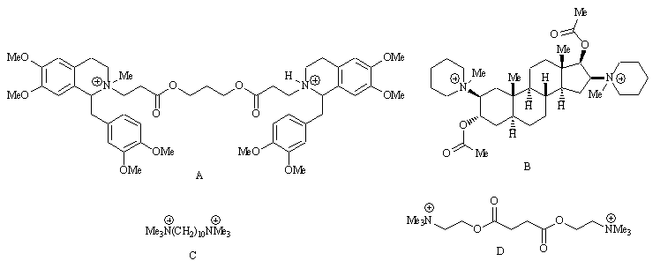

Feedback: Tubocurarine is a natural product which is the lead compound for neuromuscular blockers. Decamethonium and suxamethonium are highly simplified analogues containing the two quaternary centres that are crucial for activity, separated by a suitable linear chain of atoms. Suxamethonium contains ester groups within this chain to limit its duration of action. Atracurium is a synthetic agent which incorporates features of tubocurarine and suxamethonium and is designed to self destruct in order to limit its duration of action.
Page reference: 575-578
a. Decamethonium = Structure C
b. Tubocurarine = Structure B
c. Suxamethonium = Structure D
d. Atracurium = Structure A

Type: multiple choice question
Title: Chapter 19- Question 87
87) Which of the following structures was designed to be self destructing at physiological pH?

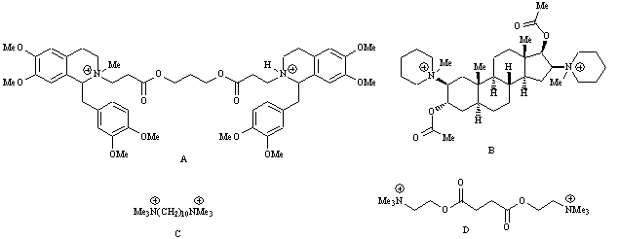
Feedback: Structure A is atracurium which is set up for a Hoffman elimination. The other
structures (B-D) are pancuronium, decamethonium and suxamethonium respectively.
Page reference: 577-578
*a. Structure A
b. Structure B
c. Structure C
d. Structure D

Type: multiple choice question
Title: Chapter 19- Question 88
88) Which of the following structures does not contain the skeleton of acetylcholine within its structure?

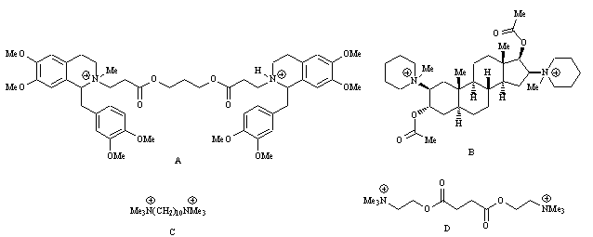
Feedback: Decamethonium does not contain an ester separated by two carbons from a quaternary nitrogen. The other structures do. Structures A, B and D are atracurium, pancuronium, and suxamethonium respectively.
Page reference: 576-578
a. Structure A
b. Structure B
*c. Structure C
d. Structure D

Type: multiple choice question
Title: Chapter 19- Question 89
89) Which of the following structures has the longest duration of activity?

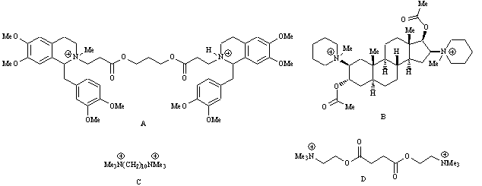
Feedback: Decamethonium does not contain an ester group and is not susceptible to esterases. The other structures do. Structures A, B and D are atracurium, pancuronium, and suxamethonium respectively.
Page reference: 576-578
a. Structure A
b. Structure B
*c. Structure C
d. Structure D

Type: multiple choice question
Title: Chapter 19- Question 90
90) Which of the following statements concerning the nicotinic receptor is true?
Feedback: The nicotinic receptor is an ion channel for sodium ions. It contains 5 protein subunits, two of which are identical. There are two cholinergic binding sites per ion channel. Finally, the channel is open when acetylcholine is bound.

The nicotinic receptor is an ion channel for sodium ions.

Page reference: 579-580
a. It is an ion channel for potassium ions.
b. It contains five protein subunits, three of which are identical.
*c. There are two cholinergic binding sites per ion channel.
d. When acetylcholine is bound the channel is shut.

Type: multiple choice question
Title: Chapter 19- Question 91
92) Which of the following statements concerning the muscarinic receptor is false?
Feedback: It is too broad a statement to say that signal transduction involves the secondary messenger IP3. It is certainly true for the muscarinic subtypes m₁, m₃ and m₅. However, the signal transduction process for the subtypes m₂ and m₄ involve cyclic AMP.
Page reference: 580
a. It is a G-protein coupled receptor.
b. There are five subtypes.
*c. Signal transduction involves the secondary messenger IP3.
d. Lack of M1 activity is thought to be associated with dementia.

Type: multiple choice question
Title: Chapter 19- Question 92
92) The following diagram shows the first part of the mechanism by which acetylcholine is inactivated by acetylcholinesterase. One of the arrows in the mechanism is incorrect. Which one?

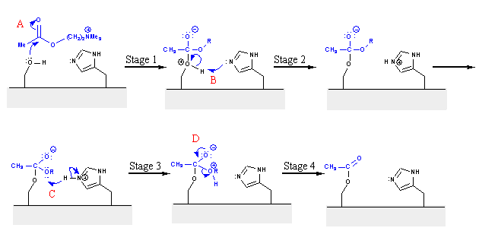
Feedback: The arrow for B is pointing the wrong way. Mechanism arrows should point from a source of two electrons and point to where these electrons are going. Oxygen's lone pair of electrons is being used to form a bond to the hydrogen on histidine. Therefore, the arrow should point from the lone pair to the hydrogen.
Page reference: 582-583
a. A
*b. B
c. C
d. D

Type: multiple choice question
Title: Chapter 19- Question 93
93) The following diagram shows the second part of the mechanism by which acetylcholine is inactivated by acetylcholinesterase. One of the arrows in the mechanism is incorrect. Which one?

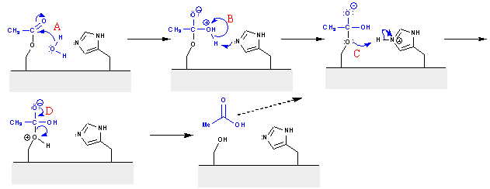
Feedback: Arrow A is drawn incorrectly. The lone pair of electrons on the water oxygen is being used to form a bond to the carbonyl group. The arrow suggests that the electrons are coming from the O-H bond.
Page reference: 582-583
*a. A
b. B
c. C
d. D

Type: matching question
Title: Chapter 19 - Question 94
94) Identify the following structures

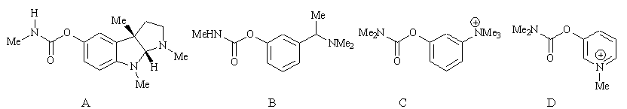
Feedback: Physostigmine is a natural product which acted as the lead compound for a series of anticholinesterase drugs known as the carbamates. Neostigmine, pyridostigmine and miotine are examples of these structures and are simplified analogues of physostigmine.
Page reference: 583-586
a. Neostigmine = Structure C
b. Pyridostigmine = Structure D
c. Physostigmine = Structure A
d. Miotine = Structure B

Type: multiple choice question
Title: Chapter 19- Question 95
95) Which of the following structures is a natural product?

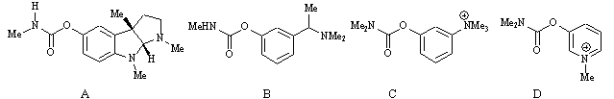
Feedback: Structure A is physostigmine which is derived from the calabar bean. The other structures are simplified analogues.
Page reference: 583-586
*a. Structure A
b. Structure B
c. Structure C
d. Structure D

Type: multiple choice question
Title: Chapter 19- Question 96
96) Miotine, neostigmine and pyridostigmine are analogues of physostigmine.
What drug design strategy has been principally used in developing these structures?

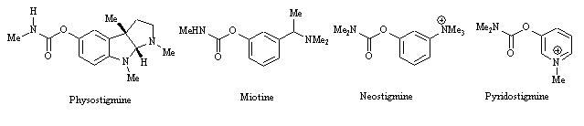

Feedback: Simplification has been carried out by removing excess rings, chiral centres and functional groups.
Page reference: 583-586
a. Extension
b. Rigidification
*c. Simplification
d. Conformational blocking

Type: matching question
Title: Chapter 19 - Question 97
97) Name the following structures:

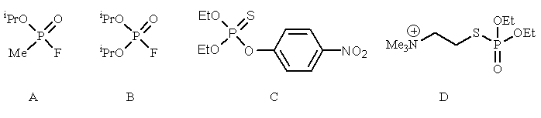
Feedback: Sarin is an organophosphate nerve gas. Dyflos is a similar agent with a slightly different structure. Ecothiopate is an organophosphate agent which is used in medicine. Parathion is an insecticide.
Page reference: 586-588
a. Parathion = Structure C
b. Dyflos = Structure B
c. Sarin = Structure A
d. Ecothiopate = Structure D

Type: multiple choice question
Title: Chapter 19- Question 98
98) What kind of compounds are the following?

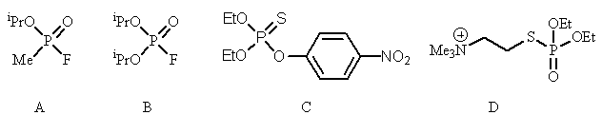
Feedback: Structures A-D are sarin, dyflos, parathion and ecothiopate respectively.
Page reference: 586-588
a. Organophosphates
*b. Organophosphonates
c. Organotoxins
d. Organophosphites

Type: multiple choice question
Title: Chapter 19- Question 99
99) What is the target for the following compounds?

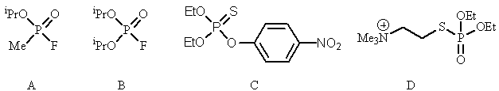

Feedback: Structures A-D are sarin, dyflos, parathion and ecothiopate respectively.
Page reference: 586-588
*a. Acetylcholinesterase enzyme
b. Muscarinic receptor
c. Nicotinic receptor
d. Choline acetyltransferase

Type: multiple choice question
Title: Chapter 19- Question 100
100) Which of the following compounds has been used as an insecticide?

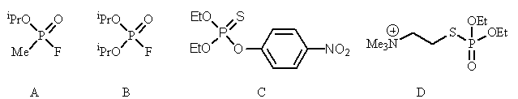
Feedback: Structures A-D are sarin, dyflos, parathion and ecothiopate respectively. Sarin is an organophosphate nerve gas. Dyflos is a similar agent with a slightly different structure. Ecothiopate is an organophosphate agent which is used in medicine. Parathion is an insecticide.
Page reference: 587-588
a. Structure A
b. Structure B
*c. Structure C
d. Structure D

Type: multiple choice question
Title: Chapter 19- Question 101
101) Which of the following compounds has been used as a medicine?

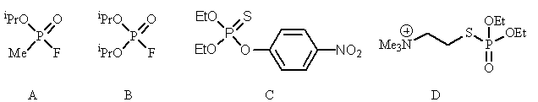
Feedback: Structures A-D are sarin, dyflos, parathion and ecothiopate respectively. Sarin is an organophosphate nerve gas. Dyflos is a similar agent with a slightly different structure. Ecothiopate is an organophosphate agent which is used in medicine. Parathion is an insecticide.
Page reference: 587-588
a. Structure A
b. Structure B
*c. Structure C
d. Structure D

Type: multiple choice question
Title: Chapter 19- Question 102
102) The nerve gases are irreversible inhibitors of the acetylcholinesterase enzyme and react with a serine residue in the active site. What kind of reaction takes place on the serine residue?
Feedback: The hydroxyl group of serine acts as a nucleophile and reacts with the nerve gas to become phosphorylated.
Page reference: 587
a. Reduction
b. Oxidation
*c. Phosphorylation
d. Esterification

Type: matching question
Title: Chapter 19 - Question 103
103) Identify the following structures

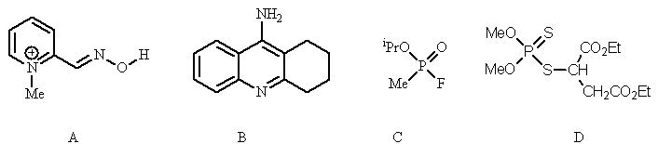
Feedback: Tacrine, malathion, and sarin are all anticholinesterases. Malathion is an organophosphorus agent used as an insecticide. Sarin is an organophosphate which has been used as a nerve gas. Tacrine is a tricyclic system used in the treatment of Alzheimer's disease. Pralidoxime is used as an antidote to organophosphate poisoning
Page reference: 586-590
a. Tacrine = Structure B
b. Malathion = Structure D
c. Pralidoxime = Structure A
d. Sarin = Structure C

Type: multiple choice question
Title: Chapter 19- Question 104
104) Which of the following has been used as a 'smart drug'?

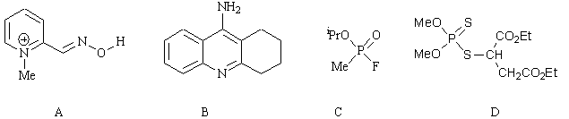
Feedback: Structure A is pralidoxime which is used as an antidote to organophosphate poisoning. Structure B is tacrine which has been used in the treatment of Alzheimer's disease. Structure C is sarin which is a nerve gas. Structure D is malathion which has been used as an insecticide.
Page reference: 589-590
a. Structure A
*b. Structure B
c. Structure C
d. Structure D

Type: multiple choice question
Title: Chapter 19- Question 105
105) Which of the following has been used as an antidote for organophosphate poisoning?

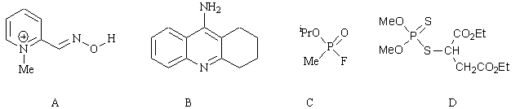
Feedback: Structure A is pralidoxime which is used as an antidote to organophosphate poisoning. Structure B is tacrine which has been used in the treatment of Alzheimer's disease. Structure C is sarin which is a nerve gas. Structure D is malathion which has been used as an insecticide.
Page reference: 588-589
*a. Structure A
b. Structure B
c. Structure C
d. Structure D

Type: multiple choice question
Title: Chapter 19- Question 106
106) Which of the following has been used as a nerve gas?

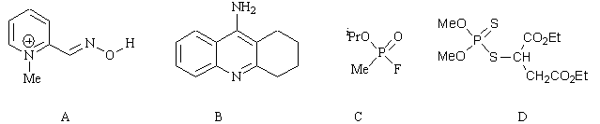
Feedback: Structure A is pralidoxime which is used as an antidote to organophosphate poisoning. Structure B is tacrine which has been used in the treatment of Alzheimer's disease. Structure C is sarin which is a nerve gas. Structure D is malathion which has been used as an insecticide.
Page reference: 587
a. Structure A
b. Structure B
*c. Structure C
d. Structure D

Type: multiple choice question
Title: Chapter 19- Question 107
107) Which of the following has been used as an insecticide?

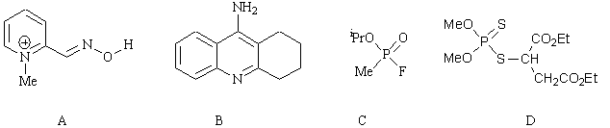
Feedback: Structure A is pralidoxime which is used as an antidote to organophosphate poisoning. Structure B is tacrine which has been used in the treatment of Alzheimer's disease. Structure C is sarin which is a nerve gas. Structure D is malathion which has been used as an insecticide.
Page reference: 587-588
a. Structure A
b. Structure B
c. Structure C
*d. Structure D

Type: multiple choice question
Title: Chapter 19- Question 108
108) What sort of agents are the following structures?

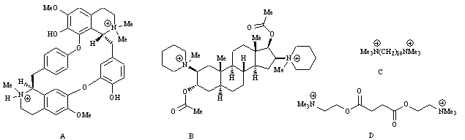

Feedback: The agents A-D are tubocurarine, pancuronium, decamethonium and suxamethonium. They are all nicotinic antagonists which are used as neuromuscular blockers.
Page reference: 575-577
a. Muscarinic agonists
b. Muscarinic antagonists
c. Nicotinic agonists
*d. Nicotinic antagonists

