Chapter 18: Anticancer agents (Part B)

Type: multiple choice question
Title: Chapter 18b Question 01
01) The following structure is used for the treatment of chronic lymphatic leukaemia:

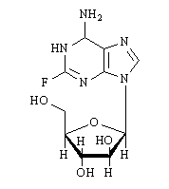
What is it called?
Feedback: Fludarabine is the correct answer. It is a nucleoside containing a fluorine substituent on the nucleic acid base moiety.
Cytarabine and gemcitabine are both nucleosides of a different structure while 6-mercaptopurine acts as a prodrug for a nucleoside.
Page reference: 518
a. Cytarabine
b. Gemcitabine
*c. Fludarabine
d. 6-Mercaptopurine

Type: multiple choice question
Title: Chapter 18b Question 02
02) The following structure is used for the treatment of chronic lymphatic leukaemia:

What nucleoside does the above structure mimic?
Feedback: The structure is called fludarabine and it mimics 2'-deoxyadenosine.
Page reference: 518
a. 2'-deoxycytidine
b. 2'-deoxythymidine
c. 2'-deoxyguanosine
*d. 2'-deoxyadenosine

Type: multiple choice question
Title: Chapter 18b Question 03
03) Fludarabine is used for the treatment of chronic lymphatic leukaemia:

The above structure acts as a prodrug. What is the active compound?
Feedback: It is the triphosphate that is recognised as a substrate for the enzyme DNA polymerase
Page reference: 518
a. Monophosphate
b. Diphosphate
*c. Triphosphate
d. Polyphosphate

Type: multiple choice question
Title: Chapter 18b Question 04
04) The following structure is used for the treatment of acute leukaemias:

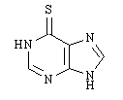
The above structure is a prodrug and can be converted to two structures which are incorporated into DNA and RNA. What are the structures?
Feedback: The structure is called 6-mercaptopurine.
Page reference: 518-519
a. GTP and dGTP
*b. Thio-GTP and thio-dGTP
c. CTP and dCTP
d. Thio-CTP and thio-dCTP

Type: multiple choice question
Title: Chapter 18b Question 05
05) Steroid hormones combine with intracellular receptors to form structures that control the expression of genes. What are these structures called?
Feedback: The structures are called nuclear transcription factors. The other terms do not exist.
Page reference: 519
a. Nuclear translation factors
*b. Nuclear transcription factors
c. Nuclear replication factors
d. Nuclear reproduction factors

Type: multiple choice question
Title: Chapter 18b Question 06
06) Ethinylestradiol is used for the treatment of prostate cancer. To which group of steroids does it belong?

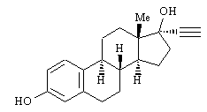
Feedback: Ethinylestradiol is an oestrogen. Oestrogens (or estrogens) are female hormones that are responsible for the development of female characteristics. These are characterised by an aromatic ring as part of the steroid structure. Glucocorticoids promote gluconegenesis and the formation of glycogen, enhance the degradation of fat and protein and inhibit the inflammatory response. Progestagens are female hormones that prepare the lining of the uterus for implantation of an ovum. Androgens are male hormones that are responsible for the development of male characteristics.
Page reference: 520
*a. Oestrogens
b. Progestins
c. Glucocorticoids
d. Androgens

Type: multiple choice question
Title: Chapter 18b Question 07
07) Fluoxymesterone is used for the treatment of metastatic breast cancer. To which group of steroids does it belong?

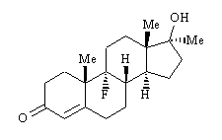

Feedback: Fluoxymesterone is an androgen. Androgens are male hormones that are responsible for the development of male characteristics. Progestagens are female hormones that prepare the lining of the uterus for implantation of an ovum. Oestrogens (or estrogens) are female hormones that are responsible for the development of female characteristics. These are characterised by an aromatic ring as part of the steroid structure. Glucocorticoids promote gluconegenesis and the formation of glycogen, enhance the degradation of fat and protein and inhibit the inflammatory response.
Page reference: 520
a. Oestrogens
b. Progestins
c. Glucocorticoids
*d. Androgens

Type: multiple choice question
Title: Chapter 18b Question 08
08) Goserelin is an LHRH agonist used to treat advanced prostate cancer. What type of agent is goserelin?
Feedback: Goserelin is a decapeptide analogue of luteinising hormone-releasing hormone. It contains a couple of unnatural amino acids to make the structure more resistant to peptidase degradation.
Page reference: 520
a. Steroid
*b. Polypeptide
c. Polynucleotide
d. Carbohydrate

Type: multiple choice question
Title: Chapter 18b Question 09
09) Tamoxifen is used for the treatment of hormone dependent breast cancer. What role does tamoxifen play?

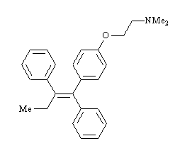

Feedback: It binds to the oestrogen receptor and prevents oestrogen from binding. Therefore, it is an antagonist for the oestrogen receptor.
Page reference: 521
*a. It acts as an antagonist for the oestrogen receptor.
b. It acts as an agonist for the oestrogen receptor.
c. It acts as an inhibitor for the aromatase enzyme.
d. It acts as an inhibitor of cytochrome P450 enzymes.

Type: multiple choice question
Title: Chapter 18b Question 10
10) Aromatase is an enzyme complex that is the target for several anticancer drugs. What reaction does it catalyse?
Feedback: Aromatase is an enzyme which converts androgens to oestrogens. Androgens are male hormones that are responsible for the development of male characteristics. Oestrogens (or estrogens) are female hormones that are responsible for the development of female characteristics. These are characterised by an aromatic ring as part of the steroid structure. The aromatase enzyme complex is responsible for catalysing oxidation of ring A in androgens to the aromatic ring of oestrogens.
Page reference: 522
a. The conversion of oestrogens to androgens
*b. The conversion of androgens to oestrogens
c. The conversion of androgens to progestins
d. The conversion of oestrogens to glucocorticoids

Type: multiple choice question
Title: Chapter 18b Question 11
11) Aromatase is an enzyme complex that is the target for several anticancer drugs. How many enzymes are involved in the aromatase enzyme complex?
Feedback: The two enzymes involved are a cytochrome P450 enzyme containing haem and a reductase enzyme using NADPH as cofactor.
Page reference: 522
*a. 2
b. 3
c. 4
d. 5

Type: multiple choice question
Title: Chapter 18b Question 12
12) Aromatase is an enzyme complex that is the target for several anticancer drugs. Which of the following anticancer drugs targets aromatase?
Feedback: Cyproterone acetate is an anti androgen and blocks the action of androgens at their receptors. Raloxifene acts as an antagonist of the oestrogen receptor. Aminoglutethimide is an aromatase inhibitor. Testosterone propionate is used as an androgenic agent.
Page reference: 522
a. Cyproterone acetate
b. Raloxifene
*c. Aminoglutethimide
d. Testosterone propionate

Type: multiple choice question
Title: Chapter 18b Question 13
13) The following diagram is representative of a group of naturally occurring compounds that are used in combination therapy to treat a variety of tumours:

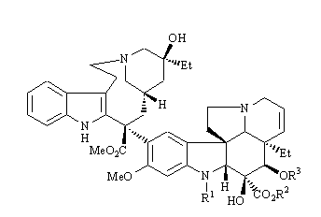

Which group of compounds is represented by the above structure?
Feedback: The spongistatins were extracted from marine sources and have a macrocylic ring system containing several sugars. Cryptophycins have been isolated from blue green algae and contain a macrocylic ring involving peptide and ester linkages. Combretastatins are much relatively simple molecules consisting of two aromatic rings linked together by a 2-carbon unit. Vinca alkaloids are alkaloids derived from the Madagascar periwinkle plant and have a tetracyclic ring system linked to a pentacyclic ring system.
Page reference: 523
a. Spongistatins
b. Cryptophycins
c. Combretastatins
*d. Vinca alkaloids

Type: multiple choice question
Title: Chapter 18b Question 14
14) The following diagram is representative of a group of naturally occurring compounds called the Vinca alkaloids that are used in combination therapy to treat a variety of tumours:

What is the target for these compounds?
Feedback: Tubulin is a structural protein which polymerises to produce microtubules in the cell. The Vinca alkaloids prevent this polymerisation.
Page reference: 523
a. Aromatase
*b. Tubulin
c. Oestrogen receptor
d. DNA

Type: multiple choice question
Title: Chapter 18b Question 15
15) The following diagram is representative of a group of naturally occurring compounds called the Vinca alkaloids that are used in combination therapy to treat a variety of tumours:

How do cancer cells normally gain resistance to these agents?
Feedback: The P-glycoprotein transports drugs such as the Vinca alkaloids out of the cancer cell such that they are no longer effective.
Page reference: 523
a. Mutation of the target structure
*b. Overexpression of the carrier protein called P-glycoprotein
c. Increased metabolism of the drug
d. Decreased ability of the drug to enter target cells

Type: multiple choice question
Title: Chapter 18b Question 16
16) What is the name of the following anticancer drug?

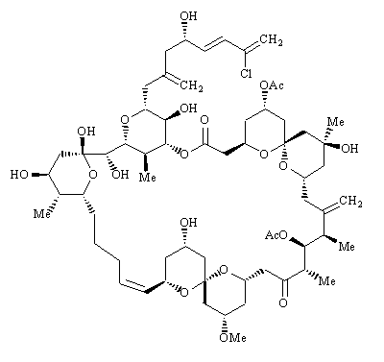
Feedback: Spongistatin 1 is an example of a spongistatin. These compounds were extracted from marine sources and have a macrocylic ring system containing several sugars. Cryptophycin 1 is an example of a cryptophycin Cryptophycins have been isolated from blue green algae and contain a macrocylic ring involving peptide and ester linkages. Phyllanthoside is a natural product obtained from the roots of a Costa Rican tree. It has three sugar molecules within its structure. Maytansine 1 is another macrocycle which was extracted from an Ethopian shrub and some similarities in structure to the cryptohycins.
Page reference: 524
*a. Spongistatin 1
b. Cryptophycin 1
c. Phyllanthoside
d. Maytansine 1

Type: multiple choice question
Title: Chapter 18b Question 17
17) What is the name of the following anticancer drug?

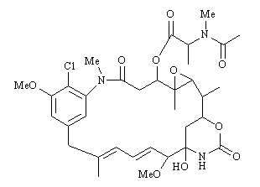
Feedback: Spongistatin 1 is an example of a spongistatin. These compounds were extracted from marine sources and have a macrocylic ring system containing several sugars. Cryptophycin 1 is an example of a cryptophycin Cryptophycins have been isolated from blue green algae and contain a macrocylic ring involving peptide and ester linkages. Phyllanthoside is a natural product obtained from the roots of a Costa Rican tree. It has three sugar molecules within its structure. Maytansine 1 is another macrocycle which was extracted from an Ethopian shrub and some similarities in structure to the cryptohycins.
Page reference: 524-525
a. Spongistatin 1
b. Cryptophycin 1
c. Phyllanthoside
*d. Maytansine 1

Type: multiple choice question
Title: Chapter 18b Question 18
18) The following structure belongs to a group of compounds obtained from the African bush willow and shows promise as an anticancer agent:

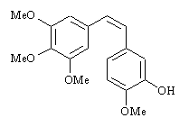

What is the name of the structure?
Feedback: The structure is combretastatin A-4 which belongs to a group of compounds called the combretastatins.
Discodermolide is a linear structure containing a six membered lactone. It was isolated from a marine sponge. Epothilone A is a macrocyclic lactone which was isolated from a bacterial source. The combretastatins are relatively simple molecules derived from the African bush willow. Paclitaxel has a complex tetracyclic ring system which includes an oxetane ring. It was obtained from the bark of yew trees.
Page reference: 525
a. Discodermolide
b. Epothilone A
*c. Combretastatin A-4
d. Paclitaxel

Type: multiple choice question
Title: Chapter 18b Question 19
19) The following structure belongs to a group of compounds obtained from the African bush willow and shows promise as an anticancer agent.

How does it work?
Feedback: The structure is combretastatin A-4. It inhibits tubulin polymerisation by binding to tubulin.
Page reference: 525
a. It inhibits tubulin depolymerisation
*b. It inhibits tubulin polymerisation
c. It inhibits both processes
d. It inhibits neither process

Type: multiple choice question
Title: Chapter 18b Question 20
20) The following structure belongs to a group of compounds obtained from the African bush willow and shows promise as an anticancer agent:

Which of the following statements is untrue?
Feedback: The structure is combretastatin A-4. The relative positions of the aromatic rings is crucial to activity. The cis-isomer is far more active than the trans-isomer.
Page reference: 525
a. The above structure is being tested as a phosphate prodrug in cancer chemotherapy.
b. It prevents angiogenesis.
*c. The cis and trans isomers are equally effective.
d. It bears a structural similarity to colchicine.

Type: multiple choice question
Title: Chapter 18b Question 21
21) The following structure is an important anticancer agent used in the treatment of breast and ovarian cancers:

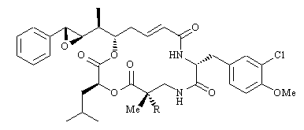

What is the name of the structure?
Feedback: The structure is paclitaxel which belongs to a group of compounds called the taxoids. Paclitaxel has a complex tetracyclic ring system which includes an oxetane ring. It was obtained from the bark of yew trees.

Discodermolide is a linear structure containing a six membered lactone. It was isolated from a marine sponge. Epothilone A is a macrocyclic lactone which was isolated from a bacterial source. The combretastatins are relatively simple molecules derived from the African bush willow.
Page reference: 525-526
a. Discodermolide
b. Epothilone A
c. Combretastatin A-4
*d. Paclitaxel

Type: multiple choice question
Title: Chapter 18b Question 22
22) The following structure is called paclitaxel and it is an important anticancer agent used in the treatment of breast and ovarian cancers:

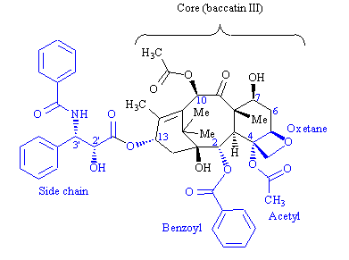
What is the natural source for this compound?
Feedback: Paclitaxel is obtained from the bark of yew trees.
Page reference: 525
a. Coral
*b. The yew tree
c. A marine bacterium
d. The willow tree

Type: multiple choice question
Title: Chapter 18b Question 23
23) The following structure is called paclitaxel and it is is an important anticancer agent used in the treatment of breast and ovarian cancers:

To which family of compounds does the above structure belong?
Feedback: The taxoids are characterised by a complex tetracyclic ring system which includes a four membered oxetane ring and an eight membered cyclooctane ring.
Page reference: 525
a. Combretastatins
b. Sarcodictyins
c. Cryptophycins
*d. Taxoids

Type: multiple choice question
Title: Chapter 18b Question 24
24) The following structure is is called paclitaxel and it is an important anticancer agent used in the treatment of breast and ovarian cancers:

How does it work?
Feedback: Paclitaxel accelerates polymerisation and stabilises the resultant microtubules. As a result depolymerisation is inhibited.
Page reference: 525
*a. It inhibits tubulin depolymerisation
b. It inhibits tubulin polymerisation
c. It inhibits both processes
d. It inhibits neither process

Type: multiple choice question
Title: Chapter 18b Question 25
25) The following structure is called paclitaxel and it is an important anticancer agent used in the treatment of breast and ovarian cancers:

Which of the following disadvantages apply to the above structure?
Feedback: There are a variety of mechanisms by which tumour cells can gain resistance to drugs. For example, resistance to paclitaxel can arise due to mutation of tubulin resulting in a weakened binding interaction with paclitaxel. Resistance can also arise due to overexpression of P-glycoprotein. This molecule is capable of transporting a variety of drugs across the cell membrane and out of the cell.
Paclitaxel cannot be taken orally and does not obey the ‘Rule of Five’. It has a high molecular weight and there are 13 hydrogen bond acceptor groups.
Page reference: 526
a. Resistance can arise due to mutation of the target structure
b. Resistance can arise due to overexpression of the carrier protein called P-glycoprotein
c. The drug cannot be taken orally
*d. All of the answers are correct.

Type: multiple choice question
Title: Chapter 18b Question 26
26) The following structure is a natural product with anticancer properties. Identify the structure.

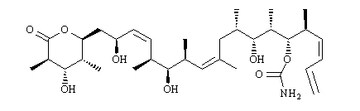

Feedback: The structure is discodermolide. Discodermolide is a linear structure containing a six membered lactone. It was isolated from a marine sponge.
Epothilone A is a macrocyclic lactone which was isolated from a bacterial source. The combretastatins are relatively simple molecules derived from the African bush willow. Paclitaxel has a complex tetracyclic ring system which includes an oxetane ring. . It was obtained from the bark of yew trees. which belongs to a group of compounds called the taxoids.
Page reference: 527
*a. Discodermolide
b. Epothilone A
c. Combretastatin A-4
d. Paclitaxel

Type: multiple choice question
Title: Chapter 18b Question 27
27) The following structure is a natural product with anticancer properties. Identify the structure.

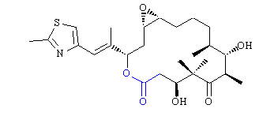

Feedback: The structure is epothilone A. Epothilone A is a macrocyclic lactone which was isolated from a bacterial source.
Discodermolide is a linear structure containing a six membered lactone. It was isolated from a marine sponge.
The combretastatins are relatively simple molecules derived from the African bush willow.
Paclitaxel has a complex tetracyclic ring system which includes an oxetane ring. It was obtained from the bark of yew trees. which belongs to a group of compounds called the taxoids.
Page reference: 527
a. Discodermolide
*b. Epothilone A
c. Combretastatin A-4
d. Paclitaxel

Type: multiple choice question
Title: Chapter 18b Question 28
28) The Ras protein plays an important part in cell signalling pathways. Abnormal Ras protein is constantly active and is observed in many cancers. Which of the following statements best explains this constant activity?
Feedback: The Ras protein is active when it binds GTP and inactive when it binds GDP. The inability to autocatalyse bound GTP means that abnormal Ras is constantly active. None of the other options account for this.
Page reference: 528
a. The abnormal Ras protein is unable to autocatalyse the hydrolysis of bound GDP.
b. The abnormal Ras protein is unable to bind GTP.
*c. The abnormal Ras protein is unable to autocatalyse the hydrolysis of bound GTP.
d. The abnormal Ras protein is unable to bind GDP.

Type: multiple choice question
Title: Chapter 18b Question 29
29) When the Ras protein is present in the cytoplasm, it can undergo an enzyme catalysed reaction that leads to the attachment of a farnesyl hydrocarbon chain to the protein. What is the name of the enzyme involved in this process?
Feedback: The reaction involved is a transfer of a farnesyl chain to the Ras protein, and so the enzyme is a transferase. The other enzymes are fictitious.
Page reference: 528-529
a. Farnesyl ligase
b. Farnesylase
*c. Farnesyl transferase
d. Farnesyl phosphorylase

Type: multiple choice question
Title: Chapter 18b Question 30
30) When the Ras protein is present in the cytoplasm, it can undergo an enzyme catalysed reaction that leads to the attachment of a farnesyl hydrocarbon chain to the protein. The enzyme involved in this process is called farnesyl transferase. What metal cofactor is required by this enzyme?
Feedback: The enzyme is an example of a zinc metalloenzyme, but magnesium and iron are also present as cofactors.
Page reference: 528-529
a. Magnesium
b. Iron
c. Zinc
*d. All of the answers are correct

Type: multiple choice question
Title: Chapter 18b Question 31
31) When the Ras protein is present in the cytoplasm, it can undergo an enzyme catalysed reaction that leads to the attachment of a farnesyl hydrocarbon chain to the protein. The enzyme involved in this process is called farnesyl transferase. What is the substrate used to provide the farnesyl group?
Feedback: The diphosphate acts as the leaving group during the enzyme catalysed reaction.
Page reference: 528-529
a. Farnesyl phosphate
*b. Farnesyl diphosphate
c. Farnesyl triphosphate
d. Farnesyl polyphosphate

Type: multiple choice question
Title: Chapter 18b Question 32
32) When the Ras protein is present in the cytoplasm, it can undergo an enzyme catalysed reaction that leads to the attachment of a farnesyl hydrocarbon chain to the protein. What role does the farnesyl chain play once it is linked to the Ras protein?

Feedback: The farnesyl chain is hydrophobic and so it anchors the Ras chain to the inner surface of the cell membrane. Activation or deactivation depends on whether Ras binds GTP or GDP respectively. The farnesyl chain plays no part in protecting the Ras protein from degradative enzymes.
Page reference: 528-529
a. It activates the Ras protein
b. It deactivates the Ras protein
*c. It anchors the Ras protein to the cell membrane
d. It protects the Ras protein from degradative enzymes

Type: multiple choice question
Title: Chapter 18b Question 33
33) When the Ras protein is present in the cytoplasm, it can undergo an enzyme catalysed reaction that leads to the attachment of a farnesyl hydrocarbon chain to the protein. To which amino acid residue in the Ras protein is the farnesyl chain attached?
Feedback: The thiol group of cysteine acts as a nucleophile to displace the diphosphate leaving group from farnesyl diphosphate.
Page reference: 528-529
a. Serine
b. Lysine
*c. Cysteine
d. Histidine

Type: multiple choice question
Title: Chapter 18b Question 34
34) When the Ras protein is present in the cytoplasm, it can undergo an enzyme catalysed reaction that leads to the attachment of a farnesyl hydrocarbon chain to the protein. After attachment of the farnesyl chain to Ras, a peptide is cleaved from Ras. What size of peptide is cleaved?
Feedback: The tripeptide H-Val-Ile-Met-OH is cleaved from the protein.
Page reference: 528-529
a. Dipeptide
*b. Tripeptide
c. Tetrapeptide
d. Pentapeptide

Type: multiple choice question
Title: Chapter 18b Question 35
35) When the Ras protein is present in the cytoplasm, it can undergo an enzyme catalysed reaction that leads to the attachment of a farnesyl hydrocarbon chain to the protein. After attachment of the farnesyl chain to Ras, a peptide is cleaved from Ras. After cleavage of the peptide, a further reaction takes place. What is it?
Feedback: A polar, ionised carboxylic acid is converted to a less polar ester. The ionised carboxylic acid would hinder the farnesyl chain from binding the Ras protein to the cell membrane.
Page reference: 528-529
a. N-methylation of an amide
b. Reduction of alkene groups on the farnesyl chain
*c. Conversion of a carboxylic acid to a methyl ester
d. Decarboxylation of a carboxylic acid group

Type: multiple choice question
Title: Chapter 18b Question 36
36) The CaaX terminal tetrapeptide of Ras has been used as the lead compound for enzyme inhibitors which prevent the attachment of the farnesyl chain to Ras. What is meant by CaaX?
Feedback: There is some variability allowed for the CaaX tetrapeptide. C has to be cysteine. a has to be an amino acid with a hydrophobic side chain restricted to valine, leucine and isoleucine. X is an amino acid with a polar side chain restricted to methionine, glutamine or serine.
Page reference: 528
a. A tetrapeptide where C is cysteine, a is any amino acid and X is methionine, glutamine or serine.
b. A tetrapeptide where C is cysteine, a is any amino acid and X is any amino acid other than those at positions a.
*c. A tetrapeptide where C is cysteine, a is valine, isoleucine or leucine and X is methionine, glutamine or serine.
d. A tetrapeptide where C is cysteine, a is valine, isoleucine or leucine and X is any amino acid.

Type: multiple choice question
Title: Chapter 18b Question 37
37) The CaaX tetrapeptide is a substrate for the enzyme involved in attaching the farnesyl chain to the Ras protein. However, placing a specific amino acid at the underlined position CaaX results in an enzyme inhibitor. Which amino acid can be placed at this position to produce an inhibitor?
Feedback: The a in CaaX is normally valine, isoleucine or leucine. Changing the amino acid (a) next to X from one of these amino acids to phenylalanine results in an inhibitor rather than a substrate.
Page reference: 526
a. Serine
b. Glycine
c. Valine
*d. Phenylalanine

Type: multiple choice question
Title: Chapter 18b Question 38
38) Specific CaaX tetrapeptides have been shown to be inhibitors of the enzyme involved in attaching the farnesyl chain to the Ras protein. However, such structures are susceptible to hydrolysis by aminopeptidases. Which peptide link in CaaX analogues is particularly susceptible to aminopeptidases?
Feedback: The bond between C and a is susceptible to aminopeptidases. These enzymes catalyse the cleavage of the amino acid at the N-terminus of a peptide chain.
Page reference: 529-530
a. Between C and the rest of the Ras protein
*b. Between C and a
c. Between a and a
d. Between a and X

Type: multiple choice question
Title: Chapter 18b Question 39
39) The following structures inhibit the enzyme responsible for linking farnesyl chains to the Ras protein:

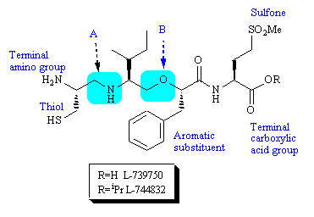
What is the rationale for moiety A?
Feedback: There is nothing illogical in any of the options presented, but the group was introduced to remove a peptide bond that was susceptible to aminopeptidases.
Page reference: 529-530
a. It replaces a peptide bond such that the N-H group can act both as a hydrogen bond donor and a hydrogen bond acceptor.
b. It replaces a peptide bond such that chain flexibility is increased, allowing the active conformation to be adopted more easily.
*c. It replaces a metabolically susceptible peptide bond with a metabolically stable group.
d. It replaces a peptide bond such that the carbonyl oxygen can no longer act as a hydrogen bond acceptor.

Type: multiple choice question
Title: Chapter 18b Question 40
40) The following structures inhibit the enzyme responsible for linking farnesyl chains to the Ras protein.

What is the rationale for the peptide bond isostere - B?
Feedback: The nitrogen or an amine is more nucleophilic than the nitrogen of an amide and in this case it can take part in an intramolecular cyclisation with a terminal ester.
Page reference: 529-530
a. It replaces a metabolically susceptible peptide bond with a metabolically stable group.
*b. It is used instead of an amine isostere since the latter can result in an intramolecular cyclisation
c. The oxygen acts as a hydrogen bond acceptor whereas the NH group of the original peptide group acted as a hydrogen bond donor.
d. It allows greater conformational freedom for the phenylalanine residue.

Type: multiple choice question
Title: Chapter 18b Question 41
41) The following structures inhibit the enzyme responsible for linking farnesyl chains to the Ras protein:

Which feature of the molecule forms an interaction with a zinc ion cofactor?
Feedback: The thiol functional group is known to be a good ligand for a zinc ion cofactor. It is present in several drugs that interact with zinc metalloenzymes. Captopril is one such example.
Page reference: 530
a. The terminal amino group
b. The sulfone
c. The terminal carboxylic acid group
*d. The thiol

Type: multiple choice question
Title: Chapter 18b Question 42
42) The following structure is an inhibitor of the enzyme responsible for adding a farnesyl chain to the Ras protein.

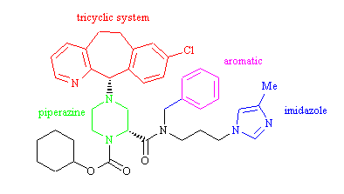
Which feature is present to protect the molecule from metabolism?
Feedback: The aromatic ring was added as a steric shield to protect the molecule from metabolism. The imidazole ring is a good ligand for zinc ion cofactors and has been used in several drugs that target zinc metalloenzymes. The tricyclic system and the piperazine ring play a role in binding the drug to the active site of the enzyme.
Page reference: 531
a. The tricyclic system
b. The piperazine ring
*c. The aromatic ring
d. The imidazole ring

Type: multiple choice question
Title: Chapter 18b Question 43
43) Which of the following Ras proteins is not farnesylated as a result of farnesyl transferase inhibitors?
Feedback: The enzyme is inhibited and so the farnesylation of all three types of Ras of Ras protein is inhibited.
Page reference: 531
a. H-Ras
b. N-Ras
c. K-Ras
*d. All of the options given are correct.

Type: multiple choice question
Title: Chapter 18b Question 44
44) Which of the following Ras proteins is totally inhibited as a result of farnesyl transferase inhibitors?
Feedback: Only the H-Ras protein is totally inhibited since the N-Ras and K-Ras proteins can be prenylated by a different enzyme and still become attached to the cell membrane.
Page reference: 531
*a. H-Ras
b. N-Ras
c. K-Ras
d. All of the options given are correct.

Type: multiple choice question
Title: Chapter 18b Question 45
45) What reaction is catalysed by protein kinases?
Feedback: Kinases are enzymes that catalyse phosphorylation reactions on protein substrates. The amino acid residues that are phosphorylated contain an alcohol or a phenol functional group.
The hydrolysis of phosphate residues is catalysed by phosphorylases. The hydrolysis of peptide bonds is catalysed by peptidases or proteases. The formation of peptide bonds takes place on ribosomes during the translation process.
Page reference: 531
*a. The phosphorylation of alcohol or phenol residues in protein substrates.
b. The hydrolysis of phosphate residues in protein substrates.
c. The hydrolysis of peptide bonds in protein substrates.
d. The formation of peptide bonds in protein substrates.

Type: multiple choice question
Title: Chapter 18b Question 46
46) Which of the following amino acids is not affected by the action of a protein kinase?
Feedback: The amino acid residues that are phosphorylated contain an alcohol or a phenol functional group. Serine and threonine have an alcohol functional group on their side chain, while tyrosine contains a phenol group. Cysteine has a thiol functional group on its side chain. It is not phosphorylated.
Page reference: 532
*a. Cysteine
b. Serine
c. Tyrosine
d. Threonine

Type: multiple choice question
Title: Chapter 18b Question 47
47) How many categories of protein kinase are there?
Feedback: The main types of protein kinase are serine-threonine kinases and tyrosine kinases.
Page reference: 532
a. 1
*b. 2
c. 3
d. 4

Type: multiple choice question
Title: Chapter 18b Question 48
48) What molecule (other than the substrate itself) is required by a protein kinase if it is to act as a catalyst for phosphorylation?
Feedback: All four options are nucleotides which are present in the body, but it is only ATP that is required by protein kinases.
Page reference: 532
*a. ATP
b. GTP
c. CTP
d. TTP

Type: multiple choice question
Title: Chapter 18b Question 49
49) ATP is required by a protein kinase if it is to act as a catalyst for phosphorylation. What role is played by ATP?
Feedback: ATP is converted to ADP and the phosphate group is transferred to the alcohol or phenol group that is being phosphorylated.
Page reference: 532
a. It provides energy for the reaction.
*b. It provides a phosphate group for the phosphorylation reaction.
c. It binds to an allosteric binding site and activates the enzyme.
d. It provides a diphosphate group for the phosphorylation reaction.

Type: multiple choice question
Title: Chapter 18b Question 50
50) Gefitinib has been used for the treatment of refractory lung cancers.

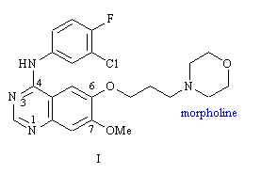

What is the target for gefitinib?
Feedback: The epidermal growth factor receptor is a membrane bound protein which has an extracellular binding site for the hormone messenger, epidermal growth factor, and an intracellular active site which catalyses phosphorylations of proteins. It is the latter site which is targeted specifically by gefitinib.
Page reference: 533-534
a. Abelson tyrosine kinase
b. Vascular endothelial growth factor receptor kinase
c. Cyclin dependent kinases
*d. Epidermal growth factor receptor kinase

Type: multiple choice question
Title: Chapter 18b Question 51
51) Gefitinib has been used for the treatment of refractory lung cancers.

What class of compounds does gefitinib belong to?
Feedback: The correct answer is 4-anilinoquinazolines.
4-Anilinopyrimidines would contain a monocyclic pyrimidine ring. 4-Anilinoquinolines and 4-anilinoisoquinolines have a bicyclic system but only one nitrogen in the ring system.
Page reference: 534
*a. 4-anilinoquinazolines
b. 4-anilinopyrimidines
c. 4-anilinoquinolines
d. 4-anilinoisoquinolines

Type: multiple choice question
Title: Chapter 18b Question 52
52) Gefitinib (I) has been used for the treatment of refractory lung cancers.

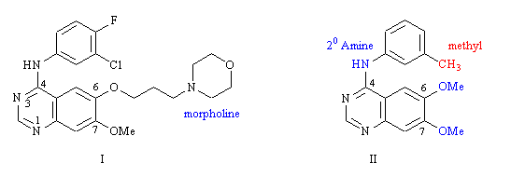
Structure II was the lead compound for structure I. Why was the methyl group replaced with a chloro group?
Feedback: The methyl group is susceptible to metabolic oxidation from cytochrome P450 enzymes to give a hydroxymethylene group. The chloro substituent does not get oxidised.
It is true that the chloro substituent is an inductive electron withdrawing group whereas the methyl substituent is electron donating but this was not the reason for the change. A chloro group is often used to replace a methyl group because it is much the same size and lipophilicity.
Page reference: 534
a. To replace an inductive electron donating group with an inductive electron withdrawing group.
b. To replace the methyl group with a smaller chloro group.
c. To replace a lipophilic methyl group with a more polar chloro group.
*d. To replace a metabolically susceptible methyl group with a metabolically stable chloro group.

Type: multiple choice question
Title: Chapter 18b Question 53
53) Gefitinib (I) has been used for the treatment of refractory lung cancers.

What role does the fluoro group play in gefitinib?
Feedback: Cytochrome P450 enzymes oxidise the para position of the aromatic ring to introduce a phenol group. Placing a fluoro substituent at the para position blocks this reaction.
The fluoro substituent acts as an electron withdrawing group but this is not the reason for its inclusion. Fluorine is a very poor hydrogen bond acceptor. The fluorine atom is a similar size to hydrogen and so it could not fill a hydrophobic pocket better than a hydrogen atom.
Page reference: 534
*a. It blocks metabolism at that position of the aromatic ring.
b. It is electron withdrawing and makes the aromatic ring less electron rich.
c. It acts as a hydrogen bond acceptor.
d. It fills a hydrophobic pocket better than a hydrogen atom.

Type: multiple choice question
Title: Chapter 18b Question 54
54) Gefitinib has been used for the treatment of refractory lung cancers.

What role does the morpholine ring play in gefitinib?
Feedback: The addition of a morpholine ring is a common tactic to increase the water solubility of a drug. In theory, the oxygen and the nitrogen could act as hydrogen bond acceptor groups, but not in this case. Similarly, it is feasible that the nitrogen could act as a hydrogen bond donor if it was protonated, but that is not the case here.
Page reference: 534
a. It acts as a hydrogen bond acceptor at the nitrogen atom.
b. It acts as a hydrogen bond acceptor at the oxygen atom.
c. It is protonated at blood pH and acts as a hydrogen bond donor.
*d. It increases water solubility.

Type: multiple choice question
Title: Chapter 18b Question 55
55) Gefitinib has been used for the treatment of refractory lung cancers.

Which molecule does gefitinib mimic?

Feedback: Gefitinib binds to the same region of the active site as ATP and is mimicking that molecule. The protein substrate binds to a different part of the active site. The molecules GTP and CTP play no part in the enzyme catalysed reaction.
Page reference: 534
a. The protein substrate for the enzyme
b. GTP
*c. ATP
d. CTP

Type: multiple choice question
Title: Chapter 18b Question 56
56) Gefitinib has been used for the treatment of refractory lung cancers.

One of the nitrogen atoms in gefitinib is an important hydrogen bond acceptor to the amino acid methionine in the active site. Which one?
Feedback: This nitrogen acts as a hydrogen bond acceptor.
Page reference: 534-535
a. The nitrogen at position 3
*b. The nitrogen at position 1
c. The aniline nitrogen
d. The morpholine nitrogen

Type: multiple choice question
Title: Chapter 18b Question 57
57) Gefitinib has been used for the treatment of refractory lung cancers.

One of the nitrogen atoms in structure I forms an important hydrogen bond to a water molecule. The latter acts as a bridge between the drug and the amino acid threonine in the active site. Which nitrogen atom is involved in this interaction?
Feedback: This nitrogen acts as a hydrogen bond acceptor to water.
Page reference: 534-535
*a. The nitrogen at position 3
b. The nitrogen at position 1
c. The aniline nitrogen
d. The morpholine nitrogen

Type: multiple choice question
Title: Chapter 18b Question 58
58) The following structure is an important anticancer drug which targets a protein kinase.

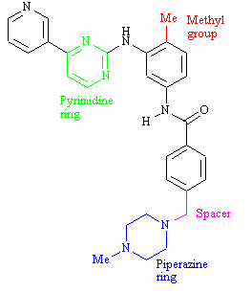

What is the protein kinase target for the drug?
Feedback: The structure is imatinib. It acts on the Abelson tyrosine kinase which catalyses the phosphorylation of tyrosine residues on protein substrates using ATP as a cofactor. Imatinib binds to the ATP binding site.
Page reference: 535-536
*a. Abelson tyrosine kinase
b. Vascular endothelial growth factor receptor kinase
c. Cyclin dependent kinases
d. Epidermal growth factor receptor kinase

Type: multiple choice question
Title: Chapter 18b Question 59
59) Imatinib is an important anticancer drug which targets a protein kinase:

What is the role of the methyl group in the structure?
Feedback: The methyl group restricts the number of conformations available to the molecule. The other options are feasible reasons for adding a methyl group, but are not relevant to this case.
Page reference: 536-537
*a. It acts as a conformational blocker.
b. It acts as an accessible group for drug metabolism.
c. It has an electron donating effect on the aromatic ring.
d. All of the options given are correct.

Type: multiple choice question
Title: Chapter 18b Question 60
60) Imatinib is an important anticancer drug which targets a protein kinase.

What effect does the methyl group have on activity?
Feedback: The methyl group prevents the molecule from adopting the active conformation for serine-threonine kinases but allows the active conformation for tyrosine kinases.
The methyl group was not introduced to accelerate metabolism or to increase the binding interactions of the aromatic ring.
Page reference: 536-537
*a. It introduces specificity for tyrosine kinases over serine-threonine kinases.
b. It introduces specificity for serine-threonine kinases over tyrosine kinases.
c. It allows the drug to be metabolised in a controlled fashion, thus reducing side effects from alternative metabolic reactions.
d. It increases the activity of the drug by increasing binding interactions between the aromatic ring and the binding site.

Type: multiple choice question
Title: Chapter 18b Question 61
61) Imatinib is an important anticancer drug which targets a protein kinase.

What is the principle reason for the spacer unit?
Feedback: A nitrogen next to an aromatic ring is defined as being aniline like. Such groups are potentially toxic and so a spacer was introduced such that the nitrogen was not directly linked to the aromatic ring.
Page reference: 536-537
a. It positions the piperazine ring in the correct position for binding.
b. It allows increased flexibility such that the piperazine ring can access greater conformational space.
*c. It avoids the potential toxicity of an aniline like nitrogen.
d. It increases the hydrophobicity of the molecule.

Type: multiple choice question
Title: Chapter 18b Question 62
62) Imatinib is an important anticancer drug which targets a protein kinase:

What role does the piperazine ring have?
Feedback: The terminal nitrogen of the piperazine ring is protonated. This increases water solubility and also allows an extra ionic bonding interaction to take place with the active site. This increases target binding affinity and selectivity.
Page reference: 536-537
a. It increases water solubility
b. It increases target selectivity
c. It increases target binding
*d. All of the options given are correct.

Type: matching question
Title: Chapter 18b - Question 63
63) The following synthesis has been used for imatinib. What are the reagents (i) – (iv)?

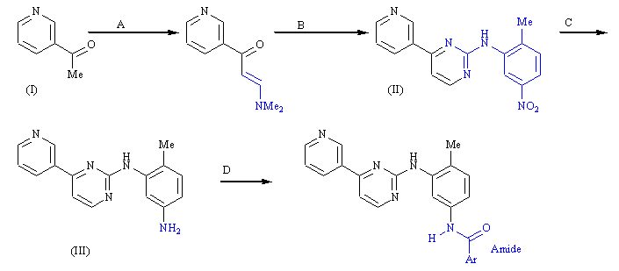

Feedback: The synthesis can be varied in order to produce a range of imatinib analogues
Page reference: 538
a. (i) = Diethoxymethyldimethylamine
b. (ii) = N-o-tolylguanidine
c. (iii) = Hydrogen gas over a palladium / charcoal catalyst
d. (iv) = 4-(4-methylpiperazin-1-ylmethyl)-benzoyl chloride

Type: multiple choice question
Title: Chapter 18b Question 64
64) Structures (I-III) are anticancer agents undergoing clinical trials:

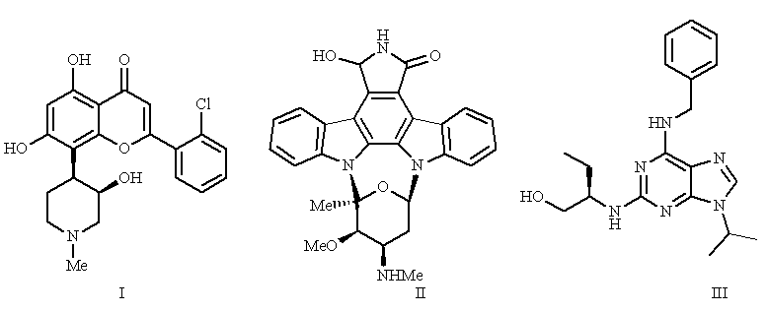
What is the target for these structures?
Feedback: Cyclin dependent kinases are important in the regulation of the cell cycle.
Page reference: 538-539
a. Abelson tyrosine kinase
b. Vascular endothelial growth factor receptor
*c. Cyclin dependent kinases
d. Epidermal growth factor receptor

Type: multiple choice question
Title: Chapter 18b Question 65
65) Structures (I-III) are anticancer agents undergoing clinical trials

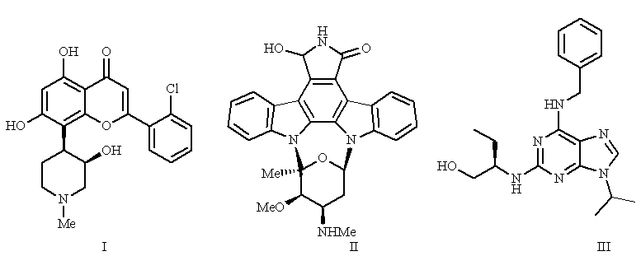
What is the name of structure I?
Feedback: The structure is flavopiridol
Roscovitine contains a purine ring system. Staurosporine is a multicyclic structure containing 8 rings. 7-Hydroxystaurosporine is an analogue of staurosporine containing an extra hydroxyl group. Flavopiridol has a benzopyran ring system included in its structure.
Page reference: 538-539
a. Roscovitine
b. Staurosporine
c. 7-hydroxystaurosporine
*d. Flavopiridol

Type: multiple choice question
Title: Chapter 18b Question 66
66) Structures (I-III) are anticancer agents undergoing clinical trials:

What is the name of structure II?
Feedback: The structure is 7-hydroxystaurosporine
Roscovitine contains a purine ring system. Staurosporine is a multicyclic structure containing 8 rings. 7-Hydroxystaurosporine is an analogue of staurosporine containing an extra hydroxyl group. Flavopiridol has a benzopyran ring system included in its structure.
Page reference: 539
a. Roscovitine
b. Staurosporine
*c. 7-hydroxystaurosporine
d. Flavopiridol

Type: multiple choice question
Title: Chapter 18b Question 67
67) Structures (I-III) are anticancer agents undergoing clinical trials

What is the name of structure III?
Feedback: The structure is roscovitine.
Roscovitine contains a purine ring system. Staurosporine is a multicyclic structure containing 8 rings. 7-Hydroxystaurosporine is an analogue of staurosporine containing an extra hydroxyl group. Flavopiridol has a benzopyran ring system included in its structure.
Page reference: 539
*a. Roscovitine
b. Staurosporine
c. 7-hydroxystaurosporine
d. Flavopiridol

Type: multiple choice question
Title: Chapter 18b Question 68
68) Matrix metalloproteinases are enzymes which are targets for potential anticancer agents. What important role do these enzymes play in the development of cancers?
Feedback: These enzymes catalyse the breakdown of the proteins that make up the extracellular matrix or connective tissue. This makes it possible for cancer cells to escape the primary tumour and to travel around the body setting up secondary tumours.
Page reference: 540
a. Inhibition of apoptosis
*b. The invasiveness and metastasis of cancer cells
c. Uncontrolled signalling pathways
d. Mutations

Type: multiple choice question
Title: Chapter 18b Question 69
69) Matrix metalloproteinases are enzymes which are targets for potential anticancer agents. What metal ion is required as a cofactor for these enzymes?
Feedback: The zinc ion plays an important binding role in the active site of matrix metalloproteinases. Inhibitors are designed such that include groups that can bind to the zinc cofactor.
Page reference: 540
a. Iron
*b. Zinc
c. Magnesium
d. Calcium

Type: multiple choice question
Title: Chapter 18b Question 70
70) Matrix metalloproteinases are enzymes which are targets for potential anticancer agents.
The collagenase enzymes are examples of matrix metalloproteinases which catalyse the hydrolysis of peptide links in protein substrates. Between which amino acids does this hydrolysis take place?
Feedback: The collagenase enzymes catalyse the hydrolysis of peptide bonds between glycine and isoleucine, or between glycine and leucine.
Page reference: 541
*a. Glycine and isoleucine
b. Glycine and valine
c. Valine and isoleucine
d. Leucine and valine

Type: multiple choice question
Title: Chapter 18b Question 71
71) Matrix metalloproteinases are enzymes which are targets for potential anticancer agents. The collagenase enzymes are examples of matrix metalloproteinases which catalyse the hydrolysis of peptide links in protein substrates.
Which amino acid in the substrate is responsible for binding to the metal ion cofactor of collagenases?
Feedback: The carbonyl oxygen of glycine is thought to bind to the zinc cofactor.
Page reference: 541
*a. Glycine
b. Leucine
c. Isoleucine
d. Valine

Type: multiple choice question
Title: Chapter 18b Question 72
72) Matrix metalloproteinases are enzymes which are targets for potential anticancer agents. The collagenase enzymes are examples of matrix metalloproteinases which catalyse the hydrolysis of peptide links in protein substrates.
Which amino acid in the active site aids the hydrolytic process of collagenases by binding to water?
Feedback: Glutamate binds to water and makes it a better nucleophile for the hydrolytic mechanism. Zinc also binds to this water molecule and aids the hydrolytic process.
Page reference: 541
a. Lysine
b. Serine
c. Cysteine
*d. Glutamate

Type: multiple choice question
Title: Chapter 18b Question 73
73) Matrix metalloproteinases are enzymes which are targets for potential anticancer agents. The collagenase enzymes are examples of matrix metalloproteinases which catalyse the hydrolysis of peptide links in protein substrates.
Which of the following features is not present in peptide based inhibitors of collagenase enzymes?
Feedback: One or more substituents are required to fit into the enzyme subsites, but they should form van der Waals interactions and not ionic interactions.
Page reference: 541
a. Replacement of the susceptible peptide bond with a moiety which is stable to hydrolysis.
*b. One or more substituents that can fit into the enzyme subsites and form ionic interactions.
c. At least one functional group capable of forming a H-bond to the enzyme backbone.
d. A group capable of strong interactions with a zinc ion cofactor.

Type: multiple choice question
Title: Chapter 18b Question 74
74) The following structure is called marimastat and is a matrix metalloproteinase inhibitor that has undergone clinical trials for the treatment of breast and prostate cancers:

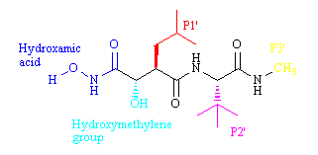

What role is played by the side chain (P1') Feedback: The side chain fits into the S1’ binding pocket. This pocket is normally occupied by an amino acid side chain present on a substrate. Since the side chain P1’ is an alkyl group, it interacts by van der Waals interactions. This implies that the S1’ subsite is hydrophobic in nature.
Page reference: 541
a. It acts as a transition state isostere
b. It binds to the zinc ion cofactor
*c. It binds to a binding sub pocket in the active site by van der Waals interactions
d. It binds to a binding sub pocket in the active site by ionic interactions

Type: multiple choice question
Title: Chapter 18b Question 75
75) The following structure is called marimastat and is a matrix metalloproteinase inhibitor that has undergone clinical trials for the treatment of breast and prostate cancers:

One of the groups in this molecule acts as a steric shield. Which one?
Feedback: The tertiary butyl group at P2' acts as a steric shield to protect peptide bonds from hydrolysis. It also hinders solvation of the peptide bonds such that energy is not expended desolvating these groups prior to binding.
Page reference: 541-542
a. The hydroxymethylene group
b. The substituent (P1')
*c. The substituent (P2')
d. The substituent (P3')
Type: multiple choice question
Title: Chapter 18b Question 76
76) The following structure is a matrix metalloproteinase inhibitor called marimastat that has undergone clinical trials for the treatment of breast and prostate cancers:

One of the groups in this molecule acts as a steric shield. Which group does the steric shield protect?
Feedback: The tertiary butyl group at P2' acts as a steric shield to protect peptide bonds from hydrolysis. It also hinders solvation of the peptide bonds such that energy is not expended desolvating these groups prior to binding.
Page reference: 541-542
a. The hydroxamic acid
b. The hydroxymethylene OH group
*c. The peptide links
d. The isopropyl residue at P1'

Type: multiple choice question
Title: Chapter 18b Question 77
77) The following structure is a matrix metalloproteinase inhibitor called marimastat hat has undergone clinical trials for the treatment of breast and prostate cancers:

Which group is present as a stable transition state isostere?
Feedback: The group mimics the transition state that is involved in the enzyme catalysed reaction, but it is a stable group which binds but does not react. As a result, the inhibitor remains bound to the active site.
Page reference: 541-542
*a. The hydroxymethylene group
b. The substituent (P1') c. The substituent (P2') d. The substituent (P3')
Type: multiple choice question
Title: Chapter 18b Question 78
78) The following molecule is a second generation matrix metalloproteinase inhibitor:

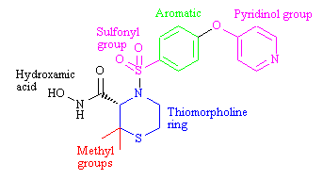
What is it called?
Feedback: Prinomastat is a second generation matrix metalloproteinase inhibitor. Celecoxib is a COX-2 inhibitor. Marimastat is a first generation matrix metalloproteinase inhibitor. Bortezomib is a boronic acid dipeptide that inhibits proteasomes.
Page reference: 542
*a. Prinomastat
b. Celecoxib
c. Marimastat
d. Bortezomib

Type: multiple choice question
Title: Chapter 18b Question 79
79) The following molecule is a second generation matrix metalloproteinase inhibitor called prinomastat:

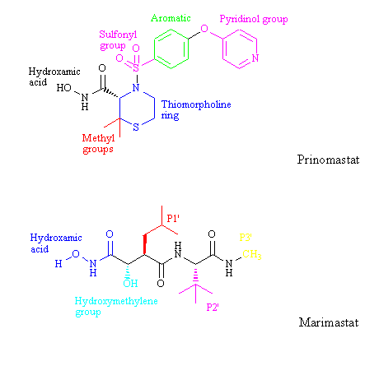
What advantage does this structure have over the first generation structure called marimastat?
Feedback: Prinomastat has decreased peptide character. As a result, it has improved pharmacokinetic properties. Unfortunately, it suffers from a lack of selectivity.
Page reference: 542
a. It has increased peptide character
b. It has increased selectivity
*c. It has improved pharmacokinetic properties
d. All of the options given are correct

Type: multiple choice question
Title: Chapter 18b Question 80
80) Prinomastat is a second generation matrix metalloproteinase inhibitor:

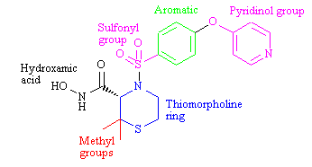
What drug design strategy has been employed by including the methyl groups?
Feedback: The methyl groups act as a steric shield to protect the hydroxamic acid group from metabolism.
Page reference: 542
a. Extension
b. Simplification
c. Rigidification
*d. Steric shield

Type: multiple choice question
Title: Chapter 18b Question 81
81) Prinomastat is a second generation matrix metalloproteinase inhibitor.

What drug design strategy has been employed by including the thiomorpholine ring?
Feedback: Incorporating the steric shield into a thiomorpholine ring restricts the number of possible conformations and increases activity.
Page reference: 542
a. Extension
b. Simplification
*c. Rigidification
d. Steric shield

Type: multiple choice question
Title: Chapter 18b Question 82
82) Prinomastat is a second generation matrix metalloproteinase inhibitor.

What drug design strategy has been employed by including the pyridinol ring?
Feedback: By including the pyridinol ring, extra binding interactions are possible with the active site, resulting in a more effective inhibitor.
Page reference: 542
*a. Extension
b. Simplification
c. Rigidification
d. Steric shield

Type: multiple choice question
Title: Chapter 18b Question 83
83) Prinomastat is a second generation matrix metalloproteinase inhibitor.

Which group interacts with the zinc ion cofactor of the enzyme?
Feedback: The hydroxamic acid group interacts with the zinc ion cofactor, through both the oxygens.
Page reference: 542
a. The sulfonyl group
b. The aromatic ring
*c. The hydroxamic acid
d. The thiomorpholine ring

Type: multiple choice question
Title: Chapter 18b Question 84
84) Prinomastat is a second generation matrix metalloproteinase inhibitor.

Which group interacts with a binding sub pocket in the active site?
Feedback: The aromatic ring fits the S1' binding sub pocket and can form van der Waals interactions.
Page reference: 542
a. The sulfonyl group
*b. The aromatic ring
c. The hydroxamic acid
d. The thiomorpholine ring

Type: multiple choice question
Title: Chapter 18b Question 85
85) Bortezomib is a dipeptide that has been approved for the treatment of multiple myeloma.

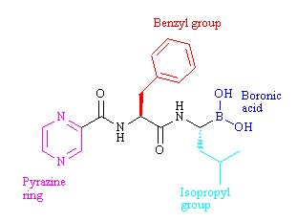

What is the target for the structure?
Feedback: The target is the proteasome. This is a structure that can destroy redundant proteins in the cell.
Page reference: 543
a. Cyclooxygenase 2
b. Matrix metalloproteinases
*c. Proteasomes
d. Tyrosine hydroxylase

Type: multiple choice question
Title: Chapter 18b Question 86
86) Bortezomib is a dipeptide that has been approved for the treatment of multiple myeloma.

The above structure is thought to form an important interaction with a threonine group in the target's active site. Which group is involved in this interaction?
Feedback: It is thought that a boron-threonine bond is formed at the active site.
Page reference: 543
a. The pyrazine ring
b. The benzyl group
c. The isopropyl group
*d. The boronic acid group

Type: multiple choice question
Title: Chapter 18b Question 87
87) Depsipeptide is a natural product currently being studied as an anticancer agent:

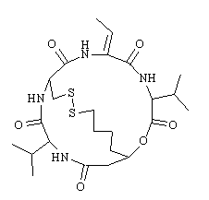
What is the target for this compound?
Feedback: Histone deacetylase catalyses the deacetylation of N-acetylated lysine residues present in histone. The enzyme is inhibited by depsipeptide.
Page reference: 544
a. Methionine aminopeptidase
*b. Histone deacetylase
c. Caspases
d. Tyrosine hydroxylase

Type: multiple choice question
Title: Chapter 18b Question 88
88) Depsipeptide is a natural product currently being studied as an anticancer agent:

What process is affected by the action of this compound?
Feedback: The structure inhibits the enzyme histone deacetylase. Deacetylation of acylated lysine residues is inhibited and this affects whether transcription takes place or not. Acetylation of the lysine residues on histone promotes transcription.
Page reference: 543-544
a. Replication
*b. Transcription
c. Translation
d. Reproduction

Type: multiple choice question
Title: Chapter 18b Question 89
89) The following structure entered phase III clinical trials as a treatment for renal cancer and multiple myeloma.

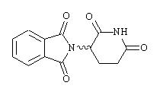
What is the name of the structure?
Feedback: Thalidomide is a synthetic product with a range of activities. Fumagillin is a fungal metabolite that inhibits an enzyme called methionine aminopeptidase. Depsipeptide is derived from a bacterial strain and is reduced to an active compound that promotes apoptosis and inhibits cell proliferation and angiogenesis. Aclarubicin is an anthraquinone which inhibits the chymotrypsin activity of proteasomes.
Page reference: 544-545
*a. Thalidomide
b. Fumagillin
c. Depsipeptide
d. Aclarubicin

Type: multiple choice question
Title: Chapter 18b Question 90
90) Thalidomide entered phase III clinical trials as a treatment for renal cancer and multiple myeloma.

The safety of the above structure can be improved by adding a substituent to the aromatic moiety. Which substituent has been used?
Feedback: The anticancer agents revamid and actimid are thalidomide analogues that contain and amino substituent.
Page reference: 544-545
a. A methyl group
*b. An amino group
c. An alcohol group
d. An aromatic ring

Type: multiple choice question
Title: Chapter 18b Question 91
91) The following structure is a natural product with anticancer properties. What is it called?

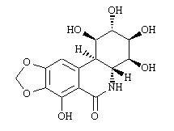
Feedback: Pancratistatin is a natural product isolated from a plant. Cephalostatin 1 was isolated from a marine worm. Bryostatin 1 was isolated from a marine invertebrate animal. Dolostatin 15 was isolated from the sea hare.
Page reference: 545
*a. Pancratistatin
b. Cephalostatin 1
c. Bryostatin 1
d. Dolostatin 15

Type: multiple choice question
Title: Chapter 18b Question 92
92) The following structure is a natural product isolated from a marine source. It boosts the immune system and makes it more effective against cancers. What is the structure called?

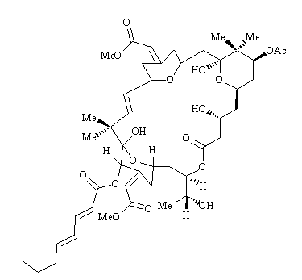
Feedback: Pancratistatin is a natural product isolated from a plant. Cephalostatin 1 was isolated from a marine worm. Bryostatin 1 was isolated from a marine invertebrate animal. Dolostatin 15 was isolated from the sea hare.
Page reference: 545
a. Pancratistatin
b. Cephalostatin 1
*c. Bryostatin 1
d. Dolostatin 15

Type: multiple choice question
Title: Chapter 18b Question 93
93) The following structure is a natural product isolated from a marine sea hare which has anticancer properties. What is it called?

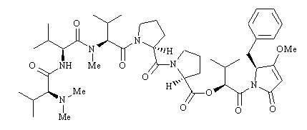
Feedback: Pancratistatin is a natural product isolated from a plant. Cephalostatin 1 was isolated from a marine worm. Bryostatin 1 was isolated from a marine invertebrate animal. Dolostatin 15 was isolated from the sea hare.
Page reference: 545
a. Pancratistatin
b. Cephalostatin 1
c. Bryostatin 1
*d. Dolostatin 15

Type: multiple choice question
Title: Chapter 18b Question 94
94) Some leukaemia cells have lost the ability to synthesise the amino acid asparagine. Which of the following can be used to treat such cancers?
Feedback: Crisantaspase is a preparation of the asparaginase enzyme which catalyses the breakdown of asparagine such that the cancer cells are starved of this amino acid.
Angiostatin and endostatin are naturally occurring proteins in the body which inhibit the formation of new blood vessels. Interferon is an immunostimulant.
Page reference: 546
a. Angiostatin
b. Endostatin
*c. Crisantaspase
d. Interferon

Type: multiple choice question
Title: Chapter 18b Question 95
95) What sort of structures are the anticancer agents trastuzumab, rituximab and cetuximab?
Feedback: These agents are antibodies which recognise distinctive antigens on cancer cells which have been overexpressed.
Page reference: 547-548
a. Signalling proteins
*b. Monoclonal antibodies
c. Steroids
d. Carbohydrates

Type: multiple choice question
Title: Chapter 18b Question 96
96) Which of the following statements is true regarding antibody-drug conjugates?
Feedback: Part of the structure of chimeric antibodies is derived from mice antibodies and so chimeric antibodies can still induce an immune response. The antibody should be humanised to reduce the risks of an immune response.
The antigen that is recognised on the cancer cell should be overexpressed. Antigens on cancer cells are usually likely to be present on normal cells as well, but in smaller quantities.
The antibody-drug complex is incapable of dissolving through the cell membrane. The conjugates are taken into the cell by receptor-mediated endocytosis.
It is important that the bond between drug and antibody is stable when the complex circulates in the blood supply due to the toxicity of the drugs which have to be used in this therapy.
Page reference: 548
a. Chimeric antibodies should be used since they do not induce an immune response.
b. The antibody is chosen such that it recognises an antigen present on cancer cells but not normal cells.
c. The antibody-drug conjugate should be capable of dissolving through the cell membrane.
*d. The link between the antibody and the drug should be stable until the conjugate has entered the cell.

Type: multiple choice question
Title: Chapter 18b Question 97
97) Which of the following groups on antibodies have been used for the attachment of drugs?
Feedback: All three groups can be used and there are advantages and disadvantages for each group. The disulfide group is reduced to thiols in order to attach drugs, The carbohydrate groups are oxidised to produce aldehyde groups to which drugs can be attached.
Page reference: 548-549
a. Lysine groups
b. Disulfide links
c. Carbohydrate groups
*d. All of the options given are correct.

Type: multiple choice question
Title: Chapter 18b Question 98
98) Which of the following drugs is suitable for using in an antibody-drug conjugate?
Feedback: The drug that is used in the antibody-drug conjugate has to be extremely potent since very little of it is delivered to each cancer cell. Agents such as cisplatin, doxorubicin and 5-fluorouracil are ineffective as the concentrations obtained by this therapy are lower than the therapeutic levels normally required for these agents.
Page reference: 549
a. Cisplatin
b. Doxorubicin
*c. Calicheamicin
d. 5-fluorouracil

Type: multiple choice question
Title: Chapter 18b Question 99
99) The following structure is a cephalosporin prodrug of an alkylating agent. What enzyme can be linked to an antibody to release the alkylating agent?

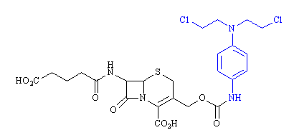
Feedback: The β-lactamase catalyses the opening of the β -lactam ring This results in a concerted mechanism which shifts the double bond in the six membered ring and breaks the bond linking the anticancer drug to the penicillin.
Page reference: 551
a. Carboxypeptidase
*b. β -lactamase
c. Aminopeptidase
d. Esterase

Type: multiple choice question
Title: Chapter 18b Question 100
100) What sort of therapy involves the delivery of a gene into a cancer cell such that the gene codes for an enzyme which can then activate the prodrug of an anticancer drug?
Feedback: ADEPT stands for antibody directed enzyme prodrug therapy and involves the linking of an enzyme to an antibody. The enzyme chosen should activate the prodrug of an anticancer drug administered at a later time.
ADAPT stands for antibody-directed abzyme prodrug therapy where the antibody has an inherent catalytic activity designed to activate the prodrug of an anticancer agent.
GDEPT stands for gene directed enzyme prodrug therapy where the antibody delivers a gene to cancer cells. The gene codes for an enzyme which will activate the prodrug of an anticancer agent.
GDAPT does not exist.
Page reference: 552
a. ADAPT
b. GDAPT
c. ADEPT
*d. GDEPT

Type: multiple choice question
Title: Chapter 18b Question 101
101) The following structure is undergoing clinical trials for the treatment of various cancers:

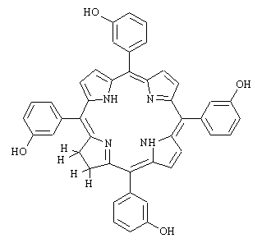

What is the name of the structure?
Feedback: The name of the structure is temoporfin. Haem refers to the cyclic system within the structure of temoporfin. Gemtuzumab is an antibody-drug conjugate. Tretinoin is a peptide drug used as an immunostimulant.
Page reference: 553-554
*a. Temoporfin
b. Haem
c. Gemtuzumab
d. Tretinoin

Type: multiple choice question
Title: Chapter 18b Question 102
102) The following structure is undergoing clinical trials for the treatment of various cancers:

What sort of therapy is involved with this structure?

Feedback: The structure shown is called temoporfin. It is used in photodynamic therapy. The other terms are not used.
Page reference: 553-554
a. Photoactive therapy
b. Photosynthesis therapy
*c. Photodynamic therapy
d. Photochemical therapy

Type: multiple choice question
Title: Chapter 18b Question 103
103) Temoporfin is undergoing clinical trials for the treatment of various cancers:

It is activated using red light. What molecule does it react with?
Feedback: Reaction with molecular oxygen produces singlet oxygen which proves highly toxic to the cell.
Page reference: 553-554
a. Lysine groups on proteins
*b. Molecular oxygen
c. Guanine groups on DNA
d. Water

Type: multiple choice question
Title: Chapter 18b Question 104
104) Temoporfin is undergoing clinical trials for the treatment of various cancers.

What reactive species is formed in this form of therapy?
Feedback: Singlet oxygen proves highly toxic to the cell
Page reference: 553-554
a. Hydroperoxide
b. A hydride ion
*c. Singlet oxygen
d. Triplet oxygen

Type: multiple choice question
Title: Chapter 18b Question 105
105) Temoporfin is undergoing clinical trials for the treatment of various cancers.

What is the most serious disadvantage of the above structure?

Feedback: Photosensitivity arises if the drug can accumulate in the eyes and skin where it is activated by the red light in normal sunlight.
Page reference: 554
a. Lack of solubility
*b. Photosensitivity
c. Metabolic susceptibility
d. Rapid excretion

Type: multiple choice question
Title: Chapter 18b - Question 106
106) Which of the following statements is false regarding the anticancer agent goserelin?
Feedback: Goserelin is a receptor agonist and not an antagonist. The other statements are accurate.
Page reference: 520
*a. It is a receptor antagonist
b. It is used for the treatment of advanced prostate cancer
c. It is a decapeptide
d. It is an analogue of luteinising hormone-releasing hormone

Type: matching question
Title: Chapter 18b - Question 107
107) Identify the following structures:

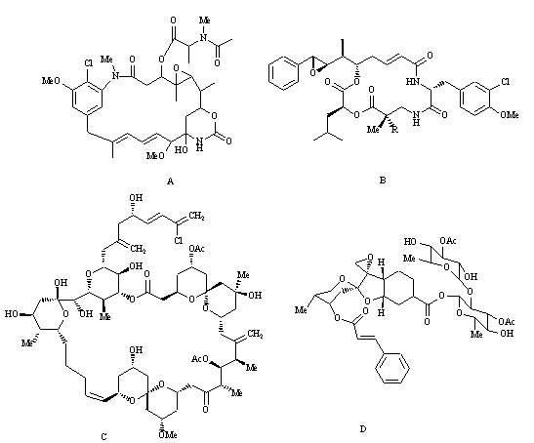
Feedback: : The structure is phyllanthoside. Phyllanthoside is a natural product obtained from the roots of a Costa Rican tree. It has three sugar molecules within its structure. Spongistatin 1 is an example of a spongistatin. These compounds were extracted from marine sources and have a macrocylic ring system containing several sugars. Cryptophycin 1 is an example of a cryptophycin Cryptophycins have been isolated from blue green algae and contain a macrocylic ring involving peptide and ester linkages. Maytansine 1 is another macrocycle which was extracted from an Ethopian shrub and some similarities in structure to the cryptohycins.
Page reference: 523-525
a. Spongistatin 1 = Structure C
b. Cryptophycin 1 = Structure B
c. Phyllanthoside = Structure D
d. Maytansine 1 = Structure A

Type: multiple choice question
Title: Chapter 18b - Question 108
108) What is the mechanism of action for the anticancer agents spongistatin 1, cryptophycin 1, phyllanthoside and maytansine 1?
Feedback: They inhibit tubulin polymerisation by to binding to tubulin.
Page reference: 523-525
a. They inhibit the aromatase enzyme
b. They are alkylating agents
c. They act as antimetabolites
*d. They inhibit tubulin polymerisation

Type: matching question
Title: Chapter 18b - Question 109
109) Identify the following structures.

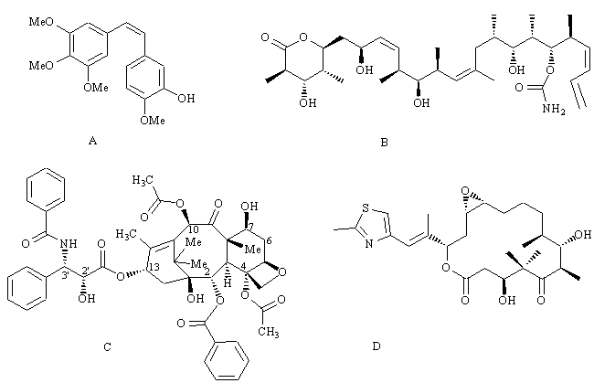
Feedback: Discodermolide is a linear structure containing a six membered lactone. It was isolated from a marine sponge. Epothilone A is a macrocyclic lactone which was isolated from a bacterial source. The combretastatins are relatively simple molecules derived from the African bush willow. Paclitaxel has a complex tetracyclic ring system which includes an oxetane ring. It was obtained from the bark of yew trees.
Page reference: 525-527
a. Discodermolide = Structure B
b. Epothilone A = Structure D
c. Combretastatin A-4 = Structure A
d. Paclitaxel = Structure C

Type: multiple choice question
Title: Chapter 18b - Question 110
110) The following structure is combretastatin A-4. What sort of target is affected by this drug?

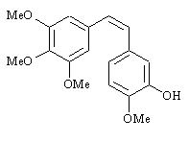

Feedback: The drug inhibits tubulin polymerisation by binding to tubulin.
Page reference: 525
*a. Structural protein
b. Enzyme
c. Receptor
d. DNA

Type: multiple choice question
Title: Chapter 18b - Question 111
111) Which of the following statements is untrue regarding combretastatin A-4?

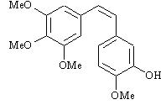

Feedback: The drug inhibits angiogenisis rather than promoting apoptosis.
Page reference: 525
a. The above structure is being tested as a phosphate prodrug in cancer chemotherapy.
*b. It promotes apoptosis.
c. The cis isomer is more active than the trans isomer.
d. It bears a structural similarity to colchicine.

Type: multiple choice question
Title: Chapter 18b - Question 112
112) The following structure is an inhibitor of the enzyme responsible for adding a farnesyl chain to the Ras protein:

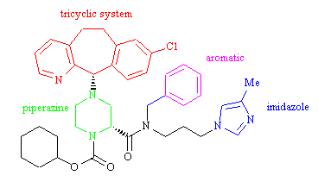
What role is played by the imidazole ring system?

Feedback: The coloured regions shown have the following roles. The imidazole ring is a good ligand for zinc ion cofactors and has been used in several drugs that target zinc metalloenzymes. The aromatic ring was added as a steric shield to protect the molecule from metabolism. The tricyclic system and the piperazine ring play a role in binding the drug to the active site of the enzyme.
Page reference: 528-531
a. It is present to increase water solubility
b. It plays a role in binding the drug to amino acids present in the enzyme's ctive site

c. It is present to protect the molecule from metabolism
*d. It binds to a zinc ion cofactor in the enzyme's active site

Type: multiple choice question
Title: Chapter 18b - Question 113
113) The following structure is an inhibitor of the enzyme responsible for adding a farnesyl chain to the Ras protein:

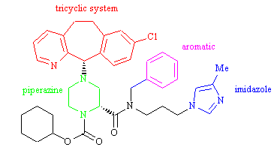
What role is played by the aromatic ring?

Feedback: The coloured regions shown have the following roles. The imidazole ring is a good ligand for zinc ion cofactors and has been used in several drugs that target zinc metalloenzymes. The aromatic ring was added as a steric shield to protect the molecule from metabolism. The tricyclic system and the piperazine ring play a role in binding the drug to the active site of the enzyme.
Page reference: 528-531
a. It fits into a hydrohobic pocket in the enzyme's active site

b. It plays a role in binding the drug to amino acids present in the enzyme's active site
*c. It is present to protect the molecule from metabolism
d. It binds to a zinc ion cofactor in the enzyme's active site

Type: multiple choice question
Title: Chapter 18b - Question 114
114) The following structure is an inhibitor of the enzyme responsible for adding a farnesyl chain to the Ras protein:

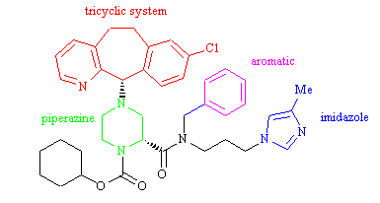

Feedback: The coloured regions shown have the following roles. The imidazole ring is a good ligand for zinc ion cofactors and has been used in several drugs that target zinc metalloenzymes. The aromatic ring was added as a steric shield to protect the molecule from metabolism. The tricyclic system and the piperazine ring play a role in binding the drug to the active site of the enzyme.
Page reference: 528-531
a. It is present to increase water solubility
*b. It plays a role in binding the drug to amino acids present in the enzyme's active site

c. It is present to protect the molecule from metabolism
d. It binds to a zinc ion cofactor in the enzyme's active site

Type: multiple choice question
Title: Chapter 18b - Question 115
115) The following structure is an inhibitor of the enzyme responsible for adding a farnesyl chain to the Ras protein:

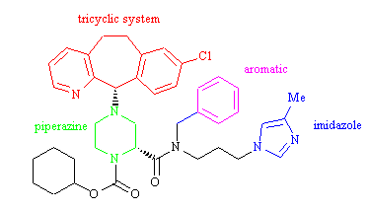
Feedback: Protein kinases are enzymes that catalyse phosphorylation reactions on protein substrates. The amino acid residues that are phosphorylated contain an alcohol or a phenol functional group.
The hydrolysis of phosphate residues is catalysed by phosphorylases. The hydrolysis of peptide bonds is catalysed by peptidases or proteases.
Page reference: 528-531
*a. Protein kinases
b. Peptidases
c. Proteases
d. Phosphorylases

Type: matching question
Title: Chapter 18b - Question 116
116) Identify the following structures:

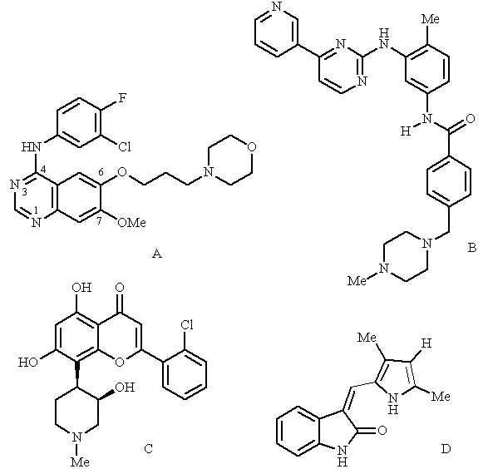
Feedback: The structures are all protein kinase inhibitors for different targets. Flavopiridol contains a benzopyran ring system and inhibits cyclin dependent kinases. Gefitinib (Iressa) is a 4-anilinoquinazoline which inhibits the kinase active site of the epidermal growth fctor receptor. SU5416 contains an oxindole ring system and targets the kinas active site of the vascular endothelial growth factor receptor. Imatinib (Glivec) contains a phenylaminopyrimidine moiety and targets the Abelson tyrosine kinase.
Page reference: 533-540
a. Flavopiridol = Structure C
b. Gefitinib = Structure A
c. SU5416 = Structure D
d. Imatinib = Structure B

Type: matching question
Title: Chapter 18b Question 117
117) Identify the targets for the following structures

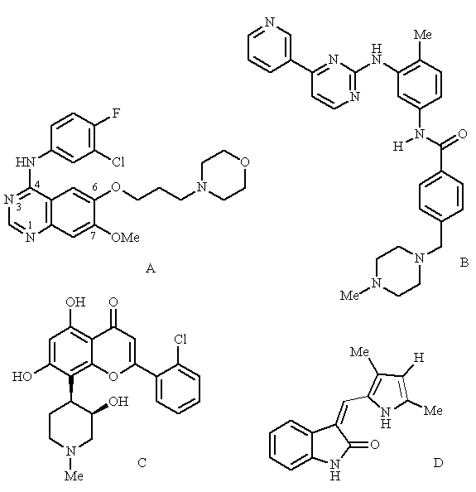

Feedback: The structures shown are gefitinab, imatinib, flavopiridol and SU5416. They all target the kinase active site of the targets described.
Page reference: 533-540
a. Cyclin-dependent kinase = Structure C
b. Epidermal growth factor receptor = Structure A
c. Vascular endothelial growth factor receptor = Structure D
d. Abelson tyrosine kinase = Structure B

Type: multiple choice question
Title: Chapter 18b Question 118
118) What sort of targets do the following structures interact with?
Feedback: The structures shown are gefitinab, imatinib, flavopiridol and SU5416. They all
interact with the kinase active site of various protein kinases.
Page reference: 533-540
a. G-protein coupled receptors
*b. Protein kinases
c. DNA
d. Ribosomes

Type: multiple choice question
Title: Chapter 18b Question 119
119) All the following structures are enzyme inhibitors which mimic the same molecule. Which molecule?

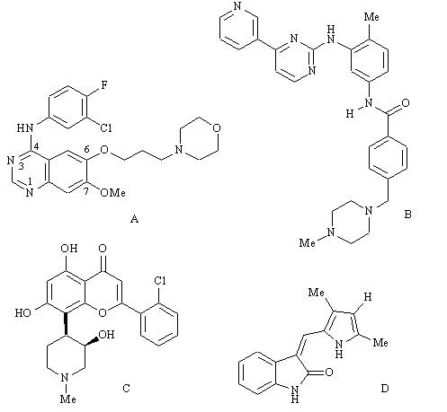
Feedback: The structures shown are gefitinab, imatinib, flavopiridol and SU5416. They all bind to the ATP binding region of different protein kinases.
Page reference: 533-540
a. Tyrosine
*b. ATP
c. A protein substrate
d. Serine

Type: multiple choice question
Title: Chapter 18b Question 120
120) The following diagram shows a model ATP binding site for Abelson tyrsoine kinase.

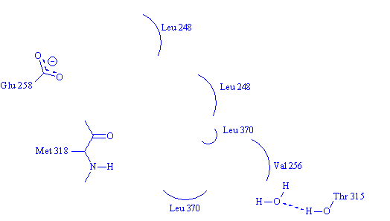
The anticancer agent imatinib binds to this site. One of the nitrogen atoms indicated below is protonated and forms an ionic interaction with glutamate 258. Which one?

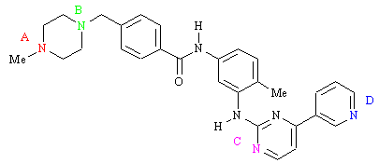
Feedback: Nitrogen atom (A) is protonated and forms an ionic interaction with Glu-258. Nitrogen atom B plays no binding role. Nitrogen atom C acts as a hydrogen bond acceptor and interacts with Met-318. Nitrogen atom D acts as a hydrogen bond acceptor and interacts with a water molecule which acts as a hydrogen bonding bridge to Thr-315.
Page reference: 537
*a. atom A
b. atom B
c. atom C
d. atom D

Type: multiple choice question
Title: Chapter 18b Question 121
121) The following diagram shows a model ATP binding site for Abelson tyrsoine kinase.

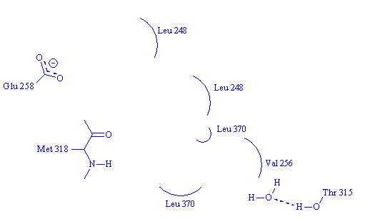
The anticancer agent imatinib binds to this site. One of the nitrogen atoms indicated below forms a hydrogen bond to a water molecule which acts as a bridge to Thr-315. Which one?

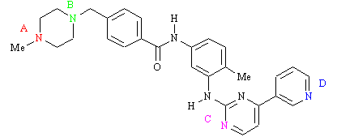
Feedback: Nitrogen atom (A) is protonated and forms an ionic interaction with Glu-258. Nitrogen atom B plays no binding role. Nitrogen atom C acts as a hydrogen bond acceptor and interacts with Met-318. Nitrogen atom D acts as a hydrogen bond acceptor and interacts with a water molecule which acts as a hydrogen bonding bridge to Thr-315.
Page reference: 537
a. Atom A
b. Atom B
c. Atom C
*d. Atom D

Type: multiple choice question
Title: Chapter 18b Question 122
122) The following diagram shows a model ATP binding site for Abelson tyrsoine kinase.

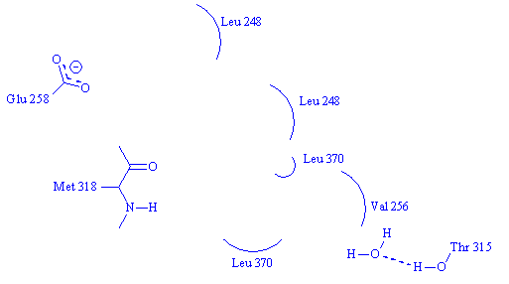

The anticancer agent imatinib binds to this site. One of the nitrogen atoms indicated below forms a hydrogen bond to Met-318. Which one?

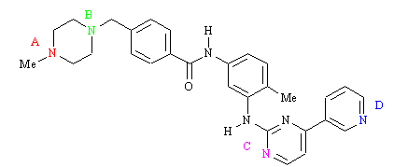

Feedback: Nitrogen atom (A) is protonated and forms an ionic interaction with Glu-258. Nitrogen atom B plays no binding role. Nitrogen atom C acts as a hydrogen bond acceptor and interacts with Met-318. Nitrogen atom D acts as a hydrogen bond
acceptor and interacts with a water molecule which acts as a hydrogen bonding bridge to Thr-315.
Page reference: 537
a. Atom A
b. Atom B
*c. Atom C
d. Atom D

Type: multiple choice question
Title: Chapter 18b Question 123
123) The following diagram shows a model ATP binding site for Abelson tyrsoine kinase

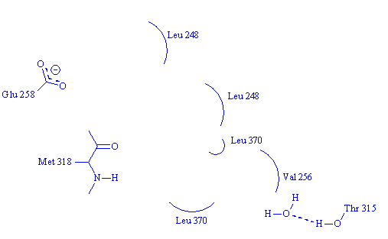

The anticancer agent imatinib binds to this site. One of the groups indicated below interacts with Met-318. Which one?

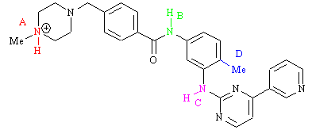
Feedback:. Nitrogen atom A is protonated and forms an ionic interaction with Glu-258.
Nitrogen atom B plays no binding role.
Nitrogen atom C acts as a hydrogen bond donor and interacts with Met-318
Nitrogen atom D acts as a conformational blocker.
Page reference: 537
a. Group A
b. Group B
*c. Group C
d. Group D

Type: multiple choice question
Title: Chapter 18b Question 124
124) The following diagram shows a model ATP binding site for Abelson tyrsoine kinase.

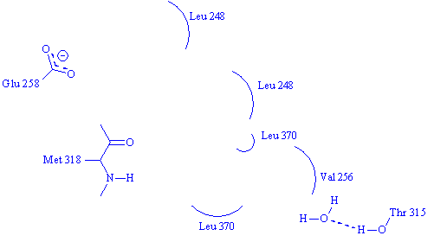

The anticancer agent imatinib binds to this site. One of the groups indicated below acts as a conformational blocker. Which one?

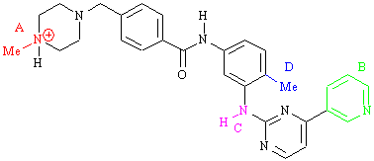
Feedback: Introduction of this methyl group results in selectivity for tyrosine kinases over serine-threonine kinases.
Page reference: 536-537
a. Group A
b. Group B
c. Group C
*d. Group D

Type: multiple choice question
Title: Chapter 18b Question 125
125) Which of the following features is not present in peptide based inhibitors of collagenase enzymes?
Feedback: It is a zinc ion cofactor that is involved
Page reference: 540-541
a. Replacement of the susceptible peptide bond with a moiety which is stable to hydrolysis.
b. One or more substituents that can fit into the enzyme subsites and form van der Waals interactions
c. At least one functional group capable of forming a H-bond to the enzyme backbone.
*d. A group capable of strong interactions with a magnesium ion cofactor.

Type: matching question
Title: Chapter 18b Question 126
126) Identify the following structures:

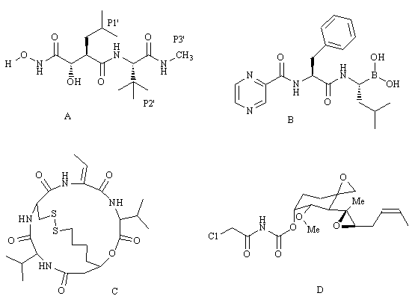
Feedback: The structure of TNP-470 includes two epoxide rings. It inhibits methionine aminopeptidase. Marimastat has a peptide structure and acts as a matrix metalloproteinase inhibitor. Bortezomib contains a boronic acid group and is a proteasome inhibitor. Depsipeptide is macrocyclic structure which promotes apoptosis and inhibits cell proliferation and angiogenesis by acting as a histone deacetylase inhibitor.
Page reference: 541-544
a. TNP-470 = Structure D
b. marimastat = Structure A
c. bortezomib = Structure B
d. depsipeptide = Structure C

Type: matching question
Title: Chapter 18b Question 127
127) What are the targets for the following structures?

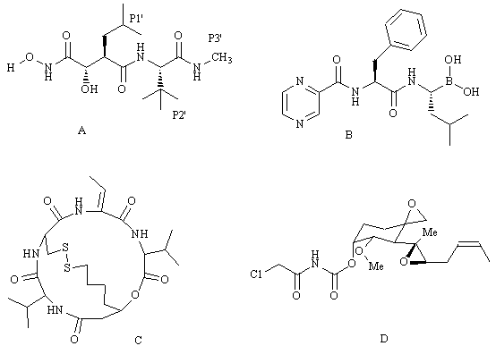

Feedback: Structures A-D are marimastat, bortezomib, depsipeptide and TNP-470
respectively. The structure of TNP-470 includes two epoxide rings. It inhibits methionine aminopeptidase. Marimastat has a peptide structure and acts as a matrix metalloproteinase inhibitor. Bortezomib contains a boronic acid group and is a proteasome inhibitor. Depsipeptide is macrocyclic structure which promotes apoptosis and inhibits cell proliferation and angiogenesis by acting as a histone deacetylase inhibitor.
Page reference: 541-544
a. Methionine aminopeptidase = Structure D
b. Matrix metalloproteinase = Structure A
c. The proteosome = Structure B
d. Histone deacetylase = Structure C

Type: multiple choice question
Title: Chapter 18b Question 128
128) The following structure is a matrix metalloproteinase inhibitor called marimastat that has undergone clinical trials for the treatment of breast and prostate cancers. Which group binds to the zinc ion cofactor of the enzyme?

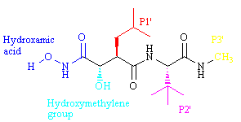

Feedback: The two oxygen atoms of the hydroxamic acid group interact with the zinc ion cofactor. The hydroxymethylene group is a transition state isostere. The side chain P1’ binds to the binding pocket S1’. The tertiary butyl group (P2’) acts as a steric shield
Page reference: 541-542
*a. The hydroxamic acid
b. The hydroxymethylene group
c. The side chain P1'
d. The side chain P2'

Type: multiple choice question
Title: Chapter 18b Question 129
129) The following structure is a matrix metalloproteinase inhibitor called marimastat that has undergone clinical trials for the treatment of breast and prostate cancers. Which group binds to the S1’ binding sub pocket in the active site by van der Waals interactions.

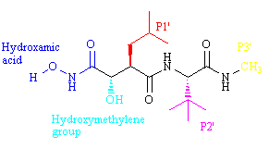

Feedback: The two oxygen atoms of the hydroxamic acid group interact with the zinc ion cofactor. The hydroxymethylene group is a transition state isostere. The side chain P1’ binds to the binding pocket S1’. The tertiary butyl group (P2’) acts as a steric shield.
Page reference: 541-542
a. The hydroxamic acid
b. The hydroxymethylene group
*c. The side chain P1'
d. The side chain P2'

Type: multiple choice question
Title: Chapter 18b Question 130
130) The following structure is a matrix metalloproteinase inhibitor called marimastat that has undergone clinical trials for the treatment of breast and prostate cancers. What role does the group P2' have?

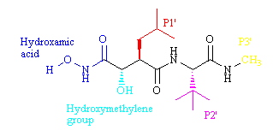
Feedback: The tertiary butyl group at P2' acts as a steric shield to protect peptide bonds from hydrolysis. It also hinders solvation of the peptide bonds such that energy is not expended desolvating these groups prior to binding.
Page reference: 541-542
a. It binds to the zinc cofactor
b. It is a conformational blocker
c. It fits a hydrophobic binding pocket
*d. It acts as a steric shield

Type: multiple choice question
Title: Chapter 18b - Question 131
131) The following structure is a matrix metalloproteinase inhibitor called marimastat that has undergone clinical trials for the treatment of breast and prostate cancers. What role does the hydroxymethylene group have?

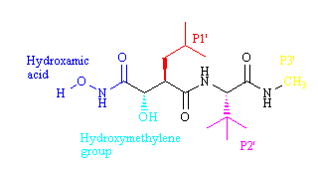

Feedback: The hydroxymethylene group is a stable transition state isostere. The hydroxyl group is also beneficial to inhibitory activity and aqueous solubility.
Page reference: 541-542
a. It binds to the zinc cofactor
b. It is a conformational blocker
c. It fits a hydrophobic binding pocket
*d. It acts as a stable transition state isostere

Type: multiple choice question
Title: Chapter 18b - Question 132
132) Bortezomib is a dipeptide that has been approved for the treatment of multiple myeloma.

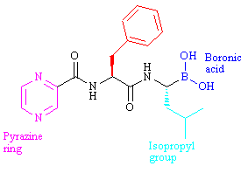
The boronic acid group is thought to form an important interaction with a specific amino acid in the enzyme target's active site. Which amino acid is involved in this interaction?

Feedback: It is thought that a boron-threonine bond is formed at the active site.
Page reference: 543
*a. Threonine
b. Serine
c. Tyrosine
d. Aspartic acid

Type: matching question
Title: Chapter 18b - Question 133
133) Identify the following structures.

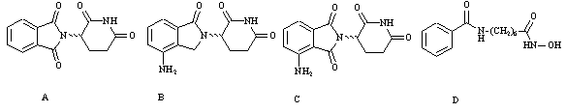
Feedback: Thalidomide is a synthetic product with a range of activities. Revamid and actimid are more recent analogues of thalidomide. Suberoylanilide hydroxamic acid is a synthetic agent that acts as an inhibitor for histone deacetylase.
Page reference: 544-545
a. Revamid = Structure B
b. Suberoylanilide hydroxamic acid = Structure D
c. Actimid = Structure C
d. Thalidomide = Structure A

Type: multiple choice question
Title: Chapter 18b - Question 134
134) Which of the following structures is not an immunomodulator?

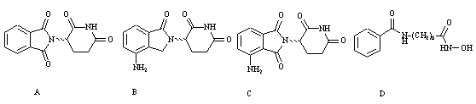

Feedback: Structures A-C are thalidomide, revamid and actimid respectively. They all have immunomodulatory properities. Suberoylanilide hydroxamic acid is a synthetic agent that acts as an inhibitor for histone deacetylase.
Page reference: 544-545
a. Structure A
b. Structure B
c. Structure C
*d. Structure D

Type: multiple choice question
Title: Chapter 18b - Question 135
135) Thalidomide entered phase III clinical trials as a treatment for renal cancer and multiple myeloma. Revamid and actimid are thalidomide analogues which have a primary amino group added to the aromatic ring. What advantage does this group offer?
Feedback: The presence of a primary amino group may well increase water solubility, but the main advantage in its presence is a reduction in drug toxicity. Using an amino group as a metabolic blocker is not a good idea since the group is susceptible to metabolism itself.
Page reference: 544-545
a. It allows an extra binding interaction and increases activity
b. It increases water solubility
*c. It reduces toxicity
d. It blocks metabolism at that position

Type: matching question
Title: Chapter 18b - Question 136
136) Identify the following structures:

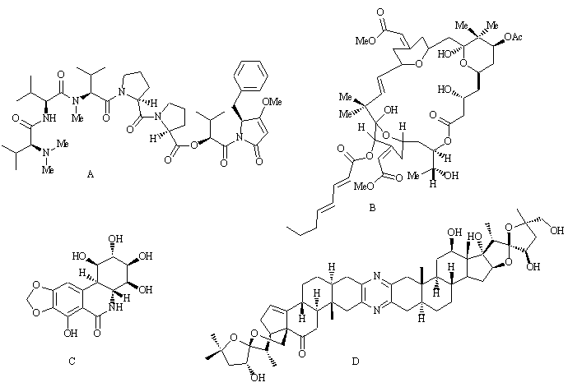
Feedback: Pancratistatin is a natural product isolated from a plant. Cephalostatin 1 was isolated from a marine worm. Bryostatin 1 was isolated from a marine invertebrate animal. Dolostatin 15 was isolated from the sea hare.
Page reference: 545-547
a. Pancratistatin = Structure C
b. Cephalostatin 1 = Structure D
c. Bryostatin 1 = Structure B
d. Dolostatin 15 = Structure A

Type: multiple choice question
Title: Chapter 18b - Question 137
137) How were the structures pancratistatin, cephalostatin 1, bryostatin 1 and
dolostatin 15 all discovered?
Feedback: All the structures mentioned were derived from natural sources. They have relatively complex structures and / or several asymmetric centres. As a result, they would be difficult to obtain by combinatorial or traditional synthesis. Computer aided drug design would also be aiming to come up with structures that had a straightforward synthesis.
Page reference: 545-547
a. By combinatorial synthesis
*b. From natural sources
c. From computer aided drug design
d. By conventional synthesis

Type: multiple choice question
Title: Chapter 18b - Question 138
138) Which of the following compounds boosts the immune system and makes it more effective against cancers?
Feedback: Bryostatin 1 was isolated from a marine invertebrate animal.
Page reference: 545
a. Pancratistatin
b. Cephalostatin 1
*c. Bryostatin 1
d. Dolostatin 15

Type: multiple choice question
Title: Chapter 18b - Question 139
139) Crisantaspase is used as an anticancer agent in the treatment of leukemia. Which of the following statements is false?
Feedback: Crisantaspase is a preparation of the asparaginase enzyme which catalyses the breakdown of asparagine such that the cancer cells are starved of this amino acid. However, it is only effective against cancer cells that are unable to synthesise their own asparagine. Therefore, not all leukaemia cells are susceptible.
Page reference: 546
a. Crisantaspase is a preparation of the asparaginase enzyme.
b. The asparaginase enzyme catalyses the breakdown of the amino acid asparagine.
*c. The agent is effective against all leukaemias.
d. Leukaemia cells starved of the amino acid asparagine will be killed.

Type: multiple choice question
Title: Chapter 18b - Question 140
140) Which of the following statements is true regarding antibody-drug conjugates?
Feedback: Part of the structure of chimeric antibodies is derived from mice antibodies and so chimeric antibodies can still induce an immune response. The antibody should be humanised to reduce the risks of an immune response.
The antigen that is recognised on the cancer cell should be overexpressed. Antigens on cancer cells are usually likely to be present on normal cells as well, but in smaller quantities.
The antibody-drug complex is incapable of dissolving through the cell membrane. The conjugates are taken into the cell by receptor-mediated endocytosis.
It is important that the bond between drug and antibody is stable when the complex circulates in the blood supply due to the toxicity of the drugs which have to be used in this therapy. The bond should only become unstable when it has entered the target cell.
Page reference: 548
a. Chimeric antibodies should be used since they do not induce an immune response.
*b. The antibody is chosen such that it recognises an antigen that is overexpressed on cancer cells.
c. The antibody-drug conjugate should be capable of dissolving through the cell membrane.
d. The link between the antibody and the drug should be unstable.

Type: multiple choice question
Title: Chapter 18b - Question 141
141) What is meant by ADEPT?
a. It involves administration of an antibody which has an inherent catalytic activity designed to activate the prodrug of an anticancer agent.
Feedback: incorrect. This describes the procedure known as ADAPT (antibody-directed abzyme prodrug therapy) where the antibody has an inherent catalytic activity designed to activate the prodrug of an anticancer agent.
Page reference: 550-552
b. It involves the administration of an antibody linked to an anticancer drug.
Feedback: Incorrrect. This describes the use of antibody-drug conjugates.
Page reference: 550-552
*c. It involves administration of an antibody linked to an enzyme, such that the enzyme activates a prodrug.
Feedback: Correct. This describes the procedure known as ADEPT (antibody directed enzyme prodrug therapy) and involves the linking of an enzyme to an antibody. The enzyme chosen should activate the prodrug of an anticancer drug administered at a later time.
Page reference: 550-552
d. It involves the delivery of a gene into a cancer cell such that the gene codes for an enzyme which can then activate the prodrug of an anticancer drug.
Feedback: incorrect. This describes a procedure known as GDEPT (gene directed enzyme prodrug therapy) where the antibody delivers a gene to cancer cells. The gene codes for an enzyme which will activate the prodrug of an anticancer agent.
Page reference: 550-552

Type: multiple choice question
Title: Chapter 18b - Question 142
142) What is meant by GDEPT?
a. It involves administration of an antibody which has an inherent catalytic activity designed to activate the prodrug of an anticancer agent.
Feedback: incorrect. This describes the procedure known as ADAPT (antibody-directed abzyme prodrug therapy) where the antibody has an inherent catalytic activity designed to activate the prodrug of an anticancer agent.
Page reference: 552-553
b. It involves the administration of an antibody linked to an anticancer drug.
Feedback: Incorrrect. This describes the use of antibody-drug conjugates.
Page reference: 552-553
c. It involves administration of an antibody linked to an enzyme, such that the enzyme activates a prodrug.
Feedback: incorrect. This describes the procedure known as ADEPT (antibody directed enzyme prodrug therapy) and involves the linking of an enzyme to an antibody. The enzyme chosen should activate the prodrug of an anticancer drug administered at a later time.
Page reference: 552-553
*d. It involves the delivery of a gene into a cancer cell such that the gene codes for an enzyme which can then activate the prodrug of an anticancer drug.
Feedback: Correct. This describes a procedure known as GDEPT (gene directed enzyme prodrug therapy) where the antibody delivers a gene to cancer cells. The gene codes for an enzyme which will activate the prodrug of an anticancer agent.
Page reference: 552-553

Type: matching question
Title: Chapter 18b - Question 143
143
) The following synthetic route has been used to produce gefitinib (I). What are the reagents (i) – (iv)?

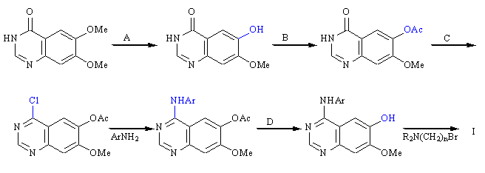

Feedback: Treatment with methionine and methane sulfonic acid demethylates one of the methoxy substituents and reveals a phenol group which can be protected with an acetyl group using pyridine / acetic anhydride. Treatment with thionyl chloride converts the lactam group to an imino chloride which is susceptible to nucleophilic substitution with aromatic amines. The acetyl protecting group is removed with methanol and ammonium hydroxide.
Page reference: 535
a. (i) = Methionine / methanesulfonic acid
b. (ii) = Pyridine / acetic anhydride
c. (iii) = Thionyl chloride
d. (iv) = Methanol / ammonium hydroxide

