Chapter 18: Anticancer agents (Part A)

Type: multiple choice question
Title: Chapter 18a Question 01
01) What term is used to indicate the birth of a cancer?
Feedback: Carcinogenesis refers to the birth of a cancer. Apoptosis refers to the process by which cells 'commit suicide'. Metastasis refers to the spread of a cancer to different parts of the body and the appearance of secondary tumours. Mutagenesis refers to the promotion of mutations in a cell's DNA.
Page reference: 489
*a. Carcinogenesis
b. Apoptosis
c. Metastasis
d. Mutagenesis

Type: multiple choice question
Title: Chapter 18a Question 02
02) What term is used to indicate the process by which a cell commits suicide?
Feedback: Carcinogenesis refers to the birth of a cancer. Apoptosis refers to the process by which cells 'commit suicide'. Metastasis refers to the spread of a cancer to different parts of the body and the appearance of secondary tumours. Mutagenesis refers to the promotion of mutations in a cell's DNA.
Page reference: 490
a. Carcinogenesis
*b. Apoptosis
c. Metastasis
d. Mutagenesis

Type: multiple choice question
Title: Chapter 18a Question 03
03) What is the term given to a gene which has become mutated and which codes for an abnormal protein that is implicated in the development of cancer?
Feedback: An oncogene is a gene which has become mutated and which codes for an abnormal protein that is implicated in cancer. A proto-oncogene is the normal form of that gene. The terms pre-oncogene and mutogene do not exist.
Page reference: 490
a. Pre-oncogene
b. Proto-oncogene
*c. Oncogene
d. Mutogene

Type: multiple choice question
Title: Chapter 18a Question 04
04) Which of the following is a protein that is involved in the processes of cellular checking, repair and suicide?
Feedback: The p53 protein plays a crucial role in apoptosis. The platelet-derived growth factor and the transforming growth factor are hormones which act as agonists for receptors. Cyclin dependent kinase is an enzyme that is involved in control of the cell cycle.
Page reference: 490
a. Platelet-derived growth factor
b. Transforming growth factor
c. Cyclin dependent kinase
*d. p53

Type: multiple choice question
Title: Chapter 18a Question 05
05) Which of the following could contribute to the development of a tumour?
Feedback: There are many checks and balances within a cell and it usually requires several abnormal mechanisms to occur before a cell becomes cancerous.
Page reference: 490
a. Abnormal signalling pathways
b. Abnormality in the cell cycle regulation
c. Evasion of programmed cell death
*d. All of the answers are correct

Type: multiple choice question
Title: Chapter 18a Question 06
06) Which of the following is involved in cell signal transduction pathways and can lead to cancer when it is in an abnormal form?
Feedback: Increased levels of normal transforming growth factor α can result in defective signalling pathways and lead to cancer. Abnormal ras protein can become permanently active, and lead to cancer by constantly activating the cell signalling pathways. Cyclins and cyclin dependent kinases are involved in the regulation of the cell cycle rather than signalling pathways. They too play a role in the birth of cancers if they are abnormal.
Page reference: 490
a. Transforming growth factor α
b. Cyclins
*c. The ras protein
d. Cyclin dependent kinases

Type: multiple choice question
Title: Chapter 18a Question 07
07) Which of the following is involved in regulation of the cell cycle?
Feedback: Cyclins activate cyclin dependent kinases which allow the cell to move from one phase of the cell cycle to another.
Granzyme is an enzyme that is injected into damaged cells from lymphocytes and induces apoptosis. Cytochrome c is released from mitochondria within cells and triggers the process that activates caspases: enzymes which destroy proteins. Platelet-derived growth factor is a hormone that acts as a receptor agonist.
Page reference: 492
*a. Cyclins and cyclin dependent kinases
b. Granzyme
c. Cytochrome c
d. Platelet-derived growth factor

Type: multiple choice question
Title: Chapter 18a Question 08
08) Which of the following enzymes are responsible for protein degradation during apoptosis?
Feedback: Telomerases are responsible for constructing the telomeres or 'tails' at the end of chromosomes. Caspases are responsible for protein degradation during apoptosis. Matrix metalloproteinases are responsible for breaking down the basement membranes around blood vessels to allow angiogenesis. Cyclin dependent kinases control the cell cycle.
Page reference: 493-494
a. Telomerases
*b. Caspases
c. Matrix metalloproteinases
d. Cyclin dependent kinases

Type: multiple choice question
Title: Chapter 18a Question 09
09) What is the name of the structure at the end of chromosomes which is crucial to the immortalisation of cancer cells?
Feedback: The centromere is in the middle of the chromosome. Telomeres are at the ends. The protein matrix and histones are proteins that are associated with the DNA of the chromosome.
Page reference: 494-495
a. Centromere
*b. Telomere
c. Protein matrix
d. Histones

Type: multiple choice question
Title: Chapter 18a Question 10
10) Which of the following induces metastasis?
Feedback: VEGF and FGF-2 stimulate the process of angiogenesis. Angiostatin inhibits it. Interleukin-6 is released from new blood vessels and promotes metastasis.
Page reference: 496-497
a. VEGF
b. FGF-2
c. Angiostatin
*d. Interleukin-6

Type: multiple choice question
Title: Chapter 18a Question 11
11) Which group of enzymes is responsible for breaking down the basement membranes round blood vessels prior to angiogenesis?
Feedback: Cyclin dependent kinases control the cell cycle. Matrix metalloproteinases are responsible for breaking down the basement membranes around blood vessels to allow angiogenesis. Telomerases are responsible for constructing the telomeres or 'tails' ate the end of chromosomes. Caspases are responsible for protein degradation during apoptosis.
Page reference: 496-497
a. Cyclin dependent kinases
*b. Matrix metalloproteinases
c. Telomerases
d. Caspases

Type: multiple choice question
Title: Chapter 18a Question 12
12) Which of the following is the most effective treatment of cancers?
Feedback: Cancer is a complex disease which takes many forms. There is no single treatment that works on its own.
Page reference: 497-498
a. Surgery
b. Radiotherapy
c. Chemotherapy
*d. A combination of all the answers

Type: multiple choice question
Title: Chapter 18a Question 13
13) Which of the following is responsible for the resistance shown by some cancer cells to anticancer drugs?
Feedback: The P-glycoprotein is capable of expelling drugs from cancer cells. Integrins are involved in anchoring cells to an extracellular matrix. The p53 protein plays an important role in cell monitoring and apoptosis. Cyclins are proteins that activate cyclin dependent kinases involved in the control of the cell cycle.
Page reference: 499
a. Integrins
b. P53 protein
*c. P-glycoprotein
d. Cyclins

Type: multiple choice question
Title: Chapter 18a Question 14
14) What is the term used for the nitrogen mustard anticancer agents?
Feedback: Alkylating agents are drugs which have a good leaving group and which can form a strong covalent bond to their target. Chain cutting agents usually bind to DNA and generate radical species which result in the cutting of the DNA chain. Antimetabolites act on cellular enzymes that catalyse important metabolic reactions within the cell. Intercalating agents are agents that can bind to DNA and insert planar regions of their skeleton between the base pairs of DNA.
Page reference: 505-506
*a. Alkylating agents
b. Chain cutting agents
c. Antimetabolites
d. Intercalating agents

Type: multiple choice question
Title: Chapter 18a Question 15
15) What is the term used for the anticancer agent cyclophosphamide?
Feedback: Alkylating agents are drugs which have a good leaving group and which can form a strong covalent bond to their target. Chain cutting agents usually bind to DNA and generate radical species which result in the cutting of the DNA chain. Antimetabolites act on cellular enzymes that catalyse important metabolic reactions within the cell. Intercalating agents are agents that can bind to DNA and insert planar regions of their skeleton between the base pairs of DNA.
Page reference: 508
*a. Alkylating agent
b. Chain cutting agent
c. Antimetabolite
d. Intercalating agent

Type: multiple choice question
Title: Chapter 18a Question 16
16) What is the term used for the anticancer agent methotrexate?
Feedback: Alkylating agents are drugs which have a good leaving group and which can form a strong covalent bond to their target. Chain cutting agents usually bind to DNA and generate radical species which result in the cutting of the DNA chain. Antimetabolites act on cellular enzymes that catalyse important metabolic reactions within the cell. Intercalating agents are agents that can bind to DNA and insert planar regions of their skeleton between the base pairs of DNA.
Page reference: 514-515
a. Alkylating agent
b. Chain cutting agent
*c. Antimetabolite
d. Intercalating agent

Type: multiple choice question
Title: Chapter 18a Question 17
17) What is the term used for the cisplatin group of anticancer agents?
Feedback: Alkylating agents are drugs which have a good leaving group and which can form a strong covalent bond to their target. Chain cutting agents usually bind to DNA and generate radical species which result in the cutting of the DNA chain. Antimetabolites act on cellular enzymes that catalyse important metabolic reactions within the cell. Intercalating agents are agents that can bind to DNA and insert planar regions of their skeleton between the base pairs of DNA.
Page reference: 505, 509
*a. Alkylating agents
b. Chain cutting agents
c. Antimetabolites
d. Intercalating agents

Type: multiple choice question
Title: Chapter 18a Question 18
18) Dactinomycin is an intercalating anticancer agent.

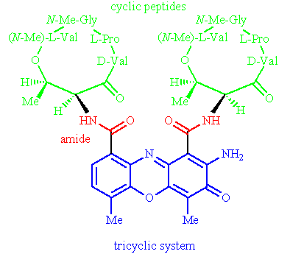
Which region of the molecule is crucial to intercalation?
Feedback: The tricyclic system is planar and can fit between the base pairs of DNA.
Page reference: 500
a. The cyclic peptides
b. The amide groups
*c. The tricyclic system
d. All of the regions

Type: multiple choice question
Title: Chapter 18a Question 19
19) Dactinomycin is an intercalating anticancer agent.

Interactions with particular base pairs are favoured in the intercalation of this compound. Which base pairs are favoured?
Feedback: Note that adenine-uracil and thymine-guanine are not possible. First, uracil is present in RNA and not DNA. Second, thymine base pairs with adenine and not guanine. Similarly, guanine base pairs with cytosine and not thymine.
Page reference: 500
*a. cytosine-guanine
b. adenine-thymine
c. adenine-uracil
d. thymine-guanine

Type: multiple choice question
Title: Chapter 18a Question 20
20) Dactinomycin is an intercalating anticancer agent.

Which region of the molecule interacts with the sugar phosphate backbone of DNA?
Feedback: The cyclic peptides have polar functional groups which can interact with the polar phosphate groups of the sugar phosphate chain.
Page reference: 500
*a. The cyclic peptides
b. The amide groups
c. The tricyclic system
d. All of the answers are correct

Type: multiple choice question
Title: Chapter 18a Question 21
21) The following group of structures are intercalating anticancer agents.

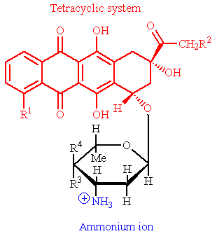
To which family of compounds do these structures belong?
Feedback: The anthracyclines contain a tetracyclic ring system where all the rings are six membered. There is also a sugar substituent. The bleomycins are glycoproteins which include a bithiazole ring system. The podophyllotoxins have a tetracyclic ring system involving two five-membered rings and two six-membered rings. The camptothecinshave a pentacyclic ring system involving four six-membered ring and one five-membered ring.
Page reference: 500
a. Podophyllotoxins
b. Camptothecins
*c. Anthracyclines
d. Bleomycins

Type: multiple choice question
Title: Chapter 18a Question 22
22) The following group of structures are intercalating anticancer agents.

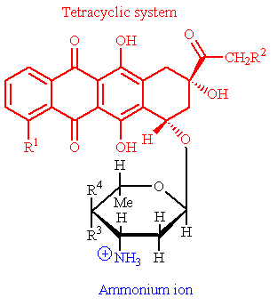
How many rings of the tetracyclic system are involved in intercalation?
Feedback:
The three 'left hand' rings are planar and are involved in the intercalation mechanism.
Page reference: 500-501
a. 1
b. 2
*c. 3
d. 4

Type: multiple choice question
Title: Chapter 18a Question 23
23) The following group of structures are intercalating anticancer agents.

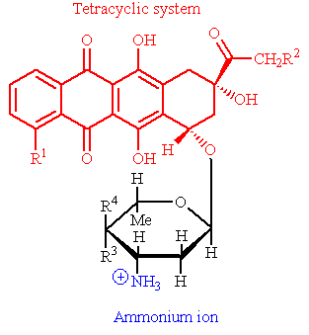
What role does the ammonium ion play in the molecule's mode of action?
Feedback: The ammonium ion is positively charged and the phosphate ion on the DNA backbone is negatively charged and so a strong ionic bond can be formed between the two groups which helps to lock the molecule in position.
Page reference: 500-501
a. It makes the molecule water soluble.
b. It prevents the molecule crossing cell membranes.
c. It forms a hydrogen bond to a deoxyribose sugar moiety on the DNA backbone.
*d. It forms an ionic bond to a phosphate group on the DNA backbone.

Type: multiple choice question
Title: Chapter 18a Question 24
24) What enzyme is involved in relieving the tension created in DNA when the DNA double helix is unravelled?
Feedback: Telomerase catalyses the formation of telomeres at the end of chromosomes. DNA polymerase catalyses the synthesis of DNA. Helicase catalyses the unwinding of the DNA double helix. Topoisomerases are enzymes which relieve the tension created by the unwinding or unravelling of DNA.
Page reference: 501
a. Telomerase
b. DNA polymerase
c. Helicase
*d. Topoisomerase II

Type: multiple choice question
Title: Chapter 18a Question 25
25) Which of the following drugs inhibits topoisomerase II?
Feedback: Daunorubicin is an intercalating agent which inhibits topoisomerase II. The other structures are alkylating agents.
Page reference: 500-501
a. Uracil mustard
*b. Daunorubicin
c. Cyclophosphamide
d. Cisplatin

Type: multiple choice question
Title: Chapter 18a Question 26
26) Which amino acid in the enzyme topoisomerase II is responsible for cleaving a phosphate-sugar link in a DNA strand?
Feedback: Tyrosine contains a phenolic group which forms a bond to a phosphate group on the DNA backbone, resulting in cleavage of a phosphate-sugar bond in the DNA backbone.
Page reference: 501
*a. Tyrosine
b. Threonine
c. Serine
d. Cysteine

Type: multiple choice question
Title: Chapter 18a Question 27
27) The following is representative of a group of natural products which are intercalating anticancer agents.

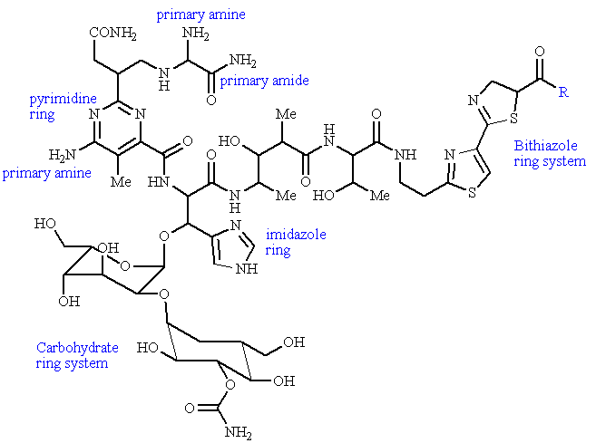
What are these group of compounds called?
Feedback: The anthracyclines contain a tetracyclic ring system where all the ring are six membered. There is also a sugar substituent. The bleomycins are glycoproteins which include a bithiazole ring system. The podophyllotoxins have a tetracyclic ring system involving two five-membered rings and two six-membered rings. The camptothecins have a pentacyclic ring system involving four six-membered ring and one five-membered ring.
Page reference: 503
a. Podophyllotoxins
b. Camptothecins
c. Anthracyclines
*d. Bleomycins

Type: multiple choice question
Title: Chapter 18a Question 28
28) Bleomycins are natural products which are intercalating anticancer agents.

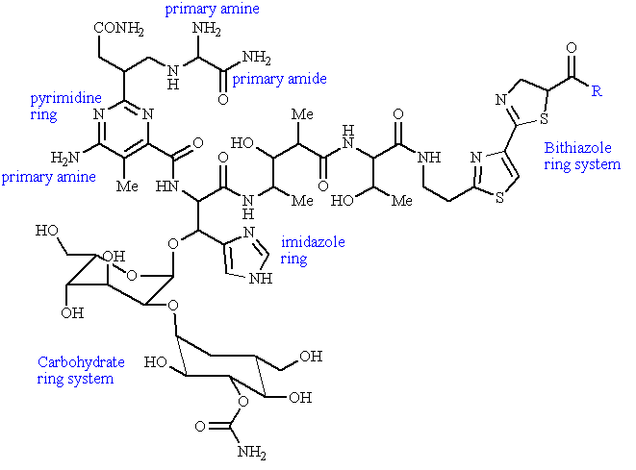

Which region of the molecule is involved in intercalation?
Feedback: The bithiazole ring system is involved in intercalation. The carbohydrate ring system is too bulky to act as an intercalating unit. The pyrimidine and imidazole rings are important in chelating a ferrous ion and the mechanism of action.
Page reference: 503
a. The carbohydrate ring system
b. The pyrimidine ring
c. The imidazole ring
*d. The bithiazole ring system

Type: multiple choice question
Title: Chapter 18a Question 29
29) Bleomycins are natural products which are intercalating anticancer agents.

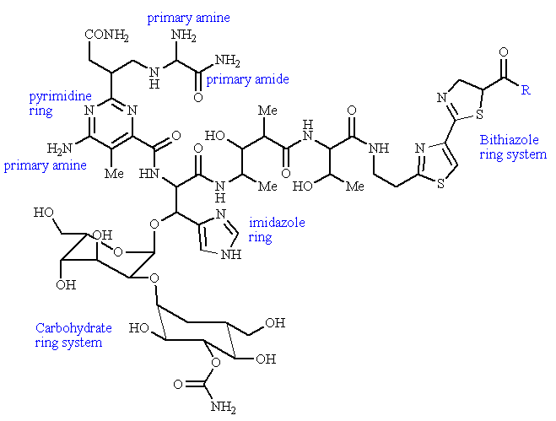
They chelate a ferrous ion as part of their mechanism of action. Which region of the molecule is important in chelating ions?
Feedback: The nitrogen atoms present in all three groups are involved in chelating the ferrous ion.
Page reference: 503
a. The pyrimidine ring
b. The imidazole ring
c. The primary amine groups
*d. All of the answers are correct

Type: multiple choice question
Title: Chapter 18a Question 30
30) The following structure is used as an anticancer agent

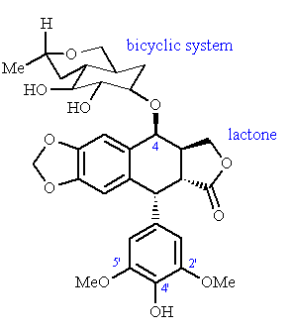
What is the name of the structure?
Feedback: Etoposide is a semi-synthetic derivative of epipodophyllotoxin. Teniposide is a closely related analogue. Podophyllotoxin is a stereoisomer of epipodophyllotoxin.
Page reference: 504
a. Epipodophyllotoxin
b. Teniposide
*c. Etoposide
d. Podophyllotoxin

Type: multiple choice question
Title: Chapter 18a Question 31
31) The following structure (etoposide) is used as an anticancer agent

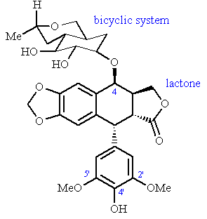

Etoposide is a semi-synthetic derivative of which compound?
Feedback: Etoposide is a semi-synthetic derivative of epipodophyllotoxin. Teniposide is a closely related analogue. Podophyllotoxin is a stereoisomer of epipodophyllotoxin.
Page reference: 504
*a. Epipodophyllotoxin
b. Teniposide
c. Etoposide
d. Podophyllotoxin

Type: multiple choice question
Title: Chapter 18a Question 32
32) The following structure (etoposide) is used as an anticancer agent

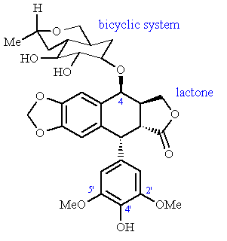
Which enzyme is targeted by etoposide?
Feedback: Topoisomerase II catalyses the temporary cleavage of DNA strands, the crossing of the strands and resealing of the strands. Etoposide stabilises the complex formed between DNA and the enzyme, thus preventing the completion of this process.
Page reference: 504
*a. Topoisomerase II
b. DNA polymerase
c. DNA ligase
d. Topoisomerase I

Type: multiple choice question
Title: Chapter 18a Question 33
33) Etoposide is used as an anticancer agent

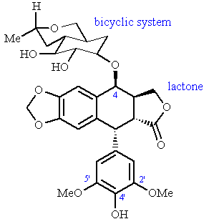

Which of the following groups is crucial to the mechanism of etoposide in producing radical species?
Feedback: Oxidation of the 4'-phenolic group can produce a semiquinone free radical.
Page reference: 504
a. The bicyclic substituent at position 4
b. The lactone
c. The methoxy substituents at positions 3' and 5'
*d. The phenolic substituent at position 4'

Type: multiple choice question
Title: Chapter 18a Question 34
34) The following group of compounds are cytotoxic alkaloids used as anticancer agents.

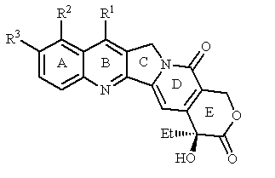
What are the group of compounds illustrated above?
Feedback: The anthracyclines contain a tetracyclic ring system where all the ring are six membered. There is also a sugar substituent. The bleomycins are glycoproteins which include a bithiazole ring system. The podophyllotoxins have a tetracyclic ring system involving two five-membered rings and two six-membered rings. The camptothecinshave a pentacyclic ring system involving four six-membered ring and one five-membered ring.
Page reference: 504-505
a. Bleomycins
*b. Camptothecins
c. Podophyllotoxins
d. Anthracyclines

Type: multiple choice question
Title: Chapter 18a Question 35
35) Camptothecins are cytotoxic alkaloids used as anticancer agents.

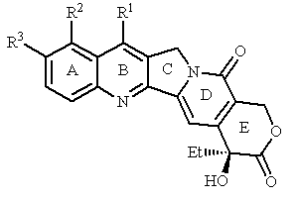
What is the target for these compounds?
Feedback: Topoisomerase I is an enzyme that relieves strain in DNA by cleaving one strand of the DNA double helix in order to pass one strand through the other.
Page reference: 504-505
a. Topoisomerase II
b. DNA polymerases
c. DNA ligase
*d. Topoisomerase I

Type: multiple choice question
Title: Chapter 18a Question 36
36) Camptothecins are cytotoxic alkaloids used as anticancer agents.

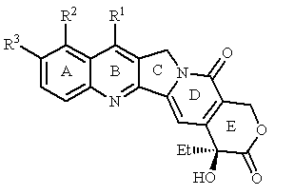
Which of the following moieties is particularly important for activity?
Feedback: The lactone ring is required for activity. If it is open, activity is greatly reduced.
Page reference: 504-505
a. Rings A and B
b. Rings A, B and C
c. Ring D
*d. Ring E

Type: multiple choice question
Title: Chapter 18a Question 37
37) The following agent is used for the treatment of Hodgkin's lymphoma as part of a multi-drug regime.

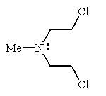
What is the name of the compound?
Feedback: Chlormethine is the name of the compound and contains two alkyl chloride groups. Carmustine also has two alkyl chloride groups, but also has a nitrosourea group. Cisplatin is a platinum complex. Busulfan is a linear molecule containing two sulfoxide groups. Carmustine also has two alkyl chloride groups, but also has a nitrosourea group.
Page reference: 506-507
a. Cisplatin
b. Busulfan
c. Carmustine
*d. Chlormethine

Type: multiple choice question
Title: Chapter 18a Question 38
38) The following agent is used for the treatment of Hodgkin's lymphoma as part of a multi-drug regime.

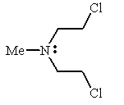
What sort of agent is it?
Feedback: The agent alkylates guanine moieties of DNA.
Page reference: 506-507
a. A topoisomerase inhibitor
*b. An alkylating agent
c. An antimetabolite
d. A receptor antagonist

Type: multiple choice question
Title: Chapter 18a Question 39
39) The following agent is used for the treatment of Hodgkin's lymphoma as part of a multi-drug regime.

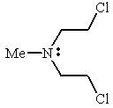
What is the name of the activated species which is formed from the above structure and which is the actual alkylating agent?
Feedback: Neighbouring group participation by the lone pair of the nitrogen forms the aziridinium ion with loss of chloride ion. The aziridinium ion acts as the alkylating agent.
Page reference: 506-507
a. A quaternary ammonium ion
b. An iminium ion
c. A cyclopropylamine ion
*d. An aziridinium ion

Type: multiple choice question
Title: Chapter 18a Question 40
40) The following structure is a modification of chlormethine:

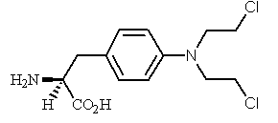
What is the name of the structure?
Feedback: All the named structures are analogues of chlormethine where the N-methyl group has been replaced with a different group. In the structure shown, a phenylalanine moiety is present in place of the methyl group. This is melphalan. In uracil mustard, a uracil group is present. In chlorambucil, a phenylbutanoic acid group is present. In estramustine, there is a steroid present.
Page reference: 507
a. Chlorambucil
b. Uracil mustard
*c. Melphalan
d. Estramustine

Type: multiple choice question
Title: Chapter 18a Question 41
41) The following structure is a modification of chlormethine

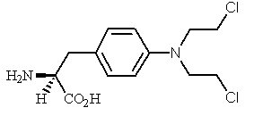

What advantages does this structure have over chlormethine?
Feedback: The aromatic ring decreases the nucleophilicity of the amine nitrogen and makes the agent more selective.
It is a mimic for the amino acid phenylalanine. It is more likely to be taken into cells by carrier proteins since carrier proteins for amino acids mistake the drug for a normal amino acid and carry it across cell membranes.
Page reference: 507
a. The aromatic ring increases the nucleophilicity of the amine nitrogen.
b. It contains a mimic for the amino acid tyrosine.
*c. It is more likely to be taken into cells by carrier proteins.
d. All of the above.

Type: multiple choice question
Title: Chapter 18a Question 42
42) The following anticancer agent has been used in the treatment of chronic lymphatic leukaemia. It contains a nucleic acid base as part of its structure.

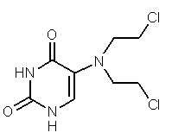
What nucleic acid base has been incorporated into the structure?
Feedback: The answer is uracil. The nucleic acid is a pyrimidine and so this rules out adenine since adenine is a purine. Cytosine can be ruled out since it has an amino substituent. Thymine is very similar to uracil but contains a methyl group. This group is not present in uracil mustard since this is has been replaced with the mustard moiety.
Page reference: 507
a. Thymine
*b. Uracil
c. Cytosine
d. Adenine

Type: multiple choice question
Title: Chapter 18a Question 43
43) The following anticancer agent has been used in the treatment of chronic lymphatic leukaemia. It contains a nucleic acid base as part of its structure.

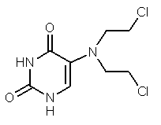
What is the rationale for the presence of this moiety?
Feedback: Since the drug contains a nucleic acid base, it is more likely to be transported across cell membranes by carrier proteins that recognise nucleic acid bases. There is no truth in the other statements.
Page reference: 507
a. The drug is more likely to be incorporated into DNA.
b. The drug is more likely to be incorporated into RNA.
*c. The drug is more likely to be taken up by fast growing cancer cells.
d. The drug is less likely to produce an immune response.

Type: multiple choice question
Title: Chapter 18a Question 44
44) The following structure has been used as an anticancer agent.

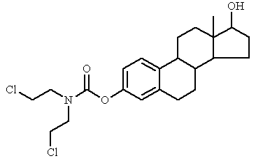
What is the name of the structure?
Feedback: Chlormethine contains two alkyl chloride groups attached to nitrogen. The other named structures are analogues of chlormethine where the N-methyl group has been replaced with a different group. In melphalan, there is a phenylalanine moiety present in place of the methyl group. In uracil mustard, a uracil group is present. In estramustine, there is a steroid present. Therefore, the structure shown is estramustine.
Page reference: 507-508
a. Chlormethine
b. Uracil mustard
c. Melphalan
*d. Estramustine

Type: multiple choice question
Title: Chapter 18a Question 45
45) The following structure has been used as an anticancer agent.

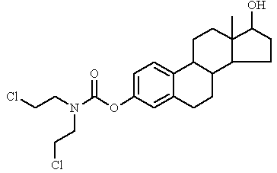
A steroid structure has been incorporated into the structure. Which steroid has been incorporated?
Feedback: Oestradiol is the steroid that has been incorporated. The steroid contains an aromatic ring and so that rules out cholesterol and testosterone. Oestrone has a ketone group instead of an alcohol group on the five membered ring.
Page reference: 507-508
a. Cholesterol
b. Testosterone
c. Oestrone
*d. Oestradiol

Type: multiple choice question
Title: Chapter 18a Question 46
46) The following drug is commonly used in anticancer therapy.

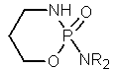

What is it called?
Feedback: Chlormethine contains two alkyl chloride groups attached to an amine. Carmustine also has two alkyl chloride groups, but has a nitrosourea group as well. Cisplatin is a platinum complex. Cyclophosphamide is a cyclic structure containing phosphorus and this is the structure that is shown
Page reference: 508
*a. Cyclophosphamide
b. Cisplatin
c. Carmustine
d. Chlormethine

Type: multiple choice question
Title: Chapter 18a Question 47
47) The following drug is commonly used in anticancer therapy.

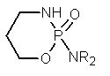
Which of the following statements is not true of the above structure?
Feedback: The drug is called cyclophosphamide. It can be taken orally and since it is a prodrug, it is not toxic to the gut wall when taken orally.
Page reference: 508
a. It is relatively non toxic.
b. It acts as a prodrug.
*c. It cannot be taken orally.
d. The structure is metabolised to release acrolein.

Type: multiple choice question
Title: Chapter 18a Question 48
48) The following drug is commonly used in anticancer therapy.

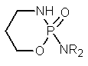

Which of the following enzymes is important in activating the above structure?
Feedback: The drug is called cyclophosphamide. Cytochrome p450 enzymes hydroxylate the ring of cyclophosphamide and this results in the degradation of the molecule with the release of acrolein and formation of a cytotoxic alkylating agent.
Page reference: 508
a. Esterases
b. Phosphorylases
c. Kinases
*d. Cytochrome P450 enzymes

Type: multiple choice question
Title: Chapter 18a Question 49
49) The following structure is used in the treatment of brain tumours.

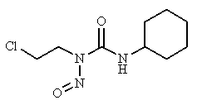
To which group of compounds does it belong?
Feedback: The structure shown contains a nitrosourea functional group and so it is a nitrosourea. The nitrogen mustards contain alkyl chloride groups attached to an amine. The camptothecins are pentacyclic structures. The podophyllotoxins are tetracyclic structures with an aromatic substituent.
Page reference: 508
*a. Nitrosoureas
b. Nitrogen mustards
c. Camptothecins
d. Podophyllotoxins

Type: multiple choice question
Title: Chapter 18a Question 50
50) The following structure is called lomustine and is used in the treatment of brain tumours.

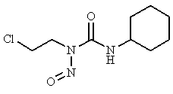
Which of the following statements is true regarding the above structure?
Feedback: Lomustine is a lipid soluble agent that can cross the blood brain barrier, and can be given orally. It decomposes spontaneously in the body without the need of an enzyme. In doing so, it generates two species, one of which acts as an alkylating agent, and the other which acts as a carbamoylating agent.
Page reference: 508-509
a. It cannot cross the blood brain barrier.
b. It is activated by an enzymatic metabolic reaction.
c. It cannot be given orally.
*d. It is both an alkylating and a carbamoylating agent.

Type: multiple choice question
Title: Chapter 18a Question 51
51) The following agent is used in the treatment of chronic granulocytic leukaemia:

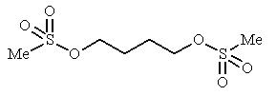
What is the structure called?
Feedback: Busulfan is a simple linear molecule containing two sulfoxide groups. Carmustine is a nitrosourea and also has two alkyl chloride groups. Streptozotocin is a nitrosourea with a sugar substituent. Cyclophosporamide is a cyclic structure containing phosphorus.
Page reference: 509
a. Carmustine
*b. Busulfan
c. Streptozotocin
d. Cyclophosphamide

Type: multiple choice question
Title: Chapter 18a Question 52
52) The following agent is used in the treatment of chronic granulocytic leukaemia:

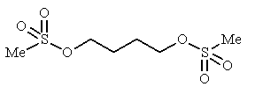
Which of the following statements is not true regarding the above agent?
Feedback: The mechanism is an SN2 nucleophilic substitution.
Page reference: 509
a. The sulfonate groups are good leaving groups.
b. It readily alkylates guanine residues.
c. It produces interstrand cross linking of DNA.
*d. The mechanism involves an SN1 nucleophilic substitution.

Type: multiple choice question
Title: Chapter 18a Question 53
53) The following agent is used for the treatment of testicular and ovarian cancers.

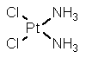
What is the agent called?
Feedback: The other named compounds belong to the same group of compounds as cisplatin.
Page reference: 509-510
a. Carboplatin
b. Oxaliplatin
*c. Cisplatin
d. Transplatin

Type: multiple choice question
Title: Chapter 18a Question 54
54) The following agent is used for the treatment of testicular and ovarian cancers.

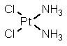
Which of the following statements is untrue regarding the above structure?
Feedback: The structure is cisplatin. It is the base pairing between cytosine and guanine that is disrupted. All of the other statements are correct.
Page reference: 509-510
a. The chlorine groups are displaced before the drug becomes active.
b. Intrastrand cross linking of DNA results from the action of the agent.
*c. Base pairing between adenine and thymine is disrupted by the agent.
d. Ondansetron is often administered with the agent to reduce nausea.

Type: multiple choice question
Title: Chapter 18a Question 55
55) The following agent is used in the treatment of a variety of cancers including melanoma:

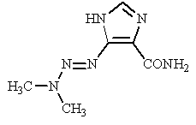
What is the agent called?
Feedback: The structure shown is dacarbazine and contains an imidazole ring. Procarbazine is a related compound which does contains an aromatic ring and no imidazole ring. Busulphan is a simple linear molecule with two sulfoxide groups. Mitomycin C is a tetracyclic structure.
Page reference: 510-511
a. Procarbazine
b. Busulfan
*c. Dacarbazine
d. Mitomycin C

Type: multiple choice question
Title: Chapter 18a Question 56
56) The following agent (dacarbazine) is used in the treatment of a variety of cancers including melanoma.

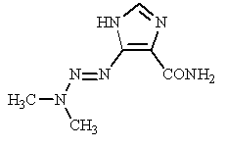

Which of the following statements is true regarding dacarbazine?
Feedback: Dacarbazine is a prodrug which is activated by cytochrome p450 enzymes. It is formaldehyde that is lost during degradation. The active agent alkylates DNA.
Page reference: 510-511
a. It is a prodrug which is activated by peptidases.
*b. The active agent is a methyldiazonium ion.
c. Acetaldehyde is lost during degradation of the compound.
d. The active agent acts as an enzyme inhibitor.

Type: multiple choice question
Title: Chapter 18a Question 57
57) The following agent is used as an anticancer drug against a variety of cancers:

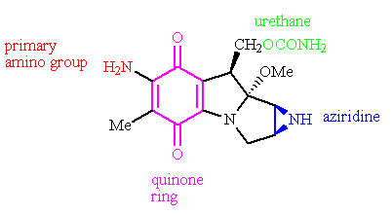
What is the structure called?
Feedback: Mitomycin C is the structure shown. It is a tetracyclic structure which includes a three membered aziridine ring. Procarbazine and dacarbazine are much simpler molecules. Adozelesin, on the other hand, is a multicyclic molecule.
Page reference: 511
a. Procarbazine
b. Adozelesin
c. Dacarbazine
*d. Mitomycin C

Type: multiple choice question
Title: Chapter 18a Question 58
58) The following agent is called mitomycin C and is used as an anticancer drug against a variety of cancers.

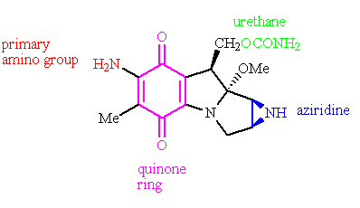
The structure is a prodrug which is converted in the body to the active compound. What is the initial step in this activation process?
Feedback: Reduction of the quinone ring system generates a diphenol which then results in ring opening of the aziridine ring. Hydrolysis of the urethane group takes place subsequent to that. The primary amino group is not alkylated at all during the process. The drug is acting as an alkylating agent and so it an amino group on DNA that gets alkylated.
Page reference: 511-512
a. Ring opening of the aziridine ring
b. Hydrolysis of the urethane group
c. Alkylation of the primary amino group
*d. Reduction of the quinone ring system

Type: multiple choice question
Title: Chapter 18a Question 59
59) The following agent is called mitomycin C and is used as an anticancer drug against a variety of cancers:

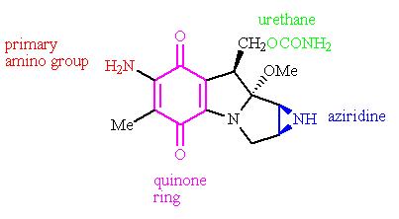

Which of the following statements is true regarding the above drug?
Feedback: Mitomycin is one of the most toxic anticancer drugs in clinical use. Interstrand cross linking takes place and not intrastrand cross linking. Guanine units are alkylated by the agent and not adenine units.
Page reference: 511
a. It is one of the safest anticancer agents used in clinical practice.
b. It promotes intrastrand cross linking in DNA.
c. Adenine units are alkylated by the agent.
*d. It is possible that the drug may be more effective against tumours in oxygen starved environments.

Type: multiple choice question
Title: Chapter 18a Question 60
60) The following structure is an anti tumour agent derived from a bacterium:

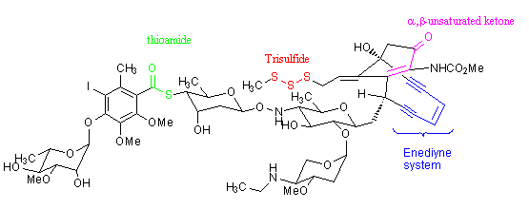
What is the name of the agent?
Feedback: Calicheamicin is the correct answer. It is a complex structure which includes an unusual enediyne system. Adozelesin is a synthetic analogue of the naturally occurring agent CC1065. Dacrabazine has a relatively simple structure which includes an imidazole ring. Oblimersin is an antisense drug made up of 18 deoxynucleotides.
Page reference: 511, 513
*a. Calicheamicin γ1
b. Adozelesin
c. Dacarbazine
d. Oblimersen

Type: multiple choice question
Title: Chapter 18a Question 61
61) The following structure is calicheamicin γ1 and is an anti tumour agent derived from a bacterium.

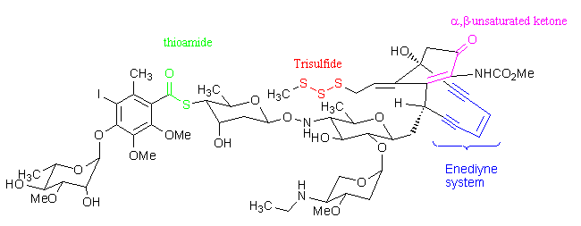
Which of the following functional groups is not involved in the mechanism of action?
Feedback: The trisulfide, α,β-unsaturated ketone and the enediyne system are involved in a process which leads to cycloaromatisation and the generation of a diradical species.
Page reference: 511, 513
*a. Thioamide
b. Trisulfide
c. α,β-unsaturated ketone
d. Enediyne system

Type: multiple choice question
Title: Chapter 18a Question 62
62) The following structure is calicheamicin γ1 and it is an anti tumour agent derived from a bacterium:

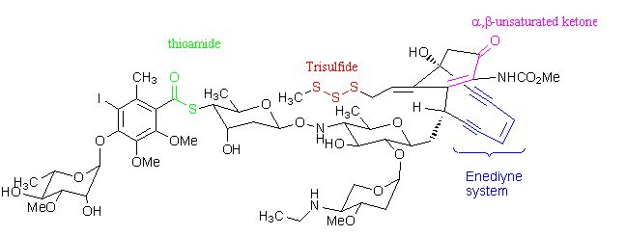
What effect does the agent have?
Feedback: A diradical species is formed which abstracts two hydrogens from DNA and generates a diradical DNA species. Oxidative cleavage of the DNA chain then occurs.
Page reference: 511, 513
a. It alkylates DNA
b. It is an antimetabolite
c. It inhibits topoisomerases
*d. It cleaves the DNA chain by the production of radicals

Type: multiple choice question
Title: Chapter 18a Question 63
63) Which of the following is an antisense drug?
Feedback: Calicheamicin γ1 is a chain cutter of DNA. Adozelesin and dacarbazine are alkylating agents. Oblimersen is an antisense agent consisting of 18 deoxynucleotides linked by a phosphorothioate backbone.
Page reference: 511
a. Calicheamicin γ1
b. Adozelesin
c. Dacarbazine
*d. Oblimersen

Type: multiple choice question
Title: Chapter 18a Question 64
64) The following structure is a biosynthetic precursor for an important enzyme cofactor required by the enzyme thymidylate synthase.

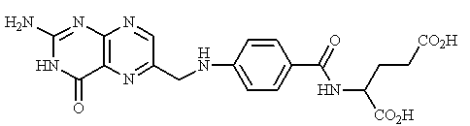
Which cofactor is involved?
Feedback: The structure shown is folic acid. Folic acid is metabolised to dihydrofolate, then to tetrahydrofolate then to N5, N10-methylene FH4. The last structure acts as the enzyme cofactor, and is converted back to dihydrofolate in the process.
Page reference: 514-515
a. Folic acid
b. Dihydrofolic acid
c. Tetrahydrofolic acid
*d. N5, N10-methylene tetrahydrofolic acid

Type: multiple choice question
Title: Chapter 18a Question 65
65) What reaction does the enzyme thymidylate synthase catalyse?
Feedback: The reaction is the conversion of deoxyuracil monophosphate to deoxythymidine monophosphate.
Page reference: 514
*a. dUMP to dTMP
b. dTMP to dUMP
c. UMP to TMP
d. TMP to UMP

Type: multiple choice question
Title: Chapter 18a Question 66
66) The following structure is a widely used antimetabolite in anticancer therapy:

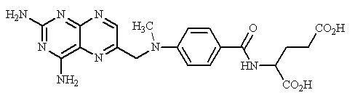
What is the name of the above structure?
Feedback: Folic acid is the natural substrate that is mimicked by methotrexate. Methotrexate inhibits dihydrofolate reductase. Raltitrexed mimics the cofactor N5, N10-methylene tetrahydrofolic acid, and inhibits the enzyme thymidylate synthase. Tetrahydrofolate is the product derived from folic acid following the reactions catalysed by dihydrofolate reductase.
Page reference: 515
a. Folic acid
*b. Methotrexate
c. Raltitrexed
d. Tetrahydrofolate

Type: multiple choice question
Title: Chapter 18a Question 67
67) The following structure is a widely used antimetabolite in anticancer therapy:

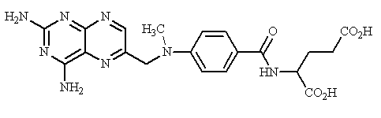
Which enzyme is directly inhibited by the above structure?
Feedback: The structure is methotrexate. Methotrexate inhibits dihydrofolate reductase resulting in a lack of the enzyme cofactor required for the enzyme thymidylate synthase. As a result, the latter enzyme is inhibited indirectly.
Page reference: 514-515
a. Thymidylate synthase
*b. Dihydrofolate reductase
c. Adenosine deaminase
d. Ribonucleotide reductase

Type: multiple choice question
Title: Chapter 18a Question 68
68) The following structure is used in the treatment of breast, liver and skin cancers.

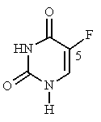
What is the name of the above structure?
Feedback: The answer is 5-fluorouracil. 5-Fluorothymidine is not possible since there is already a methyl group at the 5-position. 5-Fluorocytosine would have a primary amino substituent at position 4 of the pyrimidine ring. 5-Fluoropyrimidine would have no substituents other than the fluoro-group.
Page reference: 515-516
a. 5-fluorothymidine
*b. 5-fluorouracil
c. 5-fluorocytosine
d. 5-fluoropyrimidine

Type: multiple choice question
Title: Chapter 18a Question 69
69) The following structure is used in the treatment of breast, liver and skin cancers.

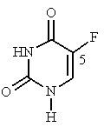
What is the target for the above structure?
Feedback: The structure is 5-fluorouracil and it acts as a prodrug. The active compound is the fluorinated analogue of 2'-deoxyuridylic acid monophosphate
Page reference: 514-516
*a. Thymidylate synthase
b. Dihydrofolate reductase
c. Adenosine deaminase
d. Ribonucleotide reductase

Type: multiple choice question
Title: Chapter 18a Question 70
70) The following structure is used in the treatment of breast, liver and skin cancers.

The above structure is a prodrug which is converted to an active agent. What is the active agent?
Feedback: The structure shown is 5-fluorouracil. The active agent is the fluorinated analogue of 2'-deoxyuridylic acid monophosphate.
Page reference: 515-516
a. FdTMP
b. FdCMP
*c. FdUMP
d. FdGMP

Type: multiple choice question
Title: Chapter 18a Question 71
71) The following structure is used in the treatment of breast, liver and skin cancers.

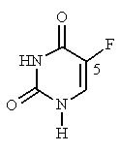

What role is played by the active agent formed from the above structure?
Feedback: The structure shown is 5-fluorouracil. The active agent is the fluorinated analogue of 2'-deoxyuridylic acid monophosphate. This acts as a suicide substrate. A suicide substrate is an agent which is normally harmless, but which is converted into a reactive species as a result of an enzyme catalysed reaction. The reactive species then directly reacts with the enzyme and is linked to the enzyme by a covalent bond leading to irreversible inhibition.
Page reference: 515
a. Allosteric enzyme inhibitor
b. Reversible enzyme inhibitor
*c. Suicide substrate
d. Transition state analogue

Type: multiple choice question
Title: Chapter 18a Question 72
72) The following structure is used as a treatment of colorectal cancer. What is it called?

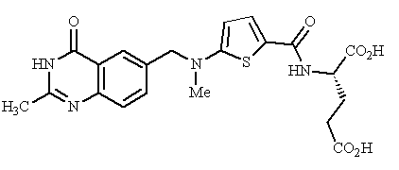
Feedback: Raltitrexed mimics the cofactor N5, N10-methylene tetrahydrofolic acid, and inhibits the enzyme thymidylate synthase.
Page reference: 516-517
a. Folic acid
b. Methotrexate
*c. Raltitrexed
d. Tetrahydrofolate

Type: multiple choice question
Title: Chapter 18a Question 73
73) The following structure has been used in combination therapy for the treatment of a variety of cancers.

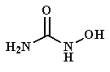

What is the name of the above structure?
Feedback: Hydroxycarbamide is a very simple molecule and is the one shown. The remaining three structures are nucleosides or nucleoside-like molecules.
Page reference: 517
a. Pentostatin
*b. Hydroxycarbamide
c. Fludarabine
d. Cytarabine

Type: multiple choice question
Title: Chapter 18a Question 74
74) The following structure has been used in combination therapy for the treatment of a variety of cancers.

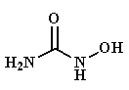
What is the target for the above structure?
Feedback: The structure is hydroxycarbamide. Its target is ribonucleotide reductase. Ribonucleotide reductase catalyses the conversion of ribose to deoxyribose in nucleotide substrates.
Page reference: 516-517
a. DNA polymerase
b. Adenosine deaminase
c. Thymidylate synthase
*d. Ribonucleotide reductase

Type: multiple choice question
Title: Chapter 18a Question 75
75) Hydroxycarbamide has been used in combination therapy for the treatment of a variety of cancers.

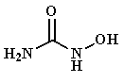
The compound destabilises a metal ion centre in the target enzyme, ribonucleotide reductase. Which ion is involved?
Feedback: The iron ion is an enzyme cofactor that is crucial to the reaction mechanism.
Page reference: 516-517
a. Magnesium
b. Calcium
*c. Iron
d. Zinc

Type: multiple choice question
Title: Chapter 18a Question 76
76) The following structure is a natural product used for the treatment of leukaemia:

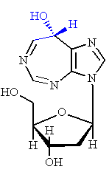
What is the name of the above structure?
Feedback: Pentostatin is a natural product which has a nucleoside-like structure. Hydroxycarbamide is a very simple molecule. The remaining two structures are nucleosides.
Page reference: 518
*a. Pentostatin
b. Hydroxycarbamide
c. Fludarabine
d. Cytarabine

Type: multiple choice question
Title: Chapter 18a Question 77
77) Pentostatin is a natural product used for the treatment of leukaemia.

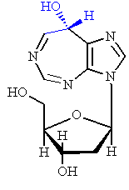
What is the target for pentostatin?
Feedback: Adenosine deaminase catalyses the deamination of adenosine to inosine.
Page reference: 518
a. DNA polymerases
*b. Adenosine deaminase
c. Thymidylate synthase
d. Ribonucleotide reductase

Type: multiple choice question
Title: Chapter 18a Question 78
78) Pentostatin is a natural product used for the treatment of leukaemia.

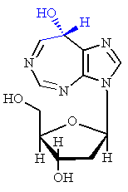
What is the name of the enzyme target that is indirectly inhibited by the above structure?
Feedback: Inhibition of adenosine deaminase leads to an increase in dATP levels. These in turn inhibit ribonucleotide reductase.
Page reference: 518
a. DNA polymerases
b. Adenosine deaminase
c. Thymidylate synthase
*d. Ribonucleotide reductase

Type: multiple choice question
Title: Chapter 18a Question 79
79) Which of the following structures inhibits DNA polymerases?
Feedback: All the structures mentioned are synthetic nucleosides that mimic natural nucleosides.
Page reference: 518
a. Cytarabine
b. Gemcitabine
c. Fludarabine
*d. All of the structures

Type: multiple choice question
Title: Chapter 18a Question 80
80) The following structure is used in the treatment of leukaemias:

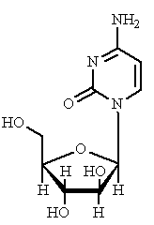
What is it called?
Feedback: Cytarabine and gemcitabine are nucleoside with a very similar structure, but gemcitabine contains two fluorine substituents. Fludarabine is a nucleoside but the nucleic acid is a purine rather than the pyrimidine in the structure shown. 6-Mercaptopurine is a prodrug for a nucleoside.
Page reference: 518
*a. Cytarabine
b. Gemcitabine
c. Fludarabine
d. 6-Mercaptopurine

Type: multiple choice question
Title: Chapter 18a Question 81
81) The following structure is used in the treatment of leukaemias:

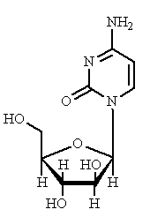
What nucleoside does the above structure mimic?
Feedback: The structure is called cytarabine and it mimics 2'-deoxycytidine.
Page reference: 518
*a. 2'-deoxycytidine
b. 2'-deoxythymidine
c. 2'-deoxyguanosine
d. 2'-deoxyadenosine

Type: multiple choice question
Title: Chapter 18a Question 82
82) Cytarabine is used in the treatment of leukaemias:

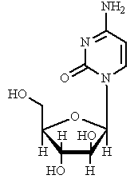
The above structure acts as a prodrug. What is the active compound?
Feedback: As the triphosphate, cytarabine more closely resembles the natural triphosphate substrates for the target enzyme. As a result it is more likely to be recognised by the enzyme and bind.
Page reference: 518
a. Monophosphate
b. Diphosphate
*c. Triphosphate
d. Polyphosphate

Type: multiple choice question
Title: Chapter 18a- Question 83
83) Which of the following definitions describes metastasis?
Feedback: Carcinogenesis refers to the birth of a cancer. Apoptosis refers to the process by which cells 'commit suicide'. Metastasis refers to the spread of a cancer to different parts of the body and the appearance of secondary tumours. Mutagenesis refers to the promotion of mutations in a cell's DNA.
Page Reference: 496-497
a. The birth of a cancer
b. The process by which cells 'commit suicide'
*c. The ability of a cancer to invade other parts of the body and to produce secondary tumours
d. The promotion of mutations in a cell's DNA

Type: multiple choice question
Title: Chapter 18a- Question 84
84) Which of the following definitions describes carcinogenesis?
Feedback: Carcinogenesis refers to the birth of a cancer. Apoptosis refers to the process by which cells 'commit suicide'. Metastasis refers to the spread of a cancer to different parts of the body and the appearance of secondary tumours. Mutagenesis refers to the promotion of mutations in a cell's DNA.
Page reference: 489
*a. The birth of a cancer
b. The process by which cells 'commit suicide'
c. The ability of a cancer to invade other parts of the body and to produce secondary tumours
d. The promotion of mutations in a cell's DNA

Type: multiple choice question
Title: Chapter 18a- Question 85
85) Which of the following definitions describes apoptosis?
Feedback: Carcinogenesis refers to the birth of a cancer. Apoptosis refers to the process by which cells 'commit suicide'. Metastasis refers to the spread of a cancer to different parts of the body and the appearance of secondary tumours. Mutagenesis refers to the promotion of mutations in a cell's DNA.
Page reference: 493-494
a. The birth of a cancer
*b. The process by which cells 'commit suicide'
c. The ability of a cancer to invade other parts of the body and to produce secondary tumours
d. The promotion of mutations in a cell's DNA

Type: multiple choice question
Title: Chapter 18a- Question 86
86) Which of the following definitions describes mutagenesis?
Feedback: Carcinogenesis refers to the birth of a cancer. Apoptosis refers to the process by which cells 'commit suicide'. Metastasis refers to the spread of a cancer to different parts of the body and the appearance of secondary tumours. Mutagenesis refers to the promotion of mutations in a cell's DNA.
Page reference: 489
a. The birth of a cancer
b. The process by which cells 'commit suicide'
c. The ability of a cancer to invade other parts of the body and to produce secondary tumours
*d. The promotion of mutations in a cell's DNA

Type: multiple choice question
Title: Chapter 18a- Question 87
87) What is meant by the term oncogene?
Feedback: An oncogene is a gene which has become mutated and which codes for an abnormal protein that is implicated in cancer. A proto-oncogene is the normal form of that gene.
Page reference: 490
a. It is a protein that is involved in cell signal transduction pathways and can lead to cancer when it is in an abnormal form.
b. It is the process by which new blood vessels are formed.
*c. It is a gene which has become mutated and which codes for an abnormal protein that is implicated in the development of cancer.
d. It is a protein that is involved in the processes of cellular checking, repair and suicide.

Type: multiple choice question
Title: Chapter 18a- Question 88
88) What is meant by the term p53?
Feedback: The p53 protein plays a crucial role in apoptosis.
Page reference: 493-494
a. It is a protein that is involved in cell signal transduction pathways and can lead to cancer when it is in an abnormal form.
b. It is the process by which new blood vessels are formed.
c. It is a gene which has become mutated and which codes for an abnormal protein that is implicated in the development of cancer.
*d. It is a protein that is involved in the processes of cellular checking, repair and suicide.

Type: multiple choice question
Title: Chapter 18a- Question 89
89) What is meant by the term angiogenesis?
Feedback: Angiogenesis is the term used to indicate the growth of new blood vessels.
Page reference: 495-496
a. It is a protein that is involved in cell signal transduction pathways and can lead to cancer when it is in an abnormal form.
*b. It is the process by which new blood vessels are formed.
c. It is a gene which has become mutated and which codes for an abnormal protein that is implicated in the development of cancer.
d. It is a protein that is involved in the processes of cellular checking, repair and suicide.

Type: multiple choice question
Title: Chapter 18a- Question 90
90) What is meant by the term ras?
Feedback: Abnormal ras protein can become permanently active, and lead to cancer by constantly activating the cell signalling pathways.
Page reference: 490
*a. It is a protein that is involved in cell signal transduction pathways and can lead to cancer when it is in an abnormal form.
b. It is the process by which new blood vessels are formed.
c. It is a gene which has become mutated and which codes for an abnormal protein that is implicated in the development of cancer.
d. It is a protein that is involved in the processes of cellular checking, repair and suicide.

Type: multiple choice question
Title: Chapter 18a- Question 91
91) Which of the following statements is true regarding the cell cycle?
Feedback: The four phases are G1, S, G2 and M. The G1 phase is where a cell is actively growing in size and preparing to copy its DNA in response to various growth factors or internal signals. The next phase is the S phase (Synthesis) where replication of DNA takes place. Once the cell's chromosomes are copied, there is another interval called the G2 phase during which the cell readies itself for cell division. Finally, there is the M phase (Mitosis) where cell division takes place to produce two daughter cells.
Page reference: 491-493
a. It is the life time of the cell
*b. It is the various stages that the cell goes through leading up to and including cell division
c. The cell cycle involves four stages labelled G1 S, G2 and D
d. The cell cycle includes 3 growth stages

Type: multiple choice question
Title: Chapter 18a- Question 92
92) What is the function of cyclins and cyclin dependent kinases?
Feedback: Cyclins activate cyclin dependent kinases which allow the cell to move from one phase of the cell cycle to another.
Page reference: 491-493
*a. They regulate the cell cycle.
b. They are responsible for protein degradation during apoptosis.
c. They are the structures at the end of chromosomes which are crucial to the immortalisation of cancer cells.
d. They inhibit angiogenesis.

Type: multiple choice question
Title: Chapter 18a- Question 93
93) What is the function of caspases?
Feedback: Caspases are responsible for protein degradation during apoptosis.
Page reference: 494
a. They regulate the cell cycle
*b. They are responsible for protein degradation during apoptosis
c. They are the structures at the end of chromosomes which are crucial to the immortalisation of cancer cells
d. They inhibit angiogenesis

Type: multiple choice question
Title: Chapter 18a- Question 94
94) What is the function of a telomere?
Feedback: The telomere acts like a splice for the DNA double helix. Normally it shortens with each cell division and eventually it becomes so short that the DNA is no longer stabilised and the cell fails to divide. If the telomere does not reduce in length with each cell division, the cell becomes immortal.
Page reference: 494-495
a. It regulates the cell cycle.
b. It is responsible for protein degradation during apoptosis.
*c. It is the structure at the end of a chromosome which is crucial to the immortalisation of cancer cells.
d. It inhibits angiogenesis

Type: multiple choice question
Title: Chapter 18a- Question 95
95) What is the function of angiostatin?
Feedback: Angiostatin inhibits angiogenesis. Angiogenesis is the production of new blood vessels. These blood vessels are essential to a growing tumour if it is to survive and continue growing. Inhibition of angiogenesis will slow down tumour growth.
Page reference: 496
a. It regulates the cell cycle
b. It is responsible for protein degradation during apoptosis
c. It is the structure at the end of a chromosome which is crucial to the immortalisation of cancer cells
*d. It inhibits angiogenesis

Type: multiple choice question
Title: Chapter 18a- Question 96
96) What is the function of interleukin-6?
Feedback: Interleukin-6 is released from new blood vessels and promotes metastasis.
Page reference: 496
a. It is involved in the anchoring of cells to an extracellular matrix.
b. It breaks down the basement membranes round blood vessels prior to angiogenesis.
c. It is responsible for the resistance shown by some cancer cells to anticancer drugs.
*d. It induces metastasis.

Type: multiple choice question
Title: Chapter 18a- Question 97
97) What is the function of matrix metalloproteinases?
Feedback: They break down the basement membranes round blood vessels prior to angiogenesis. The anchoring of cells to an extracellular matrix involves molecules called integrins. There are a variety of mechanisms by which cancer cells show resistance to anticancer drugs, one of which is the increased production of P-glycoproteins. Matrix metalloproteinases are involved in the metastasis process but do not induce it.
Page reference: 496
a. They are involved in the anchoring of cells to an extracellular matrix.
*b. They break down the basement membranes round blood vessels prior to angiogenesis.
c. They are responsible for the resistance shown by some cancer cells to anticancer drugs.
d. They induce metastasis.

Type: multiple choice question
Title: Chapter 18a- Question 98
98) What is the function of integrins?
Feedback: Integrins are important in the anchoring of cells to an extracellular matrix. They do not break down the basement membranes round blood vessels prior to angiogenesis That role is played by matrix metalloproteinases. There are a variety of mechanisms by which cancer cells show resistance to anticancer drugs, one of which is the increased production of P-glycoproteins. Integrins do not induce metastasis but the ability of cells to split from the integrins is part of the metastasis process.
Page reference: 496
*a. They are involved in the anchoring of cells to an extracellular matrix
b. They break down the basement membranes round blood vessels prior to angiogenesis
c. They are responsible for the resistance shown by some cancer cells to anticancer drugs
d. They induce metastasis

Type: multiple choice question
Title: Chapter 18a- Question 99
99) What is the function of a P-glycoprotein?
Feedback: The P-glycoprotein is capable of expelling drugs from cancer cells.
Page reference: 499
a. They are involved in the anchoring of cells to an extracellular matrix.
b. They break down the basement membranes round blood vessels prior to angiogenesis.
*c. They are responsible for the resistance shown by some cancer cells to anticancer drugs.
d. They induce metastasis.

Type: multiple choice question
Title: Chapter 18a- Question 100
100) Which of the following acts as an intercalating agent?
Feedback: Intercalating agents are agents that can bind to DNA and insert planar regions of their skeleton between the base pairs of DNA.
Page reference: 500-504
a. Nitrogen mustards
b. Calicheamicin γ1
c. Methotrexate
*d. Anthracyclines

Type: multiple choice question
Title: Chapter 18a- Question 101
101) Which of the following acts as an alkylating agent?
Feedback: Alkylating agents are drugs which have a good leaving group and which can form a strong covalent bond to their target.
Page reference: 505-508
*a. Nitrogen mustards
b. Calicheamicin γ1
c. Methotrexate
d. Anthracyclines

Type: multiple choice question
Title: Chapter 18a- Question 102
102) Which of the following acts as an antimetabolite?
Feedback: Antimetabolites act on cellular enzymes that catalyse important metabolic reactions within the cell.
Page reference: 514-515
a. Nitrogen mustards
b. Calicheamicin γ1
*c. Methotrexate
d. Anthracyclines

Type: multiple choice question
Title: Chapter 18a- Question 103
103) Which of the following acts as a chain cutting agent?
Feedback: Chain cutting agents usually bind to DNA and generate radical species which result in the cutting of the DNA chain.
Page reference: 511,513
a. Nitrogen mustards
*b. Calicheamicin γ1
c. Methotrexate
d. Anthracyclines

Type: matching question
Title: Chapter 18a- Question 104
104) Identify the following structures:

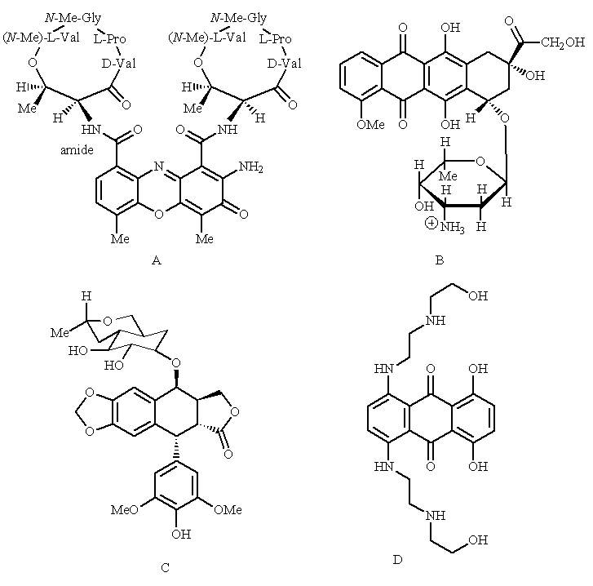

Feedback: Etoposide is an example of a podophyllotoxin. Doxorubicin is an anthracycline. Mitoxantrone is a synthetic anthracenedione structure. Dactinomycin is a naturally occurring antibiotic containing two cyclic peptides in its structure.
Page reference: 500-504
a. Etoposide = Structure C
b. Doxorubicin = Structure B
c. Mitoxantrone = Structure D
d. Dactinomycin = Structure A

Type: multiple choice question
Title: Chapter 18a - Question 105
105) Which of the following structures is not an intercalating agent?

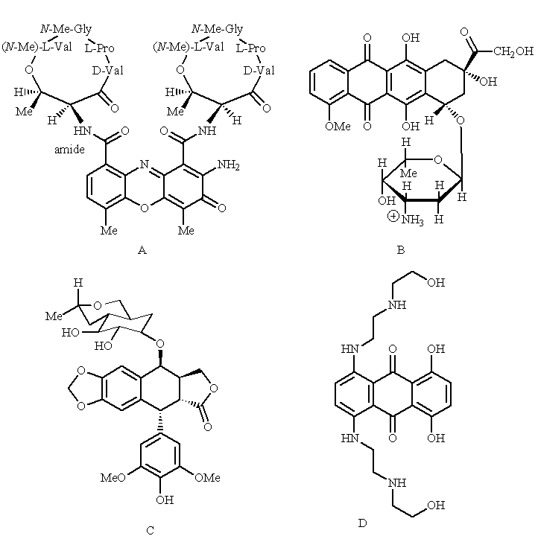

Feedback: The structures shown are dactinomycin, doxorubicin, etoposide and mitoxantrone respectively.
Page reference: 500-504
a. Structure A
b. Structure B
*c. Structure C
d. Structure D

Type: multiple choice question
Title: Chapter 18a- Question 106
106) Which of the following structures is an example of an androgen?

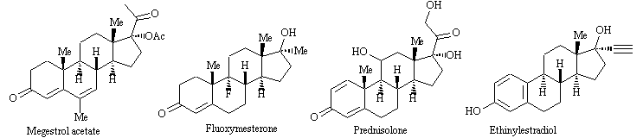
Feedback: Megestrol acetate is a progestin. Fluoxymesterone is an androgen. Prednisolone is a glucocorticoid. Ethinylestradiol is an oestrogen.
Page reference: 519-520
a. Megestrol acetate
*b. Fluoxymesterone
c. Prednisolone
d. Ethinylestradiol

Type: multiple choice question
Title: Chapter 18a- Question 107
107) Which enzyme is inhibited by all the following agents?

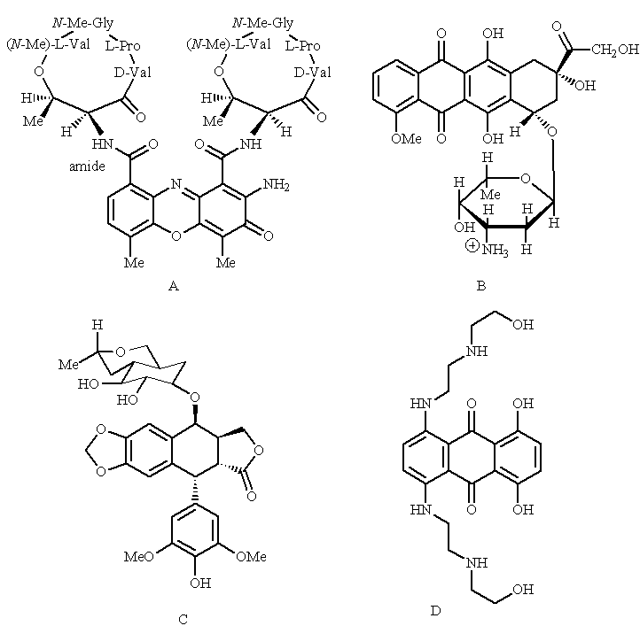
Feedback: The structures shown are dactinomycin, doxorubicin, etoposide and mitoxantrone respectively. Topoisomerase II is an enzyme which is crucial to the effective replication of DNA.
Page reference: 500-504
a. Topoisomerase I
*b. Topoisomerase II
c. Helicase
d. DNA ligase

Type: multiple choice question
Title: Chapter 18a- Question 108
108) Which of the following structures is a simplified analogue of another?

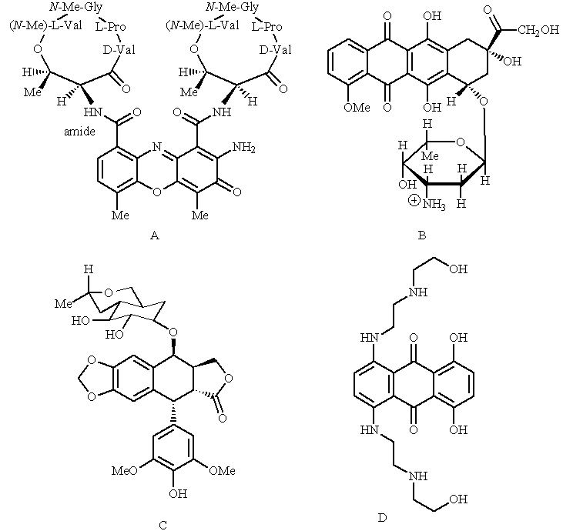
Feedback: The structures shown are dactinomycin, doxorubicin, etoposide and mitoxantrone respectively. Mitoxantrone is a simplified analouge of doxorubicin.
Page reference: 500-504
a. Structure A
b. Structure B
c. Structure C
*d. Structure D

Type: multiple choice question
Title: Chapter 18a- Question 109
109) Dactinomycin contains a tricylic ring system. What purpose does it serve in its mechanism of action?

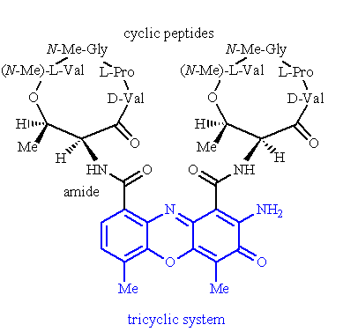
Feedback: The tricyclic system is planar and can intercalate between the base pairs of DNA. This leads to the inhibition of toposiomerase II.
Page reference: 500-502
a. The primary amine group is ionised and interacts with the phosphate groups of the DNA sugar-phosphate backbone.
b. It acts as an alkylating agent.
*c. It intercalates between the base pairs of DNA.
d. It binds to the active site of the enzyme topoisomerase II.

Type: multiple choice question
Title: Chapter 18a- Question 110
110) What role does the enzyme topoisomerase II have?
Feedback: The enzymes responsible for the four actions described are telomerase, DNA polymerase, heilcase and topoisomerase II.
Page reference: 501-502
a. It catalyses the formation of protective units at the end of chromosomes
b. It catalyses the synthesis of DNA
c. It catalyses the unwinding of the DNA double helix
*d. It catalyses crossing over of DNA strands to relieve the tension created in DNA when the DNA double helix is unravelled

Type: multiple choice question
Title: Chapter 18a- Question 111
111) Which of the following drugs inhibits topoisomerase II?
Feedback: Epirubicin is an intercalating agent which inhibits topoisomerase II. The other structures are alkylating agents.
Page reference: 502
a. Mitomycin C
*b. Epirubicin
c. Dacarbazine
d. Carboplatin

Type: multiple choice question
Title: Chapter 18a- Question 112
112) What important role does the amino acid tyrosine play in the enzyme topoisomerase II?
Feedback: The phenolic group of tyrosine acts as a nucleophile and forms a bond to a phosphate group in the DNA backbone. This results in the cleavage of the phosphate-sugar link.
Page reference: 501-502
*a. It cleaves a phosphate-sugar link in a strand of DNA.
b. It acts as a hydrogen bond donor in binding a strand of DNA.
c. It acts as a hydrogen bond acceptor in binding a strand of DNA.
d. It is ionised and forms an ionic interaction with the sugar phosphate backbone of a strand of DNA.

Type: multiple choice question
Title: Chapter 18a - Question 113
113) Which of the following structures includes an amino acid?

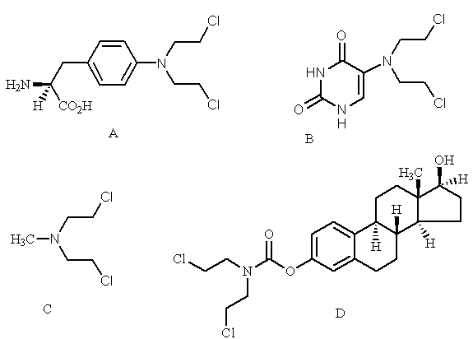
Feedback: Structure A is the alkylating agent melphalan.
Page reference: 507
*a. Structure A
b. Structure B
c. Structure C
d. StructureD

Type: multiple choice question
Title: Chapter 18a- Question 114
114) Which of the following structures includes a nucleic acid base?

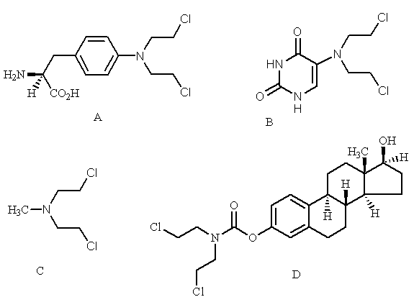
Feedback: Structure B is the alkylating agent uracil mustard
Page reference: 507
a. Structure A
*b. Structure B
c. Structure C
d. Structure D

Type: matching question
Title: Chapter 18a- Question 115
115) Identify the following structures:

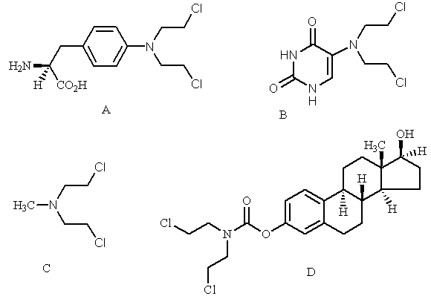
Feedback: All the named structures are either chlormethine or analogues of chlormethine where the N-methyl group has been replaced with a different group. In melphalan, a phenylalanine moiety is present in place of the methyl group. In uracil mustard, a uracil group is present. In estramustine, there is a steroid present.
Page reference: 506-508
a. Chlormethine = Structure C
b. Uracil mustard = Structure B
c. Melphalan = Structure A
d. Estramustine = Structure D

Type: multiple choice question
Title: Chapter 18a- Question 116
116) Which of the following statements is false regarding melphalan?

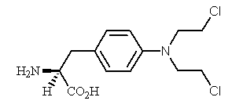
Feedback: The aromatic ring decreases the nucleophilicity of the amine nitrogen and makes the agent more selective. The idea of including an amino acid into the structure was to make it recognisable to the carrier proteins that transport amino acids across the cell membrane. It is an alkylating agent.
Page reference: 507
a. The aromatic ring increases the nucleophilicity of the amine nitrogen
*b. It contains a mimic for the amino acid phenylalanine
c. It is more likely to be taken into cells by pinocytosis
d. It is an intercalating agent

Type: matching question
Title: Chapter 18a - Question 117
117) Identify the following drugs:

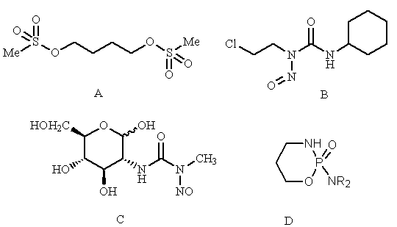
Feedback: All of these structures are alkylating agents.
Page reference: 508-509
a. Cyclophosphamide = Structure D
b. Streptozotocin structure = Structure C
c. Lomustine = Structure B
d. Busulphan = Structure A

Type: multiple choice question
Title: Chapter 18a- Question 118
118) Which of the following statements is not true of cyclophosphamide?

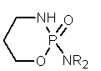
Feedback: The drug is metabolised to release acrolein.
Page reference: 508
a. It is relatively non toxic
b. It acts as a prodrug
c. It can be taken orally
*d. The structure is stable to metabolism

Type: multiple choice question
Title: Chapter 18a- Question 119
119) Which of the following statements is false regarding the anticancer drug cyclophosphamide?

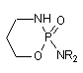

Feedback: Cytochrome p450 enzymes hydroxylate the ring of cyclophosphamide and this results in the degradation of the molecule with the release of acrolein and formation of a separate cytotoxic alkylating agent. Acrolein is thought to be resonsible for toxic side effects.
Page reference: 508
a. Acrolein is formed as a metabolite of this drug.
*b. Acrolein acts as the alkylating agent which is responsible for cyclophosphamide's anticancer activity.
c. Cyclophosphamide is the most commonly used alkylating agent used in cancer chemotherapy.
d. It is metabolised by cytochrome P450 enzymes.

Type: multiple choice question
Title: Chapter 18a- Question 120
120) Which of the following statements is true regarding the structure below?

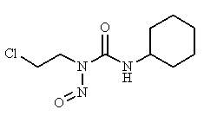

Feedback: Lomustine is a lipid soluble agent that can cross the blood brain barrier, and can be given orally. It decomposes spontaneously in the body without the need of an enzyme. In doing so, it generates two species, one of which acts as an alkylating agent, and the other which acts as a carbamoylating agent. It is not an intercalating agent.
Page reference: 508-509
a. It can cross the blood brain barrier
b. It is activated by an enzymatic metabolic reaction
c. It cannot be given orally
*d. It is both an alkylating agent and an intercalator

Type: multiple choice question
Title: Chapter 18a- Question 121
121) Which of the following statements is not true regarding the following structure:

Feedback: It alkylates guanine residues
Page reference: 509-510
a. The sulfonate groups are good leaving groups.
*b. It readily alkylates adenine residues.
c. It produces interstrand cross linking of DNA.
d. The mechanism involves an SN2 nucleophilic substitution.

Type: matching question
Title: Chapter 18a- Question 122
122) Identify the following structures:

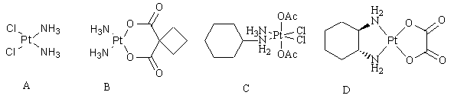
Feedback: All these compounds act as alkylating agents.
Page reference: 509-510
a. Carboplatin = Structure B
b. Oxaliplatin = Structure D
c. Cisplatin = Structure A
d. JM216 = Structure C

Type: multiple choice question
Title: Chapter 18a - Question 123
123) Cisplatin is used for the treatment of testicular and ovarian cancers.

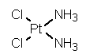
Which of the following statements is untrue?
Feedback: It is the chloro groups that are displaced.
Page reference: 509-510
*a. The amino groups are displaced before the drug becomes active
b. Intrastrand cross linking of DNA results from the action of the agent
c. Base pairing between cytosine and guanine is disrupted by the agent
d. Ondansetron is often administered with the agent to reduce nausea

Type: matching question
Title: Chapter 18a- Question 124
124) Identify the following structures:

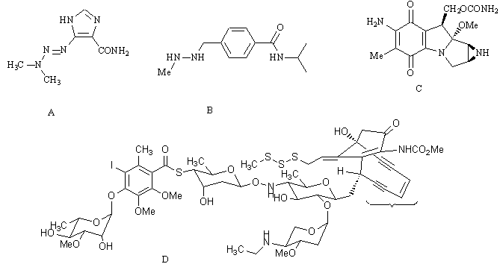
Feedback: Dacarbazine and procarbazine are related structures. Dacarbazine contains an imidazole ring, whereas procarbazine contains an aromatic ring and no imidazole ring. Calicheamicin is a complex structure which includes an unusual enediyne system. Mitomycin C is a tetracyclic structure which includes a three membered aziridine ring
Page reference: 510-513
a. Procarbazine = Structure B
b. Calicheamicin γ1 = Structure D
c. Dacarbazine = Structure A
d. Mitomycin C = Structure C

Type: multiple choice question
Title: Chapter 18a- Question 125
125) Dacarbazine is used in the treatment of a variety of cancers including melanoma. Which of the following statements is true regarding the structure below?

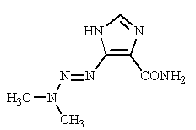

Feedback: Dacarbazine is a prodrug which is activated by cytochrome p450 enzymes. The active agent is a methyldiazonium ion. The active agent alkylates DNA.
Page reference: 510-511
a. It is a prodrug which is activated by peptidases.
*b. The active agent is a carbocation.
c. Formaldehyde is lost during degradation of the compound.
d. The active agent acts as an enzyme inhibitor.

Type: multiple choice question
Title: Chapter 18a- Question 126
126) Which of the following statements is true regarding mitomcin C?
Feedback: Mitomycin is one of the most toxic anticancer drugs in clinical use. Guanine units are alkylated by the agent and not adenine units. It is possible that the drug may be more effective against tumours in oxygen starved environments.
Page reference: 511, 512
a. It is one of the safest anticancer agents used in clinical practice.
*b. It promotes interstrand cross linking in DNA.
c. Adenine units are alkylated by the agent.
d. It is possible that the drug may be more effective against tumours in oxygen rich environments.

Type: multiple choice question
Title: Chapter 18a- Question 127
127) What sort of drug is oblimersen?
Feedback: Oblimersen is an antisense agent consisting of 18 deoxynucleotides linked by a phosphorothioate backbone.
Page reference: 511, 513
a. An alkylating agent
b. An intercalating agent
c. An enzyme inhibitor
*d. An antisense drug

Type: matching question
Title: Chapter 18a - Question 128
128) Identify the following structures:

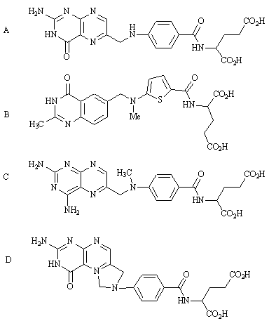
Feedback: N5,N10-methylene tetrahydrofolate is a natural product and acts as a cell’s provider of 1C units. Folic acid is the vitamin precursor for the tetrahydrofolate. Methotrexate and raltitrexed are pharmaceutical agents which are used as antimetabolites.
Page reference: 514-517
a. N5,N10-methylene tetrahydrofolate = Structure D
b. Methotrexate = Structure C
c. Folic acid = Structure A
d. Raltitrexed = Structure B

Type: multiple choice question
Title: Chapter 18a- Question 129
129) Which of the following structures is the cofactor for the enzyme thymidylate synthase?
Feedback: Structure D is N5,N10-methylene tetrahydrofolate. Structure A is folic acid which is a biosynthetic precursor for N5,N10-methylene tetrahydrofolate. The other two structures are methotrexate and raltitrexed which are both inhibitors of this enzyme.
Page reference: 514-515
a. Structure A
b. Structure B
c. Structure C
*d. StructureD

Type: multiple choice question
Title: Chapter 18a- Question 130
130) Which of the following structures does not interact with the enzyme thymidylate synthase?

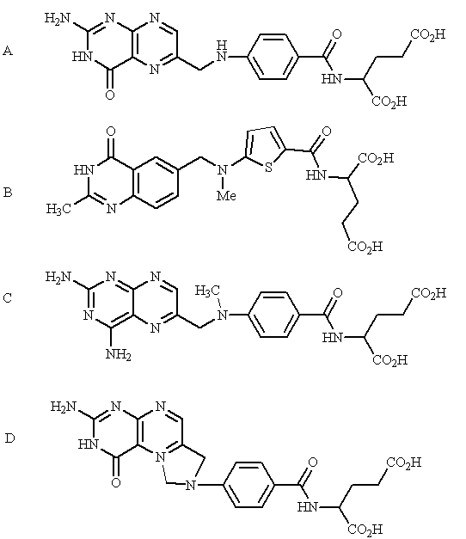

Feedback: Structure A is folic acid which is a biosynthetic precursor for the enzyme cofactor N5,N10-methylene tetrahydrofolate. Structure D is N5,N10-methylene tetrahydrofolate. The other two structures are methotrexate and raltitrexed which are both inhibitors of this enzyme.
Page reference: 515-516
*a. Structure A
b. Structure B
c. Structure C
d. Structure D

Type: matching question
Title: Chapter 18a- Question 131
131) Identify the following structures:

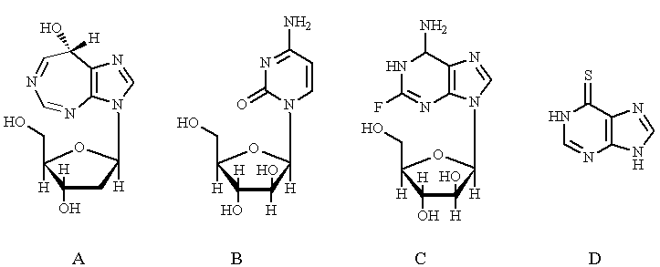
Feedback: Pentostatin is a natural product which has a nucleoside-like structure. 6-Mercaptopurine is a prodrug which includes a sulphur atom and is converted into a nucleoside in the body. The remaining two structures are nucleosides. Cytarabine has a natural nucleic acid base, but one of the hydroxyl groups on the sugar ring has a different stereochemistry from naturally occurring nucleosides. Fludarabine has the same type of sugar. It also contains a fluorine substituent on a purine ring.
Page reference: 518-519
a. cytarabine = Structure B
b. pentostatin = Structure A
c. 6-mercaptopurine = Structure D
d. fludarabine = Structure C

Type: multiple choice question
Title: Chapter 18a- Question 132
132) Which of the following structures acts as a transition state inhibitor?

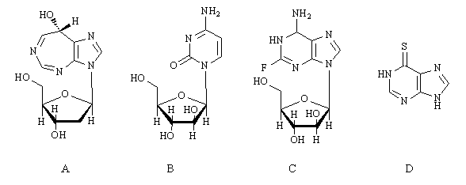
Feedback: Structure A is pentostatin which acts as a transition state inhibitor for the enzyme adenosine deaminase.
Page reference: 518
*a. Structure A
b. Structure B
c. Structure C
d. Structure D

Type: multiple choice question
Title: Chapter 18a- Question 133
133) Which of the following structures inhibits the enzyme adenosine deaminase?

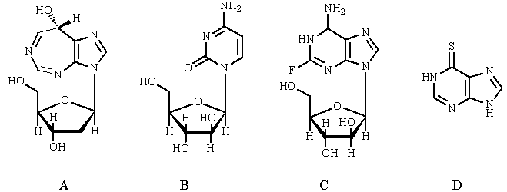
Feedback: Structure A is pentostatin which acts as a transition state inhibitor for the enzyme adenosine deaminase
Page reference: 517-518
*a. Structure A
b. Structure B
c. Structure C
d. Structure D

Type: multiple choice question
Title: Chapter 18a- Question 134
134) Which of the following structures mimics 2-deoxycytidine?

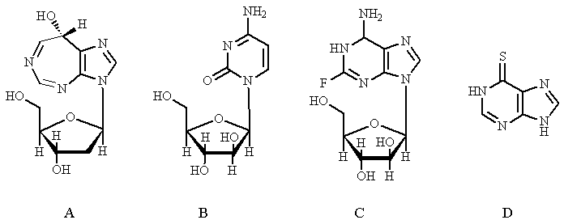
Feedback: Structure B is cytarabine. It acts as a prodrug and is phosphorylated to a triphosphate analogue which is the active drug.
Page reference: 518
a. Structure A
*b. Structure B
c. Structure C
d. Structure D

Type: multiple choice question
Title: Chapter 18a- Question 135
135) Which of the following structures acts as a prodrug and is converted into two different active compounds?

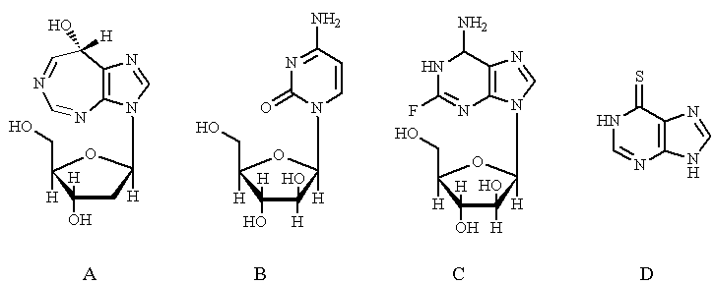

Feedback: Structure D is 6-mercaptopurine. It is converted to thio-GTP and thio-dGTP which are incorporated into RNA and DNA respectively.
Page reference: 518-519
a. Structure A
b. Structure B
c. Structure C
*d. Structure D

Type: multiple choice question
Title: Chapter 18a- Question 136
136) Which compounds combine with intracellular receptors to form nuclear transcription factors?
Feedback: Steroid hormones are released by glands in the body and travel to target cells through the blood supply. When they reach the target cell, the steroid dissolves through the cell membrane then reaches the nucleus where it combines with a nuclear transcription factor. Only then can it have an effect on transcription.
Page reference: 519
a. Peptides
*b. Steroids
c. Prostaglandins
d. Oligonucleotides

Type: multiple choice question
Title: Chapter 18a- Question 137
137) Which of the following structures is an example of a glucocorticoid?

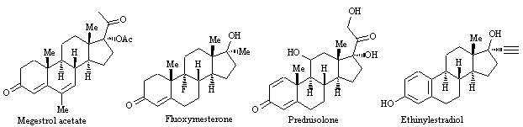
Feedback: Megestrol acetate is a progestin. Fluoxymesterone is an androgen. Prednisolone is a glucocorticoid. Ethinylestradiol is an oestrogen.
Page reference: 519
a. Megestrol acetate
b. Fluoxymesterone
*c. Prednisolone
d. Ethinylestradiol

Type: multiple choice question
Title: Chapter 18a - Question 138
138) Which of the following structures is an example of an oestrogen?

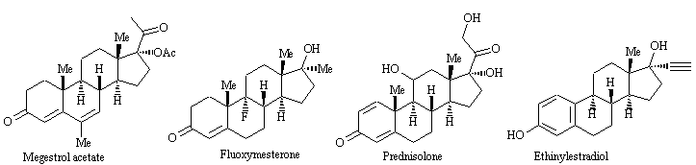
Feedback: Ethinylestradiol is an oestrogen. Megestrol acetate is a progestin. Fluoxymesterone is an androgen. Prednisolone is a glucocorticoid.
Page reference: 520
a. Megestrol acetate
b. Fluoxymesterone
c. Prednisolone
*d. Ethinylestradiol

Type: multiple choice question
Title: Chapter 18a- Question 139
139) Which of the following structures is an example of a progestin?

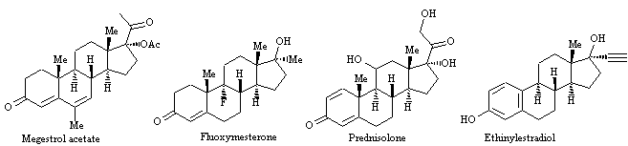

Feedback: Megestrol acetate is a progestin. Fluoxymesterone is an androgen. Prednisolone is a glucocorticoid. Ethinylestradiol is an oestrogen.
Page reference: 520
*a. Megestrol acetate
b. Fluoxymesterone
c. Prednisolone
d. Ethinylestradiol

Type: multiple choice question
Title: Chapter 18a- Question 140
140) Which of the following structures is an example of an androgen?

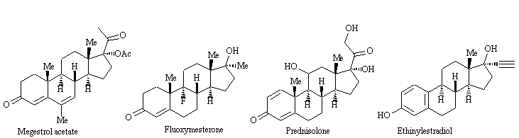

Feedback: Megestrol acetate is a progestin. Fluoxymesterone is an androgen. Prednisolone is a glucocorticoid. Ethinylestradiol is an oestrogen.
Page reference: 520
a. Megestrol acetate
*b. Fluoxymesterone
c. Prednisolone
d. Ethinylestradiol

