Chapter 17: Antiviral Agents

Type: matching question
Title: Chapter 17 - Question 01
01) Match the following terms and definitions.
Feedback: The purpose of the capsid is to protect the viral nucleic acid when the virion moves between host cells.
Page reference: 441
a. The protein coat that contains the nucleic acid of a virus = Capsid
b. The form a virus takes outside the host cell = Virion
c. The protein subunits that make up the protein coat of a virus = Protomer
d. The assembly of viral nucleic acid within a protein coat = Nucleocapsid

Type: multiple choice question
Title: Chapter 17 Question 02
02) What is meant by (+) ssRNA?
Feedback: RNA stands for ribonucleic acid. The (+) indicates that the RNA is identical to the messenger RNA used to code for viral proteins. The letters ss stand for single strand.
Page reference: 441
a. Single stranded deoxyribonucleic acid that is complementary to the messenger RNA used to code for viral proteins.
b. Double stranded ribonucleic acid.
*c. Single stranded ribonucleic acid that is identical to the messenger RNA used to code for viral proteins.
d. Single stranded ribonucleic acid that is complementary to the messenger RNA used to code for viral proteins.

Type: multiple choice question
Title: Chapter 17 Question 03
03) Which of the following is not treated by aciclovir?

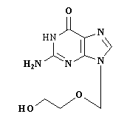
Feedback: Aciclovir is used against diseases caused by the herpes simplex virus and the varcella-zoster virus. Both of these are DNA viruses, whereas HIV is an RNA virus.
Page reference: 444-445
a. Chickenpox
*b. Human immunodeficiency virus
c. Cold sores
d. Shingles

Type: multiple choice question
Title: Chapter 17 Question 04
04) What is the active form of aciclovir?

Feedback: The monophosphate and diphosphate of aciclovir are synthesised en route to the triphosphate, but it is the triphosphate which is the active form.
Page reference: 444-445
a. The compound itself
b. The monophosphate
c. The diphosphate
*d. The triphosphate

Type: multiple choice question
Title: Chapter 17 Question 05
05) What nucleoside is mimicked aciclovir?

Feedback: Aciclovir contains the same nucleic acid base (guanine) as deoxyguanosine, but has an incomplete sugar moiety.
Page reference: 444-445
a. Deoxyadenosine
b. Deoxythymidine
c. Deoxycytidine
*d. Deoxyguanosine

Type: multiple choice question
Title: Chapter 17 Question 06
06) Which enzyme is inhibited by aciclovir?

Feedback: DNA polymerase is the enzyme which duplicates new DNA using each strand of parent DNA as a template for the construction. The enzymes reverse transcriptase and protease are present in HIV which is an RNA virus. They are not present in the DNA viruses targeted by aciclovir. RNA polymerase is present in the flu virus which is an RNA virus. It is not present in the viruses targeted by aciclovir.
Page reference: 444-445
*a. DNA polymerase
b. RNA polymerase
c. Reverse transcriptase
d. Protease

Type: multiple choice question
Title: Chapter 17 Question 07
07) Why is aciclovir selective for virally infected cells?

Feedback: Aciclovir is phosphorylated by viral thymidine kinase to the monophosphate which is then taken on to the active triphosphate by the action of cellular kinases. Aciclovir is a poor substrate for cellular thymidine kinase and so the drug is activated more slowly in non-infected cells.
There is certainly a selective uptake of aciclovir into infected cells, but the drug can still enter non infected cells. The activated form of aciclovir can inhibit cellular DNA polymerase in normal cells. However, this inhibition is weaker than the inhibition of viral DNA polymerase. The drug is not rapidly metabolised in non infected cells.
Page reference: 444-445
a. It cannot enter normal cells.
*b. It can only be activated in the presence of viral thymidine kinase.
c. The activated form fails to inhibit the target in uninfected cells.
d. It is rapidly metabolised in normal cells.

Type: multiple choice question
Title: Chapter 17 Question 08
08) The following structure is is a prodrug leading to one of the following compounds. Which one?

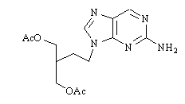

Feedback: The structure is famciclovir which is a prodrug for penciclovir. Desciclovir is an analogue of aciclovir and cidofovir is an analogue of deoxycytidine 5-monophosphate.
Page reference: 447-448
*a. Penciclovir
b. Famciclovir
c. Cidofovir
d. Desciclovir

Type: multiple choice question
Title: Chapter 17 Question 09
09) The activated form of aciclovir has a second mechanism of action other than enzyme inhibition. What is it?
Feedback: Once the drug is activated to the triphosphate derivative, it can be incorporated into the growing DNA chain. Since the sugar moiety is incomplete, no further nucleotides can be added and chain growth stops.
Page reference: 444-446
a. Antagonism of a receptor
*b. Chain terminator for DNA
c. Alkylating agent for DNA
d. Blocking a carrier protein in the cell membrane

Type: matching question
Title: Chapter 17 - Question 10
10) What nucleosides are mimicked by the following structures?

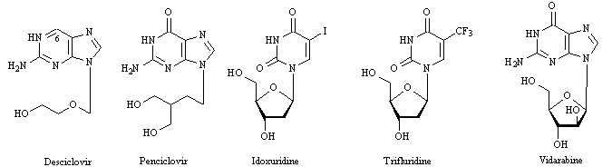

Feedback: The nucleosides that are mimicked can be determined by identifying the nucleic acid base that is present on each drug. In the case of desciclovir, the nucleic acid moiety undergoes metabolic oxidation in the body such that a carbonyl group is introduced. This results in the formation of the nucleic acid base, guanine.
Page reference: 445-449, 117
a. Desciclovir = Deoxyguanosine (1) b. Penciclovir = Deoxyguanosine (2) c. Idoxuridine = Deoxythymidine (1) d. Trifluridine = Deoxythymidine (2) e. Vidarabine = Deoxyguanosine (3)
Type: multiple choice question
Title: Chapter 17 Question 11
11) What nucleotide is mimicked by cidofovir?

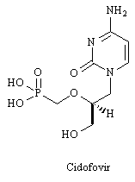
Feedback: Cidofovir contains the nucleic acid base cytosine. It also has a phosphonomethylene group to mimic a monophosphate group.
Page reference: 447
a. Deoxyadenosine monophosphate
b. Deoxythymidine monophosphate
*c. Deoxycytidine monophosphate
d. Deoxyguanosine monophosphate

Type: multiple choice question
Title: Chapter 17 Question 12
12) What disadvantage might the following structure have as an antiviral agent compared to cidofovir?

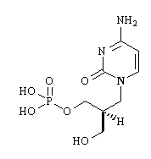
Feedback: Since the structure has a phosphate group, it is susceptible to enzymatic hydrolysis. The other options are not valid. The structure could be phosphorylated to the active triphosphate if it reached infected cells, but most of it will get hydrolysed before it does so. The drug is no more polar or hydrophobic than cidofovir, and so this is not a disadvantage either.
Page reference: 447
a. It will not be activated to the active drug
*b. It is susceptible to hydrolysis
c. It is too polar
d. It is too hydrophobic

Type: multiple choice question
Title: Chapter 17 Question 13
13) What sort of nucleic acid is carried by HIV?
Feedback: HIV contains two identical molecules of single stranded RNA which are identical to the messenger RNA used to code for viral proteins.
Page reference: 450
a. (+) ssDNA
b. dsDNA
c. (-) ssRNA
*d. (+) ssRNA

Type: multiple choice question
Title: Chapter 17 Question 14
14) What is the target for the following structure (zidovudine)?

Feedback: The activated form of is a reverse transcriptase inhibitor.
Page reference: 452-453
a. Integrase
b. Protease
*c. Reverse transcriptase
d. DNA polymerase

Type: multiple choice question
Title: Chapter 17 Question 15
15) What is the active form of zidovudine?

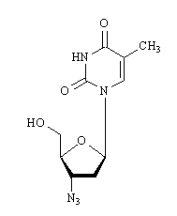
Feedback: Once the triphosphate is formed it can mimic the natural nucleotide building blocks of DNA. This allows it to be recognised by the target enzyme more readily.
Page reference: 452-453
a. The structure itself
b. The monophosphate
c. The diphosphate
*d. The triphosphate

Type: multiple choice question
Title: Chapter 17 Question 16
16) What nucleoside does zidovudine mimic?

Feedback: Zidovudine contains the nucleic acid base thymine and a deoxyribose sugar where an azide group has replaced a hydroxy group.
Page reference: 452-453
a. Deoxyadenosine
*b. Deoxythymidine
c. Deoxycytidine
d. Deoxyguanosine

Type: multiple choice question
Title: Chapter 17 Question 17
17) How many protein units make up the HIV protease enzyme?
Feedback: There are two identical protein subunits making up the protease enzyme. The protease enzyme is symmetrical.
Page reference: 456
a. 1
*b. 2
c. 3
d. 4

Type: multiple choice question
Title: Chapter 17 Question 18
18) The HIV protease enzyme can catalyse the hydrolysis of a particular peptide bond that is not hydrolysed by mammalian proteases. Between which amino acids does this take place?
Feedback: The protease enzyme catalyses the hydrolysis of peptide bonds between proline and phenylalanine where the N-terminus of proline is linked to the C-terminus of phenylalanine.
Page reference: 456
a. Phenylalanine and lysine
b. Proline and lysine
c. Phenylalanine and tyrosine
*d. Proline and phenylalanine

Type: multiple choice question
Title: Chapter 17 Question 19
19) The following structure (saquinavir) is a protease inhibitor.

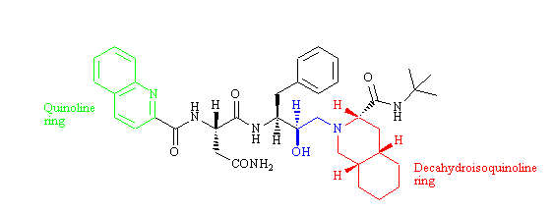
How many binding subsites of the protease active site are occupied by substituents of the above structure?
Feedback: The binding sites that are occupied are S1-S3 and S1'-S2'.
Page reference: 460-461
a. 1
b. 3
*c. 5
d. 7

Type: multiple choice question
Title: Chapter 17 Question 20
20) The following structure (saquinavir) is a protease inhibitor.

How many binding subsites of the protease active site are occupied by substituents of the above structure?
Feedback: The binding sites that are occupied are S1-S3 and S1'-S2'.
Page reference: 460-461
a. 1
b. 3
*c. 5
d. 7

Type: multiple choice question
Title: Chapter 17 Question 21
21) Which substituent is the ideal binding group for the S1 binding pocket of HIV-protease?
Feedback: The benzyl group is the residue that is present on the amino acid phenylalanine.
Page reference: 461
a. Phenyl (-Ph)
b. Phenethyl (CH2CH2Ph)
*c. Benzyl (-CH2Ph)
d. -CH2CONH2

Type: multiple choice question
Title: Chapter 17 Question 22
22) The following structure (ritonavir) is a protease inhibitor.

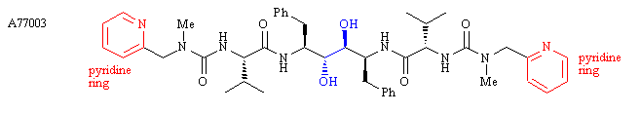
The structure A77003 (below) was an early compound in the design of ritonavir. This contained a diol shown in blue. One of these hydroxyl groups was subsequently removed. Why?

Feedback: Both hydroxy groups are involved in hydrogen bonding interactions, but one of the hydroxy groups is more involved than the other. Removing one of the OH groups results in less binding interactions but there is a net gain in binding stability since less energy is required to desolvate one hydroxyl group prior to binding than having to desolvate two such groups.
The hydroxyl group that was removed was not acting as a steric shield and was not causing the molecule to bind in an inactive mode.
Page reference: 462-466
a. The group that was removed was not taking part in any hydrogen bonding interactions with the active site.
b. The hydroxyl group that was removed was acting as a steric shield and preventing the molecule from binding properly.
*c. Removing the hydroxyl group reduced the energy penalty associated with desolvation prior to binding.
d. The group that was removed was participating in a hydrogen bonding interaction that caused the molecule to bind in an inactive mode.

Type: multiple choice question
Title: Chapter 17 Question 23
23) The following structure (ritonavir) is a protease inhibitor.

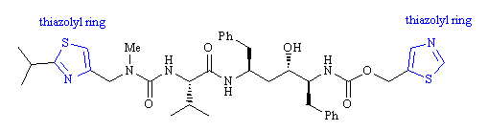

The structure A77003 (below) was an early compound in the design of ritonavir. The pyridine rings in A77003 were replaced with thiazolyl heterocycles. Why?

Feedback: The pyridine rings were prone to metabolism leading to N-oxides which were quickly excreted, mainly in bile. The thiazolyl rings were less susceptible to this form of metabolism.
Page reference: 462-466
*a. The pyridine rings were susceptible to metabolic oxidation.
b. The thiazolyl rings were smaller and decreased the molecular weight.
c. The nitrogen atoms of the pyridine rings could be protonated and make the drug too polar.
d. The thiazolyl rings fitted better into binding pockets than the pyridine rings.

Type: multiple choice question
Title: Chapter 17 Question 24
24) The following structure (ritonavir) is a protease inhibitor.

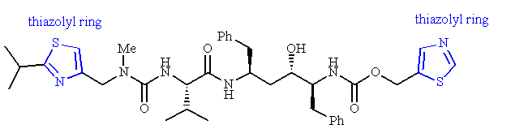e"]

A mutation in the protease enzyme results in resistance to ritonavir. Which mutation takes place?
Feedback: The isopropyl side chain of valine has an important van der Waals interaction with an isopropyl substituent on ritonavir. Altering this amino acid eliminates the interaction and results in weaker binding and weaker activity.
Page reference: 466
*a. Replacement of valine at position 82 with alanine, threonine or phenylalanine.
b. Replacement of alanine at position 82 with valine, threonine or phenylalanine.
c. Replacement of phenylalanine at position 82 with valine, threonine or alanine.
d. Replacement of threonine at position 82 with valine, alanine or phenylalanine.

Type: multiple choice question
Title: Chapter 17 Question 25
25) Ritonavir is a protease inhibitor.

A mutation in the protease enzyme results in resistance to ritonavir. An important interaction between the drug and the active site is lost as a result of the mutation. Which group in ritonavir is involved in this interaction?

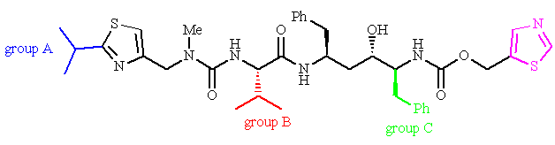
Feedback: The isopropyl group A forms a hydrophobic interaction with the isopropyl side chain present on valine.
Page reference: 466
*a. Group A
b. Group B
c. Group C
d. Group D

Type: multiple choice question
Title: Chapter 17 Question 26
26) The following structure (ritonavir) is a protease inhibitor.

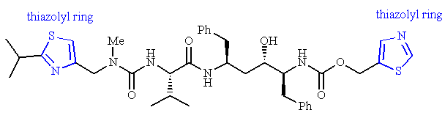
The following structure was developed from ritonavir and is active against viral strains that are resistant to ritonavir. What is it called?

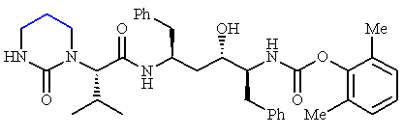
Feedback: Lopinavir is the name of the structure. Saquinavir was the first clinically useful protease inhibitor. Aciclovir is not a protease inhibitor. Nelfinavir is a protease inhibitor, but it was not developed from ritonavir.
Page reference: 465-466
a. Nelfinavir
*b. Lopinavir
c. Saquinavir
d. Aciclovir

Type: multiple choice question
Title: Chapter 17 Question 27
27) Lopinavir is a protease inhibitor that was developed from ritonavir.

Lopinavir is active against viral strains that are resistant to ritonavir. What is the significance of the region shown in blue in lopinavir?

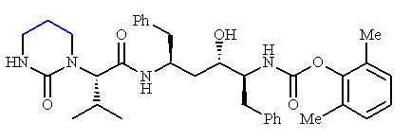
Feedback: The ring imparts conformational restraint on the urea functional group. This enhances H-bonding interactions between the urea group and the S2 subsite.
Page reference: 465-466
a. It is involved in a hydrophobic interaction with the active site.
*b. It acts as a conformational restraint for the urea group.
c. It acts as a conformational blocker and orientates the rest of the chain.
d. It prevents one of the nitrogens of the urea group acting as a hydrogen bond donor.

Type: multiple choice question
Title: Chapter 17 Question 28
28) What feature of the protease active site permits a hybridisation strategy to be used in the design of protease inhibitors?
Feedback: Since the active site is symmetrical, inhibitors can bind 'left to right' or 'right to left'. Since that is the case, it is feasible to take the right hand half of one inhibitor and link it to the left hand half of a different inhibitor.
The other statements above are perfectly correct but do not explain why the hybridisation strategy is feasible. For example, one option indicates that there are the same number of subsites in either half, but does not indicate that the subsites in one half are identical to the corresponding subsites in the other half.
Page reference: 466-467
a. There are two aspartate residues in the active site which are involved in the catalytic mechanism of the enzyme.
b. There are two isoleucine residues in the flap region of the active site.
*c. The active site is symmetrical.
d. There are the same number of subsites in one half of the active site as the other half.

Type: multiple choice question
Title: Chapter 17 Question 29
29) What advantage is there in replacing the benzyl group at the P1 position of a protease inhibitor with a PhSCH2 group?
Feedback: Incorporating a sulphur atom extends the side chain allowing simultaneous binding to the S1 and S3 subsites.
Page reference: 467
a. The new group fits the S1 subsite more efficiently.
b. The new group binds to the S1 and S2 subsites simultaneously.
*c. The new group binds to the S1 and S3 subsites simultaneously.
d. The new group binds to the S3 subsite rather than the S1 subsite.

Type: multiple choice question
Title: Chapter 17 Question 30
30) Which of the following protease inhibitors incorporates a residue that is capable of interacting simultaneously with two different subsites?
Feedback: Nelfinavir has an extended P1 residue that can bind simultaneously to both the S1 and S3 subsites.
Page reference: 467
*a. Nelfinavir
b. Palinavir
c. Saquinavir
d. Amprenavir

Type: multiple choice question
Title: Chapter 17 Question 31
31) The following protease inhibitor (palinavir) illustrates an extension strategy involving the group shown in blue.

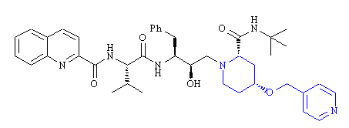
Which protease inhibitor does palinavir mimic on its left hand side?
Feedback: The left hand side or N-terminus side is most closely related to the N-terminus side of saquinavir in that both structures contain identical P1 and P3 side chains. However, the P2 side chain is different and so the molecules are not identical on this side
Page reference: 468
a. Nelfinavir
b. Indinavir
*c. Saquinavir
d. Amprenavir

Type: multiple choice question
Title: Chapter 17 Question 32
32) Amprenavir is a protease inhibitor developed by Verrtx Pharmaceuticals. What was the lead compound for this structure?

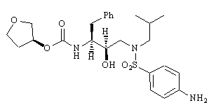
Feedback: Saquinavir was the lead compound for amprenavir. The aim was to improve oral bioactivity by decreasing the molecular weight and peptide character of the structure.
Page reference: 468-469
a. Nelfinavir
b. Palinavir
*c. Saquinavir
d. Amprenavir

Type: multiple choice question
Title: Chapter 17 Question 33
33) What sort of nucleic acid is carried by the flu virus?
Feedback: The flu virus contains single stranded RNA. It is a negative copy which means that it is complementary to the messenger RNA used to code for viral proteins.
Page reference: 471
*a. (-)ssRNA
b. (+)ssRNA
c. dsRNA
d. dsDNA

Type: multiple choice question
Title: Chapter 17 Question 34
34) Which type of influenza virus is most susceptible to mutations?
Feedback: Mutations occur almost yearly with influenza A, but much more slowly with influenza B. Mutations do not appear to occur at a significant rate for influenza C.
Page reference: 473
*a. Influenza A
b. Influenza B
c. Influenza C
d. None of the answers are correct. They are all equally susceptible

Type: multiple choice question
Title: Chapter 17 Question 35
35) Amantadine was one of the earliest antiviral drugs used clinically against the influenza virus.

What is its mechanism of action at low concentration?
Feedback: At high concentration, amantadine acts as a buffer. At low concentrations, it blocks a viral ion channel. It does not bind to viral nucleic acid or to a viral enzyme.
Page reference: 473
a. It acts as a base and buffers the pH of endosomes, preventing the acidic pH required for fusion to take place between the viral membrane and that of the endosome.
b. It binds to viral nucleic acid and prevents replication and transcription.
*c. It binds to a specific region of a viral ion channel and blocks it.
d. It binds to a viral enzyme and inhibits it.

Type: multiple choice question
Title: Chapter 17 Question 36
36) Amantadine was one of the earliest antiviral drugs used clinically against the influenza virus.

What is its mechanism of action at high concentration?
Feedback: At high concentration, amantadine acts as a buffer. At low concentrations, it blocks a viral ion channel. It does not bind to viral nucleic acid or to a viral enzyme.
Page reference: 473
*a. It acts as a base and buffers the ph of endosomes, preventing the acidic ph required for fusion to take place between the viral membrane and that of the endosome.
b. It binds to viral nucleic acid and prevents replication and transcription.
c. It binds to a specific region of a viral ion channel and blocks it.
d. It binds to a viral enzyme and inhibits it.

Type: multiple choice question
Title: Chapter 17 Question 37
37) Sialic acid binds to the active site of neuraminidase. Which feature of sialic acid has the most significant binding interaction?

Feedback: All the functional groups mentioned have a binding role, but the carboxylate ion is able to form the strongest interaction since it is ionic.

Page reference: 474
a. The triol
*b. The carboxylate ion
c. The amide
d. The alcohol

Type: multiple choice question
Title: Chapter 17 Question 38
38) Zanamivir has been used in the treatment of influenza.

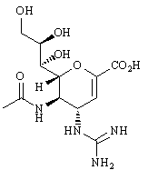
What is the target for the above structure?
Feedback: Hemagglutinin is a glycoprotein on the surface of the flu virus which plays a role in the adsorption process. RNA and DNA polymerases are enzymes that catalyse the synthesis of RNA and DNA respectively. RNA polymerase is carried by the flu virus but not DNA polymerase. Neuraminidase is an enzyme on the surface of the flu virus that catalyses the splitting of sialic acid from glycoproteins or glycolipids. This is the target for zanamivir and oseltamivir.
Page reference: 475-478
a. Hemagglutinin
b. RNA polymerase
c. DNA polymerase
*d. Neuraminidase

Type: multiple choice question
Title: Chapter 17 Question 39
39) Zanamivir has been used in the treatment of influenza.

What sort of drug is it?
Feedback: The drug mimics the transition state for the catalytic reaction carried out by neuraminidase, but is stable to the catalytic process.
Page reference: 475-478
a. Antagonist
b. Prodrug
c. Suicide substrate
*d. Transition state inhibitor

Type: multiple choice question
Title: Chapter 17 Question 40
40) Zanamivir has been used in the treatment of influenza.

How many binding pockets are used by zanamivir when it binds to the target binding site?
Feedback: The inhibitor binds to the same four binding pockets as the natural substrate.
Page reference: 475-478
a. 1
b. 2
c. 3
*d. 4

Type: multiple choice question
Title: Chapter 17 Question 41
41) Zanamivir has been used in the treatment of influenza.

What molecular modelling software program was used in the design of zanamivir?
Feedback: GRID was used to identify the likely binding regions within a model active site.
Page reference: 475-478
a. DOCK
*b. GRID
c. CoMFA
d. Monte-Carlo

Type: multiple choice question
Title: Chapter 17 Question 42
42) Oseltamivir is an antiviral drug used against influenza.

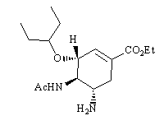
What is the target for oseltamivir?
Feedback: Hemagglutinin is a glycoprotein on the surface of the flu virus which plays a role in the adsorption process. RNA and DNA polymerases are enzymes that catalyse the synthesis of RNA and DNA respectively. RNA polymerase is carried by the flu virus but not DNA polymerase. Neuraminidase is an enzyme on the surface of the flu virus that catalyses the splitting of sialic acid from glycoproteins or glycolipids. This is the target for zanamivir and oseltamivir

Page reference: 479-481
a. Hemagglutinin
b. RNA polymerase
c. DNA polymerase
*d. Neuraminidase

Type: multiple choice question
Title: Chapter 17 Question 43
43) Oseltamivir is an antiviral drug used against influenza.

What sort of drug is it?
Feedback: The drug mimics the transition state for the catalytic reaction carried out by neuraminidase, but is stable to the catalytic process.
Page reference: 479-481
a. Antagonist
b. Prodrug
c. Suicide substrate
*d. Transition state inhibitor

Type: multiple choice question
Title: Chapter 17 Question 44
44) The following drug entered phase III clinical trials for the treatment of the cold virus.

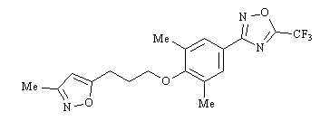
What is it called?
Feedback: Pleconaril entered phase III clinical trials for the treatment of the cold virus. Disoxaril also entered clinical trials but proved too toxic. Zanamivir and oseltamivir are active against the flu virus and not the cold virus.
Page reference: 484
*a. Pleconaril
b. Disoxaril
c. Zanamivir
d. Oseltamivir

Type: multiple choice question
Title: Chapter 17 Question 45
45) Pleconaril entered phase III clinical trials for the treatment of the cold virus.

What is the target for pleconaril?
Feedback: The target is a protein which is a constituent of the viral protein coat.
Page reference: 483-484
a. Viral nucleic acid
b. A viral enzyme
c. An antigen on infected host cells
*d. A capsid protein

Type: multiple choice question
Title: Chapter 17 Question 46
46) Pleconaril entered phase III clinical trials for the treatment of the cold virus.

How does pleconaril have an antiviral effect?
Feedback: The drug stabilises the viral protein coat and prevents the uncoating process.
Page reference: 483-484
a. It blocks the replication and transcription of viral nucleic acid
*b. It prevents the uncoating process
c. It inhibits an enzyme catalysed reaction
d. It prevents adsorption

Type: multiple choice question
Title: Chapter 17 - Question 47
47) Which is the normal order of the following events in the life cycle of viruses?
Feedback: The life cycle starts with the virus adsorbing or attaching to the cell membrane of the host cell. Penetration then takes place with uncoating to free the viral nucleic acid. Replication and transcription leads to new viral protein allowing the assembly of nucleocapsids. Finally, the virus departs the host cell, usually by budding.
Page reference: 441-442
a. Penetration, uncoating, replication and transcription, budding, assembly of nucleopcapsids
b. Budding, uncoating, penetration, replication and transcription, assembly of nucleocapsids
c. Uncoating, penetration, replication and transcription, assembly of nucleocapsids, budding
*d. Uncoating, penetration, replication and transcription, assembly of nucleocapsids, budding

Type: matching question
Title: Chapter 17 - Question 48
48) Match the following structures to the antiviral drugs below:

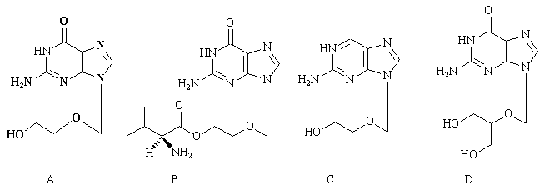

Feedback: The structure is now known as aciclovir. The old spelling was acyclovir. Valaciclovir is an L-valyl prodrug of aciclovir. Desciclovir is an analogue of aciclovir that lacks a carbonyl group.
Page reference: 444-448
a. Desciclovir = Structure C
b. Aciclovir = Structure A
c. Valaciclovir = Structure B
d. Gangciclovir = Structure D

Type: matching question
Title: Chapter 17 - Question 49
49) Match the following structures to the antiviral agents:

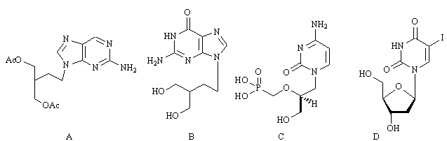

Feedback: Famciclovir is a prodrug for penciclovir. Cidofovir is an analogue of deoxycytidine 5-monophosphate. Idoxuridine is an analogue of deoxythymidine
Page reference: 444-448
a. Penciclovir = Structure B
b. Cidofovir = Structure C
c. Idoxuridine = Structure D
d. Famciclovir = Structure A

Type: multiple choice question
Title: Chapter 17- Question 50
50) Which of the following statements comparing cidofovir with aciclovir is true?
Feedback: Cidofovir is more polar than aciclovir due to the phosphonomethylene group. As a result it has poorer oral bioavailability. It also has toxic side effects for the kidneys.
The drug has the equivalent of a monophosphate group and so it is active against viral strains that lack the viral thymidine kinase required to activate aciclovir and related compounds. This gives cidofovir a broader spectrum of activity.
Page reference: 444-448
*a. It has poorer oral bioavailability
b. It is less polar
c. It has a narrower spectrum of activity
d. It has fewer side effects

Type: multiple choice question
Title: Chapter 17- Question 51
51) Which of the following targets is not a current or potential drug target in anti-HIV therapy?
Feedback: Neuraminidase is a drug target in tackling the flu virus but not HIV.
Page reference: 450-452
a. Reverse transcriptase
b. Integrase
c. Protease
*d. Neuraminidase

Type: multiple choice question
Title: Chapter 17- Question 52
52) What role does the enzyme reverse transcriptase have in the HIV life cycle?
Feedback: The enzyme integrase is responsible for incorporating viral DNA into host DNA once it has been synthesised. The enzyme protease is responsible for processing the viral proteins of HIV following transcription and translation. The enzyme reverse transcriptase is responsible for catalysing the synthesis of viral DNA from single stranded RNA once HIV has infected the host cell. The glycoprotein gp120 along with gp41 are crucial to the adsorption and penetration of the virus.
Page reference: 450-451
a. It catalyses the incorporation of HIV DNA into host DNA
b. It processes HIV proteins during the production of new viruses
*c. It catalyses the synthesis of HIV DNA in the host cell
d. It is crucial to adsorption and penetration of the virus

Type: multiple choice question
Title: Chapter 17- Question 53
53) What role does the enzyme integrase have in the HIV life cycle?
Feedback: The enzyme integrase is responsible for incorporating viral DNA into host DNA once it has been synthesised. The enzyme protease is responsible for processing the viral proteins of HIV following transcription and translation. The enzyme reverse transcriptase is responsible for catalysing the synthesis of viral DNA from single stranded RNA once HIV has infected the host cell. The glycoprotein gp120 along with gp41 are crucial to the adsorption and penetration of the virus.
Page reference: 450-451
*a. It catalyses the incorporation of HIV DNA into host DNA
b. It processes HIV proteins during the production of new viruses
c. It catalyses the synthesis of HIV DNA in the host cell
d. It is crucial to adsorption and penetration of the virus

Type: multiple choice question
Title: Chapter 17- Question 54
54) What role does the enzyme protease have in the HIV life cycle?
Feedback: The enzyme integrase is responsible for incorporating viral DNA into host DNA once it has been synthesised. The enzyme protease is responsible for processing the viral proteins of HIV following transcription and translation. The enzyme reverse transcriptase is responsible for catalysing the synthesis of viral DNA from single stranded RNA once HIV has infected the host cell. The glycoprotein gp120 along with gp41 are crucial to the adsorption and penetration of the virus.
Page reference: 450-451
a. It catalyses the incorporation of HIV DNA into host DNA
*b. It processes HIV proteins during the production of new viruses
c. It catalyses the synthesis of HIV DNA in the host cell
d. It is crucial to adsorption and penetration of the virus

Type: multiple choice question
Title: Chapter 17- Question 55
55) What role does the glycoprotein gp120 have in the HIV life cycle?
Feedback: The enzyme integrase is responsible for incorporating viral DNA into host DNA once it has been synthesised. The enzyme protease is responsible for processing the viral proteins of HIV following transcription and translation. The enzyme reverse transcriptase is responsible for catalysing the synthesis of viral DNA from single stranded RNA once HIV has infected the host cell. The glycoprotein gp120 along with gp41 are crucial to the adsorption and penetration of the virus.
Page reference: 450-451
a. It catalyses the incorporation of HIV DNA into host DNA
b. It processes HIV proteins during the production of new viruses
c. It catalyses the synthesis of HIV DNA in the host cell
*d. It is crucial to adsorption and penetration of the virus

Type: matching question
Title: Chapter 17 - Question 56
56) Match the following structures with the correct drugs:

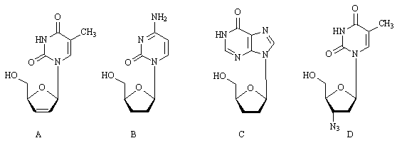
Feedback: All the structures are nucleoside like, in that they have a nucleic acid base attached to a five membered ring which mimics a sugar ring. All the structures inhibit the reverse transcriptase enzyme.
Page reference: 452-453
a. Zidovudine = Structure D
b. Didanosine = Structure C
c. Stavudine = Structure A
d. Zalcitabine = Structure B

Type: matching question
Title: Chapter 17 – Question 57
57) Match the following structures to the following drugs

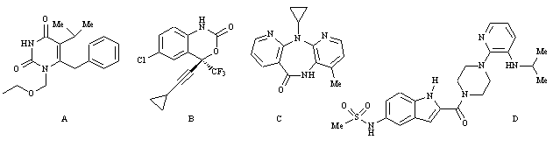

Feedback: All four compounds are examples of non-nucleoside reverse transcriptase inhibitors.
Page reference: 453-455
a. Nevirapine = Structure C
b. Delavirdine = Structure D
c. Efavirenz = Structure B
d. Emivirine = Structure A

Type: multiple choice question
Title: Chapter 17- Question 58
58) Which of the following statements is true regarding nevirapine?

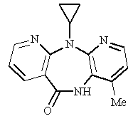
Feedback: Nevirapine is a chiral molecule that binds to an allosteric binding site next to the active site of reverse transcriptase. It bears no resemblance to a nucleoside and it is a first generation, non-nucleoside reverse transcriptase inhibitor.
Page reference: 453-455
*a. It is a non nucleoside reverse transcriptase inhibitor (NNRTI).
b. It binds to the substrate binding site of reverse transcriptase.
c. It is an achiral molecule.
d. It is an example of a second generation drug of its class.

Type: multiple choice question
Title: Chapter 17- Question 59
59) Which of the following statements is true for non-nucleoside reverse transcriptase inhibitors?
Feedback: The non-nucleoside reverse transcriptase inhibitors bind to an allosteric binding site next to the active site of reverse transcriptase. Since they do not occupy the active site, they can be used alongside nucleoside reverse transcriptase inhibitors which do occupy the active site. There are significant binding interactions between second and third generation NNRTI's and the main protein chain in the binding site. Resistance can arise due to a mutation where lysine is mutated to asparagine.
Page reference: 453-455
a. They cannot be used alongside nucleoside reverse transcriptase inhibitors.
b. They bind to the active site.
*c. Resistance can arise due to a mutation where a lysine in the target binding site is mutated to asparagine.
d. Binding interactions between NNRTI's and the main protein chain in the binding site are not important.

Type: multiple choice question
Title: Chapter 17- Question 60
60) What role do the aspartate residues Asp 25 and Asp 25' play in the HIV protease enzyme?
Feedback: Aspartic acid 25 and 25' are involved in the catalytic mechanism which hydrolyses the peptide bond of a protein substrate.
Page reference: 455-459
a. They bind directly to the substrate.
*b. They are involved in the catalytic mechanism which leads to peptide bond hydrolysis in a protein substrate.
c. They are located in the flap region of the protease active site and are involved in binding a water molecule. The latter acts as a hydrogen bonding bridge to a bound protein substrate.
d. They have no significant role.

Type: multiple choice question
Title: Chapter 17- Question 61
61) What role do the isoleucine residues Ile 50 and Ile 50' play in the HIV protease enzyme?
Feedback: The amino acids concerned do not bind directly to the substrate and are not involved directly with the mechanism.
Page reference: 455-459
a. They bind directly to the substrate.
b. They are involved in the catalytic mechanism which leads to peptide bond hydrolysis in a protein substrate.
*c. They are located in the flap region of the protease active site and are involved in binding a water molecule. The latter acts as a hydrogen bonding bridge to a bound protein substrate.
d. They have no significant role.

Type: multiple choice question
Title: Chapter 17- Question 62
62) Which statement is false?
Feedback: Only the HIV protease enzyme is symmetrical. Since there is a significant difference between the HIV protease enzyme and mammalian protease enzymes in terms of symmetry, it is feasible that inhibitors could be designed which would show selectivity for the viral enzyme over the mammalian enzymes.
Page reference: 455-459
*a. Both mammalian and HIV protease enzymes are symmetrical.
b. It is possible to design inhibitors that prove selective for the HIV protease over mammalian proteases.
c. The protease enzyme of HIV hydrolyses peptide bonds in protein substrates.
d. The protease enzyme in the HIV enzyme has a different substrate selectivity from protease enzymes in humans, despite catalysing the same reaction.

Type: matching question
Title: Chapter 17 - Question 63
63) Match the following structures to the antiviral agents stated below.

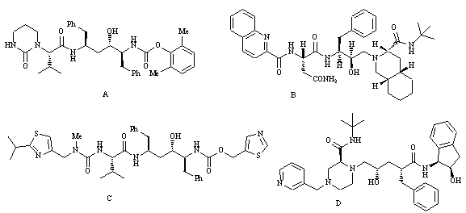

Feedback: All these agents are protease inhibitors.
Page reference: 459-469
a. ritonavir = Structure C
b. lopinavir = Structure A
c. saquinavir = Structure B
d. indinavir = Structure D

Type: matching question
Title: Chapter 17 - Question 64
64) The following structure is saquinavir. Match the coloured moieties (A-E) to the following binding subsites in the HIV protease active site.

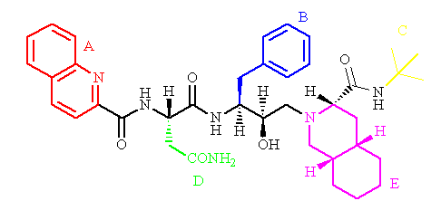

Feedback: The coloured moieties mimic the amino acid residues of protein substrates that would normally fit into these binding subsites.
Page reference: 459-461
a. subsite S1' = Moiety E
b. subsite S2' = Moiety C
c. subsite S1 = Moiety B
d. subsite S2 = Moiety D
e. subsite S3 = Moiety A

Type: multiple choice question
Title: Chapter 17- Question 65
65) The following structure is saquinavir. Which coloured moiety forms a hydrogen bond to Asp25 and Asp25' when the drug is bound to the active site of the HIV protease enzyme?

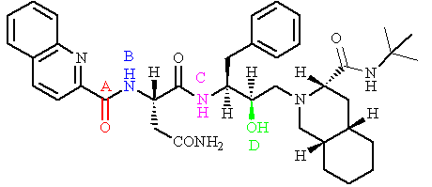

Feedback: The hydroxy group is part of a hydroxyethylamine transition state isostere that mimics a peptide bond but is not hydrolysed.
Page reference: 459-461
a. Moiety A
b. Moiety B
c. Moiety C
*d. Moiety D

Type: multiple choice question
Title: Chapter 17- Question 66
66) The following structure is saquinavir. Which moiety acts as a transition state isostere?

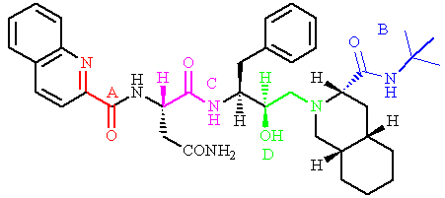
Feedback: Moiety D is a hydroxyylamine moiety which mimics the transition state for the catalytic reaction. It is stable to the catalytic reaction.
Page reference: 459-461
a. Moiety A
b. Moiety B
c. Moiety C
*d. Moiety D

Type: matching question
Title: Chapter 17 - Question 67
67) The following structure is saquinavir. Match the following groups to the coloured moieties shown (A-E)

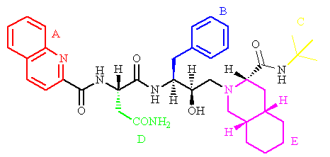
Feedback: The moieties shown are designed to fit the enzyme binding subsites that would normally be occupied by the amino acid residues of protein substrates.
Page reference: 459-461
a. Quinoline ring = Moiety A
b. Decahydroisoquinoline ring = Moiety E
c. Benzyl group = Moiety B
d. Tertiary butyl group = Moiety C
e. Asparagine residue = Moiety D

Type: multiple choice question
Title: Chapter 17- Question 68
68) The following structure is saquinavir.

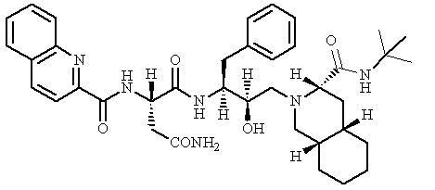

Which of the following structures was the initial lead compound used in the design of saquinavir?

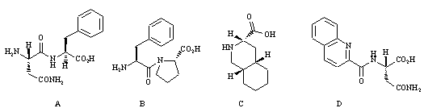

Feedback: Structure A is the dipeptide L-phenylalanyl-L-proline. This dipeptide is hydrolysed by the HIV protease enzyme but not by mammalian protease enzymes. Since it alredy shows selectivity, inhibitors developed from this substrate have a good chance of showing selectivity as well.
Page reference: 459-461
*a. Structure A
b. Structure B
c. Structure C
d. Structure D

Type: multiple choice question
Title: Chapter 17- Question 69
69) The dipeptide L-phenylalanyl-L-proline was chosen as the lead compound for the development of saquinavir. Which of the following statements is the best explanation for this choice?
Feedback: The dipeptide was susceptible to hydrolysis. If it had been stable, it would have been a poor choice as a lead compound since it is unlikely that it could bind efficiently to the active site. As a result, analogues would be unlikely to bind as well. There is nothing wrong with the statement 'the residues of the two constituent amino acids fit binding subsites in the active site and so analogues will be easily recognised and bound strongly.' However, that would not be a reason in itself for choosing this dipeptide. If the dipeptide also was bound strongly to mammalian proteases, there would be little chance of achieving inhibitor selectivity. The dipeptides of all the naturally occurring amino acids are easy to synthesise.
Page reference: 459-461
a. the dipeptide is stable to hydrolysis by the HIV protease and so any analogues are likely to act as inhibitors rather than substrates
b. The residues of the two constituent amino acids fit binding subsites in the active site and so analogues will be easily recognised and bound strongly
*c. the HIV protease catalyses the hydrolysis of the dipeptide whereas mammalian proteases do not. This allows the possibility of target selectivity.
d. the dipeptide was easy to synthesise compared to other dipeptides and so subsequent analogues would also be easily obtainable

Type: multiple choice question
Title: Chapter 17- Question 70
70) Which of the following protease inhibitors was developed from a symmetrical lead compound?
Feedback: The early structures leading to ritonavir were symmetrical molecules which took advantage of the symmetrical nature of the active site in the HIV protease enzyme.
Page reference: 462-466
*a. Ritonavir
b. Nelfinavir
c. Saquinavir
d. Indinavir

Type: multiple choice question
Title: Chapter 17- Question 71
71) The lead compound and early structures leading to the important protease inhibitors ritonavir and lopinavir were symmetrical molecules. Why were symmetrical molecules chosen?
Feedback: They were easy to synthesise and could bind left to right or right to left in the symmetrical binding site, increasing the chances of good activity but these were not the principal reasons for choosing symmetrical lead compounds. The molecules may have been symmetrical but they still contained chiral centres.
Page reference: 462-466
a. They were easy to synthesise.
b. They did not have chiral centres.
*c. The binding site for the HIV protease enzyme is symmetrical whereas the binding sites for mammalian proteases are not
d. They could bind left to right or right to left in the symmetrical binding site, increasing the chances of good activity.

Type: multiple choice question
Title: Chapter 17- Question 72
72) Which of the following protease inhibitors was developed using a hybrid strategy?
Feedback: Indinavir was developed by linking one half of a structure containing a hydroxyethylene transition state isostere with one half of saquinavir.
Page reference: 466-467
a. Ritonavir
b. Lopinavir
c. Saquinavir
*d. Indinavir

Type: matching question
Title: Chapter 17 - Question 73
73) Match the following structures to the following protease inhibitors

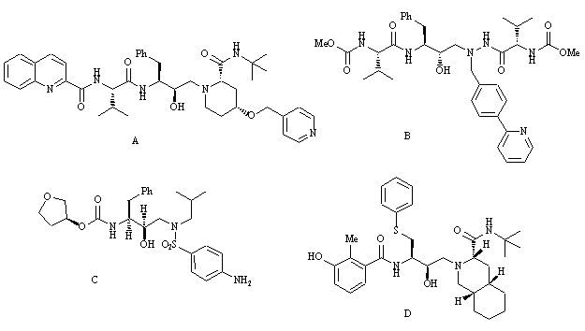
Feedback: All four structures contain a hydroxylamine transition state isostere in place of the peptide bond which would normally be hydrolysed by the enzyme.
Page reference: 467-469
a. Nelfinavir = Structure D
b. Palinavir = Structure A
c. Atazanavir = Structure B
d. Amprenavir = Strcuture C

Type: multiple choice question
Title: Chapter 17- Question 74
74) Palinavir is an HIV protease inhibitor. Which of the following statements is true regarding the group coloured blue?

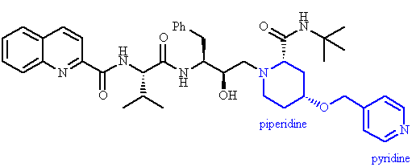

Feedback: The blue coloured moiety spans two binding subsites and does away with the need for two separate binding groups. As a result, the molecular weight of the molecule is decreased.
Page reference: 468
a. The moiety in blue was added such that water solubility could be increased with the addition of a pyridine ring.
*b. The moiety in blue was designed to span the two binding subsites (S1' and S3').
c. The moiety in blue was added such that the pyridine ring could form a hydrogen bonding interaction with a binding region not normally accessible to protein substrates.
d. The blue coloured moiety was added as a steric shield to prevent hydrolysis of the C-terminal peptide bond.

Type: multiple choice question
Title: Chapter 17- Question 75
75) Neuraminidase is an enzyme carried by the flu virus. What role does it play?
Feedback: Hemagglutinin is a glycoprotein on the surface of the flu virus which plays a role in the adsorption process. RNA and DNA polymerases are enzymes that catalyse the synthesis of RNA and DNA respectively. Neuraminidase is an enzyme that catalyses the splitting of sialic acid from glycoproteins or glycolipids.
Page reference: 471-473
a. It plays a role in the adsorption process
b. It catalyses the synthesis of RNA
c. It catalyses the synthesis of DNA
*d. It catalyses the splitting of sialic acid from glycoproteins or glycolipids

Type: multiple choice question
Title: Chapter 17- Question 76
76) Hemagglutinin is a glycoprotein carried by the flu virus. What role does it play?
Feedback: Hemagglutinin is a glycoprotein on the surface of the flu virus which plays a role in the adsorption process. RNA and DNA polymerases are enzymes that catalyse the synthesis of RNA and DNA respectively. Neuraminidase is an enzyme that catalyses the splitting of sialic acid from glycoproteins or glycolipids.
Page reference: 471-473
*a. It plays a role in the adsorption process
b. It catalyses the synthesis of RNA
c. It catalyses the synthesis of DNA
d. It catalyses the splitting of sialic acid from glycoproteins or glycolipids

Type: multiple choice question
Title: Chapter 17- Question 77
77) RNA polymerase is an enzyme carried by the flu virus. What role does it play?
Feedback: Hemagglutinin is a glycoprotein on the surface of the flu virus which plays a role in the adsorption process. RNA and DNA polymerases are enzymes that catalyse the synthesis of RNA and DNA respectively. RNA polymerase is carried by the flu virus but not DNA polymerase. Neuraminidase is an enzyme on the surface of the flu virus that catalyses the splitting of sialic acid from glycoproteins or glycolipids.
Page reference: 471-473
a. It plays a role in the adsorption process.
*b. It catalyses the synthesis of RNA.
c. It catalyses the synthesis of DNA.
d. It catalyses the splitting of sialic acid from glycoproteins or glycolipids.

Type: matching question
Title: Chapter 17 - Question 78
78) The following structures are all used in the treatment of flu. Match the structures against the following drug names.

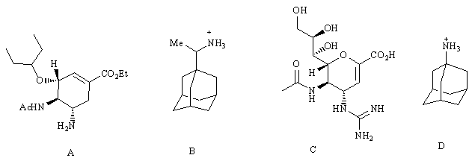

Feedback: Amantadine and rimantadine are examples of adamantanes and represent some of the earliest clinically useful antiviral agents. Zanamivir and oseltamivir are more recent drugs that were developed by rational design as transition state inhibitors.
Page reference: 473-481
a. Zanamivir = Structure C
b. Amantadine = Structure D
c. Rimantadine = Structure B
d. Oseltamivir = Structure A

Type: multiple choice question
Title: Chapter 17- Question 79
79) The following structures are all antiviral agents. What virus are they all used against?

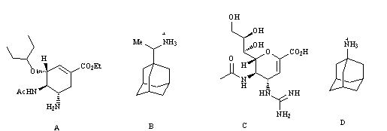
Feedback: Different viruses have different susceptibilities to drugs. It is important to appreciate that the virus responsible for colds is different from the virus responsible for flu. As a result, drugs which are useful in the treatment of flu are not useful in the treatment of colds.
Page reference: 473-482
a. HIV
*b. Flu virus
c. Cold virus
d. Herpesvirus

Type: multiple choice question
Title: Chapter 17- Question 80
80) Which of the following statements is untrue?
Feedback: The vesicles are called endosomes.
Page reference: 441-442, 471-473
a. Some virions are taken into a host cell by a process known as endocytosis which involves the cell membrane wrapping round the virion and being pinched off to produce vesicles.
*b. Vesicles that have brought virions into the host cell are called exosomes.
c. Membrane bound vesicles that contain virions fuse with cell structures called lysosomes.
d. Host cell enzymes can aid the virus in the uncoating process.

Type: multiple choice question
Title: Chapter 17- Question 81
81) Which of the following statements is false regarding the characteristics of a good protein target for antiviral drugs?
Feedback: The ideal target should be shared between various viruses in order to design a drug with a broad antiviral activity.
Page reference: 443-444
a. It should be important to the life cycle of the virus.
b. It should bear little resemblance to human proteins.
*c. It should be unique for a specific virus.
d. It should be important in the early stages of the virus life cycle.

Type: multiple choice question
Title: Chapter 17- Question 82
82) Aciclovir is a prodrug which is phosphorylated in virally infected cells to the active antiviral agent. Which of the following structures is the active agent?

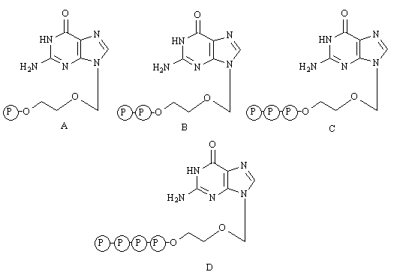
Feedback: It is the triphosphate which is the active compound. The monphosphate and diphosphate are biosynthetic intermediates to the triphosphate. The tetraphosphate is not formed.
Page reference: 444-447
a. Structure A
b. Structure B
*c. Structure C
d. Structure D

