Chapter 16: Antibacterial Agents

Type: multiple choice question
Title: Chapter 16 Question 01
01) What structure do the sulfonamides mimic when acting as enzyme inhibitors?
Feedback: Para-Aminobenzoic acid is a substrate for the enzyme dihydropteroate synthetase. The sulfonamides mimic this feature.
Dihydropteroate is the product from this enzyme catalysed reaction. L-glutamic acid is added to dihydropteroate to form dihydrofolate. Neither are mimicked by the sulfonamides. The sulfonamides are derivatives of para-aminosulfonic acid and so this is not mimicked either.
Page reference: 385
a. Dihydropteroate
b. L-glutamic acid
c. Para-aminosulfonic acid
*d. Para-aminobenzoic acid

Type: multiple choice question
Title: Chapter 16 Question 02
02) Which of the following is the general mechanism of action for sulfonamides?
Feedback: The sulfonamides inhibit dihydropteroate synthetase. Such inhibition prevents the synthesis of pyrimidine nucleic acid bases which in turn prevents the synthesis of nucleic acids.
Page reference: 382
*a. Inhibition of an enzyme required for the synthesis of important nucleic acid building blocks.
b. Inhibition of cell wall synthesis.
c. Disruption of protein synthesis.
d. Inhibition of nucleic acid transcription and replication.

Type: multiple choice question
Title: Chapter 16 Question 03
03) Which of the following is the general mechanism of action for β-lactams?
Feedback: The β-lactams inhibit an enzyme called transpeptidase which is responsible for the last step of cell wall synthesis.
Page reference: 382
a. Inhibition of a metabolic enzyme.
*b. Inhibition of cell wall synthesis.
c. Disruption of protein synthesis.
d. Inhibition of nucleic acid transcription and replication.

Type: multiple choice question
Title: Chapter 16 Question 04
04) Which of the following is the general mechanism of action for vancomycin?
Feedback: Vancomycin binds to the building blocks required for cell wall synthesis and prevents them being incorporated into the growing cell wall.
Page reference: 382
a. Inhibition of a metabolic enzyme.
*b. Inhibition of cell wall synthesis.
c. Disruption of protein synthesis.
d. Inhibition of nucleic acid transcription and replication.

Type: multiple choice question
Title: Chapter 16 Question 05
05) Which of the following is the general mechanism of action for tetracyclines?
Feedback: The tetracyclines bind to ribosomes and inhibit the translation process that normally leads to the synthesis of new proteins.
Page reference: 382
a. Inhibition of a metabolic enzyme.
b. Inhibition of cell wall synthesis.
*c. Disruption of protein synthesis.
d. Inhibition of nucleic acid transcription and replication.

Type: multiple choice question
Title: Chapter 16 Question 06
06) What term is used to describe the inhibition of two different enzymes in the same biosynthetic pathway?
Feedback: Sequential blocking is more effective than inhibiting one or other of the separate enzymes. It allows lower and safer doses of each inhibitor to achieve the same effect as using one inhibitor.
Enzyme inhibition refers to any drug that inhibits an enzyme. Multidrug therapy signifies that more than one drug is used in a therapy but does not mean that the drugs are acting at two different enzymes in the same biosynthetic pathways. Parallel inhibition is not a term that is used in medicinal chemistry.
Page reference: 387
a. Enzyme inhibition
*b. Sequential blocking
c. Parallel inhibition
d. Multidrug therapy

Type: multiple choice question
Title: Chapter 16 Question 07
07) What is the name of the following structure?

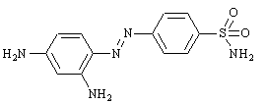
Feedback: Prontosil is the dye that led to the discovery of the sulfonamides. It acts as a prodrug where the molecule is cleaved to release sulfanilamide. Sulfathiazole and sulfadiazine are conventional sulfonamides.
Page reference: 382-383
a. Sulfanilamide
*b. Prontosil
c. Sulfathiazole
d. Sulfadiazine

Type: multiple choice question
Title: Chapter 16 Question 08
08) Which of these statements is true about the following structure?

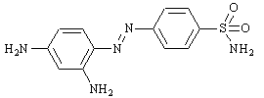
Feedback: The structure is prontosil which acts as a prodrug and is converted to sulfanilamide in the body. Since it needs to be metabolised to the active compound, it is inactive when tested in vitro. Prontosil itself is inactive and is converted in the body to the active sulfonamide.
Page reference: 382-383
a. It is a prodrug which is converted to prontosil in the body.
*b. It is a prodrug which is converted to sulfanilamide in the body.
c. It was the first active sulfonamide.
d. It shows antibacterial activity in vitro.

Type: multiple choice question
Title: Chapter 16 Question 09
09) What is the name of the following structure?

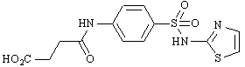
Feedback: Succinyl sulfathiazole is a polar prodrug for sulfathiazole. Sulfanilamide is the simplest sulfonamide structure and is formed from prontosil. Benzoyl sulfathiazole is a hydrophobic prodrug of sulfathiazole.
Page reference: 385
a. Sulfanilamide
b. Benzoyl sulfathiazole
*c. Succinyl sulfathiazole
d. Sulfathiazole

Type: multiple choice question
Title: Chapter 16 Question 10
10) What type of infection is the following drug used for?

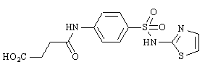
Feedback: Since the prodrug is ionised and polar, it fails to cross the gut wall and is concentrated in the gut when taken orally. It is therefore effective against gut infections.
Page reference: 383
a. Urinary tract infections
b. Eye infections
c. Mucous membrane infection
*d. Gut infections

Type: multiple choice question
Title: Chapter 16 Question 11
11) What is the target for the antimalarial drug trimethoprim?
Feedback: Dihydrofolate reductase is the enzyme that catalyses the synthesis of tetrahydrofolate from dihydrofolate.
Page reference: 387
a. Dihydropteroate synthetase
*b. Dihydrofolate reductase
c. Transpeptidase
d. L-Ala racemase

Type: multiple choice question
Title: Chapter 16 Question 12
12) Which two amino acids are involved in the biosynthesis of penicillins?
Feedback: Cysteine provides the sulfur atom in the penicillin structure, while valine is the source for the geminal dimethyl groups. (Geminal means that the methyl groups are attached to the same carbon).
Page reference: 389
a. Valine and methionine
b. Alanine and methionine
c. Alanine and cysteine
*d. Valine and cysteine

Type: multiple choice question
Title: Chapter 16 Question 13
13) What is the name of the following penicillin?

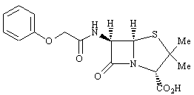

Feedback: Penicillin G is also known as benzyl penicillin. Penicillin V is also known as phenoxymethylpenicillin and is similar in structure having an extra oxygen atom between the aromatic ring and the rest of the molecule.
Methicillin and nafcillin are semi-synthetic penicillins which can be synthesised from penicillin G or penicillin V.
Page reference: 389
a. Penicillin G
*b. Penicillin V
c. Methicillin
d. Nafcillin

Type: multiple choice question
Title: Chapter 16 Question 14
14) The following diagram represents the general formula for a penicillin.

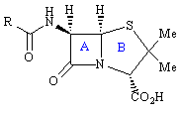
What type of ring is ring A?
Feedback: Ring A is a β-lactam and ring B is a thiazolidine. A lactone functional group is a cyclic ester and is not present in penicillins. A thiazole is an unsaturated five membered heterocycle and this is not present either.
Page reference: 389
a. Thiazole
b. Thiazolidine
*c. β -lactam
d. β -lactone

Type: multiple choice question
Title: Chapter 16 Question 15
15) The following diagram represents the general formula for a penicillin.

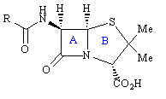
What type of ring is ring B?
Feedback: Ring A is a β -lactam and ring B is a thiazolidine. A lactone functional group is a cyclic ester and is not present in penicillins. A thiazole is an unsaturated five membered heterocycle and this is not present either.
Page reference: 389
a. Thiazole
*b. Thiazolidine
c. β -lactam
d. β -lactone

Type: multiple choice question
Title: Chapter 16 Question 16
16) What structure or structures is/are formed if the acyl side chain of a penicillin is hydrolysed?
Feedback: Penicillenic acids and penillic acids are formed if the acyl side chain promotes the hydrolysis of the β lactam ring. Removing the acyl side chain gives 6-APA. The amino group is at position 6 of the penicillin nucleus and not position 7.
Page reference: 396
a. Penicillenic acids
b. Penillic acids
c. 7-aminopenicillanic acid
*d. 6-aminopenicillanic acid

Type: multiple choice question
Title: Chapter 16 Question 17
17) Penicillins act on an important bacterial enzyme. Which enzyme is the target for penicillin G?
Feedback: Transpeptidase is the target. A β-lactamase is a bacterial enzyme which breaks down penicillins before they get a chance to act. L-Ala racemase is an enzyme involved in one of the early stages of cell wall synthesis and is unaffected by penicillins. Penicillin acylase is an enzyme which can be used to cleave the side chain of penicillins to produce 6-APA.
Page reference: 390-391
a. β -lactamase
*b. Transpeptidase
c. L-Ala racemase
d. Penicillin acylase

Type: multiple choice question
Title: Chapter 16 Question 18
18) Penicillins act on an important bacterial enzyme called transpeptidase. What role does this play?
Feedback: Transpeptidase catalyses the final crosslinking stage in cell wall synthesis. The reaction L-alanine to D-alanine is carried out by L-Ala racemase. The transport of building blocks across the cell membrane is carried out by a carrier lipid and this is unaffected by penicillins.
Page reference: 390-391
a. It racemises L-alanine to D-alanine prior to its incorporation into the bacterial cell wall.
b. It acylates amino acid residues in the bacterial cell wall.
*c. It catalyses the final crosslinking stage in cell wall synthesis.
d. It catalyses the transport of the building blocks for cell wall synthesis across the cell membrane.

Type: multiple choice question
Title: Chapter 16 Question 19
19) Penicillins act on an important bacterial enzyme called transpeptidase. What role does penicillin play when it interacts with transpeptidase?
Feedback: A covalent bond is formed between penicillin and the active site of the enzyme, and so inhibition is irreversible.
Agonist and antagonist are wrong as these refer to agents acting on receptors rather than enzymes.
Page reference: 391-393
a. An agonist
b. An antagonist
c. A reversible inhibitor
*d. An irreversible inhibitor

Type: multiple choice question
Title: Chapter 16 Question 20
20) Which of the following statements best describes the mechanism of action of penicillins?
Feedback: A serine residue acts as a nucleophile in the active site of the enzyme and not lysine. It reacts with the β-lactam ring and not the carboxylate group. The latter group is ionised and forms an ionic interaction with the active site, but this is not involved in the mechanism leading to irreversible inhibition.
Page reference: 391-393
a. A serine residue in the active site of the enzyme acts as a nucleophile and reacts with the carboxylate group of penicillin to form an ester.
b. A lysine residue in the active site of the enzyme acts as a nucleophile and reacts with the carboxylate group of penicillin to form an ester.
*c. A serine residue in the active site of the enzyme acts as a nucleophile and reacts with the β -lactam ring.
d. A lysine residue in the active site of the enzyme acts as a nucleophile and reacts with the β-lactam ring.

Type: multiple choice question
Title: Chapter 16 Question 21
21) Which of the following statements best describes the importance of the bicyclic system in penicillins to antibacterial activity?
Feedback: There is some truth in all the statements but the most important influence of the bicyclic system is to increase the reactivity of the β-lactam ring to attacking nucleophiles by increasing bond angle strain.
Page reference: 397
a. It acts as a scaffold to hold the carboxylate group and acyl side chain in the correct relative orientations for binding.
b. It is the correct shape and size to fit the binding site.
*c. It increases the strain of the β-lactam ring and increases reactivity and antibacterial activity.
d. It is a folded ring system and protects the β-lactam ring from hydrolysis.

Type: multiple choice question
Title: Chapter 16 Question 22
22) What molecular feature is penicillin G said to mimic?
Feedback: D-Ala-D-Ala is the normal substrate for the transpeptidase enzyme and so it is sensible to propose that penicillin mimics this feature.
N-Acetylmuramic acid and N-acetylglucosamine are present in the cell wall but are not involved in the enzyme catalysed reaction. The terminal glycine of the pentapeptide glycyl chain is involved in the enzyme catalysed reaction, but is not the feature mimicked by penicillins.
Page reference: 391
a. N-acetylmuramic acid
b. N-acetylglucosamine
c. The pentapeptide moiety Gly-Gly-Gly-Gly-Gly
*d. The dipeptide moiety D-Ala-D-Ala

Type: multiple choice question
Title: Chapter 16 Question 23
23) Why is penicillin G sensitive to acid and enzyme catalysed hydrolysis?
Feedback: The β-lactam ring is a four membered ring and so it is susceptible to ring strain. The β-lactam carbonyl group behaves more like a ketone carbonyl group than an amide carbonyl group since the lone pair of the nitrogen cannot interact with it. The acyl side chain can participate in a hydrolytic mechanism that opens up the β-lactam ring. Therefore, all three factors have a role to play in the sensitivity of penicillin G to acid and enzyme catalysed hydrolysis.
Page reference: 397-398
a. Ring strain
b. A reactive β-lactam carbonyl group
c. Nucleophilic influence of the acyl side chain
*d. All of the answers are correct

Type: multiple choice question
Title: Chapter 16 Question 24
24) What tactic is successfully used to increase the stability of penicillins to acid hydrolysis whilst retaining antibacterial activity?
Feedback: Adding an electron withdrawing group to the side chain decreases the nucleophilicity of the carbonyl group in that side chain, and reduces the rate at which it participates in the opening of the β-lactam ring.
Expanding a ring to reduce ring strain would increase the stability of the penicillin but would also reduce activity.
Adding an electron withdrawing group to the β-lactam ring would not be easy to do synthetically and is likely to affect activity adversely.
Removing the acyl side chain would increase stability since it removes the carbonyl group on the side chain, but biological activity would also be lost since important binding groups are lost as well.
Page reference: 398-399
a. Expanding one or other ring to relieve ring strain
b. Adding an electron withdrawing group to the β-lactam ring
*c. Adding an electron withdrawing group to the acyl side chain
d. Removing the acyl side chain

Type: multiple choice question
Title: Chapter 16 Question 25
25) What feature of ampicillin is important in its acid stability?

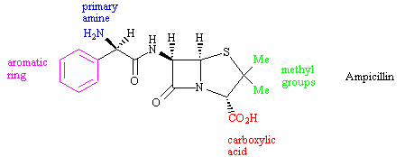

Feedback: The primary amine acts as an electron withdrawing group and decreases the nucleophilicity of the carbonyl group in the side chain. This reduces the rate at which the carbonyl group participates in opening the β-lactam ring.
Page reference: 399
a. The carboxylic acid
b. The aromatic ring
*c. The primary amine
d. The methyl groups

Type: multiple choice question
Title: Chapter 16 Question 26
26) The following reaction is carried out to synthesise a range of semi-synthetic penicillins.

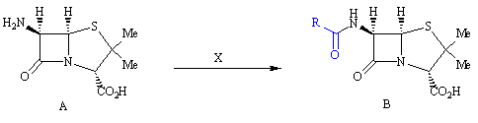
What is the name of structure A?
Feedback: The amino substituent is at position 6 of the bicyclic penicillanic acid moiety
Page reference: 396
a. 6-aminopenicillin
b. 7-aminopenicillenic acid
c. 7-aminopenicillanic acid
*d. 6-aminopenicillanic acid

Type: multiple choice question
Title: Chapter 16 Question 27
27) The following reaction is carried out to synthesise a range of semi-synthetic penicillins.

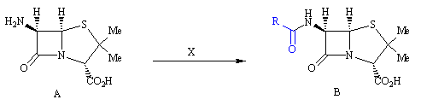
What is reagent X?
Feedback: Primary amines undergo an acylation reaction with an acid chloride to give a secondary amide.
The amine could also react with an alkyl chloride but this would be an alkylation reaction and there would be no carbonyl group in the side chain. This would be detrimental to activity.
Page reference: 396
*a. An acid chloride
b. An amide
c. An alkyl chloride
d. An aryl chloride

Type: multiple choice question
Title: Chapter 16 Question 28
28) The following reaction is carried out to synthesise a range of semi-synthetic penicillins.

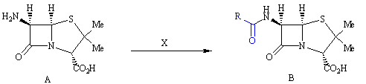
How is structure A obtained?
Feedback: 6-APA can be obtained by the enzymatic removal of the acyl side chain of benzyl penicillin.
A total synthesis is impractical since it would take too long and would be low yielding.
Converting a penicillin structure to a cephalosporin structure can be done but not the other way round.
Benzyl penicillin could be converted to 6-APA by a chemical hydrolysis, but not with sodium hydroxide. This would also open the β-lactam ring.
Page reference: 396-397
a. By total synthesis
b. By ring contraction of a cephalosporin
*c. By enzymatic hydrolysis of benzyl penicillin
d. By chemical hydrolysis of benzyl penicillin with sodium hydroxide

Type: multiple choice question
Title: Chapter 16 Question 29
29) What is meant by a semi-synthetic process?
Feedback: A semi-synthetic synthesis involves the use of a natural product and converting it to the desired product.
Page reference: 396-397
*a. The synthesis involves the use of a natural product as starting material.
b. The synthesis is incomplete.
c. The synthesis involves a mixture of synthetic reagents and enzymes.
d. The synthesis involves the separate synthesis of each half of the molecule, and then the halves are linked together.

Type: multiple choice question
Title: Chapter 16 Question 30
30) What is the relevance of β-lactamase enzymes to penicillins?
Feedback: β-Lactamase enzymes catalyse the opening of β-lactam rings and result in the deactivation of penicillins. Thus, bacteria that are able to produce these enzymes are resistant to penicillins and are not susceptible. Fungi and mammalian cells do not produce β-lactamase enzymes.
Page reference: 395
a. Fungi containing β-lactamase enzymes can synthesise penicillins.
*b. Bacteria containing β-lactamase enzymes show resistance to penicillins.
c. Mammalian cells are unaffected by penicillins because they contain β-lactamase enzymes.
d. Only bacteria containing β-lactamase enzymes are susceptible to penicillins.

Type: multiple choice question
Title: Chapter 16 Question 31
31) The following structure was an important penicillin that was introduced in the 1960s to counter the threat of penicillin resistant strains of S. aureus.

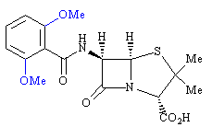

What is the name of the structure?
Feedback:
Page reference: 399
a. Penicillin G
b. Amoxicillin
*c. Methicillin
d. Nafcillin

Type: multiple choice question
Title: Chapter 16 Question 32
32) The following structure (methicillin) was an important penicillin that was introduced in the nineteen sixties to counter the threat of penicillin resistant strains of S. aureus.

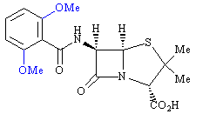

What role do the blue coloured groups play in making methicillin more effective than penicillin G against resistant strains of S. aureus?
Feedback: The methoxy groups act as steric shields to hinder the ability of β-lactamases to hydrolyse the β lactam ring. It is quite feasible that they act as steric shields for the acyl carbonyl group as well, but this is not their main purpose.
Page reference: 399
a. They have an electron withdrawing effect on the aromatic ring giving it a broader spectrum of activity.
b. They have an electron donating effect on the aromatic ring giving it a broader spectrum of activity.
c. They have a steric effect blocking the enzymatic hydrolysis of the acyl side chain.
*d. They have a steric effect blocking the enzymatic hydrolysis of the β-lactam ring.

Type: multiple choice question
Title: Chapter 16 Question 33
33) The following structure (methicillin) was an important penicillin that was introduced in the 1960s to counter the threat of penicillin resistant strains of S. aureus.

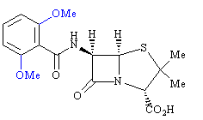
Which of the following statements is true regarding the above structure?
Feedback: There is no electron-withdrawing group, and so the penicillin is acid sensitive. As a result, it cannot be taken orally. The presence of the steric shields also makes it more difficult for the penicillin to attack the transpeptidase enzyme. This means that methicillin has a lower activity and a narrower spectrum of activity compared to penicillin G.
Page reference: 399
*a. There is no electron withdrawing group on the side chain, and so it is acid sensitive.
b. It can be taken orally.
c. It is more active than penicillin G.
d. It has a broader spectrum of activity compared to penicillin G.

Type: multiple choice question
Title: Chapter 16 Question 34
34) The following structure (methicillin) was an important penicillin that was introduced in the 1960s to counter the threat of penicillin resistant strains of S. aureus.

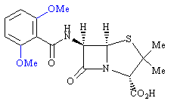
What would be the effect of replacing the methoxy groups in methicillin with ethoxy groups?
Feedback: Resistance to enzymatic hydrolysis would increase since larger steric shields are used. Unfortunately, the level and breadth of antibacterial activity would decrease since the steric shields will also hinder binding to the transpeptidase enzyme.
Page reference: 399
a. Activity would increase
*b. Resistance to enzymatic hydrolysis would increase
c. Activity against a broad spectrum of bacterial strains would increase
d. Stability to acid catalysed hydrolysis would increase

Type: multiple choice question
Title: Chapter 16 Question 35
35) The following structure was an improvement of a drug that was introduced in the 1960s to counter the threat of penicillin resistant strains of S.aureus.

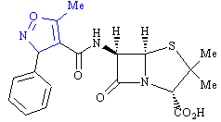
What is the name of this structure?
Feedback: Oxacillin is the correct answer. Methicillin was the drug that was introduced in the 1960's to counter the threat of penicillin resistant strains of S. aureus. However, it was susceptible to acid hydrolysis and had to be injected. Oxacillin was an improvement since it was acid resistant. Cloxacillin is an analogue of oxacillin. Ampicillin is one of the early broad spectrum penicillins.
Page reference: 400
*a. Oxacillin
b. Methicillin
c. Cloxacillin
d. Ampicillin

Type: multiple choice question
Title: Chapter 16 Question 36
36) The following structure (oxacillin) was an improvement of a drug that was introduced in the 1960s to counter the threat of penicillin resistant strains of S.aureus.

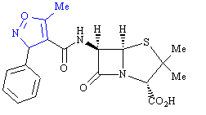
What is the significance of the feature shown in blue?
Feedback: The heterocyclic ring has both an electron withdrawing and steric effect which stabilises the molecule to acid hydrolysis, allowing it to be administered orally. Therefore, all of the answers are correct.
Page reference: 400
a. It has an electron withdrawing effect
b. It has a steric effect
c. It results in oral activity
*d. All of the answers are correct

Type: multiple choice question
Title: Chapter 16 Question 37
37) What is the name of the structure that allows some penicillins to cross the outer barrier of Gram negative cells?
Feedback: Porins are tunnels through the outer barrier of Gram negative bacteria that allow molecules to pass through the membrane if they are of the right character. Penicillins which exist as zwitterions are able to pass through porins.
Page reference: 393
*a. Porins
b. Transport proteins
c. Ion channels
d. Liposomes

Type: multiple choice question
Title: Chapter 16 Question 38
38) Which of the following features in a penicillin favours the ability of the penicillin to cross the outer membranes of Gram negative bacteria?
Feedback: Some penicillins can cross the outer membranes of Gram negative bacteria by passing through structures called porins. Penicillins which are zwitterionic in nature are more likely to pass through these porins than those which are not.
Page reference: 393-395
a. Hydrophobic character
b. Large molecular weight
*c. Zwitterionic character
d. All of the answer are correct

Type: multiple choice question
Title: Chapter 16 Question 39
39) What modifications to the penicillin side chain can lead to an improvement in activity against Gram negative bacteria?
Feedback: Hydrophobic groups on the side chain favour activity against Gram positive bacteria rather than Gram negative bacteria.
There is no general pattern that relates the Gram negative activity of a penicillin to the size of the group on the side chain or the presence of a heteroaromatic ring.
Page reference: 400-401
a. Hydrophobic groups on the side chain
*b. A hydrophilic group at the alpha position of the side chain
c. A larger group on the side chain
d. A heteroaromatic ring on the side chain rather than an aromatic ring

Type: multiple choice question
Title: Chapter 16 Question 40
40) What is the name of the following structure?

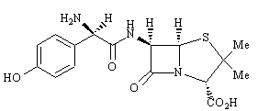
Feedback: Ampicillin is very similar to amoxicillin but lacks the phenol group.
Page reference: 401
a. Ampicillin
b. Methicillin
c. Penicillin G
*d. Amoxicillin

Type: multiple choice question
Title: Chapter 16 Question 41
41) What is the name of the following structure?

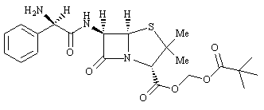

Feedback: Pivampicillin is a prodrug for ampicillin. The other two compounds, talampicillin and bacampicillin, are also prodrugs of ampicillin.
Page reference: 402
a. Ampicillin
*b. Pivampicillin
c. Talampicillin
d. Bacampicillin

Type: multiple choice question
Title: Chapter 16 Question 42
42) Pivampicillin (below) is used as a prodrug for ampicillin. What advantage does it offer over ampicillin?

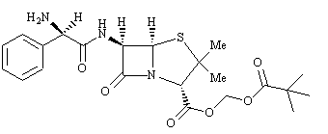
Feedback: The prodrug masks a highly polar carboxylic acid group. As a result, the penicillin is more easily absorbed across the gut wall. Once in the body, it is converted to ampicillin and so it cannot have better activity than ampicillin against either Gram positive or Gram negative bacteria.
Page reference: 402
a. It has increased activity.
b. It crosses the blood brain barrier more easily.
*c. It crosses the gut wall more easily.
d. It is more active against Gram negative bacteria.

Type: multiple choice question
Title: Chapter 16 Question 43
43) Why is a methyl ester of a penicillin not used as a prodrug?
Feedback: The methyl ester is too close to the penicillin skeleton. As a result, the latter acts as a steric shield and prevents esterase enzymes from hydrolysing the ester.
The methyl ester being resistant to acid catalysed hydrolysis would be an advantage since it would allow the prodrug to survive the acids of the stomach.
That the methyl ester is inactive is not a disadvantage since the prodrug would be expected to be inactive, and would only be activated following hydrolysis of the methyl ester.
That the methyl ester would produce toxic methanol on hydrolysis is a drawback, but the level of methanol produced from a typical dose of penicillin would be relatively low and unlikely to be toxic.
Page reference: 402
a. The methyl ester is resistant to acid catalysed hydrolysis.
b. The methyl ester is inactive.
*c. The methyl ester is resistant to enzymatic hydrolysis in humans.
d. The methyl ester would produce toxic methanol on hydrolysis.

Type: multiple choice question
Title: Chapter 16 Question 44
44) Pivampicillin (below) is used as a prodrug for ampicillin.

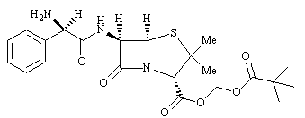
Which of the following mechanisms best describes the conversion of the prodrug to ampicillin?

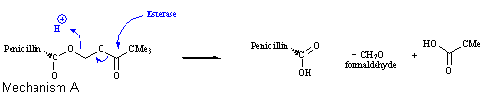
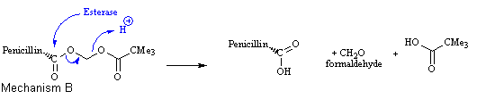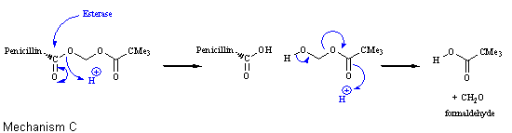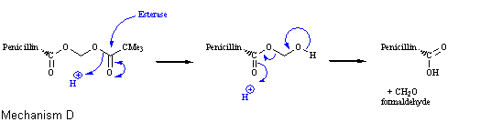

Feedback: The mechanism shown in D is the most accurate. The mechanisms shown in B and C are both wrong since the esterase enzyme is shown attacking the ester group closest to the penicillin nucleus, and it is known that this ester is shielded from attack. The mechanism in A suggests that ampicillin is released as a direct result of the enzyme action, when in fact a chemically unstable intermediate is formed first as shown in mechanism D.
Page reference: 402
a. Mechanism A
b. Mechanism B
c. Mechanism C
*d. Mechanism D

Type: matching question
Title: Chapter 16 - Question 45
45) Identify the component parts (i), (ii), (iii) and (iv) of cephalosporin C.

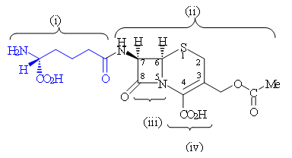
Feedback: The side chain is the 7-aminoadipic group. The bicyclic system including the ring substituents and the 7-amino group is 7-aminocephalosporinic acid. The 4 membered ring is a -lactam ring. The 6 membered ring is a dihydrothiazine ring
Page reference: 405
a. (i) = 7-aminoadipic group
b. (ii) = 7-aminocephalosporinic acid
c. (iii) = -lactam
d. (iv) = Dihydrothiazine

Type: multiple choice question
Title: Chapter 16 Question 46
46) What was the origin of cephalosporin C?
Feedback: Cephalosporin C was isolated from a fungus growing in waters near a sewage outlet in Sardinia.
Page reference: 404
a. A fungus
b. A bacterial strain
*c. A plant
d. A South American frog

Type: multiple choice question
Title: Chapter 16 Question 47
47) What are the biosynthetic precursors for cephalosporins?
Feedback: The biosynthetic precursors for cephalosporin C are the same as those for the penicillins. Cyclisation results in a six membered dihydrothiazine ring instead of a five membered thiazolidine ring.
Page reference: 405
a. Lysine and methionine
b. Alanine and cysteine
c. Valine and methionine
*d. Valine and cysteine

Type: multiple choice question
Title: Chapter 16 Question 48
48) Why was cephalosporin C considered an important lead compound for antibacterial agents?
Feedback: Cephalosporin C had a lower level of activity than penicillin G, but it had a better breadth of activity against Gram positive and Gram negative bacteria. It was also more stable to acid and enzymatic hydrolysis. Like penicillins, it was not easily synthesised from simple starting materials.
Page reference: 405
a. It has a higher level of activity than penicillin G.
b. It was more easily synthesised than penicillin G.
*c. It has a better breadth of activity against Gram positive and Gram negative bacteria.
d. It is more susceptible to acid and enzymatic hydrolysis.

Type: multiple choice question
Title: Chapter 16 Question 49
49) The following features are present in cephalosporins. All of the features, bar one, are involved in the mechanism by which cephalosporins react with the target enzyme. Which feature is not involved?
Feedback: The ß-lactam ring is the group that is attacked by serine in the active site of the transpeptidase enzyme. Ring opening occurs with simultaneous elimination of the acyl side chain. This elimination is made possible by the double bond present in the dihydrothiazine ring.
The acyl side chain at the 7-position is important in binding the cephalosporin to the active site, but not to the mechanism of inhibition.
Page reference: 405
*a. The acyl side chain at position 7
b. The ß-lactam ring
c. The alkene group in the dihydrothiazine ring
d. The acyl side chain at position 3

Type: multiple choice question
Title: Chapter 16 Question 50
50) Several modifications have been carried out on the cephalosporin skeleton to produce useful antibacterial agents. Which of the following modifications is not useful?
Feedback: It is not easy to introduce a substituent at position 6, and no useful antibacterial agents have been developed with substituents at this position.
Page reference: 406
a. Varying the acyl side chain at position 7
b. Varying the acetoxymethyl group at position 3
c. Introducing a substituent at position 7
*d. Introducing a substituent at position 6

Type: multiple choice question
Title: Chapter 16 Question 51
51) Which of the following statements is true?
Feedback: Cephalosporin analogues can be prepared from 7-aminocephalosporinic acid (7-ACA). None of the procedures described in the remaining options are feasible for cephalosporins. 7-ACA was prepared from cephalosporins by removing the 7-acyl chain with a chemical procedure.
Page reference: 406-407
*a. Cephalosporin analogues can be prepared by a semi-synthetic synthesis.
b. Cephalosporin analogues can be prepared by fermentation.
c. 7-aminocephalosporinic acid can be prepared by fermentation then used in the synthesis of cephalosporin analogues.
d. 7-aminocephalosporinic acid can be prepared by the enzymatic cleavage of the 7-acyl side chain of cephalosporin C, then used in the synthesis of cephalosporin analogues.

Type: matching question
Title: Chapter 16 - Question 52
52) The following scheme illustrates the synthesis of 7-ACA from a cephalosporin, and its subsequent conversion to a range of cephalosporins. What are the reagents (i), (ii), (iii) and (iv)?

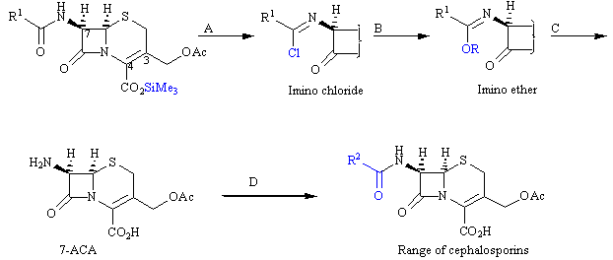

Feedback: Phosphorus pentachloride reacts selectively with the side chain amide over the ß-lactam ring to produce an imino chloride. Treatment of the imino chloride with an alcohol under mild conditions results in substitution of the chloro group to give an imino ether which is hydrolysed in the presence of water. This produces 7-aminocephalosporinic acid which can be treated with a range of acid chlorides to give cephalosporin analogues.
Page reference: 406
a. Reagent (i) = Phosphorus pentachloride
b. Reagent (ii) = An alcohol
c. Reagent (iii) = Water
d. Reagent (iv) = An acid chloride

Type: multiple choice question
Title: Chapter 16 Question 53
53) Which acid chloride (RCOCl) is used in the synthesis of cephalothin?

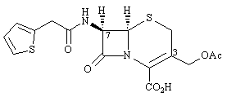
Feedback: The acid chloride is the reagent that adds the side chain to 7-aminocephalosporinic acid. The side chain of cephalothin contains a thiophen ring and so the acid chloride must contain a thiophene ring separated from the acid chloride group by a methylene unit.
Page reference: 406-407
a. R=CH3CH2
b. R= PhCH2
*c. 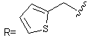
d. 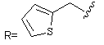

Type: multiple choice question
Title: Chapter 16 Question 54
54) Cephaloridine has a pyridinium ring in place of the acetyl group in cephalothin. Which of the following statements is true?

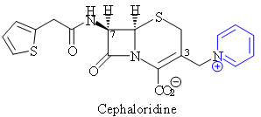
Feedback: Cephaloridine is poorly absorbed through the gut wall and has to be injected. It has a longer duration of action since the acyl group that was replaced is susceptible to enzymatic hydrolysis. The pyridinium ring does act as a good leaving group in the inhibition mechanism. It is also less easily metabolised than the acetyl group of cephalothin.
Page reference: 407
a. Cephaloridine is more easily absorbed through the gut wall.
b. Cephaloridine has a shorter duration of action than cephalothin.
*c. The pyridinium ring acts as a good leaving group in the inhibition mechanism.
d. The pyridinium ring is more easily metabolised than the acetyl group of cephalothin.

Type: multiple choice question
Title: Chapter 16 Question 55
55) The following structure (cefalezin) is a first generation cephalosporin.

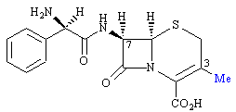
Which of the following statements is true for the methyl substituent at position 3?
Feedback: A methyl group at the 3-position is generally bad for activity since it is a poor leaving group. However, if a suitable 7-acyl side chain is present, the methyl group at position 3 is good for oral activity since it aids oral absorption. It does not act as a steric shield.
Page reference: 407-408
a. It is a good leaving group
b. It is generally good for activity
*c. It is good for oral activity
d. It acts as a steric shield

Type: matching question
Title: Chapter 16 - Question 56
56) The following scheme shows the synthesis of 3-methylated cephalosporins. Identify (i) – (iv).

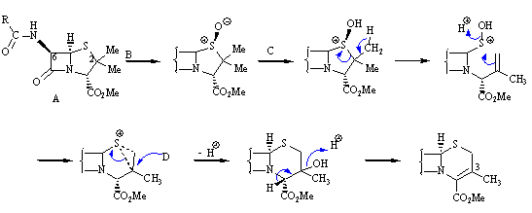
Feedback: This synthesis shows how penicillins can be converted to cephalosporins. The method involves a ring expansion. The first step is oxidation of the sulfur in penicillin. Treatment with acid then leads to the ring expansion.
Page reference: 408
a. (i) = Penicillin
b. (ii) = Hydrogen peroxide
c. (iii) = Toluene / para-toluenesulfonic acid
d. (iv) = Water

Type: multiple choice question
Title: Chapter 16 Question 57
57) The following structure is an example of a cephamycin.

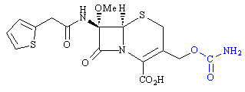
What is the name of the structure?
Feedback: Cefoxotin has a substituent including a urethane group at position 3, and a side chain at position 7 which includes a thiophene ring. Cefuroxime and cephamycin C have different side chains at position 7, while cefotaxime has different groups at both positions 3 and 7.
Page reference: 408-409
a. Cefuroxime
*b. Cefoxitin
c. Cephamycin C
d. Cefotaxime

Type: multiple choice question
Title: Chapter 16 Question 58
58) The following structure is an example of a cephamycin.

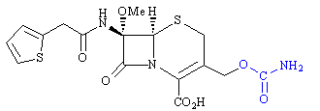
What is the name of the lead compound that led to this structure?
Feedback: Cephamycin C is the lead compound for cephamycins.
Cefoxitin is an example of a cephamycin which was developed from this lead compound. Cefuroxime and Cefotaxime are examples of oximinocephalosporins.
Page reference: 408-409
a. Cefuroxime
b. Cefoxitin
*c. Cephamycin C
d. Cefotaxime

Type: multiple choice question
Title: Chapter 16 Question 59
59) The following structure is an example of a cephamycin.

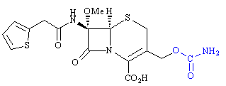
What is the significance of the urethane group (in blue)?

Feedback: Compared to an ester group, a urethane is more stable to acid and enzyme catalysed hydrolysis due to the influence of the nitrogen’s lone pair of electrons on the neighbouring carbonyl group. The urethane group has no steric effect.
Page reference: 408-409
a. It acts as a steric shield leading to longer activity.
*b. It is resistant to hydrolysis by esterases leading to longer activity.
c. It acts as a steric shield for the -lactam ring leading to lower activity.
d. It acts as a polar group resulting in better water solubility.

Type: multiple choice question
Title: Chapter 16 Question 60
60) What class of cephalosporins is illustrated by cefuroxime?

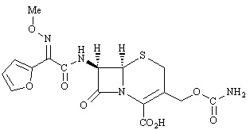

Feedback: The correct answer is oximinocephalosporins. These are characterised by an iminomethoxy group at the alpha-position of the acyl side chain.
Page reference: 408-409
*a. Oximinocephalosporins
b. Aminocephalosporins
c. Iminocephalosporins
d. Furylcephalosporins

Type: multiple choice question
Title: Chapter 16 Question 61
61) Which of the following statements is generally true about second generation cephalosporins when compared to first generation cephalosporins?
Feedback: The second generation cephalosporins are the cephamycins and the first generation of oximinocephalosporins.
Page reference: 408-409
*a. They have variable activity against Gram positive cocci and increased activity against Gram negative bacteria.
b. They have variable activity against Gram negative cocci and increased activity against Gram positive bacteria.
c. They have variable activity against Gram positive bacteria and increased activity against Gram negative cocci.
d. They have variable activity against Gram negative bacteria and increased activity against Gram positive cocci.

Type: multiple choice question
Title: Chapter 16 Question 62
62) Third and fourth generation cephalosporins contain a heterocyclic ring (X) that results in enhanced activity against Gram negative bacteria. What sort of ring is X?

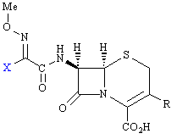
Feedback: The aminothiazole ring enhances the penetration of cephalosporins through the outer membrane of Gram negative bacteria and may also increase affinity for the transpeptidase enzyme.
Page reference: 409
a. Pyrrole
b. Furan
*c. Aminothiazole
d. Thiophene

Type: multiple choice question
Title: Chapter 16 Question 63
63) Identify the following ß-lactam antibiotic.

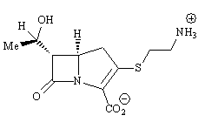

Feedback: Imipenem and meropenem are analogues of thienamycin. Clavulanic acid is a different type of structure that acts as a -lactamase inhibitor.
Page reference: 411
a. Imipenem
b. Clavulanic acid
*c. Thienamycin
d. Meropenem

Type: multiple choice question
Title: Chapter 16 Question 64
64) What drugs are present in the preparation Timentin?
Feedback: The combination of amoxicillin and clavulanic acid is sold as Augmentin. The combination of clavulanic acid and ticarcillin is known as Timentin. The combination of ampicillin and sulbactam is known as Unasyn.
Page reference: 413
*a. Ticarcillin and clavulanic acid
b. Ampicillin and sulbactam
c. Ampicillin and clavulanic acid
d. Amoxicillin and clavulanic acid

Type: multiple choice question
Title: Chapter 16 Question 65
65) What drugs are present in the preparation Unasyn?
Feedback: The combination of amoxicillin and clavulanic acid is sold as Augmentin. The combination of clavulanic acid and ticarcillin is known as Timentin. The combination of ampicillin and sulbactam is known as Unasyn.
Page reference: 414
a. Ticarcillin and clavulanic acid.
*b. Ampicillin and sulbactam.
c. Ampicillin and clavulanic acid.
d. Amoxicillin and clavulanic acid.

Type: multiple choice question
Title: Chapter 16 Question 66
66) Which of the following statements best describes clavulanic acid?
Feedback: Clavulanic acid reacts with the active site of -lactamases, such that it is linked irreversibly to two amino acids by covalent bonds.
The terms agonist and antagonist refer to compounds that interact with receptors and not enzymes.
Page reference: 413
*a. An irreversible enzyme inhibitor
b. A reversible enzyme inhibitor
c. An agonist
d. An antagonist

Type: multiple choice question
Title: Chapter 16 Question 67
67) Which of the following amino acids is involved in the mechanism by which clavulanic acid inhibits its macromolecular target?
Feedback: Serine acts as a nucleophilic group in the active site and is responsible for opening up the -lactam ring of clavulanic acid.
Page reference: 413
*a. Serine
b. Threonine
c. Cysteine
d. Histidine

Type: multiple choice question
Title: Chapter 16 Question 68
68) Which of the following antibacterial agents does not affect cell wall synthesis?
Feedback: Erythromycin binds to ribosomes and inhibits the translation process leading to the synthesis of proteins. The other agents inhibit parts of the biosynthetic process leading to the construction of bacterial cell walls.
Page reference: 414, 427
a. Vancomycin
b. Bacitracin
c. Cycloserine
*d. Erythromycin

Type: multiple choice question
Title: Chapter 16 Question 69
69) What molecule is mimicked by the antibacterial agent D-cycloserine?
Feedback: D-Cycloserine mimics D-alanine and inhibits L-Ala racemase and D-Ala-D-Ala ligase. The former enzyme catalyses the racemisation of L-Ala to D-Ala. The latter enzyme catalyses the linkage of two D-Ala amino acids to give the dipeptide D-Ala-D-Ala.
Page reference: 414-415
a. L-alanine
*b. D-alanine
c. Glycine
d. Penicillin

Type: multiple choice question
Title: Chapter 16 Question 70
70) Vancomycin forms interactions to a 'tail' segment of an important biosynthetic building block. What amino acids are involved in the tail segment?
Feedback: Lysine has a butyl side chain with a primary amino group at the end. Alanine has a simple methyl side chain. The side chains themselves are not involved in the important interactions with vancomycin.
Page reference: 416-417
a. D-Lys-L-Ala-L-Ala
b. L-Ala-D-Lys-D-Lys
c. D-Ala-L-Lys-L-Lys
*d. L-Lys-D-Ala-D-Ala

Type: multiple choice question
Title: Chapter 16 Question 71
71) Vancomycin forms interactions to a 'tail' segment of an important biosynthetic building block. What sort of interactions are involved?
Feedback: Hydrogen bonding takes place between amide groups in both the vancomycin and the 'tail' segment of the biosynthetic building block. A carboxylate ion on the 'tail' is also involved, but the interactions are through hydrogen bonds rather than ionic bonds.
Page reference: 416-417
a. Ionic bonds
*b. Hydrogen bonds
c. Van der Waals interactions
d. Induced dipole-dipole interactions

Type: multiple choice question
Title: Chapter 16 Question 72
72) Vancomycin forms interactions to a 'tail' segment of an important biosynthetic building block. How many of these interactions are there?

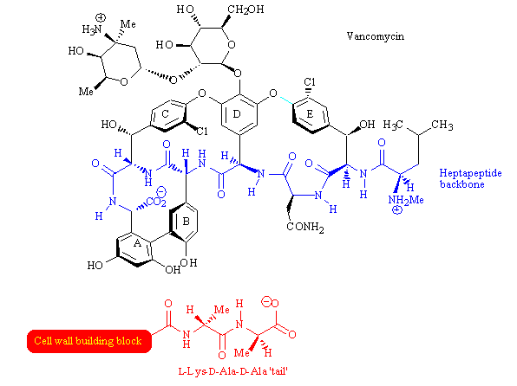

Feedback: There are three interactions involving the terminal alanine unit of the tail, one interaction involving the penultimate alanine, and one interaction involving the lysine unit.
Page reference: 416-417
a. 2
b. 3
c. 4
*d. 5

Type: multiple choice question
Title: Chapter 16 Question 73
73) Which of the following statements is true regarding vancomycin?
Feedback: Vancomycin is not an enzyme inhibitor. It 'caps' the building blocks for cell wall synthesis and acts as a steric shield, preventing these substrates from entering the active sites of enzymes.
Page reference: 416-417
a. It inhibits the transglycosidase enzyme.
b. It inhibits the transpeptidase enzyme.
c. It inhibits both enzymes.
*d. It inhibits neither enzyme.

Type: multiple choice question
Title: Chapter 16 Question 74
74) What is meant by VIRSA?
Feedback: The correct answer is 'Vancomycin resistant Staphylococcus aureus'. The terms 'Vigorously resistant Staphylococcus aureus' and 'Vancomycin immune resistance Staphylococcus aureus' do not exist. The term 'vancomycin-resistant enterococci' (VRE) is used and refers to organisms that are resistant to vancomycin and which can cause life-threatening gut infections.
Page reference: 418
a. Vigorously resistant Staphylococcus aureus
*b. Vancomycin resistant Staphylococcus aureus
c. Vancomycin resistant Enterococcus faecalis
d. Vancomycin immune resistance Staphylococcus aureus

Type: multiple choice question
Title: Chapter 16 Question 75
75) Vancomycin resistant enterococci have resulted due to a modification of a D-Ala group in a cell wall precursor. What modification has taken place?
Feedback: The terminal group is lactic acid rather than alanine. Lactic acid has a hydroxyl group instead of the amino group present in alanine. This means that the terminal unit is linked to the 'tail' of the biosynthetic precursor by an ester group rather than an amide group.
Page reference: 418
*a. D-alanine to D-lactic acid
b. D-alanine to L-alanine
c. D-alanine to D-lysine
d. D-alanine to L-lysine

Type: multiple choice question
Title: Chapter 16 Question 76
76) Vancomycin resistant enterococci have resulted due to a modification of a D-Ala group in a cell wall precursor. The modified cell wall precursor is unable to form as many intermolecular bonds with vancomycin as the natural precursor. How many fewer bonds are there?
Feedback: There is one fewer hydrogen bond. The NH of D-alanine has been replaced with an oxygen in D-lactic acid, resulting in the loss of a hydrogen bond donor.
Page reference: 418
*a. 1
b. 2
c. 3
d. 4

Type: multiple choice question
Title: Chapter 16 Question 77
77) The following molecule is teicoplanin. What is the significance of the alkyl chain in blue?

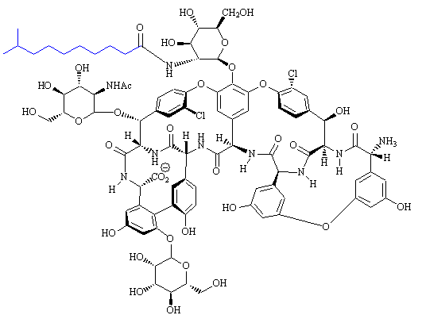

Feedback: The alkyl chain anchors the molecule to the bacterial cell membrane such that it is localised at its site of action.
Page reference: 416
a. It increases the hydrophobic character of the molecule such that it crosses cell membranes more easily.
b. It acts as a steric shield to increase the metabolic stability of the molecule.
*c. It acts as a hydrophobic anchor such that the molecule is anchored to the bacterial cell membrane.
d. It acts as a metabolic handle such that the molecule can be metabolised to safe, rapidly excreted products.

Type: multiple choice question
Title: Chapter 16 Question 78
78) What group of antibiotics are given an enhanced activity in the presence of vancomycin?
Feedback: Vancomycin disrupts cell wall synthesis which allows increased absorption of aminoglycosides into bacterial cells.
Page reference: 419
a. Penicillins
*b. Aminoglycosides
c. Tetracyclines
d. Macrolides

Type: multiple choice question
Title: Chapter 16 Question 79
79) Aminoglycosides are given an enhanced activity in the presence of vancomycin. Why does this occur?
Feedback: Disruption of the cell membrane structure allows aminoglycosides to enter the bacterial cell more easily. Disruption of the bacterial cell wall has no significant effect on the ease with which aminoglycosides enter the cell, since these molecules can pass through cell walls in any case.
Vancomycin disrupts RNA synthesis and this would disrupt protein synthesis. Therefore, the disruption of RNA synthesis and reduction of the extent to which other antibiotics are metabolised or pumped back out of the bacterial cell are not inconceivable. However, it is vancomycin's effect on cell membranes that explains why aminoglycoside activity is enhanced.
Page reference: 419
*a. Vancomycin disrupts the bacterial cell membrane making it easier for the above antibiotics to enter the bacterial cell.
b. Vancomycin disrupts the bacterial cell wall making it easier for the above antibiotics to enter the bacterial cell.
c. Vancomycin disrupts RNA synthesis and reduces the extent to which other antibiotics are metabolised.
d. Vancomycin disrupts RNA synthesis and reduces the extent to which other antibiotics are pumped back out of the bacterial cell.

Type: multiple choice question
Title: Chapter 16 Question 80
80) What cell structure is affected by vancomycin?
Feedback: Vancomycin prevents the building blocks of the cell wall from being added to the growing cell wall and so the wall is weakened. It is also known to disrupt cell membrane structure, and to disrupt RNA synthesis. If RNA synthesis is disrupted, the structure of ribosomes will be affected since they contain ribosomal RNA.
Page reference: 419
a. Cell membrane
b. Cell wall
c. Ribosomes
*d. All of the answers are correct

Type: multiple choice question
Title: Chapter 16 Question 81
81) What cell structure is targeted by valinomycin?
Feedback: Valinomycin dissolves in the cell membranes of bacterial cells and can act as an ion carrier, leading to the uncontrolled movement of ions across the cell membrane.
Page reference: 420
*a. The cell membrane
b. The cell wall
c. Nucleic acids
d. Ribosomes

Type: multiple choice question
Title: Chapter 16 Question 82
82) What role is played by valinomycin?
Feedback: Valinomycin carries potassium ions across the cell membrane in an uncontrollable fashion leading to cell death.
Page reference: 420-421
a. Enzyme inhibitor
b. Receptor antagonist
*c. Ion carrier
d. Alkylating agent

Type: multiple choice question
Title: Chapter 16 Question 83
83) Which of the following antibiotics is an aminoglycoside?
Feedback: Chloramphenicol does not belong to any general class of antibiotics. Doxycycline is a tetracycline. Erythromycin is a macrolide. Streptomycin is an aminoglycoside.
Page reference: 424
a. Chloramphenicol
b. Doxycycline
c. Erythromycin
*d. Streptomycin

Type: multiple choice question
Title: Chapter 16 Question 84
84) Which functional group is thought to be chiefly responsible for the toxicity of chloramphenicol?
Feedback: Aromatic ntro substituents are generally responsible for toxic side effects and are best avoided. Drug metabolism can lead to potentially carcinogenic aromatic amines.
Page reference: 426
a. An alkyl halide
*b. A nitro group
c. A ketone
d. A tertiary amine

Type: multiple choice question
Title: Chapter 16 Question 85
85) Which of the following antibiotics is one of the safest antibiotics in clinical use?

Feedback: Erythromycin is the drug of choice against a variety of diseases including Legionnaires disease. Chloramphenicol is one of the least safe antibacterial agents. Doxycycline is a tetracycline and should be avoided for young children and pregnant mothers. Streptomycin is an aminoglycoside and can cause ear and kidney problems if the dose levels are not carefully controlled.
Page reference: 427
a. chloramphenicol
b. doxycycline
*c. erythromycin
d. streptomycin

Type: multiple choice question
Title: Chapter 16 Question 86
86) What cell structure is targeted by drugs such as the macrolides, tetracyclines and aminoglycosides?
Feedback: These compounds bind to bacterial ribosomes and disrupt the translation process leading to the synthesis of proteins.
Page reference: 424
*a. Ribosomes
b. Nucleus
c. Cell membrane
d. Cell wall

Type: multiple choice question
Title: Chapter 16 Question 87
87) What process is directly disrupted by drugs such as the macrolides, tetracyclines and aminoglycosides?
Feedback: These drugs target ribosomes and inhibit the process of translation - the process by which proteins are synthesised based on the genetic code presented by messenger RNA.
Page reference: 424
a. Replication
b. Transcription
*c. Translation
d. Biosynthetic pathways

Type: multiple choice question
Title: Chapter 16 Question 88
88) The following structure is a synthetic antibacterial agent called ciprofloxacin.

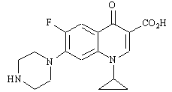

What is the most likely mechanism of bacterial resistance to the above structure?
Feedback: Efflux mechanisms are where the drug is actively pumped out of the bacterial cell by bacterial proteins in the cell membrane.
Page reference: 429
a. Modified target enzyme
b. Enzymatic modification of the structure
*c. Efflux mechanisms
d. Increased production of target enzymes

Type: multiple choice question
Title: Chapter 16 Question 89
89) The following structure has been used as a topical agent for skin infections, and as a means of combating the transmission of S. aureus in hospitals.

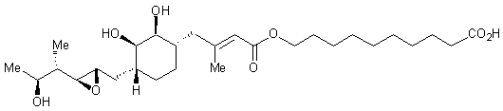

What is the name of the structure?
Feedback: Mupirocin is the correct answer. It is an antibiotic derived from a micro-organism. Metronidazole and nitrofurantoin are synthetic compounds with a simpler structure. Fusidic acid has a steroid structure.
Page reference: 435
a. Metronidazole
*b. Mupirocin
c. Nitrofurantoin
d. Fusidic acid

Type: multiple choice question
Title: Chapter 16 Question 90
90) The following structure (mupirocin) has been used as a topical agent for skin infections, and as a means of combating the transmission of S. aureus in hospitals.

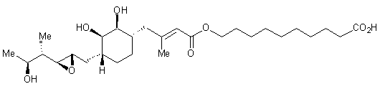
What is the target for the above structure?
Feedback: The target is isoleucyl tRNA synthetase. Transpeptidase is the target for penicillins and cephalosporins. DNA-dependant RNA-polymerase is the target for rifampicin. Topoisomerases are the target for quinolones and isoquinolones
Page reference: 435
a. Transpeptidase
b. DNA-dependant RNA polymerase
c. Topoisomerases
*d. Isoleucyl tRNA synthetase

Type: multiple choice question
Title: Chapter 16 - Question 91
91) Which of the following structures do the sulfonamides mimic when acting as enzyme inhibitors?

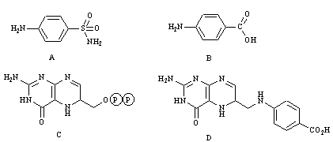
Feedback: Structure B is para-aminobenzoic acid, which is a substrate for the enzyme dihydropteroate synthetase. The sulfonamides mimic this feature.
Structure A is sulfanilamide which is a sulfonamide.
Structure B is the other substrate for dihydropteroate synthetase, and which gets linked to para-aminobenzoic acid.
Structure D is dihydropteroate which is the product from the enzyme catalysed reaction catalysed by dihydropteroate synthetase.
Page reference: 385-386
a. Structure A
*b. Structure B
c. Structure C
d. Structure D

Type: multiple choice question
Title: Chapter 16 - Question 92
92) Which of the following statements is untrue?
Feedback: A bacterial cell is prokaryotic whereas an animal cell is eukaryotic.
Page reference: 381-382
*a. A bacterial cell is eukaryotic whereas an animal cell is prokaryotic.
b. A bacterial cell has a cell wall whereas an animal cell does not.
c. Bacterial cells do not have a well defined nucleus, whereas animal cells do.
d. Bacteria may contain enzymes that are not present in animal cells.

Type: multiple choice question
Title: Chapter 16- Question 93
93) Which of the following drugs act by inhibiting an enzyme required for the synthesis of important nucleic acid building blocks?
Feedback: The sulfonamides inhibit dihydropteroate synthetase. Such inhibition prevents the synthesis of pyrimidine nucleic acid bases which in turn prevents the synthesis of nucleic acids.
Page reference: 382
a. ß-lactams
b. Fluoroquinolones
*c. Sulfonamides
d. Erythromycin

Type: multiple choice question
Title: Chapter 16- Question 94
94) Which of the following drugs act by inhibiting cell wall synthesis?
Feedback: The ß-lactams inhibit an enzyme called transpeptidase which is responsible for the last step of cell wall synthesis.
Page reference: 382
*a. -lactams
b. Fluoroquinolones
c. Sulfonamides
d. Erythromycin

Type: multiple choice question
Title: Chapter 16- Question 95
95) Which of the following drugs inhibits cell wall synthesis?
Feedback: Vancomycin binds to the building blocks required for cell wall synthesis and prevents them being incorporated into the growing cell wall.
Page reference: 382
*a. Vancomycin
b. Tetracyclines
c. Cephalosporins
d. Polymyxins

Type: multiple choice question
Title: Chapter 16- Question 96
96) Which of the following drugs act by disrupting protein synthesis?
Feedback: Erythromycin binds to ribosomes and inhibits the translation process leading to new proteins.
Page reference: 382
a. -lactams
b. Fluoroquinolones
c. Sulfonamides
*d. Erythromycin

Type: multiple choice question
Title: Chapter 16- Question 97
97) Which of the following drugs act by inhibiting nucleic acid transcription and replication?
Feedback: The fluoroquinolones stabilise a DNA / topoisomerase complex and prevent the mechanism by which tension is eased in the DNA strand during transcription and replication. This results in the inhibition of these processes.
Page reference: 382
a. -lactams
*b. Fluoroquinolones
c. Sulfonamides
d. Erythromycin

Type: multiple choice question
Title: Chapter 16- Question 98
98) Which of the following drugs act by disrupting protein synthesis?
Feedback: The tetracyclines bind to ribosomes and inhibit the translation process that normally leads to the synthesis of new proteins.

Page reference: 382
a. Vancomycin
*b. Tetracyclines
c. Cephalosporins
d. Polymyxins

Type: multiple choice question
Title: Chapter 16- Question 99
99) What is meant by the term sequential blocking?
Feedback: Sequential blocking is used to inhibit two separate enzymes in the one biosynthettic pathway. It is more effective than inhibiting one or other of the separate enzymes. It allows lower and safer doses of each inhibitor to achieve the same effect as using one inhibitor.
Administering two different drugs is true to the extent that two separate drugs are used, but it is not specified whether the drugs act on targets within the same biosynthetic pathway. There is no truth in the remaining two options.
Page reference: 387
a. Administering two different drugs
*b. The inhibition of two different enzymes in the same biosynthetic pathway
c. The order in which different binding regions of a binding site are occupied by a drug structure
d. The protection of vulnerable functional groups in a drug

Type: multiple choice question
Title: Chapter 16- Question 100
100) The following general structure is representative of sulfonamides. Which of the following statements is true for active sulfonamides?

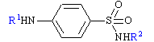
Feedback: R1 can be a hydrogen or an acyl group. The latter is removed in the body by enzyme catalysed hydrolysis to release a primary amine which is essential for activity.
A variety of groups can be placed at R2.
The aromatic ring is essential.
The sulfonamide group is essential for activity.
Page reference: 383
*a. R1 can be H or an acyl group
b. R2 must be hydrogen
c. The aromatic ring is not essential
d. The sulfonamide functional group can be replaced with an ester

Type: multiple choice question
Title: Chapter 16- Question 101
101) Trimethoprim is often administered alongside sulfamethoxazole in order to inhibit two separate enzymes in the same biosynthetic pathway. What is the name of this preparation?
Feedback: The answer is co-trimoxazole. The other options are preparations of a penicillin with a lactamase inhibitor.
Page reference: 387
a. Augmentin
b. Timentin
c. Zosyn
*d. Co-trimoxazole

Type: multiple choice question
Title: Chapter 16- Question 102
102) Which of the following structures is penicillin G?

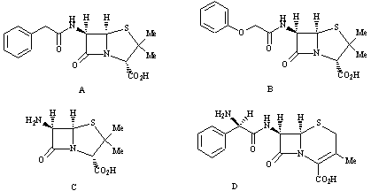
Feedback: Structure A is penicillin G which is also known as benzyl penicillin.
Structure B is penicillin V which is also known as phenoxymethylpenicillin and is similar in structure having an extra oxygen atom between the aromatic ring and the rest of the molecule.
Structure C is 6-aminopenicillanic acid and structure D is a cephalosporin structure called cefalexin.
Page reference: 389
*a. Structure A
b. Structure B
c. Structure C
d. Structure D

Type: multiple choice question
Title: Chapter 16- Question 103
103) Which of the following diagrams represents the building blocks used in the biosynthesis of penicillins?

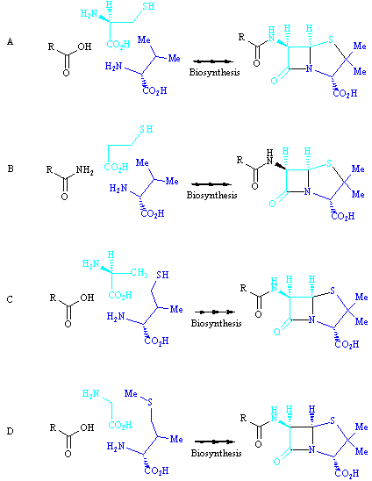

Feedback: The building blocks are the two amino acids cysteine and valine, as well as a carboxylic acid as the side chain. Cysteine provides the sulfur atom in the penicillin structure, while valine is the source for the geminal dimethyl groups. (Geminal means that the methyl groups are attached to the same carbon).
Page reference: 389
*a. Diagram A
b. Diagram B
c. Diagram C
d. Diagram D

Type: multiple choice question
Title: Chapter 16- Question 104
104) Which of the following structures is penicillin V?

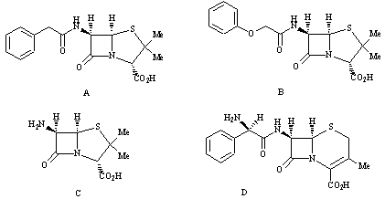
Feedback: Structure A is penicillin G which is also known as benzyl penicillin.
Structure B is penicillin V which is also known as phenoxymethylpenicillin. It is similar in structure to penicillin G but has an extra oxygen atom between the aromatic ring and the rest of the molecule.
Structure C is 6-aminopenicillanic acid and structure D is a cephalosporin structure called cefalexin.
Page reference: 389
a. Structure A
*b. Structure B
c. Structure C
d. Structure D

Type: multiple choice question
Title: Chapter 16- Question 105
105) Which of the following statements is true regarding the properties of benzylpenicillin?
Feedback: Penicillins are bactericidal agents and not bacteriostatic agents since they actively kill bacterial cells. Benzylpenicillin has good activity against certain types of bacterial species, but not all. It is also susceptible to attack by bacterial -lactamases which makes it ineffective against these bacterial strains. It is wrong to say that benzylpenicillin has no side effects. Certain individuals can be allergic to benzylpenicillin.
Page reference: 389-390
*a. It is a bactericidal agent
b. It is active over a wide range of bacterial species
c. It is resistant to β-lactamases
d. It has no side effects

Type: matching question
Title: Chapter 16 - Question 106
106) The diagram shows a general structure of penicillins.

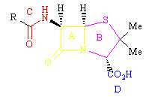

Match the following functional groups or rings with the regions shown.

Feedback: All four groups are important to the activity of penicillins
Page reference: 389
a. Carboxylic acid = Region D
b. Seconday amide = Region C
c. Thiazolidine = Region B
d. β-lactam = Region A

Type: multiple choice question
Title: Chapter 16- Question 107
107) What crucial feature of a penicillin is involved in its mechanism of action?

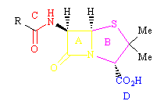

Feedback: Region A is the β-lactam ring which is reactive to nucleophiles. The carboxylic acid and acyl side chain are important binding groups in binding the penicillin to the active site prior to reaction. The thiazolidine ring increases the reactivity of the β-lactam ring due to increased ring strain.
Page reference: 390-393
a. Region D
*b. Region A
c. Region C
d. Region B

Type: multiple choice question
Title: Chapter 16- Question 108
108) Which enzyme catalyses the hydrolysis of the four membered ring present in penicillins?
Feedback: The four membered ring is the β-lactam and this is broken open by β-lactamases. The final cross linking reaction of the bacterial cell wall is catalysed by the transpeptidase enzyme. The hydrolysis of the side chain is catalysed by penicillin acylase. Esterases are responsible for the hydrolysis of esters.
Page reference: 395
a. Transpeptidase
b. Penicillin acylase
*c. β-lactamase
d. Esterase

Type: multiple choice question
Title: Chapter 16- Question 109
109) Methicillin is an important penicillin that was introduced in the 1960s to counter the threat of penicillin resistant strains of S. aureus. Which of the following structures is methicillin?

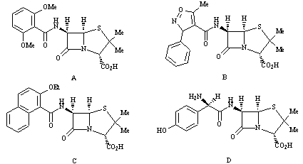
Feedback: Structures B, C and D are oxacillin, nafcillin and amoxicillin respectively. Oxacillin and nafcillin were also developed as effective agents against penicillin resistant bacteria.
Page reference: 399
*a. Structure A
b. Structure B
c. Structure C
d. Structure D

Type: multiple choice question
Title: Chapter 16- Question 110
110) Methicillin is an important penicillin that was introduced in the 1960s to counter the threat of penicillin resistant strains of S. aureus. Which group or groups in methicillin plays an important role in making this penicillin more effective than penicillin G against resistant strains of S. aureus?

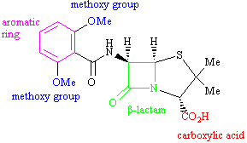
Feedback: The methoxy groups act as steric shields to hinder the ability of β-lactamases to hydrolyse the β-lactam ring.
Page reference: 399
a. The aromatic ring
*b. The methoxy groups
c. The β-lactam ring
d. The carboxylic acid

Type: multiple choice question
Title: Chapter 16- Question 111
111) Methicillin is an important penicillin that was introduced in the 1960s to counter the threat of penicillin resistant strains of S. aureus. Which of the following statements is true regarding the structure?

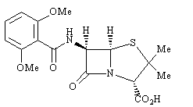
Feedback: It is acid sensitive, but it is because there is no electron withdrawing group present on the side chain. Since the compound is acid sensitive, it cannot be taken orally. The presence of the steric shields also makes it more difficult for the penicillin to attack the transpeptidase enzyme. This means that methicillin has a lower activity and a narrower spectrum of activity compared to penicillin G.
Page reference: 399
a. There is an electron withdrawing group on the side chain, and so it is acid sensitive
b. It can be taken orally
*c. It is less active than penicillin G
d. It has a broader spectrum of activity compared to penicillin G

Type: multiple choice question
Title: Chapter 16- Question 112
112) Methicillin is an important penicillin that was introduced in the 1960s to counter the threat of penicillin resistant strains of S. aureus. Which of the following statements is false?

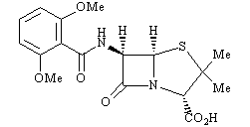
Feedback: The methoxy groups may well be electron withdrawing in an inductive sense, but they can also interact with the ring through resonance. This has the effect of increasing electron density in the ring and making it electron rich. As a result, the aromatic ring cannot act as an electron withdrawing group with respect to the neighbouring side chain amide and the structure is acid sensitive.
Page reference: 399
*a. The methoxy groups on the aromatic ring withdraw electrons from the ring making it electron deficient.
b. The methoxy groups act as steric shields for the β-lactam ring.
c. Replacing ethoxy groups on the aromatic ring would increase acid stability but decrease activity.
d. The methoxy groups are at the ortho position of the aromatic ring. If they were at the meta position, they would be less effective.

Type: multiple choice question
Title: Chapter 16- Question 113
113) Oxacillin was introduced as an improvement over methicillin for the treatment of penicillin resistant strains of S. aureus. Which of the following structures is oxacillin?

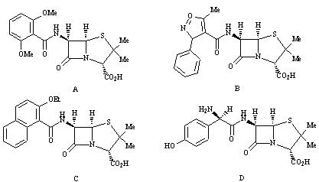
Feedback: Structures A, C and D are meethicillin, nafcillin and amoxicillin respectively. Nafcillin was also developed as an effective agent against penicillin resistant bacteria.
Page reference: 400
a. Structure A
*b. Structure B
c. Structure C
d. Structure D

Type: multiple choice question
Title: Chapter 16- Question 114
114) Oxacillin was introduced as an improvement over methicillin for the treatment of penicillin resistant strains of S. aureus. Which of the following statements is false?

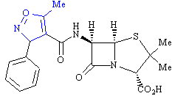
Feedback: The blue coloured ring has an electron withdrawing effect on the neighbouring amide group, and it is this effect which stabilises the molecule to acid and allows it to be administered orally.
Page reference: 400
*a. The feature coloured blue has an electron donating effect on the neighbouring amide.
b. The feature coloured blue has a steric effect which protects the β-lactam ring.
c. The feature coloured blue makes the structure more stable to acid.
d. The feature coloured blue makes the structure orally active.

Type: multiple choice question
Title: Chapter 16- Question 115
115) Which of the following structures is amoxicillin?

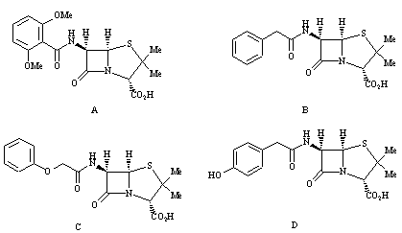

Feedback: Structures A-C are methicillin, penicillin G and ampicillin respectively.
Page reference: 401
a. Structure A
b. Structure B
c. Structure C
*d. Structure D

Type: multiple choice question
Title: Chapter 16- Question 116
116) Which of the following structures is pivampillin?

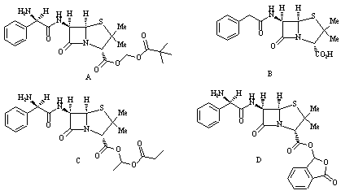
Feedback: Pivampicillin is a prodrug for ampicillin (structure B). The other two compounds (C and D) are bacampicillin and talampicillin respectively, and these compounds are also prodrugs of ampicillin.
Page reference: 402
*a. Structure A
b. Structure B
c. Structure C
d. Structure D

Type: multiple choice question
Title: Chapter 16- Question 117
117) Proampicillin is a prodrug and is converted to ampicillin in the body.

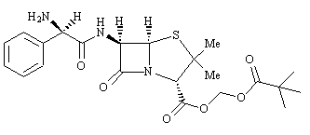
Which of the arrows in the following mechanism is incorrect?

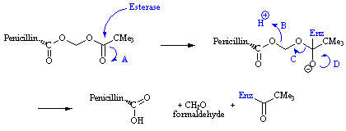
Feedback: Arrow A is wrong because it is drawn from the carbon atom. The arrow should start from the centre of the  bond that is being broken.
Page reference:
*a. Arrow A
b. Arrow B
c. Arrow C
d. Arrow D

Type: multiple choice question
Title: Chapter 16- Question 118
118) A serine residue in the active site of the transpeptidase enzyme reacts with cephalosporins, resulting in a covalent bond being formed between the enzyme and the cephalosporin.

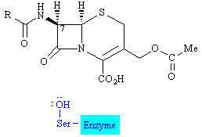
What is the structure of this enzyme bound product?

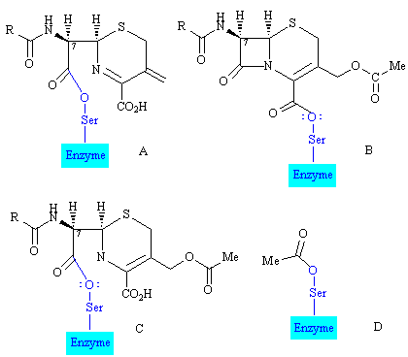
Feedback: The serine residue reacts with the -lactam ring of cephalosporins and so options B and D are wrong. Option C is wrong because ring opening coincides with a concerted mechanism that sees the expulsion of the acetoxy moiety as an acetate ion. The double bond in the dihydrothiazine ring is important in allowing this mechanism to take place.
Page reference: 405
*a. Structure A
b. Structure B
c. Structure C
d. Structure D

Type: multiple choice question
Title: Chapter 16- Question 119
119) The following features are present in cephalosporins. Which feature is involved in the mechanism by which cephalosporins react with the target enzyme?

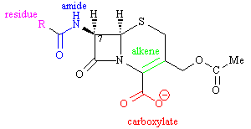
Feedback: The β-lactam ring is the group that is attacked by serine in the active site of the transpeptidase enzyme. Ring opening occurs with simultaneous elimination of the acyl side chain. This elimination is made possible by the double bond present in the dihydrothiazine ring.
The other groups may help to bind the drug to the active site but are not involved in the mechanism.
Page reference: 405
a. The secondary amide of the side chain
b. The carboxylate group
*c. The alkene group in the dihydrothiazine ring
d. The residue on the side chain

Type: multiple choice question
Title: Chapter 16- Question 120
120) Cephaloridine has a pyridinium ring in place of the acetyl group in cephalothin. Which of the following statements is true?

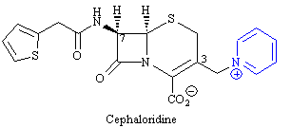

Feedback: Cephaloridine has a longer duration of action since the acyl group that was replaced is susceptible to enzymatic hydrolysis.
The other options are false. Cephaloridine is poorly absorbed through the gut wall and has to be injected. The pyridinium ring does not act as a binding group. It acts as a good leaving group in the inhibition mechanism. It is also less easily metabolised than the acetyl group of cephalothin.
Page reference: 407-408
a. Cephaloridine is more easily absorbed through the gut wall.
*b. Cephaloridine has a longer duration of action than cephalothin.
c. The pyridinium ring acts as a good binding group in the inhibition mechanism.
d. The pyridinium ring is more easily metabolised than the acetyl group of cephalothin.

Type: multiple choice question
Title: Chapter 16- Question 121
121) Cefalexin is a first generation cephalosporin. Which of the following structures is cefalexin?

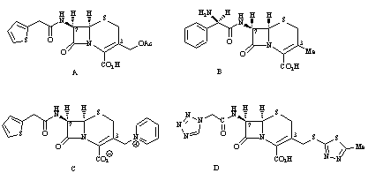
Feedback: The other structures are also first generation cephalosporins, mainly cephalothin (A), cephaloridine (C) and cefazolin (D)
Page reference: 407-408
a. Structure A
*b. Structure B
c. Structure C
d. Structure D

Type: multiple choice question
Title: Chapter 16- Question 122
122) Cefalexin is a first generation cephalosporin. Which of the following statements is true for the methyl substituent at position 3?

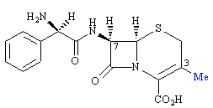
Feedback: A methyl group at the 3-position is generally bad for activity since it is a poor leaving group. However, if a suitable 7-acyl side chain is present, the methyl group at position 3 is good for oral activity since it aids oral absorption. It does not act as a steric shield and it is not a good leaving group.
Page reference: 408
a. It is a good leaving group
*b. It is generally bad for activity
c. It is bad for oral activity
d. It acts as a steric shield

Type: multiple choice question
Title: Chapter 16- Question 123
123) Third and fourth generation cephalosporins contain an aminothiazole ring (shown in blue). Which of the following statements is false?

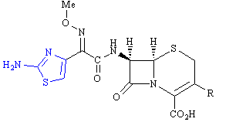

Feedback: The advantages of having an aminothiazole ring present are in increasing binding interactions and penetration through the outer membrane of Gram negative bacteria. It has no influence on the reactivity of the β-lactam ring.
Page reference: 409-410
a. Third and fourth generation cephalosporins show enhanced activity against Gram negative bacteria.
b. The aminothiazole ring enhances the penetration of cephalosporins through the outer membrane of Gram negative bacteria.
c. The aminothiazole ring may increase affinity for the transpeptidase enzyme.
*d. The aminothiazole ring increases the reactivity of the β-lactam ring.

Type: multiple choice question
Title: Chapter 16- Question 124
124) Which of the following structures is thienamycin?

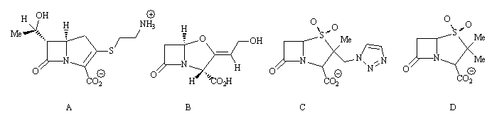
Feedback: Structures B, C and D are clavulanic acid, tazobactam and sulbactam respectively.
Page reference: 411
*a. Structure A
b. Structure B
c. Structure C
d. Structure D

Type: multiple choice question
Title: Chapter 16- Question 125
125) Which of the following structures is clavulanic acid?

Feedback: Structures A, C and D are thienamycin, tazobactam and sulbactam respectively.
Page reference: 412
a. Structure A
*b. Structure B
c. Structure C
d. Structure D

Type: multiple choice question
Title: Chapter 16- Question 126
126) Which of the following structures does not target the transpeptidase enzyme?
Feedback: Clavulanic acid inhibits the β-lactamase enzyme, and prevents the enzyme from deactivating penicillins.
Page reference: 412-413
a. Penicillin G
*b. Clavulanic acid
c. Cefalexin
d. Thienamycin

Type: multiple choice question
Title: Chapter 16- Question 127
127) What is the name of the preparation containing amoxicillin and clavulanic acid?
Feedback: The combination of amoxicillin and clavulanic acid is sold as Augmentin. The combination of clavulanic acid and ticarcillin is sold as Timentin. The combination of ampicillin and sulbactam is sold as Unasyn. Zosyn is a combination of tazobactam and piperacillin.
Page reference: 412-413
a. Timentin
b. Unasyn
c. Zosyn
*d. Augmentin

Type: multiple choice question
Title: Chapter 16- Question 128
128) What is the name of the preparation containing ticarcillin and clavulanic acid?
Feedback: The combination of amoxicillin and clavulanic acid is sold as Augmentin. The combination of clavulanic acid and ticarcillin is sold as Timentin. The combination of ampicillin and sulbactam is sold as Unasyn. Zosyn is a combination of tazobactam and piperacillin.
Page reference: 413
*a. Timentin
b. Unasyn
c. Zosyn
d. Augmentin

Type: multiple choice question
Title: Chapter 16- Question 129
129) What is the name of the preparation containing ampicillin and sulbactam?
Feedback: The combination of amoxicillin and clavulanic acid is sold as Augmentin. The combination of clavulanic acid and ticarcillin is sold as Timentin. The combination of ampicillin and sulbactam is sold as Unasyn. Zosyn is a combination of tazobactam and piperacillin.
Page reference: 414
a. Timentin
*b. Unasyn
c. Zosyn
d. Augmentin

Type: multiple choice question
Title: Chapter 16- Question 130
130) The following diagram shows clavulanic acid in the active site of a β-lactamase enzyme.

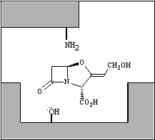

What is the final result of the interaction of clavulanic acid with the enzyme?

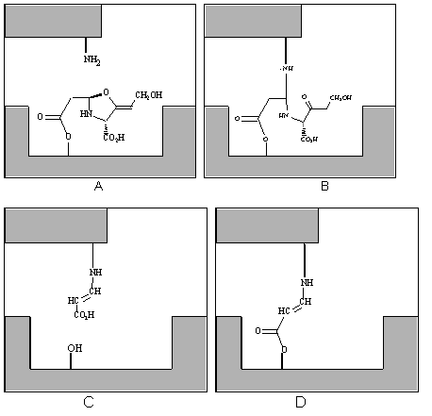
Feedback: Diagrams A and B are formed in the mechanism leading to the final structure. Diagram C would occur if the ester bond was broken, but this reaction is very slow.
Page reference: 413
a. Diagram A
b. Diagram B
c. Diagram C
*d. Diagram D

Type: multiple choice question
Title: Chapter 16- Question 131
131) Which of the following structures is tazobactam?

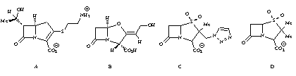

Feedback: Structures A, B and D are thienamycin, clavulanic acid and sulbactam respectively.
Page reference: 413-414
a. Structure A
b. Structure B
*c. Structure C
d. Structure D

Type: multiple choice question
Title: Chapter 16- Question 132
132) What is the name of the preparation containing tazobactam and piperacillin?
Feedback: The combination of amoxicillin and clavulanic acid is sold as Augmentin. The combination of clavulanic acid and ticarcillin is sold as Timentin. The combination of ampicillin and sulbactam is sold as Unasyn. Zosyn is a combination of tazobactam and piperacillin.
Page reference: 414
a. Timentin
b. Unasyn
*c. Zosyn
d. Augmentin

Type: multiple choice question
Title: Chapter 16- Question 133
133) What antibacterial agent works by mimicking D-alanine?
Feedback: D-Cycloserine mimics D-alanine and inhibits L-Ala racemase and D-Ala-D-Ala ligase. The former enzyme catalyses the racemisation of L-Ala to D-Ala. The latter enzyme catalyses the linkage of two D-Ala amino acids to give the dipeptide D-Ala-D-Ala.
The other agents mentioned inhibit cell wall synthesis at different stages.
Page reference: 414-415
a. Vancomycin
*b. D-cycloserine
c. Bacitracin
d. Penicillin G

Type: multiple choice question
Title: Chapter 16- Question 134
134) What sort of structure is streptomycin?

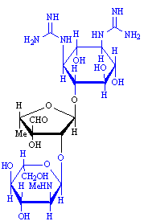
Feedback: Streptomycin is an aminoglycoside, so named because it contains carbohydrate rings with amino substituents.
Page reference: 424-425
a. A penicillin
b. A tetracycline
c. A macrolide
*d. An aminoglycoside

Type: multiple choice question
Title: Chapter 16- Question 135
135) What sort of structure is erythromycin?

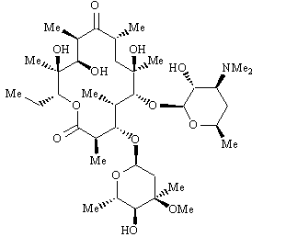

Feedback: Erythromycin is a macrolide, containing a large 14 membered rings.
Page reference: 427
a. A penicillin
b. A tetracycline
*c. A macrolide
d. An aminoglycoside

Type: multiple choice question
Title: Chapter 16- Question 136
136) What sort of structure is doxycycline?

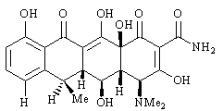

Feedback: Doxycycline is a tetracycline, containing four rings fused together.
Page reference: 425-426
a. A penicillin
*b. A tetracycline
c. A macrolide
d. An aminoglycoside

Type: multiple choice question
Title: Chapter 16- Question 137
137) Which of the following side effects is unique to chloramphenicol?
Feedback: Chloramphenicol is a relatively toxic drug. The aromatic nitro group is thought to be responsible.
Page reference: 426
*a. Gray Baby Syndrome
b. Allergic reactions
c. Lowering of blood pressure
d. Anaemia

Type: multiple choice question
Title: Chapter 16- Question 138
138) Which functional group is thought to be chiefly responsible for the toxicity of chloramphenicol?

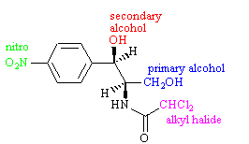
Feedback: Aromatic nitro groups are normally avoided if possible since they commonly cause toxic effects.
Page reference: 426
a. A secondary alcohol
*b. An aromatic nitro group
c. An alkyl chloride
d. A primary alcohol

Type: multiple choice question
Title: Chapter 16- Question 139
139) Which of the following statements is false regarding erythromycin?
Feedback: Erythromycin is one of the safest antibiotics currently in use.
Page reference: 427
*a. It has serious side effects.
b. It was isolated from a soil microorganism discovered in the Phillipines.
c. It is a member of the macrolide group of antibiotics.
d. It acts by binding to the 50S subunit of bacterial ribosomes.

Type: matching question
Title: Chapter 16 - Question 140
140) The following structures are synthetic antibacterial agents. Match the structures to the agents.

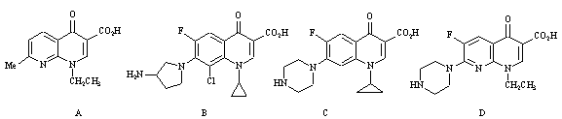
Feedback: The structures are all examples of quinolones and fluoroquinoones
Page reference: 428-431
a. Ciprofloxacin = Structure C
b. Nalidixic acid = Structure A
c. Enoxacin = Structure D
d. Clinafloxacin = Structure B

Type: multiple choice question
Title: Chapter 16- Question 141
141) Which of the following structures is a fluoroquinolone?

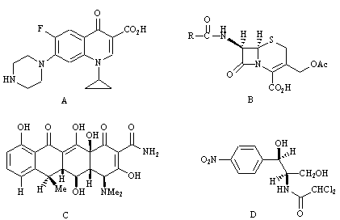
Feedback: Structure A is a fluoroquinoline. Structure B is a cephalosporin. Structure C is a tetracycline. Structure D is chloramphenicol.
Page reference: 428-431
*a. Structure A
b. Structure B
c. Structure C
d. Structure D

Type: multiple choice question
Title: Chapter 16- Question 142
142) Which statement is false regarding the fluoroquinoline antibacterial agents?
Feedback: The drugs target enzymes called topoisomerases. Helicases catalyse an unwinding process and the topoisomerases are required to relieve the strain resulting from this uncoiling.
Page reference: 429-431
*a. They target enzymes called helicases
b. They inhibit replication
c. They inhibit transcription
d. They stabilise an enzyme-DNA-drug complex where four fluoroquinoline molecules are stacked together

Type: multiple choice question
Title: Chapter 16- Question 143
143) Proflavine is an antibacterial agent that was used in the second world war. Which one of the following structures is proflavine?

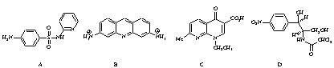

Feedback: The other structures are sulphapyridine (A), nalidixic acid (C) and chloramphenicol (D).
Page reference: 431
a. Structure A
*b. Structure B
c. Structure C
d. Structure D

Type: multiple choice question
Title: Chapter 16- Question 144
144) Which of the following antibacterial agents targets DNA?
Feedback: Proflavine acts as an intercalator, slipping between the stacked base pairs of DNA.
Page reference: 431
a. Penicillin V
b. Erythromycin
*c. Proflavine
d. D-cycloserine

Type: multiple choice question
Title: Chapter 16- Question 145
145) Which of the following drugs acts as an intercalator?
Feedback: Proflavine fits between the base pairs of the DNA double helix and disrupts its structure.
Page reference: 431
a. Methacillin
b. Sulfathiazole
c. Valinomycin
*d. Proflavine

Type: multiple choice question
Title: Chapter 16- Question 146
146) Which of the following structures has been used as a topical agent for skin infections, and as a means of combating the transmission of S. aureus in hospitals?

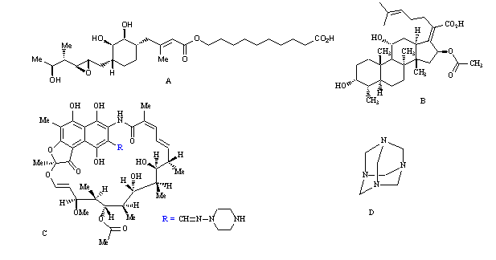
Feedback: Structure A is mupirocin. The other structures are fusidic acid, rifampicin and methenamine.
Page reference: 435
*a. Structure A
b. Structure B
c. Structure C
d. Structure D

Type: multiple choice question
Title: Chapter 16- Question 147
147) Which of the following agents targets the enzyme isoleucyl tRNA synthetase?
Feedback: Mupirocin targets the enzyme isoleucyl t-RNA synthetase. Isoniazid inhibits the biosynthesis of mycolic acid. Ethambutol inhibits arabinosyl transferase. Metronidazole is reduced within bacterial cells resulting in the production of radicals which attack DNA.
Page reference: 435
a. Isoniazid
b. Ethambutol
c. Metronidazole
*d. Mupirocin

Type: multiple choice question
Title: Chapter 16- Question 148
148) Which of the following drugs does not act against cell wall synthesis?
Feedback: Chloramphenical inhibits the translation process leading to new proteins. The other agents inhibit different stages of cell wall synthesis.

Page reference: 426
a. Vancomycin
b. Penicillins
c. Cycloserine
*d. Chloramphenicol

