Chapter 14: Combinatorial synthesis

Type: multiple choice question
Title: Chapter 14 Question 01
01) Solid phase synthesis is frequently used in combinatorial chemistry. What is meant by solid phase synthesis?
Feedback: In solid phase synthesis, molecules are constructed on a solid phase support. Reagents are added in solution.
Page reference: 300-301
a. Reactions are carried out without solvent.
b. Reagents and reactants are attached to a solid phase support.
c. Reagents are used in the solid phase.
*d. Molecules are constructed on a solid phase support.

Type: multiple choice question
Title: Chapter 14 Question 02
02) There are several advantages of solid phase synthesis over conventional synthesis. Which of the following statements is NOT an advantage?
Feedback: This is not an advantage since it is necessary to remove the product from the solid support at the end of the synthesis. The structures should however remain attached to the solid support under the various reaction conditions used in the synthesis.
Page reference: 300-301
a. Excess reagents can be used to force the equilibrium of a reaction to products.
b. Impurities and by products are easily removed.
c. Intermediates do not need to be isolated and purified.
*d. Structures can be strongly linked to the solid support such that they cannot be removed.

Type: multiple choice question
Title: Chapter 14 Question 03
03) The following is an important resin used in combinatorial chemistry:

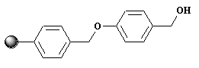
Identify the resin
Feedback: The Wang resin has a primary alcohol group present to which a molecule can be attached. The Rink resin contains a primary amino group for this purpose. The Merrifield resin has an alkyl chloride group and the dihydropyran-functionalised resin has a dihydropyran ring.
Page reference: 303
*a. Wang resin
b. Rink resin
c. Merrifield resin
d. Dihydropyran-functionalised resin

Type: multiple choice question
Title: Chapter 14 Question 04
04) The following is an important resin used in combinatorial chemistry.

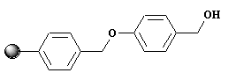
Where does a starting material get bound to this resin?
Feedback: The primary alcohol is the point of attachment. This is not a phenol group since it is not directly attached to the aromatic ring. The ether and the aromatic ring are unreactive under the conditions used.
Page reference: 303
a. The phenol group
b. The aromatic ring
*c. The alcohol
d. The ether

Type: multiple choice question
Title: Chapter 14 Question 05
05) The following is an important resin used in combinatorial chemistry.

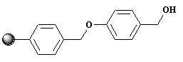

What functional group needs to be present on a molecule if it is to be attached to this resin?
Feedback: The alcohol on the anchor reacts with a carboxylic acid on the first reactant such that an ester bond links the reactant to the anchor.
Page reference: 303
a. Phenol
b. Alcohol
c. Alkyl halide
*d. Carboxylic acid

Type: multiple choice question
Title: Chapter 14 Question 06
06) The following is an important resin used in combinatorial chemistry.

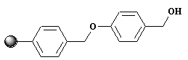

What conditions are used to cleave a molecule from this resin?
Feedback: Hydrofluoric acid is used to cleave the ester bond linking peptides to the Merrifield resin. Piperidine is used to deprotect the Fmoc protecting group from primary amines. Hydrogen and a palladium charcoal catalyst is used to remove benzyl or benzyloxycarbonyl protecting groups. Trifluoroacetic acid is used to cleave the ester bond linking a molecule to the Wang resin, the amide bond linking a molecule to a Rink resin and the ketal group linking a molecule to a dihydropyran-derivatised resin. It is also used to remove several protecting groups.
Page reference: 303
a. Hydrofluoric acid
b. Piperidine
c. Hydrogen and a palladium charcoal catalyst
*d. Trifluoroacetic acid

Type: multiple choice question
Title: Chapter 14 Question 07
07) The following is an important resin used in combinatorial chemistry.

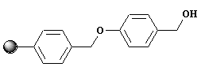
What functional group is present on a molecule once it is released from this resin?
Feedback: The same functional group that was present initially is regenerated.
Page reference: 303
a. Carboxamide
*b. Carboxylic acid
c. Ester
d. Alcohol

Type: multiple choice question
Title: Chapter 14 Question 08
08) The following is an important resin used in combinatorial chemistry.

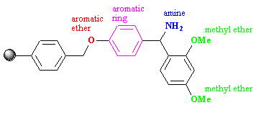
Identify the resin
Feedback: The Wang resin has a primary alcohol group present to which a molecule can be attached. The Rink resin contains a primary amino group for this purpose. The Merrifield resin has an alkyl chloride group and the dihydropyran-functionalised resin has a dihydropyran ring.
Page reference: 303
a. Wang resin
*b. Rink resin
c. Merrifield resin
d. dihydropyran-functionalised resin

Type: multiple choice question
Title: Chapter 14 Question 09
09) The following is an important resin used in combinatorial chemistry.

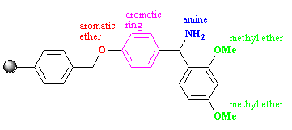
Where does a starting material get bound to this resin?
Feedback: The aromatic rings and the ethers are unreactive under the reaction conditions used.
Page reference: 303
*a. The amine group
b. The aromatic ring
c. The aromatic ether
d. The methyl ether

Type: multiple choice question
Title: Chapter 14 Question 10
10) The following is an important resin used in combinatorial chemistry.

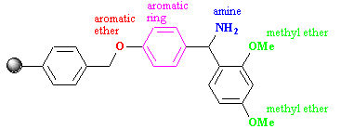
What functional group needs to be present on a molecule if it is to be attached to this resin?
Feedback: Reaction of a carboxylic acid with the primary amine present on the anchor results in an amide bond linking the first reactant to the anchor.
Page reference: 303
a. Phenol
b. Alcohol
c. Alkyl halide
*d. Carboxylic acid

Type: multiple choice question
Title: Chapter 14 Question 11
11) The following is an important resin used in combinatorial chemistry.

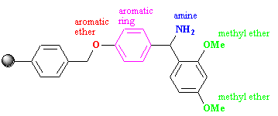
What conditions are used to cleave a molecule from this resin?
Feedback: Hydrofluoric acid is used to cleave the ester bond linking peptides to the Merrifield resin. Piperidine is used to deprotect the Fmoc protecting group from primary amines. Hydrogen and a palladium charcoal catalyst is used to remove benzyl or benzyloxycarbonyl protecting groups. Trifluoroacetic acid is used to cleave the ester bond linking a molecule to the Wang resin, the amide bond linking a molecule to a Rink resin and the ketal group linking a molecule to a dihydropyran-derivatised resin. It is also used to remove several protecting groups.
Page reference: 303
a. Hydrofluoric acid
b. Piperidine
c. Hydrogen and a palladium charcoal catalyst
*d. Trifluoroacetic acid

Type: multiple choice question
Title: Chapter 14 Question 12
12) The following is an important resin used in combinatorial chemistry.

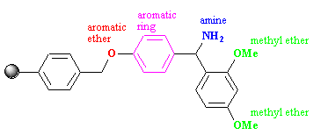
What functional group is present on a molecule once it is released from this resin?
Feedback: The amino group that was originally part of the linker is transferred to the final product once it is cleaved from the anchor.
Page reference: 303
*a. Carboxamide
b. Carboxylic acid
c. Ester
d. Alcohol

Type: multiple choice question
Title: Chapter 14 Question 13
13) The following is an important resin used in combinatorial chemistry.

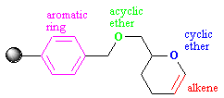

Identify the resin.
Feedback: The Wang resin has a primary alcohol group present to which a molecule can be attached. The Rink resin contains a primary amino group for this purpose. The Merrifield resin has an alkyl chloride group and the dihydropyran-functionalised resin has a dihydropyran ring.
Page reference: 303
a. Wang resin
b. Rink resin
c. Merrifield resin
*d. Dihydropyran-functionalised resin

Type: multiple choice question
Title: Chapter 14 Question 14
14) The following is an important resin used in combinatorial chemistry.

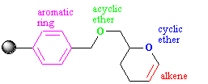
Where does a starting material get bound to this resin?
Feedback:
Page reference: 303
*a. The alkene group
b. The aromatic ring
c. The acyclic ether
d. The cyclic ether

Type: multiple choice question
Title: Chapter 14 Question 15
15) The following is an important resin used in combinatorial chemistry.

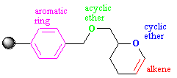

What functional group needs to be present on a molecule if it is to be attached to this resin?
Feedback:
Page reference: 303
a. Ether
*b. Alcohol
c. Alkyl halide
d. Nitrile

Type: multiple choice question
Title: Chapter 14 Question 16
16) The following is an important resin used in combinatorial chemistry.

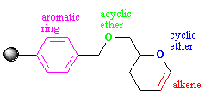
What conditions are used to cleave a molecule from this resin?
Feedback: Hydrofluoric acid is used to cleave the ester bond linking peptides to the Merrifield resin. Piperidine is used to deprotect the Fmoc protecting group from primary amines. Hydrogen and a palladium charcoal catalyst is used to remove benzyl or benzyloxycarbonyl protecting groups. Trifluoroacetic acid is used to cleave the ester bond linking a molecule to the Wang resin, the amide bond linking a molecule to a Rink resin and the ketal group linking a molecule to a dihydropyran-derivatised resin. It is also used to remove several protecting groups.
Page reference: 303
a. Hydrofluoric acid
b. Piperidine
c. Hydrogen and a palladium charcoal catalyst
*d. Trifluoroacetic acid

Type: multiple choice question
Title: Chapter 14 Question 17
17) The following is an important resin used in combinatorial chemistry.

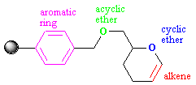
What functional group is present on a molecule once it is released from this resin?
Feedback: The functional group that was originally present on the first reactant is restored.
Page reference: 303
a. Ether
*b. Alcohol
c. Alkyl halide
d. Nitrile

Type: multiple choice question
Title: Chapter 14 Question 18
18) The following structure is a protecting group used in peptide synthesis.

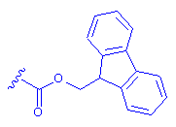

What functional group does it protect?
Feedback: The protecting group is used to protect the amine functional group of amino acids.
Page reference: 303-304
a. Carboxylic acid
*b. Amine
c. Alcohol
d. Phenol

Type: multiple choice question
Title: Chapter 14 Question 19
19) The following structure is a protecting group used in peptide synthesis.

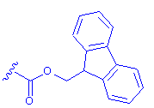

What is the name of the protecting group?
Feedback: The fluorenyl moiety is the tricyclic system that is present.
The other protecting groups mentioned in the options have a single aromatic ring (benzyloxycarbonyl and benzyl) or no rings at all (tert-butyloxycarbonyl).
Page reference: 303-304
a. Tertiary-butyloxycarbonyl
b. Benzyloxycarbonyl
c. Benzyl
*d. 9-fluorenylmethoxycarbonyl

Type: multiple choice question
Title: Chapter 14 Question 20
20) The following structure is a protecting group used in peptide synthesis.

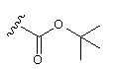

What functional group does it protect?
Feedback: When the protecting group is added to an amine, a urethane functional group is formed.
Page reference: 304
a. Carboxylic acid
*b. Amine
c. Alcohol
d. Phenol

Type: multiple choice question
Title: Chapter 14 Question 21
21) The following structure is a protecting group used in peptide synthesis.

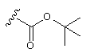
What is the name of the protecting group?
Feedback: The Tertiary-butyloxycarbonyl group is used to protect amino groups, as are the benzyloxycarbonyl and 9-fluorenylmethoxycarbonyl groups. The benzyl group is used as a protecting group for carboxylic acids, alcohols or phenols.
Page reference: 304
*a. Tertiary-butyloxycarbonyl
b. Benzyloxycarbonyl
c. Benzyl
d. 9-fluorenylmethoxycarbonyl

Type: multiple choice question
Title: Chapter 14 Question 22
22) The following structure is a protecting group used in peptide synthesis.

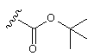
What conditions are used to release the protecting group during a solid phase peptide synthesis?
Feedback: Trifluoroacetic acid is more acidic than acetic acid due to the electron withdrawing effect of the three fluorine atoms present.
Page reference: 304
a. Hydrofluoric acid
b. Piperidine
c. Hydrogen and a palladium charcoal catalyst
*d. Trifluoroacetic acid

Type: multiple choice question
Title: Chapter 14 Question 23
23) A pharmaceutical laboratory wishes to synthesise all the possible dipeptides containing the amino acids (Thr, Ile, Phe, Tyr, Ser).
How many dipeptides are possible?
Feedback:
The 25 dipeptides are as follows:
Thr-Thr, Thr-Ile, Thr-Phe, Thr-Tyr, Thr-Ser
Ile-Thr, Ile-Ile, Ile-Phe, Ile-Tyr, Ile-Ser
Phe-Thr, Phe-Ile, Phe-Phe, Phe-Tyr, Phe-Ser
Tyr-Thr, Tyr-Ile, Tyr-Phe, Tyr-Tyr, Tyr-Ser
Ser-Thr, Ser-Ile, Ser-Phe, Ser-Tyr, Ser-Ser
Page reference: 306
a. 20
*b. 25
c. 10
d. 5

Type: multiple choice question
Title: Chapter 14 - Question 24
24) A pharmaceutical laboratory wishes to synthesise all the possible dipeptides containing the amino acids (Thr, Ile, Phe, Tyr, Ser).
How would you carry out these syntheses using combinatorial techniques?
a. Mix all five amino acids together and add the mixture to a resin such that the amino acids are attached to the resin, then add another mixture of the five amino acids such that dipeptides are formed on the resin.
Feedback: incorrect. All the dipeptides are attached to resin beads in the one vessel and there is no easy way of separating them, other than by separating each bead individually.
Page reference: 306-308
*b. Split the resin between five vessels and add a different amino acid to each vessel such that the amino acid is attached to the resin. Mix the resin beads from all the vessels and resplit the beads back into five vessels, then add a different amino acid to each vessel to form dipeptides on each resin.
Feedback: Correct. The procedure will generate five vessels of dipeptides. Each vessel will contain a mixture of dipeptides but no one dipeptide will be in more than one vessel. The identity of the second amino acid will be known for all the dipeptides in any one vessel.
Page reference: 306-308
c. Split the resin between five vessels and add a different amino acid to each vessel such that it is attached to the resin , then add a different amino acid to each vessel to form dipeptides on each resin.
Feedback: incorrect. The procedure will only produce five dipeptides. Each of the five vessels will contain a single dipeptide.
Page reference: 306-308
d. Split the resin between five vessels and add a different amino acid to each vessel such that it is attached to the resin , then add a mixture of the five amino acids to each vessel to form dipeptides on each resin.
Feedback: incorrect. The procedure could potentially produce all 25 dipeptides in five different vessels. The first amino acid of the dipeptides in any specific vessel will be identical. However, this procedure suffers from the disadvantage that the different amino acids added at the second stage are competing against each other and some may be more reactive than others. As a result, the five dipeptides expected in a single vessel may not be formed if one of the amino acids is much less reactive than the other four.
Page reference: 306-308

Type: multiple choice question
Title: Chapter 14 Question 25
25) The following linker is useful in a process called 'tagging'

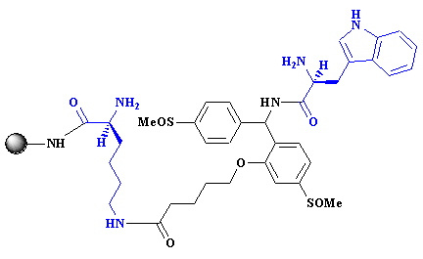

Identify the linker
Feedback: The other options are fictitious
Page reference: 312
a. Di-amino linker
b. Tagging linker
c. Amino acid linker
*d. Safety catch linker

Type: multiple choice question
Title: Chapter 14 Question 26
26) The following linker is useful in a process called 'tagging'

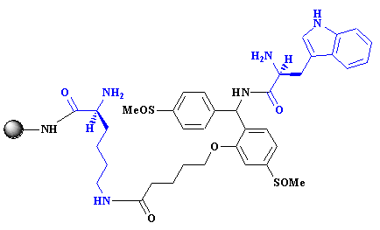

What are the moieties coloured in blue?
Feedback: These are amino acid structures. The structures of amino acids are given in Appendix 1. The linker is known as the safety catch linker.
Page reference: 312
a. Arginine and tryptophan
*b. Lysine and tryptophan
c. Arginine and lysine
d. Lysine and phenylalanine

Type: multiple choice question
Title: Chapter 14 Question 27
27) The following linker is useful in a process called 'tagging'

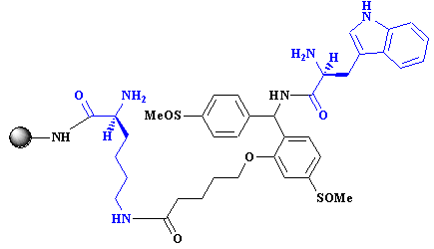
What functional groups in the linker molecule are used to attach molecules?
Feedback: The linker is known as the safety catch linker.
Page reference: 312
a. The amide groups
b. The aromatic rings
*c. The primary amino groups
d. The methanesulfinyl groups

Type: multiple choice question
Title: Chapter 14 Question 28
28) The following linker is useful in a process called 'tagging'

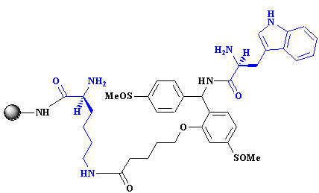

What sorts of molecules are usually constructed as tags?
Feedback: Peptides are used since they are easily constructed and easily analysed by automated sequencers. Another option is to use oligonucleotides. The linker is known as the safety catch linker.

Page reference: 312
*a. Peptides
b. Carbohydrates
*c. Lipids
d. Polyesters

Type: multiple choice question
Title: Chapter 14 Question 29
29) Consider the following synthesis

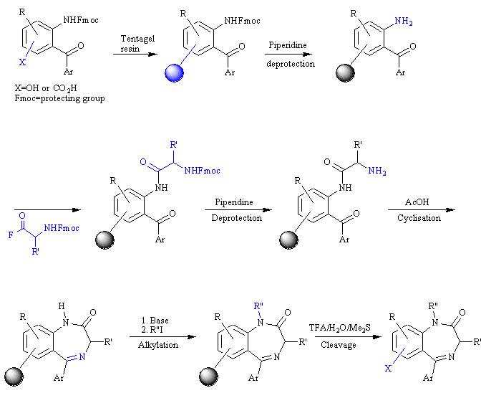
Molecular tags (A-I) are constructed on the resin bead as the synthesis is carried out in order to identify R, R' and R". The tagging molecules are used to create an encryption code as follows

R
R'
R"

methyl
A
D
G

ethyl
B
E
H

propyl
C
F
I

isopropyl
AB
DE
GH

n-butyl
AC
DF
GI

tert-butyl
BC
EF
GJ

benzyl
ABC
DEF
GHI

On completion of the synthesis, the molecular tags are released from a set of resin beads and identified by gas chromatography as shown below.

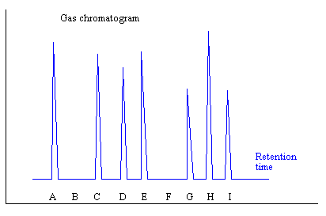
What structure has been formed on the bead?

Feedback: The code AC stands for n-butyl, the code DE stands for isopropyl and the code GHI stands for benzyl.
Page reference: 313-314
a. R= n-butyl; R'= isopropyl; R" methyl
b. R= ethyl; R'= propyl; R" benzyl
*c. R= n-butyl; R'= isopropyl; R" benzyl
d. R= n-butyl; R'= ethyl; R" ethyl

Type: multiple choice question
Title: Chapter 14 Question 30
30) The following structure is a protecting group used in peptide synthesis.

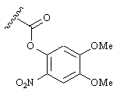
What is the name of the protecting group?
Feedback:
Page reference: 314
a. Tertiary-butyloxycarbonyl
b. Benzyloxycarbonyl
*c. Nitroveratryloxycarbonyl
d. 9-fluorenylmethoxycarbonyl

Type: multiple choice question
Title: Chapter 14 Question 31
31) The following structure is a protecting group used in peptide synthesis.

What conditions are used to release the protecting group during a solid phase peptide synthesis?
Feedback: The protecting group is a nitroveratryloxycarbonyl group
Page reference: 314
a. Hydrofluoric acid
b. Piperidine
*c. Light
d. Trifluoroacetic acid

Type: multiple choice question
Title: Chapter 14 Question 32
32) The following structure is a protecting group used in peptide synthesis.

There are several advantages to the above technique. Which of the following statements is untrue?
Feedback: There is no reason why this technique should be more likely to generate active compounds than any other technique of combinatorial chemistry. The real advantages are in miniaturisation and spatial resolution. The protecting group is a nitroveratryloxycarbonyl group.
Page reference: 314
a. It allows miniaturisation of the process.
*b. It is more likely to result in active compounds.
c. It allows spatial resolution of the products.
d. It reduces the quantity of chemicals required for a synthesis.

Type: multiple choice question
Title: Chapter 14 Question 33
33) What is the term used to describe the 3-dimensional space around a molecule when it is in a target binding site?
Feedback: The space accessed by a molecule when it is in the binding site will depend on how flexible the molecule is. This in turn depends on the number of rotatable single bonds that are present. Conformations refer to the different shapes of a molecule that can be adopted by single bond rotation.
The other terms are not used in medicinal chemistry.
Page reference: 321
a. Stereochemical space
*b. Conformational space
c. Configurational space
d. Constitutional space

Type: multiple choice question
Title: Chapter 14- Question 34
34) Combinatorial chemistry can be useful at various stages of the drug design / development process. Which of the following is such a stage?
Feedback: Optimising a lead compound requires the synthesis of a large number of analogues and so combinatorial chemistry can be important at this stage. The other options do not require compounds to be synthesised and so there is no need for combinatorial chemistry.
Page reference: 299-300
a. Purifying a lead compound
*b. Optimising a lead compound
c. Structure determination of the lead compound
d. Pharmacological testing

Type: multiple choice question
Title: Chapter 14- Question 35
35) There are several advantages of solid phase synthesis over conventional synthesis. Which of the following statements is untrue?
Feedback: Excess reagents are frequently used to force an equilibrium reaction to completion. The excess reagents are also easily removed.
Page reference: 300-301
*a. Excess reagents are a problem since it can result in over reaction.
b. Impurities and by products are easily removed.
c. Intermediates do not need to be isolated and purified.
d. Structures can be linked to the solid support such that they are stable to various reaction conditions, but can be removed easily under certain conditions.

Type: multiple choice question
Title: Chapter 14- Question 36
36) What term is used for a molecular unit which is attached to the solid support and which contains a reactive functional group that allows attachment of a starting material?
Feedback: The linker or anchor is the overall moiety which is attached to the solid support and which contains the functional group required to attach the first molecule in the synthetic process.
Page reference: 302-303
a. Resin activator
b. Hook
*c. Linker
d. Joiner

Type: multiple choice question
Title: Chapter 14- Question 37
37) Which of the following statements regarding linkers is wrong?
Feedback: The statement is true for some linkers but not all. Several linkers will react with a specific functional group and allow the molecule to have the same functional group when it is removed at the end of the synthesis.
Page reference: 302-303
a. The link between the molecule and the solid support must be stable to the reaction conditions used in the synthesis.
b. The link between the molecule and the solid support must be easily cleaved under specific conditions.
*c. A linker reacts with a specific functional group when the first molecule is attached. At the end of the synthesis the molecule departs with a different functional group.
d. It is important that the resin bead swells to allow molecules to access linkers within the bead.

Type: multiple choice question
Title: Chapter 14- Question 38
38) The following structures are protecting groups used in peptide synthesis.

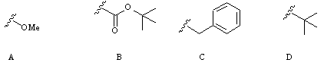

Which of these would you use to protect an amino group?
Feedback: This protecting group is used to protect the amine functional group of amino acids. The other protecting groups have been used to protect the carboxylic acid group of amino acids.
Page reference: 304-305
a. Structure A
*b. Structure B
c. Structure C
d. Structure D

Type: multiple choice question
Title: Chapter 14- Question 39
39) The following structures are protecting groups used in peptide synthesis.

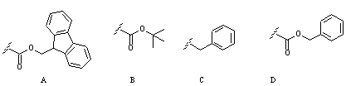
Which of these would you use to protect a carboxylic acid group?
Feedback: Structure C is a benzyl protecting group which can be used to protect carboxylic acids or hydroxyl groups. The other protecting groups have been used to protect the amino group of amino acids.
Page reference: 304-305
a. Structure A
b. Structure B
*c. Structure C
d. Structure D

Type: multiple choice question
Title: Chapter 14- Question 40
40) The following structures are protecting groups used in peptide synthesis.

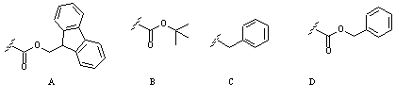

Which of these would you use to protect the side chain of serine?
Feedback: Structure C is a benzyl protecting group which can be used to protect carboxylic acids or hydroxyl groups. Serine has a primary alcohol in its side chain and so a benzyl protecting group could be used. The other protecting groups have been used to protect the amino group of amino acids.
Page reference: 304-305
a. Structure A
b. Structure B
*c. Structure C
d. Structure D

Type: matching question
Title: Chapter 14 - Question 41
41) The following structures are protecting groups used in peptide synthesis.

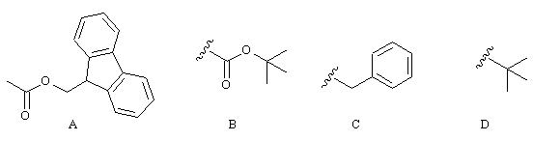

Match the structures to the following names

Feedback: Structures A and B are used to protect amino groups. Structures C and D are used to protect carboxylic acids.
Page reference: 303-305
a. Tertiary-butyloxycarbonyl = Structure B
b. Tertiary butyl = Structure D
c. Benzyl = Structure C
d. 9-fluorenylmethoxycarbonyl = Structure A

Type: multiple choice question
Title: Chapter 14- Question 42
42) The following structures are protecting groups used in peptide synthesis.

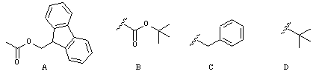
Which of these protecting groups can be removed by using piperidine?
Feedback: Structure A can be removed under relatively mild conditions compared to the other protecting groups shown.

Page reference: 303, 304
*a. Structure A
b. Structure B
c. Structure C
d. Structure D

Type: multiple choice question
Title: Chapter 14- Question 43
43) The following structures are protecting groups used in peptide synthesis.

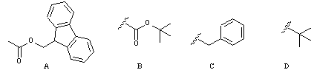
Which of these protecting groups requires the most vigorous conditions for removal?
Feedback: The benzyl group (structure C) requires vigorous conditions such as hydrofluoric acid for removal. The tertiary butyl and tertiary butyloxycarbonyl groups (structures D and B respectively) can be removed using trifluoroacetic acid. The 9-fluorenylmethoxycarbonyl group (structure A) can be removed using piperidine.
Page reference: 304-305
a. Structure A
b. Structure B
*c. Structure C
d. Structure D

Type: multiple choice question
Title: Chapter 14- Question 44
44) Which of the following statements is true?
Feedback: Parallel combinatorial synthesis will not produce a mixture of compounds in each reaction vessel.
A single synthetic route is used with different reagents.
A large number of compounds are produced with mixtures in each reaction vessel, but a single synthetic route is used with different reagents.
In a parallel synthesis, there is only one product per reaction vessel, whereas a mixed synthesis generate several products in each reaction vessel.
Page reference: 305-307
a. Parallel combinatorial synthesis involves the synthesis of a large number of compounds using the same reaction sequence, where there is a mixture of compounds in each reaction vessel.
b. Parallel combinatorial synthesis involves the synthesis of a large number of compounds using different reaction sequences, where there is a different, single compound formed in each reaction vessel.
c. Mixed combinatorial synthesis involves the synthesis of a large number of compounds using a variety of different synthetic routes to produce a mixture of compounds in each reaction vessel
*d. A parallel combinatorial synthesis carried out in a specified number of vessels will produce less compounds than a mixed combinatorial synthesis.

Type: multiple choice question
Title: Chapter 14- Question 45
45) Consider the following synthesis

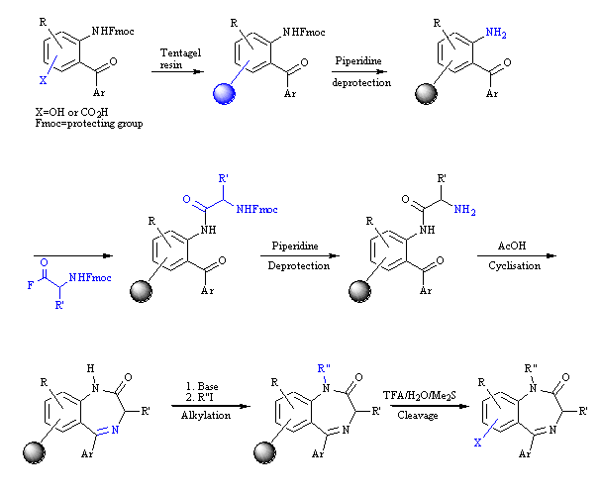
Molecular tags (A-I) are constructed on the resin bead as the synthesis is carried out in order to identify R, R' and R". The tagging molecules are used to create an encryption code as follows:

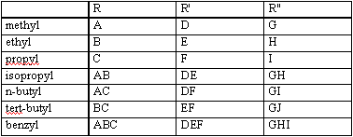
On completion of the synthesis, the molecular tags are released from a set of resin beads and identified by gas chromatography as shown below:

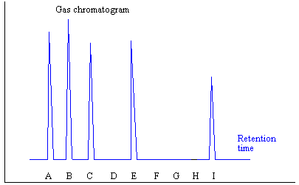
What structure has been formed on the bead?
Feedback: The code ABC stands for benzyl, the code E stands for ethyl and the code I stands for propyl.
Page reference: 312-314
a. R= n-butyl; R'= isopropyl; R" methyl
b. R= ethyl; R'= propyl; R" benzyl
*c. R= benzyl; R'= ethyl; R" propyl
d. R= n-butyl; R'= ethyl; R" ethyl

Type: multiple choice question
Title: Chapter 14- Question 46
46) The following structures are all protecting groups used in peptide synthesis.

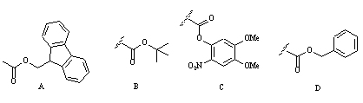

What functional group is normally protected by these groups?
Feedback: All the protecting groups shown can protect the amino group of an amino acid.
Page reference: 304-305
a. Carboxylic acid
*b. Amine
c. Alcohol
d. Phenol

Type: matching question
Title: Chapter 14 - Question 47
47) The following structures are all protecting groups used in peptide synthesis.

Match the above structures to the following names

Feedback: All the protecting groups mentioned here can be used to protect amine functional groups. Once added, urethanes are formed.
Page reference: 304-305
a. Tertiary-butyloxycarbonyl = Structure B
b. Benzyloxycarbonyl = Structure D
c. Nitroveratryloxycarbonyl = Structure C
d. 9-fluorenylmethoxycarbonyl = Structure A

Type: multiple choice question
Title: Chapter 14- Question 48
48) The following structures are all protecting groups used in peptide synthesis.

Which of these protecting groups can be removed using light?
Feedback: Structure C is a nitroveratryloxycarbonyl group.
Page reference: 314-315
a. Structure A
b. Structure B
*c. Structure C
d. Structure D

Type: multiple choice question
Title: Chapter 14- Question 49
49) What is the name of the combinatorial technique which involves the use of a photolabile protecting group?
Feedback: Photolithography is the technique used. Photosensitivity is a term used for chemicals which are susceptible to light. Photofixation is a fictitious term. Photosynthesis is a biological process by which plants capture the energy of light to fuel synthesis.
Page reference: 314-315
a. Photosensitivity
*b. Photolithography
c. Photofixation
d. Photosynthesis

Type: multiple choice question
Title: Chapter 14- Question 50
50) There are several advantages to photolithography. Which of the following statements is untrue regarding these advantages?
Feedback: The products are tested when they are still bound to the solid support. To do otherwise would defeat the whole point of the exercise which is to locate specific products at specific locations of the plate.
Page reference: 314-315
a. It allows miniaturisation of the process.
b. It in involves the use of photolabile protecting groups.
c. It allows spatial resolution of the products.
*d. It requires release of the product from the solid phase before detection of active compounds.

Type: multiple choice question
Title: Chapter 14- Question 51
51) Dynamic combinatorial chemistry is an alternative method of producing compounds other than the classic mix and split method. Which of the following statements is true about dynamic combinatorial chemistry?
Feedback: The process depends on the target being present.
The process relies on the presence of the target to bind active structures that are formed in the reaction vessel. This in turn leads to an amplification of the active compound. It is necessary to 'freeze' the reaction before identifying active compounds. The process requires the reactions to be in equilibrium such that active compounds are amplified.
Page reference: 318-320
*a. The target should be present in the reaction flask.
b. There is no scope for amplification.
c. Active compounds can be identified as they are formed.
d. The reactions involved should be irreversible.

Type: multiple choice question
Title: Chapter 14- Question 52
52) What is meant by conformational space?
Feedback: The space accessed by a molecule when it is in the binding site will depend on how flexible the molecule is. This in turn depends on the number of rotatable single bonds that are present. Conformations refer to the different shapes of a molecule that can be adopted by single bond rotation.
Page reference: 321
a. The volume occupied by a molecule in the binding site.
*b. The 3-dimensional space around a molecule when it is in a target binding site.
c. The positions of a molecule where extra substituents could be added without introducing steric strain within the molecule.
d. The positions of a molecule where extra substituents could be added without introducing bad steric interactions with the binding site.

Type: multiple choice question
Title: Chapter 14- Question 53
53) What name is given to the core structure of a series of related compounds?
Feedback: The scaffold is the molecular core that is common to a series of compounds.
Page reference: 321
a. The lead compound
b. The skeleton
*c. The scaffold
d. The pharmacophore

Type: multiple choice question
Title: Chapter 14- Question 54
54) What term is given to a scaffold that is present in a wide range of drugs with different activities?
Feedback: A privileged scaffold is a core structure that is present in many different drugs with different activities. Examples of privileged scaffold include steroids, benzodiazepines and benzenesulfonamides.
Page reference: 322
*a. Privileged
b. Common
c. Preferred
d. Active

Type: multiple choice question
Title: Chapter 14- Question 55
55) Which of the following statements is true with respect to scaffolds?
Feedback: The bigger the scaffold, the less scope there is for adding different substituents since most orally active drugs have a molecular weight less than 500.
There is no reason why an important binding group should not be part of the scaffold.
It is better to have the substituents spread around the whole molecule since this allows the best exploration of the conformational space around the scaffold.
A molecule such as a sugar has various hydroxy groups. If this is to act as a good scaffold, these groups have to be reacted independently of each other such that different substituents can be added to the molecule. This means that protection and deprotection stages have to be introduced to the synthesis which complicates the procedure rather than simplifying it.
Page reference: 321-322
a. The scaffold should be small to allow a wide variation of substituents.
b. The scaffold should not be capable of forming any binding interactions with the target.
c. Substituents should be localised at particular regions of the scaffold.
*d. Similar functional groups on the scaffold simplify the synthesis of analogues.

