Chapter 12: Drug development

Type: multiple choice question
Title: Chapter 12 Question 01
01) What is a major disadvantage of the therapeutic ratio?
Feedback: The therapeutic ratio is an indication of the relative dose levels of a drug which will be effective, versus those which will be lethal. It gives no indication of chronic or non-lethal toxicity.
Page reference: 250-251
a. It gives no indication of the efficacy of the drug.
b. It gives no indication of the lethality of the drug.
c. It gives no indication of the dose levels that are more likely to produce the desired effect rather than death.
*d. It gives no indication of the risk of non fatal and chronic toxicity.

Type: multiple choice question
Title: Chapter 12 Question 02
02) Which of the following detection methods is not commonly used to detect isotopically labelled drug metabolites?
Feedback: Nuclear magnetic resonance can be used to detect metabolites labelled with stable isotopes such as 13C. Scintillation counting is used to detect metabolites labelled with radioactive isotopes such as 14C or 3H. Mass spectrometry can be used to detect metabolites labelled with isotopes such as deuterium.
Page reference: 252
*a. Infra red spectroscopy
b. Nuclear magnetic resonance spectroscopy
c. Scintillation counting (detection of radioactivity)
d. Mass spectrometry

Type: multiple choice question
Title: Chapter 12 Question 03
03) What term is used in formulation studies to describe the ratio of active drug to the total contents of a dose?
Feedback: Page reference: 253
a. Dose level
b. Drug level
*c. Drug load
d. Dose load

Type: multiple choice question
Title: Chapter 12 Question 04
04) What term is used to signify a preparation that appears identical to the preparation of an active drug but which has no biological activity?
Feedback: Placebos are important as a comparison to the active drug in clinical trials.
The terms dummy drug and gazebo are not used in medicinal chemistry. The term peptidomimetic refers to a drug that has been derived from a peptide lead compound but which lacks peptide character.
Page reference: 255
a. Dummy drug
b. Peptidomimetic
*c. Placebo
d. Gazebo

Type: multiple choice question
Title: Chapter 12 Question 05
05) What is meant by a double blind clinical trial?
Feedback: In a double blind clinical trial, it is important that the doctors treating the two groups of patients should not know which group is receiving the drug and which group is receiving the placebo since they may unwittingly 'give the game away'.
Page reference: 255
a. Two patients in a control study are given a placebo rather than the active drug.
b. One batch of patients receives the drug while two batches of patients receive the placebo.
c. One batch of patients receives the drug and one batch receives the placebo. The doctors determine which patients should have priority in receiving the experimental drug.
*d. One batch of patients receives the drug and one batch receives the placebo. Neither the patient nor the doctor knows whether the drug or the placebo is being administered.

Type: multiple choice question
Title: Chapter 12 Question 06
06) Which of the following can be patented?
Feedback: It makes sense for a pharmaceutical company to patent a series of compounds rather than a specific drug since it makes it more difficult for competitors to discover and patent a similar compound. Similarly, patenting a synthetic route is advantageous since any competitor who finds an alternative drug will have to use a different synthetic route which might be more expensive and make the product less profitable. Consequently, it is best to patent the series of compounds and the synthetic route.
Page reference: 257-258
a. A specific drug
b. The medicinal use of a series of compounds
c. The synthesis of a series of compounds
*d. All of the answers are correct

Type: multiple choice question
Title: Chapter 12 Question 07
07) What is meant by GLP?
Feedback: The other terms are not used in medicinal chemistry.
Page reference: 259-260
*a. Good laboratory practice
b. Good licensing practice
c. General licensing procedures
d. General laboratory principles

Type: multiple choice question
Title: Chapter 12 Question 08
08) What is meant by GMP?
Feedback: The other terms are not used in medicinal chemistry.
Page reference: 259-260
a. Good medicinal practice
*b. Good manufacturing practice
c. General manufacturing procedures
d. General medicinal principles

Type: multiple choice question
Title: Chapter 12 Question 09
09) What is meant by GCP?
Feedback: The other terms are not used in medicinal chemistry.
Page reference: 259-260
a. Good chemical practice
b. General chemical practice
c. General chemical procedures
*d. Good clinical practice

Type: multiple choice question
Title: Chapter 12 Question 10
10) What is meant by chemical development?
Feedback: The development of an effective drug is drug development. The development of a production process is called process development. The development of a large scale synthesis is chemical development. The development of new synthetic methods is part of organic chemistry research.
Page reference: 260-262
a. The development of an effective drug
b. The development of a production process for a drug
*c. The development of a large scale synthesis for a drug
d. The development of new synthetic methods

Type: multiple choice question
Title: Chapter 12 Question 11
11) Which of the following is not a priority in chemical development?
Feedback: In chemical development, the yield, cost and purity of the final product is crucial. Since the work is being carried out on a single product, it is not possible to optimise the activity. That is fixed for the product concerned.
Page reference: 260-262
a. Optimising the overall yield of a drug
*b. Optimising the activity of a drug
c. Developing a cheap synthetic route
d. Optimising the purity of a drug

Type: multiple choice question
Title: Chapter 12 Question 12
12) What term is used to describe the process by which a synthetic procedure is developed such that it is suitable for a production plant?
Feedback: The other terms have no significant meaning in this context.
Page reference: 263
a. Plant development
b. Product development
*c. Process development
d. Production development

Type: multiple choice question
Title: Chapter 12 Question 13
13) Which of the following is not a priority in process development?
Feedback: The number of side effects for a particular drug is fixed and unchangeable, so it cannot be altered by how the drug is produced. The other options are features of the process by which the drug is produced and these features can be varied.
Page reference: 263
a. Minimising cost
*b. Minimising side effects
c. Minimising the number of reactions
d. Minimising the number of operations

Type: multiple choice question
Title: Chapter 12 Question 14
14) What is meant by the optimum temperature of a reaction?
Feedback: The temperature at which the maximum yield is obtained is not necessarily the one at which the optimum purity or minimum level of impurities is obtained. The optimum temperature is the one at which the best yield can be obtained with acceptable purity standards.
Page reference: 260-262
a. The temperature that results in the maximum possible yield.
b. The temperature that results in the minimum amount of impurities.
*c. The temperature that results in an acceptably high level of yield and an acceptably low level of impurities.
d. None of the answers are correct.

Type: multiple choice question
Title: Chapter 12 Question 15
15) What are the consequences of increasing the temperature for a particular reaction?
Feedback: It is not possible to come up with a rule that holds for all reactions. For many reactions, increasing the temperature will increase the yield but increase the side products. For others, the yield will decrease as the level of side products increase. It is necessary to monitor both the yield and level of impurities for a particular reaction as the temperature is varied.
Page reference: 260-262
a. Increased yield and increased side products
b. Increased yield and decreased side products
c. Decreased yield and increased side products
*d. Any of the consequences described

Type: multiple choice question
Title: Chapter 12 Question 16
16) Which of the following procedures is not suitable for scale up?
Feedback: Rotary evaporation is possible in a research laboratory but it is not feasible on a large scale. Distillation would have to be carried out instead.
Page reference: 260-262
a. Liquid-liquid extraction
b. Crystallisation
c. Distillation
*d. Rotary evaporation

Type: multiple choice question
Title: Chapter 12 Question 17
17) What is meant by a drug's 'specifications'?
Feedback: A drug's specifications are the purity tests that have to be carried out and the purity standards that have to be met. These specifications have to be met by each batch of the drug that is produced in the production plant.
Page reference: 262
a. The molecular dimensions of a molecule.
b. The physical properties of a drug.
*c. The purity tests and purity standards required of a drug.
d. The functional groups on a drug that are important to its activity.

Type: multiple choice question
Title: Chapter 12- Question 18
18) Which of the following areas of study is part of preclinical trials?
Feedback: Preclinical trials refer to the various tests and processes which are carried out on a compound prior to clinical trials. The compound concerned is a potential clinical agent and is the result of the drug discovery and development process of which the other options are part. Page reference: 250-253
a. Drug design
b. Lead discovery
*c. Formulation
d. Structure-activity relationships

Type: multiple choice question
Title: Chapter 12- Question 19
19) Which of the following definitions best describes the ED50 of a drug?
Feedback: The ED50 is the dose of drug required to produce an effect in 50% of the animals tested. The LD50 value represents the dose of drug which kills 50 % of the animals tested. The therapeutic index is the ratio LD50 to ED50.
Page reference: 250-251
a. The dose of a drug required to produce 50% of a maximum effect.
*b. The dose of a drug required to produce a measurable effect in 50% of the animals tested.
c. The ratio of LD50 to ED50.
d. The dose of a drug required to kill 50% of a group of animals.

Type: multiple choice question
Title: Chapter 12- Question 20
20) Which of the following definitions best describes the LD50 of a drug?
Feedback: The ED50 is the dose of drug required to produce an effect in 50% of the animals tested. The LD50 value represents the dose of drug which kills 50 % of the animals tested. The therapeutic index is the ratio LD50 to ED50
Page reference: 250-251
a. The dose of a drug required to produce 50% of a maximum effect.
b. The dose of a drug required to produce a measurable effect in 50% of the animals tested.
c. The ratio of LD50 to ED50.
*d. The dose of a drug required to kill 50% of a group of animals.

Type: multiple choice question
Title: Chapter 12- Question 21
21) Which of the following definitions best describes the therapeutic index of a drug?
Feedback: The ED50 is the dose of drug required to produce an effect in 50% of the animals tested. The LD50 value represents the dose of drug which kills 50 % of the animals tested. The therapeutic index is the ratio LD50 to ED50.
Page reference: 250-251
a. The dose of a drug required to produce 50% of a maximum effect.
b. The dose of a drug required to produce a measurable effect in 50% of the animals tested.
*c. The ratio of LD50 to ED50.
d. The dose of a drug required to kill 50% of a group of animals.

Type: multiple choice question
Title: Chapter 12- Question 22
22) Which of the following detection processes could be carried out using infra red spectroscopy?
Feedback: Nuclear magnetic resonance can be used to detect metabolites labelled with stable isotopes such as 13C. Scintillation counting is used to detect metabolites labelled with radioactive isotopes such as 14C or 3H. Mass spectrometry can be used to detect metabolites labelled with isotopes such as deuterium. Infra red spectroscopy is useful in identifying specific functional groups within molecules.
Page reference: 252
a. Detection of a metabolite labelled with 13C.
*b. Detection of a metabolite with a ketone functional group.
c. Detection of a metabolite labelled with 2H.
d. Detection of a metabolite labelled with 14C.

Type: multiple choice question
Title: Chapter 12- Question 23
23) Which of the following detection processes could best be carried out using nmr spectroscopy?
Feedback: Nuclear magnetic resonance can be used to detect metabolites labelled with stable isotopes such as 13C. Scintillation counting is used to detect metabolites labelled with radioactive isotopes such as 14C or 3H. Mass spectrometry can be used to detect metabolites labelled with isotopes such as deuterium. Infra red spectroscopy is useful in identifying specific functional groups within molecules.
Page reference: 252
*a. Detection of a metabolite labelled with 13C
b. Detection of a metabolite with a ketone functional group
c. Detection of a metabolite labelled with 2H
d. Detection of a metabolite labelled with 14C

Type: multiple choice question
Title: Chapter 12- Question 24
24) Which of the following detection processes could best be carried out using scintillation counting?
Feedback: Nuclear magnetic resonance can be used to detect metabolites labelled with stable isotopes such as 13C. Scintillation counting is used to detect metabolites labelled with radioactive isotopes such as 14C or 3H. Mass spectrometry can be used to detect metabolites labelled with isotopes such as deuterium. Infra red spectroscopy is useful in identifying specific functional groups within molecules.
Page reference: 252
a. Detection of a metabolite labelled with 13C.
b. Detection of a metabolite with a ketone functional group.
c. Detection of a metabolite labelled with 2H.
*d. Detection of a metabolite labelled with 14C.

Type: multiple choice question
Title: Chapter 12- Question 25
25) Which of the following detection processes could best be carried out using mass spectrometry?
Feedback: Nuclear magnetic resonance can be used to detect metabolites labelled with stable isotopes such as 13C. Scintillation counting is used to detect metabolites labelled with radioactive isotopes such as 14C or 3H. Mass spectrometry can be used to detect metabolites labelled with isotopes such as deuterium. Infra red spectroscopy is useful in identifying specific functional groups within molecules.
Page reference: 252
a. Detection of a metabolite labelled with 13C
b. Detection of a metabolite with a ketone functional group
*c. Detection of a metabolite labelled with 2H
d. Detection of a metabolite labelled with 14C

Type: multiple choice question
Title: Chapter 12- Question 26
26) Which of the following molecules of adrenaline, labelled with the radioisotope 14C would be unsuitable for metabolic studies? (The position of the radioisotope is indicated by the red star.)

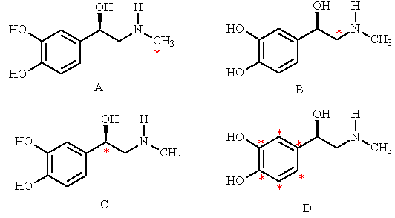

Feedback: Structure D would be unsuitable since the label is on an N-methyl group. An N-methyl group is easily lost as a result of a metabolic reaction and so the label would be lost from the molecule.
Page reference: 252
a. Structure A
b. Structure B
c. Structure C
*d. Structure D

Type: multiple choice question
Title: Chapter 12- Question 27
27) Which of the following labelled structures of morphine would you choose to carry out a study on drug metabolism?

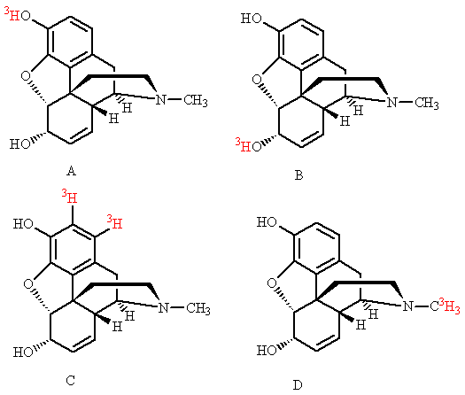

Feedback: Structure C is the structure least likely to lose its tritium label. Structures A and B would be unsuitable since the label is on a phenol or an alcohol. Both of these functional groups easily exchange their proton with water and so a tritium label would be quickly exchanged as well. Structure D would be unsuitable since the label is on an N-methyl group. An N-methyl group is easily lost as a result of a metabolic reaction and so the label would be lost from the molecule.
Page reference: 252
a. Structure A
b. Structure B
*c. Structure C
d. Structure D

Type: multiple choice question
Title: Chapter 12- Question 28
28) Which of the following labelled molecules of atropine would you choose to carry out a metabolic study?

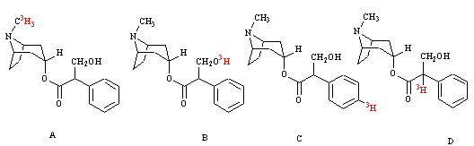

Feedback: Structure C is the structure least likely to lose its tritium label. Structure B would be unsuitable since the label is on an alcohol group. This functional group easily exchanges its proton with water and so a tritium label would be quickly exchanged as well. Structure A would be unsuitable since the label is on an N-methyl group. An N-methyl group is easily lost as a result of a metabolic reaction and so the label would be lost from the molecule. Structure D is unsuitable since the label is on a carbon next to a carbonyl group. The electron withdrawing effect of the carbonyl group makes the label acidic and it can be easily lost from the molecule. Page reference: 252
a. Structure A
b. Structure B
*c. Structure C
d. Structure D

Type: multiple choice question
Title: Chapter 12- Question 29
29) The following structures are of penicillin G methyl ester, labelled with 14C (indicated by the red star). Which of these would you not use for a metabolic study?

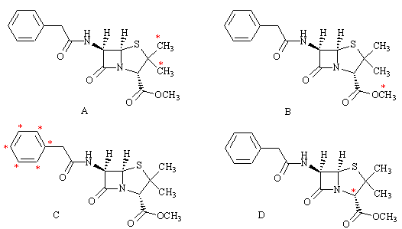
Feedback: In structure B, the labelled carbon is on the alkoxy moiety of an ester. Esters are susceptible to enzyme catalysed hydrolysis which would result in the loss of the isotope from the drug.
Page reference: 252
a. Structure A
*b. Structure B
c. Structure C
d. Structure D

Type: multiple choice question
Title: Chapter 12- Question 30
30) Which of the following is not part of formulation studies?
Feedback: The effect of temperature on the synthesis of a drug is part of chemical development and is not part of formulation studies. Formulation studies relate to how a drug is prepared for administration, as well as the stability and lifetime of the drug in that preparation. Page reference: 253
a. The effect of temperature on the stability of a drug
b. The shelf life of a drug
*c. The effect of temperature on the synthesis of a drug
d. The suitability of containers for storing a drug

Type: multiple choice question
Title: Chapter 12- Question 31
31) What is meant by chiral switches?
Feedback: Chiral switching is carried out on racemic drugs which were patented before it was fully appreciated that the different enantiomers could have differing activities. It would not be possible to do a chiral switch on a racemic drug introduced to the market now.
Page reference: 258
a. The ability of a drug target to bind both possible enantiomers of a chiral drug in two different binding modes
b. The epimerisation of a chiral centre
c. The patenting of the opposite enantiomer of a chiral drug that is already on the market
*d. The patenting of the active enantiomer of a racemic drug which is already on the market

Type: multiple choice question
Title: Chapter 12- Question 32
32) What is meant by an orphan drug?
Feedback: A novel pharmaceutical agent is known as a New Chemical Entity. A compound that has a useful biological activity and is the starting point for the design of a new drug is known as a lead compound. An established drug that acts as the reference point for related drugs is known as a parent drug.
Page reference: 259
a. A novel pharmaceutical agent
*b. A drug which is effective against a relatively rare medical problem
c. A compound that has a useful biological activity and is the starting point for the design of a new drug
d. An established drug that acts as the reference point for related drugs

