Chapter 10: Drug design: optimizing target interactions

Type: multiple choice question
Title: Chapter 10 Question 01
01) What modification could you reasonably carry out on an alcohol to assess whether the group is important to target binding?
Feedback: The easiest conversion is to an ester. The alcohol could be converted to an ester by treatment with acetic anhydride.
Page reference: 187-188
a. Convert it to an amine
b. Convert it to an amide
c. Convert it to an alkane
*d. Convert it to an ester

Type: multiple choice question
Title: Chapter 10 Question 02
02) What modification could you reasonably carry out on an amine to assess whether the group is important to target binding?
Feedback: The easiest modification would be to convert the amine to an amide with a reagent such as acetyl chloride.
Page reference: 190-191
a. Convert it to an ether
*b. Convert it to an amide
c. Convert it to an alkane
d. Convert it to an ester

Type: multiple choice question
Title: Chapter 10 Question 03
03) What modification could you reasonably carry out on a phenol to assess whether the group is important to target binding?
Feedback: The easiest modification would be to convert the phenol to an ester with a reagent such as acetic anhydride.
Page reference: 187-188
a. Convert it to an amine
b. Convert it to an amide
c. Convert it to an alkane
*d. Convert it to an ester

Type: multiple choice question
Title: Chapter 10 Question 04
04) What modification could you reasonably carry out on an alkene to assess whether the group is important to target binding?
Feedback: The easiest modification would be to convert the alkene to an alkane with a reagent such as hydrogen gas over a palladium / charcoal catalyst.
Page reference: 189
a. Convert it to an ether
b. Convert it to an amide
*c. Convert it to an alkane
d. Convert it to an ester

Type: multiple choice question
Title: Chapter 10 Question 05
05) What modification could you reasonably carry out on a carboxylic acid to assess whether the group is important to target binding?
Feedback: The easiest modification would be to convert the carboxylic acid to an ester by reacting it with an alcohol in the presence of an acid catalyst.
Page reference: 193-194
a. Convert it to an ether
b. Convert it to an amide
c. Convert it to an alkane
*d. Convert it to an ester

Type: multiple choice question
Title: Chapter 10 Question 06
06) Which of the following statements is true regarding an alcohol?
Feedback: The alcohol has an OH group where the oxygen can act as a hydrogen bond acceptor and the hydrogen can act as a hydrogen bond donor.
Page reference: 187-188
a. It can only participate in hydrogen bonding as a hydrogen bond donor.
b. It can only participate in hydrogen bonding as a hydrogen bond acceptor.
*c. It can participate in hydrogen bonding both as a hydrogen bond donor and a hydrogen bond acceptor.
d. It cannot participate in hydrogen bonding at all.

Type: multiple choice question
Title: Chapter 10 Question 07
07) Which of the following statements is true regarding a phenol?
Feedback: The phenol has an OH group where the oxygen can act as a hydrogen bond acceptor and the hydrogen can act as a hydrogen bond donor.
Page reference: 187-188
a. It can only participate in hydrogen bonding as a hydrogen bond donor.
b. It can only participate in hydrogen bonding as a hydrogen bond acceptor.
*c. It can participate in hydrogen bonding both as a hydrogen bond donor and a hydrogen bond acceptor.
d. It cannot participate in hydrogen bonding at all.

Type: multiple choice question
Title: Chapter 10 Question 08
08) Which of the following statements is true regarding an ester?
Feedback: The ester functional group contains two oxygen atoms, both of which could act as hydrogen bond acceptors. There are no hydrogens attached to oxygen so the group cannot act as a hydrogen bond donor.
Page reference: 194
a. It can only participate in hydrogen bonding as a hydrogen bond donor.
*b. It can only participate in hydrogen bonding as a hydrogen bond acceptor.
c. It can participate in hydrogen bonding both as a hydrogen bond donor and a hydrogen bond acceptor.
d. It cannot participate in hydrogen bonding at all.

Type: multiple choice question
Title: Chapter 10 Question 09
09) Which of the following statements is true regarding a carboxylic acid?
Feedback: A carboxylic acid (CO2H) contains two oxygen atoms, both of which can act as hydrogen bond acceptors. The acidic hydrogen on one of these oxygens can act as a hydrogen bond donor.
If the carboxylic acid group is ionised to a carboxylate group (CO2-), the latter cannot act as a hydrogen bond donor, but it can still act as a hydrogen bond acceptor. It is also capable of ionic bonding.
Page reference: 193-194
a. It can only participate in hydrogen bonding as a hydrogen bond donor.
b. It can only participate in hydrogen bonding as a hydrogen bond acceptor.
*c. It can participate in hydrogen bonding both as a hydrogen bond donor and a hydrogen bond acceptor.
d. It cannot participate in hydrogen bonding at all.

Type: multiple choice question
Title: Chapter 10 Question 10
10) Which of the following statements is true regarding a ketone?
Feedback: A ketone contains a carbonyl group (C=O) where the oxygen can act as a hydrogen bond acceptor. There are no hydrogens attached to a heteroatom and so a ketone cannot act as a hydrogen bond donor.
Page reference: 189-190
a. It can only participate in hydrogen bonding as a hydrogen bond donor.
*b. It can only participate in hydrogen bonding as a hydrogen bond acceptor.
c. It can participate in hydrogen bonding both as a hydrogen bond donor and a hydrogen bond acceptor.
d. It cannot participate in hydrogen bonding at all.

Type: multiple choice question
Title: Chapter 10 Question 11
11) Which of the following statements is true regarding a tertiary amide?
Feedback: The tertiary amide (R2NCOR) has a carbonyl oxygen that can act as a hydrogen bond acceptor. There is no hydrogen attached to nitrogen and so the group cannot act as a hydrogen bond donor. The nitrogen itself does not act as a hydrogen bond acceptor since its lone pair interacts with the carbonyl group.
Page reference: 191-192
a. It can only participate in hydrogen bonding as a hydrogen bond donor.
*b. It can only participate in hydrogen bonding as a hydrogen bond acceptor.
c. It can participate in hydrogen bonding both as a hydrogen bond donor and a hydrogen bond acceptor.
d. It cannot participate in hydrogen bonding at all.

Type: multiple choice question
Title: Chapter 10 Question 12
12) Which of the following statements is true regarding a quaternary ammonium ion (RNH3+)?
Feedback: The hydrogens of the quaternary ammonium ion are attached to a positively charged nitrogen and can act as hydrogen bond donors. The nitrogen cannot act as a hydrogen bond acceptor since it has no lone pair of electrons available.
The group can also take part in ionic interactions.
Page reference: 193
*a. It can only participate in hydrogen bonding as a hydrogen bond donor.
b. It can only participate in hydrogen bonding as a hydrogen bond acceptor.
c. It can participate in hydrogen bonding both as a hydrogen bond donor and a hydrogen bond acceptor.
d. It cannot participate in hydrogen bonding at all.

Type: matching question
Title: Chapter 10 - Question 13
13) The following reactions were used to synthesise analogues from a lead compound bearing a tertiary amine functional group. Which of the following reagents was used for steps A, B and C?

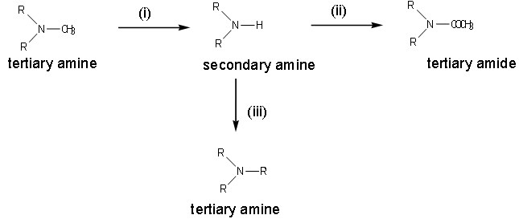

Feedback: Step A is a demethylation reaction involving the conversion of a tertiary amine to a secondary amine. Step B is an acetylation reaction where an amine is converted to an amide. Step C is an alkylation reaction involving the conversion of a secondary amine to a tertiary amine.
The reagent lithium aluminium hydride is a reducing agent and is not used in the synthesis shown.
Page reference: 190-191
a. Step A = Vinyloxycarbonyl chloride
b. Step B = Acetyl chloride
c. Step C = An alkyl iodide
d. None of the steps = Aithium aluminium hydride

Type: matching question
Title: Chapter 10 - Question 14
14) The following reaction sequence was used to remove a hydroxyl group from a drug as part of an SAR study.
Which of the following reagents was used for steps A, B and C?

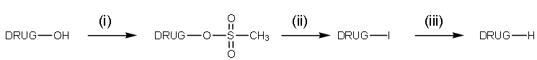
Feedback: Step A is a mesylation reaction where the alcohol is converted to a mesylate. Step B is a nucleophilic substitution where the mesylate group is displaced by an iodide. Step C is a reduction.
The reagent vinyloxycarbonyl chloride is used for N-demethylations and is not relevant here.
Page reference: 187-188
a. Step A = Sodium iodide
b. Step B = Lithium aluminium hydride
c. Step C = Methanesulfonyl chloride
d. None of the steps = Vinyloxycarbonyl chloride

Type: multiple choice question
Title: Chapter 10 Question 15
15) A medicinal chemist carried out the following modification of an alcohol group as part of an SAR study. Which of the following is reagent A?

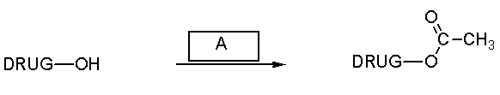

Feedback: The reaction is an esterification which involves reacting the alcohol with a carboxylic acid in the presence of an acid catalyst.
Page reference: 187-188
a. Ethanal
b. Ethanamide
*c. Ethanoic acid / HCl
d. Iodoethane

Type: multiple choice question
Title: Chapter 10 Question 16
16) A medicinal chemist carried out the following modification of a primary amine group as part of an SAR study. Which of the following is reagent A?

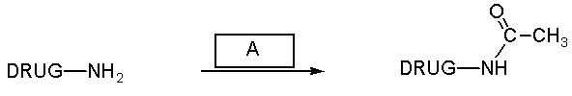

Feedback: The reaction involves acylation of the primary amide with acetyl chloride (ethanoyl chloride).
Page reference: 190-191
a. Ethanal
b. Ethanamide
c. Ethanoic acid / HCl
*d. Acetyl chloride

Type: multiple choice question
Title: Chapter 10 Question 17
17) A medicinal chemist carried out the following modification of an alkene group as part of an SAR study. Which of the following is reagent A?

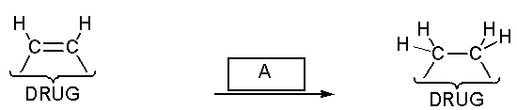

Feedback: The modification is a reduction involving addition of hydrogen across the double bond in the presence ot palladium.charcoal which acts as a catalyst.
Page reference: 189
a. LiAlH4
*b. H2 in the presence of Pd/C
c. NaBH4
d. Grignard reagent

Type: multiple choice question
Title: Chapter 10 Question 18
18) A medicinal chemist carried out the following modification of a ketone group as part of an SAR study. Which of the following is reagent A?

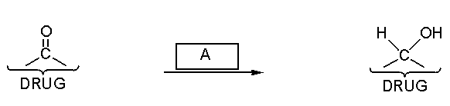

Feedback: Lithium aluminium hydride acts as a reducing agent to convert the ketone to a secondary alcohol. Hydrogen gas does not reduce carbonyl groups particularly easily. Methyl iodide will not react. The Grignard reagent would react with the ketone, but an alkyl group would be added to the molecule, and a tertiary alcohol would be formed.
Page reference: 189-190
*a. LiAlH4
b. H2
c. Methyl iodide
d. Grignard reagent

Type: multiple choice question
Title: Chapter 10 Question 19
19) A medicinal chemist carried out the following modification of an amide group as part of an SAR study. Which of the following is reagent A?

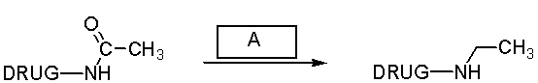

Feedback: Lithium aluminium hydride is a strong reducing agent which can reduce the carbonyl group of an amide to give the product shown. Sodium borohydride is a weaker reducing agent which will not react with amides. Methyl iodide will not react with the amide either, unless the amide is treated with a strong base first, in which case N-methylation is possible. Hydrochloric acid is unlikely to affect the amide unless the reaction is heated, in which case hydrolysis is likely.
Page reference: 191-192
*a. LiAlH4
b. NaBH4
c. Methyl iodide
d. HCl

Type: multiple choice question
Title: Chapter 10 Question 20
20) A medicinal chemist carried out the following modification of a carboxylic acid group as part of an SAR study. Which of the following is reagent A?

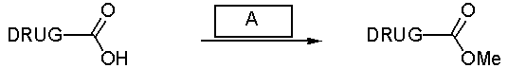
Feedback: This is an esterification reaction which requires the addition of an alcohol in the presence of an acid catalyst.
Methanoic acid is a carboxylic acid, methanal is an aldehyde, and methyl magnesium iodide is a Grignard reagent.
Page reference: 193-4
a. Methanoic acid/HCl
*b. Methanol / HCl
c. Methanal / HCl
d. Methyl magnesium iodide

Type: multiple choice question
Title: Chapter 10 Question 21
21) A ketone group in a lead compound was reduced to an alcohol and the product was shown to have only slightly reduced activity. What conclusion might be drawn?
Feedback: It is not possible from these results to state whether the ketone is an important binding group or not. The alcohol retains activity and so it may be capable of binding to the same binding region as the ketone. If the alcohol is binding, it is more likely to be acting as a hydrogen bond acceptor than a hydrogen bond donor since the ketone can only bind as a hydrogen bond acceptor.
Page reference: 189-190
a. The ketone is not an important binding group.
b. The ketone is an important binding group.
c. The ketone may be an important binding group if the alcohol is acting as a hydrogen bond donor to the same binding region.
*d. The ketone may be an important binding group if the alcohol is acting as a hydrogen bond acceptor to the same binding region.

Type: multiple choice question
Title: Chapter 10 Question 22
22) A lead compound containing a methyl ester functional group was hydrolysed to give an analogue with a carboxylic acid functional group. An in vivo bioassay which involved oral administration suggested that the ester was active and that the acid was inactive. However, an in vitro bioassay suggested that the ester was inactive and that the acid was active.
Which of the following is the most likely explanation for these results?
Feedback: The most likely explanation is that the lead compound acts as a prodrug and is metabolised to the active compound once it is absorbed. This implies that the carboxylic acid is an important binding group and that the ester is not. The in vivo bioassay for the carboxylic acid would be negative since the compound is too polar to get absorbed into the blood supply. The in vitro assay for the ester would be negative since it is not metabolised to the active carboxylic acid.
Page reference: 194
a. The ester is an important binding group and the carboxylic acid is not.
*b. The carboxylic acid is an important binding group but the ester is not.
c. Both the carboxylic acid and the ester are important binding groups.
d. Neither the carboxylic acid nor the ester are important binding groups.

Type: multiple choice question
Title: Chapter 10 Question 23
23) A secondary amide group in a lead compound was reduced to an amine functional group. In vitro tests showed that the lead compound was active and that the product was inactive. However, in vivo tests showed that both the amide and amine were inactive. Which of the following statements is not plausible?
Feedback: There is no evidence to suggest that the amine is an important binding group. The most likely scenario is that the amide is acting as a hydrogen bond acceptor through its carbonyl oxygen. This would fit in with the observation that the amine is inactive in vitro. The negative result for the amide in the in vivo test could be due to hydrolysis of the amide bond by metabolic enzymes to give inactive compounds.
Page reference: 191-192
a. The amide is an important binding group but the amine is not.
*b. Both the amide and the amine are important binding groups.
c. The carboxyl group of the amide may be an important hydrogen bond acceptor group.
d. In the in vivo bioassay, the amide is converted to the amine by metabolic or digestive enzymes.

Type: multiple choice question
Title: Chapter 10 Question 24
24) A lead compound contains a carboxylic acid functional group. This was esterified to give an analogue with an ester group. In vitro tests showed that the carboxylic acid was active whereas the ester was inactive. On the other hand, in vivo tests where the test compounds were administered orally showed that the ester was active, and the carboxylic acid was inactive. Which of the following explanations is not plausible?
Feedback: The in vitro tests are at odds with the correct statement. These tests indicate that the carboxylic acid is an important binding group and not the ester.
The most likely explanation is that the ester acts as a prodrug and is metabolised during the in vivo studies to give the active carboxylic acid. The carboxylic acid shows no activity in vivo, since it is too polar to get absorbed into the blood supply.
Page reference: 193-194
a. The carboxylic acid is not absorbed in the in vivo studies.
*b. The ester is an important binding group but the carboxylic acid group is not.
c. The ester is absorbed in the in vivo studies.
d. The ester is metabolised to the carboxylic acid in the in vivo studies.

Type: multiple choice question
Title: Chapter 10 Question 25
25) Structures (II-IV) are analogues of a lead compound containing an aromatic ring (structure I). Structures II and III had similar activity to the lead compound whereas structure IV showed a marked increase in activity. Which of the following explanations best fits the facts?

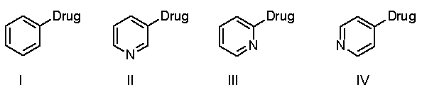

Feedback: 'Introducing a nitrogen increases basicity and so increased basicity is good for activity' and 'introducing a nitrogen increases the polarity and water solubility of the analogues, and so increased polarity is good for activity' are highly unlikely since the activity should have been improved for all three analogues II-IV. An aromatic hydrogen is unlikely to have any significant steric effect, although the possibility cannot be ruled out.

The heterocyclic nitrogen can act as a hydrogen bond acceptor with an extra hydrogen bonding region in the binding site. The fact that structure IV has increased activity and not II or III emphasises the importance of having the nitrogen at the correct position of the ring if it is to interact with the extra binding region. This adds weight to the theory.

Page reference: 195-196, 202-204
a. Introducing a nitrogen increases basicity and so increased basicity is good for activity.
b. Introducing a nitrogen increases the polarity and water solubility of the analogues, and so increased polarity is good for activity.
*c. Introducing a nitrogen means that an additional hydrogen bonding interaction is possible with an extra binding region in the binding site.
d. Introducing a nitrogen removes an aromatic hydrogen. The aromatic hydrogen removed may have been bad for activity for steric reasons.

Type: multiple choice question
Title: Chapter 10 Question 26
26) Which strategy of drug design was used to develop pronethalol from adrenaline?

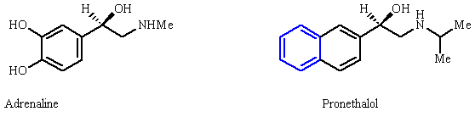]

Feedback: The catechol ring system of adrenaline was replaced with a naphthalene ring which has a greater capacity to form van der Waals interactions with a sizeable hydrophobic binding region.
Page reference: 206
*a. Ring fusion
b. Simplification
c. Rigidification
d. Chain extension

Type: multiple choice question
Title: Chapter 10 Question 27
27) Pronethalol is a selective antagonist of β-adrenoceptors over β -adrenoceptors. What is the likely explanation for this?
Feedback: Compared to adrenaline, pronethalol has a larger hydrophobic group and will show a preference for a binding site with a larger hydrophobic binding region. This implies that the β -adrenoceptor has a larger hydrophobic binding region than the β -adrenoceptor.
Page reference: 206
*a. A larger van der Waals binding region in the binding site of the β -adrenoceptor.
b. A larger van der Waals binding region in the binding site of the β -adrenoceptor.
c. A larger hydrogen bonding region in the binding site of the β -adrenoceptor.
d. A larger hydrogen bonding region in the binding site of the β -adrenoceptor.

Type: multiple choice question
Title: Chapter 10 Question 28
28) In order to synthesise N-phenethylmorphine, morphine was converted to normorphine.

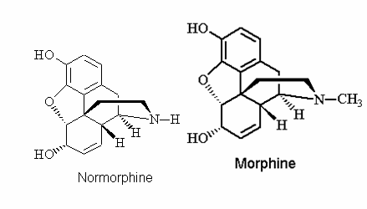
Which of the following reagents was used to convert morphine to normorphine?
Feedback: Vinyloxycarbonylchloride is used for N-demethylations. Methanol is a solvent and will have no effect on morphine. Lithium aluminium hydride and Raney nickel are reducing agents and will not demethylate the N-methyl group of morphine. Raney nickel is more likely to reduce the alkene and possibly the aromatic ring.
Page reference: 201, 623
a. Methanol
b. Lithium aluminium hydride
*c. Vinyloxycarbonyl chloride
d. Raney nickel

Type: multiple choice question
Title: Chapter 10 Question 29
29) What expression is used to describe the shape that a molecule adopts when it binds to its target binding site?
Feedback: Conformation is a stereochemical description of the various shapes that a molecule can adopt through single bond rotation. The active conformation is the shape that is adopted when the drug binds to its target.
Configuration and constitution are stereochemical terms that are used to describe isomers that have the same molecular formula, but are different molecules having different chemical and physical properties. The pharmacophore indicates the important binding groups of an active drug and their relative positions.
Page reference: 199
a. Active configuration
*b. Active conformation
c. Active constitution
d. Pharmacophore

Type: multiple choice question
Title: Chapter 10 Question 30
30) Isoprenaline shows selectivity for β-adrenoceptors over β-adrenoceptors, whereas adrenaline does not. Which of the following statements is the correct explanation for this?

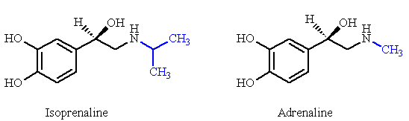

Feedback:
The statement 'isoprenaline is more hydrophobic and is more easily absorbed' is not inaccurate, but it does not explain the target selectivity of isoprenaline.

The statement ' β-Adrenoceptors are concentrated in the brain requiring drugs to cross the blood brain barrier' is wrong since β -adrenoceptors are in the periphery and the drugs do not need to cross the blood brain barrier to reach them.

It is the size of the N-substituents that is important for selectivity rather than the basicity of the amine groups.

Page reference: 200
a. Isoprenaline is more hydrophobic and is more easily absorbed.
*b. The amine binding region in the binding site of the β -adrenoceptor is more spacious than the one for the β-adrenoceptor, and can accommodate an isopropyl group more easily.
c. β-Adrenoceptors are concentrated in the brain requiring drugs to cross the blood brain barrier.
d. The different basicity of the two structures affects target selectivity.

Type: multiple choice question
Title: Chapter 10 Question 31
31) A lead compound has a methyl ether. You wish to produce a series of analogues from the lead compound by removing the methyl group and adding different alkyl groups.

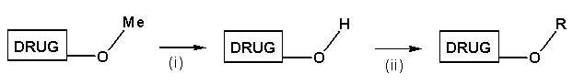
Which of the following conditions could be used to remove the methyl group in order to get an alcohol?
Feedback: 48% Hydrobromic acid demethylates methyl ethers. The other reagents mentioned do not affect ethers.
Page reference: 201
a. LiAlH4
b. H2 with a Pd/C catalyst
c. KMnO4
*d. 48% HBr

Type: multiple choice question
Title: Chapter 10 Question 32
32) A lead compound contains a tertiary amine. You wish to produce a series of analogues from the lead compound by removing the methyl group to form a secondary amine, then adding different alkyl groups.

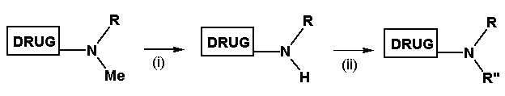

Which of the following reagents could be used to remove the methyl group in order to get the secondary amine?
Feedback: Vinyloxycarbonyl chloride is commonly used to demethylate N-methyl groups. The other reagents are reducing agents (LiAlH4 and H2 with a Pd/C catalyst) or an oxidising agent (CrO3). None of these will demethylate the amine.
Page reference: 201
a. LiAlH4
b. H2 with a Pd/C catalyst
*c. Vinyloxycarbonyl chloride
d. CrO3

Type: multiple choice question
Title: Chapter 10 Question 33
33) A lead compound has a methyl ester functional group. You wish to produce a series of analogues from the lead compound by converting it to a carboxylic acid and synthesising different esters.

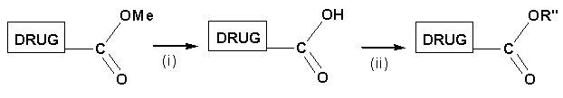

Which of the following conditions could be used to form the carboxylic acid?
Feedback: The ester has to be hydrolysed using aqueous base. Lithium aluminium hydride is not suitable for this purpose since it will reduce the ester group to a primary alcohol. Ozone and chromic acid will not react with the ester group.
Page reference: 201
a. LiAlH4
*b. aq. NaOH
c. Ozone
d. CrO3

Type: multiple choice question
Title: Chapter 10 Question 34
34) A lead compound has a methyl ester functional group. You wish to produce a series of analogues from the lead compound by converting it to a carboxylic acid and synthesising different esters.

What conditions would you use to convert the carboxylic acid to different esters?
Feedback:
Adding an alcohol in the presence of an acid catalyst will result in an esterification. The other reagents mentioned are organometallic reagents which will react as bases with a carboxylic acid and remove the acidic proton to give a carboxylate ion.
Page reference: 201
*a. R"OH / H+
b. R"MgI
c. R"Li
d. R"2CuLi

Type: multiple choice question
Title: Chapter 10 Question 35
35) What strategy of drug design is frequently used on complex lead compounds derived from natural products?
Feedback: Natural products are often complex structures which are difficult to synthesise. Simplification removes excess functional groups and superfluous regions of the molecule to produce simpler molecules which are easier to synthesise and which retain activity.
Page reference: 208
a. Extension
*b. Simplification
c. Rigidification
d. Conformational blocking

Type: multiple choice question
Title: Chapter 10 Question 36
36) Which of the following is not necessarily true about analogues produced by the simplification strategy?
Feedback: Simplified molecules tend to be more flexible and have the ability to adopt a larger number of conformations. This makes it more likely that they will fit different binding sites from the one intended, and lead to side effects.
Page reference: 210-212
a. They adopt several conformations.
b. They are easier to synthesise.
c. They are cheaper to synthesise.
*d. They have less side effects.

Type: multiple choice question
Title: Chapter 10 Question 37
37) Structure I is an antihypertensive agent which acts by inhibiting the enzyme ACE. Structure II was designed to bind to the binding site more strongly and to have greater activity.
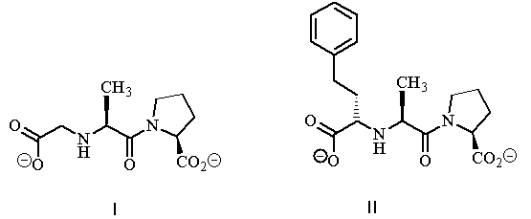

Which of the following strategies was used in the design of II?
Feedback: Extension is a strategy where extra binding groups are attached to a molecule such that they can bind to extra binding regions in the binding site.
Page reference: 203
a. Simplification
b. Rigidification
c. Use of an isostere
*d. Extension

Type: multiple choice question
Title: Chapter 10 Question 38
38) Cilazaprilat is an antihypertensive agent derived from the lead compound (I).

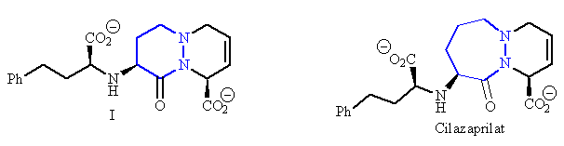

What strategy was used in its design?
Feedback: A six membered ring in the lead compound has been expanded to a seven membered ring.
Page reference: 204
a. Rigidification
b. Chain extension
*c. Ring expansion
d. Ring fusion

Type: multiple choice question
Title: Chapter 10 Question 39
39) The following structures are various non steroidal anti-inflammatory agents.

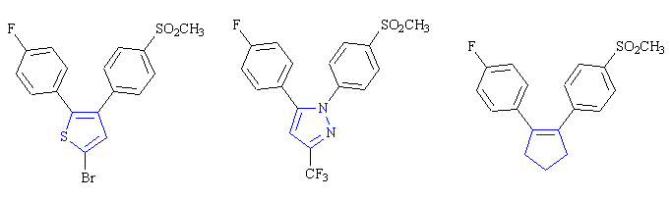

What strategy has been adopted in their design?
Feedback: The five membered ring at the heart of each molecule has been varied in character.
Page reference: 204
*a. Ring variation
b. Ring fusion
c. Ring expansion
d. Rigidification

Type: multiple choice question
Title: Chapter 10 Question 40
40) In the development of the antifungal agent, nevirapine, structure (II) was found to bind more strongly to the target enzyme than the lead compound (I). Which of the following statements is correct?

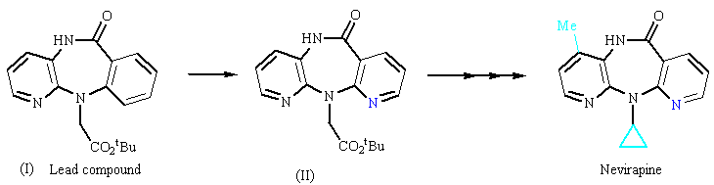

Feedback: Taking the options in turn, the strategy used was one of ring variation rather than ring expansion. The extra nitrogen allows an extra hydrogen bonding interaction to take place rather than a van der Waals interaction. The extra nitrogen can act as a hydrogen bond acceptor and not as a hydrogen bond donor.
Page reference: 205
a. The strategy used was one of ring expansion.
b. The extra nitrogen in blue allows an extra binding interaction to take place through van der Waals interactions.
c. The extra nitrogen in blue can act as a hydrogen bond donor.
*d. The strategy used could be described as extension since a further binding interaction has occurred.

Type: multiple choice question
Title: Chapter 10 Question 41
41) Hydrogen is often replaced in drugs with a fluorine atom for a variety of reasons. What term is used to describe the fluorine atom when it is used to replace hydrogen?
Feedback: An isostere is a group having a similar size, shape and valency to the original group. The other terms have no meaning in medicinal chemistry. An isotope is an element having a different number of neutrons from another element, but the same number of protons and electrons. An isomer is a molecule having the same molecular formula as another, but having a different arrangement of atoms and bonds. An isobar is used to represent atmospheric pressure in meteorological maps.
Page reference: 205
a. Isotope
*b. Isostere
c. Isomer
d. Isobar

Type: multiple choice question
Title: Chapter 10 Question 42
42) Which of the following statements best describes a bio-isostere?
Feedback: A bio-isostere is a group which can be used in place of another without affecting the activity of a drug. It includes classical and non classical isosteres, and it does not need to have the same valency as the original group. Usually, the bio-isostere would be expected to have a similar size, shape and chemical property to the original group.
Page reference: 206
a. A group having the same valency as another group.
b. A group that is the same as a non classical isostere.
*c. A group that can be used in place of another group whilst retaining the important biological activity of the drug.
d. A group having the same size as another group.

Type: multiple choice question
Title: Chapter 10 Question 43
43) DU 122290 is an analogue of sultopride. The former shows greater selectivity for the D3 receptor over the D2 receptor. Which of the following statements is incorrect?

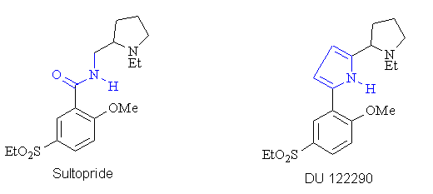
Feedback: The introduction of a pyrrole ring certainly removes a carbonyl oxygen and prevents it acting as a hydrogen bond acceptor in DU 122290. However, if this is an important binding interaction for the D3 receptor, DU 122290 should show selectivity for the D2 receptor and not the D3 receptor as observed.
Page reference: 206
a. The introduction of a pyrrole ring reduces the number of possible conformations for the side chain.
*b. The introduction of a pyrrole ring removes a carbonyl oxygen which could act as a hydrogen bond acceptor to a relevant binding region in the D3 binding site.
c. The introduction of the pyrrole ring introduces increased rigidity and favours the active conformation for the D3 receptor over the active conformation for the D2 receptor.
d. The pyrrole ring in DU 122290 represents a bio-isosteric group for the amide bond in sultopride.

Type: multiple choice question
Title: Chapter 10 Question 44
44) Which of the following statements is most likely to be true of the relative pharmacokinetics of sultopride and DU 122290?
Feedback: Amides are susceptible to hydrolysis by digestive and metabolic enzymes, and so the replacement of the amide group by the pyrrole ring should increase the lifetime of the compound.
The statement ' Sultopride is likely to have a longer lifetime in the body since the amide bond is a natural functional group found in peptides and proteins and is less likely to be seen as 'foreign'' is wrong as it suggests that the drug could be attacked by the immune system. However, the immune system does not normally identify small drug sized molecules as being foreign. The pyrrole ring is not susceptible to peptidases.
Page reference: 206
a. Sultopride is likely to have a longer lifetime in the body since the amide bond is a natural functional group found in peptides and proteins and is less likely to be seen as 'foreign'.
b. DU 122290 is likely to have a longer lifetime in the body since it will bind longer to its target binding site.
c. DU 122290 is likely to have a shorter lifetime in the body since the pyrrole ring is susceptible to peptidases.
*d. Sultopride is likely to have a shorter lifetime in the body since it contains an amide group that is susceptible to digestive and metabolic enzymes.

Type: multiple choice question
Title: Chapter 10 Question 45
45) The simplification strategy is commonly used in drug design. What must be retained in a molecule during the simplification process?
Feedback: The pharmacophore defines the important binding groups and their relative positions. The other factors play a role in drug activity but need not be retained during simplification.
Page reference: 208
a. The molecular weight
b. The stereochemistry
*c. The pharmacophore
d. The hydrophobic character

Type: multiple choice question
Title: Chapter 10 Question 46
46) There are three general methods by which molecules can be simplified. Which of the following is not one of these methods?
Feedback: The three main methods of simplifying a molecule are to remove excess rings, asymmetric centres and excess functional groups. Simplification normally results in more flexible molecules and not less flexible molecules.
Page reference: 208
a. Removal of excess rings
*b. Removal of excess flexibility
c. Removal of excess functional groups
d. Removal of excess asymmetric centres

Type: multiple choice question
Title: Chapter 10 Question 47
47) Cocaine was isolated as the active principle from coca leaves. Studies into structure activity relationships showed that the important functional groups for binding are those shown in blue.

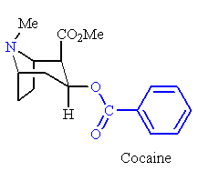
What binding interactions are likely for the aromatic ring?
Feedback: The aromatic ring is a hydrophobic group and so it will interact with a hydrophobic binding region by van der Waals interactions.
Page reference: 209
a. Hydrogen bonding as a hydrogen bond donor
b. Hydrogen bonding as a hydrogen bond acceptor
*c. Van der Waals interactions
d. Ionic bonding

Type: multiple choice question
Title: Chapter 10 Question 48
48) Cocaine was isolated as the active principle from coca leaves. Studies into structure activity relationships showed that the important functional groups for binding are those shown in blue.

Procaine has been a highly successful local anaesthetic that was ultimately developed from cocaine. What strategy was used in its design?

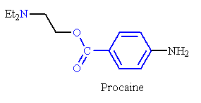
Feedback: Procaine is a simpler molecule than cocaine having lost the bicyclic system of cocaine and one of the ester groups. The important pharmacophore of amine, aromatic ester and aromatic ring have been retained.
Page reference: 209
a. Rigidification
b. Extension
*c. Simplification
d. Chain contraction

Type: multiple choice question
Title: Chapter 10 Question 49
49) Structure (II) is a muscarinic agonist developed from the lead compound (I). Which strategy of drug design was used and why?

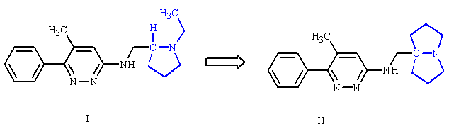

Feedback: In this case, the bicyclic system was introduced to remove an asymmetric centre - a form of simplification. This also allows the compound to be synthesised more readily.
It is possible to argue that rigidification was carried out since the ethyl chain in structure I is now locked into a ring. However, this was not the principle motivation for preparing structure II.
The modification could also be seen as a ring fusion but the focus of the change was to remove the asymmetric centre and not to increase hydrophobic character.
Similarly, the modification was not carried out to produce a me too drug.
Page reference: 210
a. Rigidification was used to decrease the number of possible conformations.
b. Ring fusion was used to increase van der Waals interactions with a hydrophobic binding region.
*c. A bicyclic system was introduced to remove an asymmetric centre.
d. A bicyclic system was introduced to generate a 'me too' drug to avoid patent restrictions.

Type: multiple choice question
Title: Chapter 10 Question 50
50) The following hypothetical structure has an asymmetric centre as shown by the asterisk.

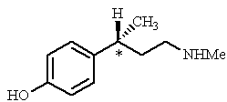

There are several possible disadvantages in having an asymmetric centre present in a drug. Which of the following statements is not one such disadvantage?
Feedback: Enantiomers have the same chemical and physical properties, the only exceptions being their ability to rotate plane polarised light in opposite directions and their interaction with other chiral molecules. Therefore, enantiomers cannot have different chemical stabilities.
Page reference: 208
a. The different enantiomers of a chiral drug are likely to have different levels of activity.
b. The different enantiomers of a chiral drug are likely to have different side effects.
*c. Different enantiomers are likely to vary significantly in their chemical stability.
d. Synthesising a single enantiomer tends to be more expensive than synthesising a racemate.

Type: multiple choice question
Title: Chapter 10 Question 51
51) Combretastatin is an anti cancer agent discovered from an African plant. Analogue (I) is more active than combretastatin whereas analogue II is less active.

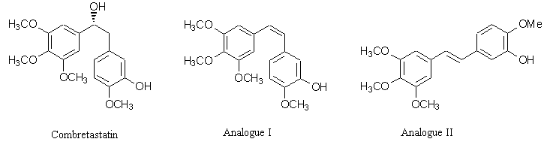

What strategy has been used in designing analogues I and II?
Feedback: Inserting a double bond into the chain connecting the two aromatic rings prevents single bond rotation and locks the molecule into a specific shape or conformation.
Page reference: 210-212, 525
a. Simplification
b. Isosteric replacement
*c. Rigidification
d. Chain contraction

Type: multiple choice question
Title: Chapter 10 Question 52
52) Structure (III) is a serotonin antagonist. A methyl group has been introduced into analogue (IV) resulting in increased activity.

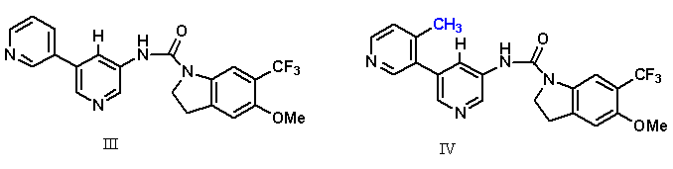
What strategy has been used here?
Feedback: Conformational blocking involves the addition of a substituent to reduce the number of conformations available.
Page reference: 212-213, 372
a. Extension
b. Rigidification
*c. Conformational blocking
d. Isosteric replacement

Type: multiple choice question
Title: Chapter 10 Question 53
53) Succinyl proline was the lead compound for captopril which acts as an inhibitor of the angiotensin converting enzyme.
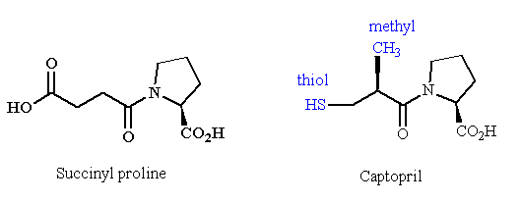

What is the relevance of the methyl group in captopril?
Feedback: The statement 'it is an exposed group and is easily oxidised by metabolic enzymes to a carboxylic acid which binds by ionic interactions to a hydrophilic binding region' is wrong. The methyl group is certainly exposed and could conceivably be oxidised to a carboxylic acid by metabolic enzymes. However, the binding pocket in the active site is hydrophobic and accepts a methyl group rather than a carboxylic acid.
There is nothing logically wrong with the two other incorrect options but the real relevance of the methyl group is that it represents an extension strategy where the methyl group binds to an extra hydrophobic binding region.
Page reference: 216
*a. It represents an extension strategy where the methyl group binds to an extra hydrophobic binding region.
b. It acts as a conformational blocker and correctly orientates the important binding groups with respect to each other.
c. It is an exposed group and is easily oxidised by metabolic enzymes to a carboxylic acid which binds by ionic interactions to a hydrophilic binding region.
d. It introduces an asymmetric centre.

Type: matching question
Title: Chapter 10 - Question 54
54) The following diagram shows the significant stages in the development of oxamniquine from lucanthone.

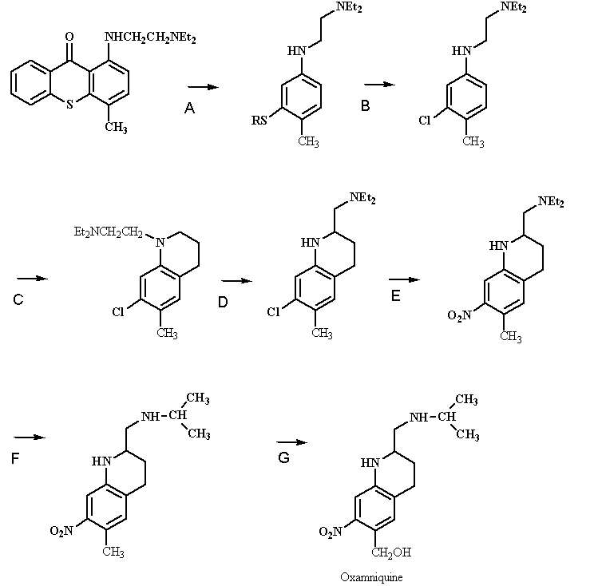

Identify the drug design strategy used in the following steps.
Feedback: Simplification is a strategy which involves the removal of excess functional groups and / or rings in order to obtain a simpler molecule which is easier to synthesise. The strategy of rigidification involves limiting the number of possible conformations such that the molecule is more likely to be in the active conformation. Substituent variation involves the variation of substituents on an aromatic ring (or other functional group) in order to improve the pharmacodynamics or pharmacokinetics of the drug. Extension involves adding an extra binding group to the molecule in order to obtain increased target binding.
Page reference: 219-223
a. Step A = Simplification
b. Step C = Rigidification
c. Step E = Substituent variation
d. Step G = Extension

Type: multiple choice question
Title: Chapter 10- Question 55
55) Which of the following terms refers to the study of which structural features of a drug are important to its biological activity?
Feedback: Structure activity relationships involves the synthesis of a series of analogues of a lead compound to discover how changes in structure affect the biological activity. In this way, important binding groups and the drug's pharmacophore can be identified.
Page reference: 185-187
a. Pharmacodynamics
b. Pharmacokinetics
*c. Structure-activity relationships
d. Pharmacological activity

Type: matching question
Title: Chapter 10 - Question 56
56) Identify which of the bonding interactions shown below are possible for the functional groups highlighted.

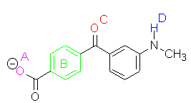

Feedback: The oxygen of the carboxylate group could act as a hydrogen bond acceptor but ionic bonding will be stronger. The aromatic ring will interact by van der Waals interactions. The carbonyl oxygen of the ketone is a hydrogen bond acceptor. The NH proton is a hydrogen bond donor. The nitrogen itself is unlikely to be a hydrogen bond acceptor since the lone pair will interact with the  system of the aromatic ring.
Page reference: 188-191, 193-194
a. The carboxylate group = Ionic bonding
b. The aromatic ring = Van der Waals interactions
c. The ketone = Hydrogen bonding as a hydrogen bond acceptor
d. The NH proton = Hydrogen bonding as a hydrogen bond donor

Type: multiple choice question
Title: Chapter 10- Question 57
57) Which of the groups in the following molecule can act both as a hydrogen bond donor and a hydrogen bond acceptor?

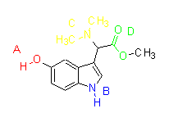
Feedback: Group A is a phenol. The hydrogen can act as a hydrogen bond donor and the oxygen as a hydrogen bond acceptor.
Group B is part of the heterocyclic ring system. The proton can act as a hydrogen bond donor, but the nitrogen is unlikely to act as a hydrogen bond acceptor since the lone pair interacts with the π electrons in the heterocyclic system.
Group C is a tertiary amine and the nitrogen can act as a hydrogen bond acceptor
Group D is an ester where both oxygens can act as hydrogen bond acceptors.
Page reference: 187-188, 190-191, 194
*a. Group A
b. Group B
c. Group C
d. Group D

Type: multiple choice question
Title: Chapter 10- Question 58
58) Which of the groups in propranolol can only act as a hydrogen bond acceptor?

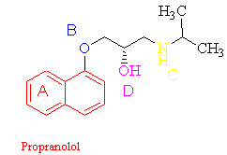
Feedback: Group A is a naphthalene ring. It can only interact by van der Waals interactions.
Group B is an ether and can only act as a hydrogen bond acceptor.
Group C is a secondary amine where the hydrogen can act as a hydrogen bond donor and the nitrogen can act as a hydrogen bond acceptor.
Group D is an alcohol where the hydrogen can act as a hydrogen bond donor and the oxygen as a hydrogen bond acceptor.
Page reference: 187-191
a. Group A
*b. Group B
c. Group C
d. Group D

Type: multiple choice question
Title: Chapter 10- Question 59
59) Which of the groups in the following structure can only interact through van der Waals interactions?

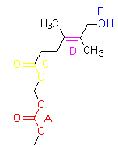
Feedback: Group A is a carbonate group. Each of the three oxygens can act as a hydrogen bond acceptor.
Group B is an alcohol where the hydrogen can act as a hydrogen bond donor and the oxygen as a hydrogen bond acceptor.
Group C is an ester where both oxygens can act as hydrogen bond acceptors.
Group D is an alkene which can only interact by van der Waals interactions.
Page reference: 187-189,194
a. Group A
b. Group B
c. Group C
*d. Group D

Type: multiple choice question
Title: Chapter 10- Question 60
60) Which of the groups in the following structure has the potential to form ionic interactions?

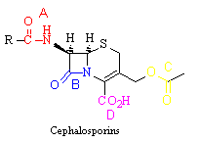

Feedback: Group A is a secondary amide. The oxygen can act as a hydrogen bond acceptor and the NH proton can act as a hydrogen bond donor. The nitrogen itself is unlikely to act as a hydrogen bond acceptor since the lone pair of electrons interacts with the carbonyl group.
Group B is part of the β-lactam ring.
Group C is an ester where both oxygens can act as hydrogen bond acceptors.
Group D is a carboxylic acid which can act as a hydrogen bond donor and a hydrogen bond acceptor in the un-ionised form. However, this group could lose its acidic proton to become ionised and form a stronger ionic bond.
Page reference: 191-194
a. Group A
b. Group B
c. Group C
*d. Group D

Type: multiple choice question
Title: Chapter 10- Question 61
61) Which of the groups in the following structure can only act as a hydrogen bond donor?

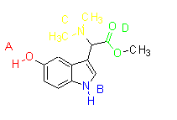
Feedback: Group A is a phenol. The hydrogen can act as a hydrogen bond donor and the oxygen as a hydrogen bond acceptor.
Group B is part of the heterocyclic ring system. The proton can act as a hydrogen bond donor, but the nitrogen is unlikely to act as a hydrogen bond acceptor since the lone pair interacts with the π electrons in the heterocyclic system.
Group C is a tertiary amine and the nitrogen can act as a hydrogen bond acceptor.
Group D is an ester where both oxygens can act as hydrogen bond acceptors.

Page reference: 187-188, 190-191, 194
a. Group A
*b. Group B
c. Group C
d. Group D

Type: multiple choice question
Title: Chapter 10- Question 62
62) Which of the following groups can form ionic interactions and also act as a hydrogen bond donor?
Feedback: A carboxylate ion can act as a hydrogen bond acceptor and can also participate in ionic interactions
A hydroxyl group can act as a hydrogen bond donor and a hydrogen bond acceptor.
An ammonium group can take part in ionic interactions and the hydrogens can act as hydrogen bond donors.
A ketone can act as a hydrogen bond acceptor.
Page reference: 187-191, 193-194
a. Carboxylate group (RCO2-)
b. Hydroxyl group (OH)
*c. Ammononium group (RNH3+)
d. Ketone (C=O)

Type: multiple choice question
Title: Chapter 10- Question 63
63) Which of the following groups can form ionic interactions and also act as a hydrogen bond acceptor?
Feedback: A carboxylate ion can act as a hydrogen bond acceptor and can also participate in ionic interactions.
A hydroxyl group can act as a hydrogen bond donor and a hydrogen bond acceptor.
An ammonium group can take part in ionic interactions and the hydrogens can act as hydrogen bond donors.
A ketone can act as a hydrogen bond acceptor.

Page reference: 187-191, 193-194
*a. Carboxylate group (RCO2-)
b. Hydroxyl group (OH)
c. Ammononium group (RNH3+)
d. Ketone (C=O)

Type: multiple choice question
Title: Chapter 10- Question 64
64) Which of the following aims in drug design is related to the pharmacodynamics of a drug?
Feedback: The reduction of side effects can be achieved by improving the affinity and selectivity of the drug for its target. The other aims are related to pharmacokinetics.

Page reference: 185
*a. The reduction of side effects.
b. The maximisation of metabolic stability.
c. The minimisation of elimination by the kidneys.
d. The maximisation of oral bioavailability.

Type: multiple choice question
Title: Chapter 10- Question 65
65) Isoprenaline is an adrenergic agonist. The isoprenaline analogue shown below demonstrates a dramatic rise in activity. What design strategy has been used?

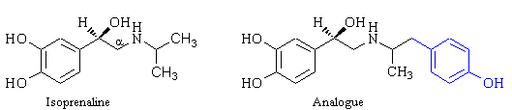

Feedback: The rationale behind the extension strategy is to add extra functional groups to the lead compound with the aim of finding additioal binding interactions with the binding site. In this case, the extra phenol group could be providing extra van der Waals interactions and hydrogen bonding interactions.
Page reference: 202-204
a. Simplification
b. Rigidification
*c. Extension
d. Chain extension

Type: multiple choice question
Title: Chapter 10- Question 66
66) Isoprenaline is an adrenergic agonist. The isoprenaline analogue shown below demonstrates a dramatic rise in activity in in vitro studies. What is the most likely conclusion that can be drawn?

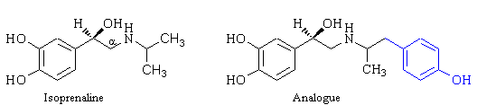

Feedback: The strategy used here is an extension strategy where the rationale is to add extra functional groups to the lead compound with the aim of finding additional binding interactions with the binding site. In this case, the extra phenol group could be providing extra van der Waals interactions and hydrogen bonding interactions.
Since in vitro studies are involved drug metabolism is not possible. The options 'the analogue has an altered pKa' and 'activity has increased due to increased molecular weight' may have some influence on activity but are unlikely to result in the dramatic increase in activity observed.
Page reference: 202-204
a. The analogue has an altered pKa.
*b. The extra phenol ring in the analogues is interacting with an additional binding region in the binding site.
c. Activity has increased due to increased molecular weight.
d. The extra substituent is protecting the terminal methyl groups of isoprenaline from metabolic reactions.

Type: multiple choice question
Title: Chapter 10- Question 67
67) Isoprenaline is an adrenergic agonist. The extension analogue shown below demonstrates a dramatic rise in activity in in vitro studies, demonstrating interactions with an additional binding region. Which of the following possibilities is not possible?

Feedback: The aromatic ring of the phenol could be involved in additional van der Waals interactions. The phenol group itself can participate in hydrogen bonding as a hydrogen bond donor via the hydrogen, or as a hydrogen bond acceptor via the oxygen. The phenol is unlikely to ionise at physiological pH.

Page reference: 188-189, 202-204
a. An additional van der Waals interaction.
b. An additional hydrogen bonding interaction where the phenol is acting as a hydrogen bond donor.
c. An additional hydrogen bonding interaction where the phenol is acting as a hydrogen bond acceptor.
*d. An additional ionic interaction.

Type: multiple choice question
Title: Chapter 10- Question 68
68) Which of the following statements best describes the term pharmacophore?
Feedback: A pharmacophore indicates the important binding groups and their relative positions. Pharmacodynamics is the study of how a drug interacts with its target binding site. Pharmacokinetics is the study of how a drug is absorbed, distributed, metabolised and excreted in the body. A chromophore is a conjugated unsaturated system responsible for the colour in coloured compounds.
Page reference: 198-199
a. The study of how a drug interacts with its target binding site.
b. The study of how a drug is absorbed, distributed, metabolised and eliminated.
c. The pattern and extent of conjugation within a molecule.
*d. The functional groups and atoms that are responsible for a drug's pharmacological action.

Type: multiple choice question
Title: Chapter 10- Question 69
69) Which of the following statements best describes an active conformation?
Feedback: The active conformation is the shape that is adopted when the drug binds to its target. This is not necessarily the most stable conformation.
The functional groups that are important binding groups and their relative positions describes a pharmacophore.
The most active geometrical isomer of a drug containing an alkene functional group refers to the most active configuration of a drug containing an alkene functional group.
Page reference: 199
a. The most stable conformation of a molecule.
*b. The shape that a molecule adopts when it binds to its target binding site.
c. The functional groups that are important binding groups and their relative positions.
d. The most active geometrical isomer of a drug containing an alkene functional group.

Type: multiple choice question
Title: Chapter 10- Question 70
70) It is common practice to vary the length and size of alkyl groups when making analogues of a lead compound. Which of the following statements is true?
Feedback: Activity would increase due to increasing van der Waals interactions. There is no obvious reason why an increase in the length or size of an alkyl group should stabilise a molecule, or why increased stability should lead to higher activity and selectivity. An increase in activity will result from better van der Waals interactions with a hydrophobic region of the binding site.

Page reference: 195, 200-201
a. Replacing a straight chain alkyl group with a branched alkyl group may increase activity by filling up a hydrophobic pocket and increasing hydrogen bonding interactions.
*b. Increasing the chain length or size of an alkyl group may increase target selectivity if one target binding site is more spacious than another.
c. Increasing the chain length or size of an alkyl group increases activity and selectivity by stabilising the analogue.
d. Increasing the chain length of an alkyl group may increase activity by leading to better van der Waals interactions with a hydrophilic region of the binding site.

Type: multiple choice question
Title: Chapter 10- Question 71
71) Which of the following is not true of analogues produced by a rigidification strategy?
Feedback: More rigid molecules have less rotatable bonds and a smaller number of possible conformations. Assuming that the active conformation is retained, it is likely that activity and selectivity will increase.

Page reference: 210-212
*a. They have a greater number of conformations.
b. They are more difficult to synthesise.
c. They are likely to be more selective.
d. They are likely to be more active.

Type: multiple choice question
Title: Chapter 10- Question 72
72) Which of the following is not necessarily true about analogues produced by the simplification strategy?
Feedback: In general, analogues produced by a simplification strategy are likely to be more flexible. As a result, there is less chance of the active conformation being adopted at any one time.
Page reference: 208-210
*a. They are more likely to adopt the active conformation.
b. They are easier to synthesise.
c. They are cheaper to synthesise.
d. They have more side effects.

Type: multiple choice question
Title: Chapter 10- Question 73
73) In the development of the antifungal agent, nevirapine, structure (II) was found to bind more strongly to the target enzyme than the lead compound (I) using in vitro tests. Which of the following statements is false?

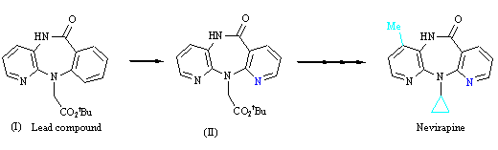

Feedback: Since in vitro tests are being carried out on the isolated enzyme, there is no way of knowing whether the analogue is more or less stable to metabolic reactions.
Page reference: 197-198
a. The strategy used was one of ring variation.
*b. The extra nitrogen in blue prevents a metabolic reaction taking place at that position.
c. The extra nitrogen in blue can act as a hydrogen bond acceptor.
d. The strategy used could be described as extension since a further binding interaction has occurred.

Type: multiple choice question
Title: Chapter 10- Question 74
74) DU 122290 is an analogue of sultopride. The former shows greater selectivity for the D3 receptor over the D2 receptor. Which of the following statements is correct?

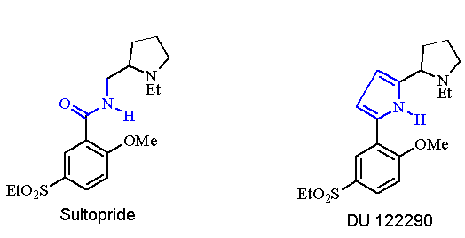

Feedback: The introduction of the pyrrole ring prevents a single bond rotation and decreases the number of possible conformations for the side chain.
The introduction of a pyrrole ring certainly removes carbonyl oxygen and prevents it acting as a hydrogen bond acceptor in DU 122290. However, if this is an important binding interaction for the D3 receptor, DU 122290 should show selectivity for the D2 receptor and not the D3 receptor as observed.
If the active conformation for the D2 receptor was favoured, the analogue should show selectivity for the D2 receptor over the D3 receptor.
Page reference: 207, 210-212,
a. The introduction of a pyrrole ring increases the number of possible conformations for the side chain.
b. The introduction of a pyrrole ring removes a carbonyl oxygen which could act as a hydrogen bond acceptor to a relevant binding region in the D3 binding site.
c. The introduction of the pyrrole ring introduces increased rigidity and favours the active conformation for the D2 receptor over the active conformation for the D3 receptor.
*d. The pyrrole ring in DU 122290 represents a bio-isosteric group for the amide bond in sultopride.

Type: multiple choice question
Title: Chapter 10- Question 75
75) Structure (I) has a highly flexible side chain.

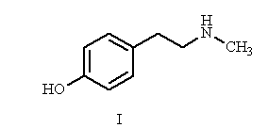

Which of the following statements is false?
Feedback: A flexible molecule may be able to bind in different binding modes to the one target, but this is more likely to result in decreased activity.
Page reference: 210-211
a. A flexible molecule is less likely to be in its active conformation when it approaches its target binding site. This results in decreased activity.
b. A flexible molecule is more likely to adopt conformations that will bind to different targets, resulting in side effects.
*c. A flexible molecule may be able to bind to its target binding site in different binding modes resulting in an increase in activity.
d. A flexible molecule is less likely to show target selectivity.

Type: multiple choice question
Title: Chapter 10- Question 76
76) Structure (I) has a highly flexible side chain.

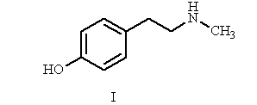

Which of the following analogues does not represent a suitable rigidification strategy to lower the number of possible conformations?

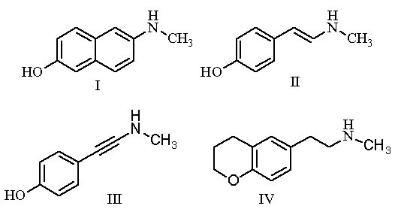

Feedback: In structure IV, none of the rotatable bonds in the side chain are constrained and so the side chain as many different conformations as before.
Structure I has two of the single bonds in the side chain constrained, while structures II and III have one bond constrained.

Page reference: 210-213
a. Structure I
b. Structure II
c. Structure III
*d. Structure IV

Type: multiple choice question
Title: Chapter 10 - Question 77
77) Which of the intermolecular bonding interactions below are possible for a phenol?
Feedback: The phenol oxygen can act as a hydrogen bond acceptor and the phenol proton can act as a hydogen bond donor.
Page reference: 187-188
*a. Hydrogen bonding only
b. van der Waals interactions only
c. Ionic bonding only
d. Both hydrogen bonding and ionic bonding

Type: multiple choice question
Title: Chapter 10 - Question 78
78) Which of the intermolecular bonding interactions below are possible for an aromatic ring?
Feedback: The aromatic ring has no heteroatoms and cannot form hydrogen bonds nor ionic bonds. Van der Waals interactions are possible.
Page reference: 188-189
a. Hydrogen bonding only
*b. van der Waals interactions only
c. Ionic bonding only
d. Both hydrogen bonding and ionic bonding

Type: multiple choice question
Title: Chapter 10 - Question 79
79) Which of the intermolecular bonding interactions below are possible for a carboxylic acid?
Feedback: The hydrogen of an un-ionised carboxylic acid can act as a hydrogen bond donor while the oxygens can act as hydrogen bond acceptors. If the acid is deprotonated and ionised, it can form ionic interactions. In the ionised situation, the oxygens can no longer act as hydrogen bond acceptors.
Page reference: 193-194
a. Hydrogen bonding only
b. van der Waals interactions only
c. Ionic bonding only
*d. Both hydrogen bonding and ionic bonding

Type: multiple choice question
Title: Chapter 10 Question 80
80) A medicinal chemist carried out the following modification of an alcohol group as part of an SAR study. What sort of functional group was formed in the reaction?

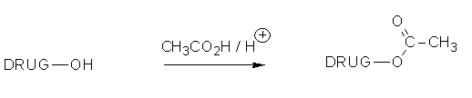

Feedback: By converting the alcohol to an ester, biological activity drops. This implies that the alcohol is an important binding group and that the ester masks it from carrying out this role.
Page reference: 187-188
a. Amide
b. Ether
*c. Ester
d. Ketone

Type: multiple choice question
Title: Chapter 10 Question 81
81) A medicinal chemist carried out the following modification of an alcohol group as part of an SAR study. The product showed a drastic drop in activity. What does this imply about the alcohol group?

Feedback: By converting the alcohol to an ester, biological activity drops. This implies that the alcohol is an important binding group and that the ester masks it from carrying out this role.
Page reference: 187-188
*a. It is an important binding group
b. It is not an important binding group
c. It stabilises the molecule
d. It destabilises the molecule

Type: multiple choice question
Title: Chapter 10 Question 82
82) A medicinal chemist carried out the following modification of an alcohol group as part of an SAR study. The product showed a drastic drop in activity. Which of the following explanations is not valid in explaining the drop of activity observed?

Feedback: The ester product certainly cannot ionise, but neither can the alcohol and so the ability to ionise is irrelevant, and cannot be used as an explanation for the drop in activity. The other three explanations are all valid depending on whether the alcohol group acts as a hydrogen bond donor, hydrogen bond acceptor or both.
Page reference: 187-188
*a. The product cannot ionise.
b. The product has no hydrogen to act as a hydrogen bond donor.
c. The product is unlikely to act as a hydrogen bond acceptor due to the extra methyl group acting as a steric shield.
d. The carbonyl group that has been introduced has an electron withdrawing effect on the original alcoholic oxygen, making it a weaker hydrogen bond acceptor.

Type: multiple choice question
Title: Chapter 10 Question 83
83) Which of the following reagents might react with the alcohol to give another useful analogue for SAR studies?
Feedback: This reaction would convert the alcohol to an ether. if the reaction is to be carried out, it is important to ensure that the rest of the molecule is stable to this reagent since sodium hydride is a strong base.
The other reagents would not result in any useful analogues. Lithium aluminium hydride and the Grignard reagent would act as bases and produce the alkoxide ion of the alcohol. No reaction would take place with hydrogen gas over the palladium charcoal catalyst.
Page reference: 187-188
a. LiAlH4
b. H2 in the presence of Pd/C
*c. NaH followed by an alkyl iodide
d. Grignard reagent

Type: multiple choice question
Title: Chapter 10 Question 84
84) A medicinal chemist carried out the following modification of a primary amine group as part of an SAR study. What sort of functional group was formed in the reaction?

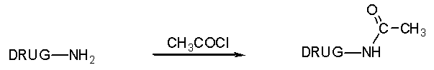
Feedback: By converting the amine to an amide, biological activity drops. This implies that the amine is an important binding group and that the amide masks it from carrying out this role.
Page reference: 190-191
*a. Amide
b. Ether
c. Ester
d. Ketone

Type: multiple choice question
Title: Chapter 10 Question 85
85) A medicinal chemist carried out the following modification of a primary amine group as part of an SAR study. The product showed a drastic drop in activity. What does this imply about the amine group?

Feedback: By converting the amine to an amide, biological activity drops. This implies that the amine is an important binding group and that the amide masks it from carrying out this role.
Page reference: 190-191
*a. It is an important binding group
b. It is not an important binding group
c. It stabilises the molecule
d. It destabilises the molecule

Type: multiple choice question
Title: Chapter 10 Question 86
86) Which of the following binding interactions is impossible for an amine group?
Feedback: Primary and secondary amines can act as hydrogen bond donors or hydrogen bond acceptors while tertiary amines can act as hydrogen bond acceptors only.
If the amine is protonated and ionised, it can form an ionic bond or it can act as a hydrogen bond donor.
Page reference: 190-191
a. Hydrogen bonding as a hydrogen bond donor
b. Hydrogen bonding as a hydrogen bond acceptor
*c. Van der Waals interactions
d. Ionic bond

Type: multiple choice question
Title: Chapter 10 Question 87
87) A medicinal chemist carried out the following modification of a primary amine group as part of an SAR study. The product showed a drastic drop in activity. Which of the following explanations would not be a valid hypothesis to explain the drop of activity observed?

Feedback: The product can still form hydrogen bonds. The carbonyl oxygen is a hydrogen bond acceptor, while the hydrogen on the nitrogen can act as a hydrogen bond donor. 'The product cannot ionise' is a feasible hypothesis if the original amine was ionised and interacted by ionic interactions. 'The product is unlikely to act as a hydrogen bond donor due to the extra methyl group acting as a steric shield' is a feasible hypothesis if the original amine was acting as a hydrogen bond donor and 'the carbonyl group of the product has an electron withdrawing effect on the neighbouring nitrogen making it a poor hydrogen bond acceptor' is feasible if the original amine was acting as a hydrogen bond acceptor.
Page reference: 190-191
a. The product cannot ionise.
*b. The product cannot form hydrogen bonds.
c. The product is unlikely to act as a hydrogen bond donor due to the extra methyl group acting as a steric shield.
d. The carbonyl group of the product has an electron withdrawing effect on the neighbouring nitrogen making it a poor hydrogen bond acceptor.

Type: multiple choice question
Title: Chapter 10 Question 88
88) Which of the following reagents would react with the amine to give another useful analogue for SAR studies?
Feedback: Reaction with an alkyl iodide would convert the primary amine to a secondary and/ or a tertiary amine. The tertiary amine would be unable to act as a hydrogen bond donor, and the size of the added alkyl groups may inhibit the original bonding interactions.
The other reagents would not give any useful products. Lithium aluminium hydride and the Grignard reagent would act as bases to remove a proton from the amino group. No reaction would take place with hydrogen gas over a palladium charcoal catalyst.
Page reference: 190-191
a. LiAlH4
b. H2 in the presence of Pd/C
*c. Alkyl iodide
d. Grignard reagent

Type: multiple choice question
Title: Chapter 10 Question 89
89) A medicinal chemist carried out the following modification of an alkene group as part of an SAR study. What sort of functional group was formed in the reaction?

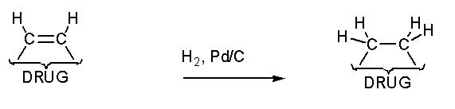
Feedback: Reduction of the alkene results in an alkane.
Page reference: 189
a. Amide
b. Ether
c. Ester
*d. None of the answers are correct

Type: multiple choice question
Title: Chapter 10 Question 90
90) A medicinal chemist carried out the following modification of an alkene group as part of an SAR study. The product showed a drastic drop in activity. What does this imply about the alkene group?

Feedback: Reduction of the alkene results in an alkane.

Page reference: 189
*a. It is an important binding group
b. It is not an important binding group
c. It stabilises the molecule
d. It destabilises the molecule

Type: multiple choice question
Title: Chapter 10 Question 91
91) A medicinal chemist carried out the following modification of an alkene group as part of an SAR study. Which of the following explanations would be a valid hypothesis to explain the drop of activity observed?

Feedback: The alkene cannot ionise or form hydrogen bonds either. An alkane can form van der Waals interactions. Reduction radically alters the stereochemistry of the functional group from planar to tetrahedral at both carbon centres. If the alkene is forming an important interaction, it is likely to be to a planar region of the binding site and so altering the stereochemistry is likely to have a significant effect.

Page reference: 189
a. The product cannot ionise.
b. The product cannot form hydrogen bonds.
c. The product cannot form van der Waals interactions.
*d. The product is bulkier and forms weaker van der Waals interactions with a planar binding region.

Type: multiple choice question
Title: Chapter 10 Question 92
92) Which of the following reagents would react with the alkene to give another useful analogue for SAR studies?
Feedback: Adding bromine will result in electrophilic addition and the formation of a dibromoalkane. This will radically alter the stereochemistry of this region and also add large substituents. Both of these changes are likely to disrupt any van der Waals interactions that might be formed by the alkene and such an analogue would likely have decreased activity.
The other reagents would fail to react with an alkene.
Page reference: 189
a. LiAlH4
*b. Br2
c. NaH followed by an alkyl iodide
d. Grignard reagent

Type: multiple choice question
Title: Chapter 10 Question 93
93) A medicinal chemist carried out the following modification of a ketone group as part of an SAR study. What sort of functional group was formed in the reaction?

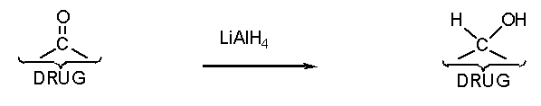
Feedback:

Page reference: 189-190
*a. Alcohol
b. Ether
c. Ester
d. Aldehyde

Type: multiple choice question
Title: Chapter 10 Question 94
94) A medicinal chemist carried out the following modification of a ketone group as part of an SAR study. The product showed a drastic drop in activity. What does this imply about the ketone group?

Feedback:

Page reference: 189-190
*a. It is an important binding group
b. It is not an important binding group
c. It stabilises the molecule
d. It destabilises the molecule

Type: multiple choice question
Title: Chapter 10 Question 95
95) The following diagram shows the significant stages in the development of oxamniquine from lucanthone.

Why is the introduction of a branched alkyl chain in step F advantageous?
Feedback: The correct answer is that the group is bulkier and fills up a hydrophobic pocket although one would consider the possibilities of the other options.

Page reference: 219-223
a. The group is more hydrophobic and increases the overall hydrophobicity of the molecule.
*b. The group is bulkier and fills up a hydrophobic pocket.
c. The group is more resistant to drug metabolism.
d. The group decreases the basicity of the acyclic amine nitrogen.

Type: multiple choice question
Title: Chapter 10 Question 96
96) A medicinal chemist carried out the following modification of a ketone group as part of an SAR study. The product showed a drastic drop in activity. Which of the following explanations would be a valid hypothesis to explain the drop of activity observed?

Feedback: The ketone is planar, whereas the product alcohol has a tetrahedral carbon. This is a significant change in stereochemistry which is likely to have an effect on binding.
The ketone cannot ionise or form van der Waals interactions. The product can form hydrogen bonds, both as a donor and an acceptor.

Page reference: 189-190
a. The product cannot ionise.
*b. The product has a different stereochemistry which could move oxygen out of range of the binding region.
c. The product cannot form hydrogen bonds.
d. The product cannot form van der Waals interactions.

Type: multiple choice question
Title: Chapter 10 Question 97
97) Which of the following reagents would react with the ketone to give another useful analogue for SAR studies?
Feedback: Sodium borohydride can reduce ketones in the same way as lithium aluminium hydride but under milder conditions. The other reagents would not give any useful product.
Page reference: 189-190
*a. NaBH4
b. H2
c. Methyl iodide
d. HCl

Type: multiple choice question
Title: Chapter 10 Question 98
98) A medicinal chemist carried out the following modification of an amide group as part of an SAR study. What sort of functional group was formed in the reaction?

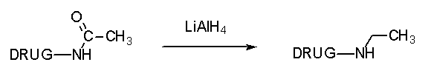
Feedback:
Page reference: 191-192
a. Amide
*b. Amine
c. Nitrile
d. Nitro

Type: multiple choice question
Title: Chapter 10 Question 99
99) A medicinal chemist carried out the following modification of an amide group as part of an SAR study. The product showed a drastic drop in activity. What does this imply about the amide group?

Feedback:
Page reference: 191-192
*a. It is an important binding group.
b. It is not an important binding group.
c. It stabilises the molecule.
d. It destabilises the molecule.

Type: multiple choice question
Title: Chapter 10 Question 100
100) Which of the following binding interactions are possible for a secondary amide group?
Feedback: The carbonyl oxygen can act as a hydrogen bond acceptor. The hydrogen linked to nitrogen can act as a hydrogen bond donor. The nitrogen does not act as a hydrogen bond acceptor since its lone pair interacts with the neighbouring carbonyl group.
Hence, the amide group could act as a hydrogen bond donor or a hydrogen bond acceptor or both.
Page reference: 191-192
a. Hydrogen bonding as a hydrogen bond donor only.
b. Hydrogen bonding as a hydrogen bond acceptor only.
*c. Hydrogen bonding both as a hydrogen bond donor and acceptor.
d. Ionic bonding.

Type: multiple choice question
Title: Chapter 10 Question 101
101) A medicinal chemist carried out the following modification of an amide group as part of an SAR study. The product showed a drastic drop in activity. Which of the following explanations would be a valid hypothesis to explain the drop of activity observed?

Feedback: Reduction removes the carbonyl oxygen and so this group is no longer available to act as a hydrogen bond acceptor.
The statement 'the product cannot ionise' is invalid on two counts. First, the amine product can ionise. Second, even if the amine product does not ionise, the original amide cannot ionise either.
The amine can act as a hydrogen bond donor.
The amide cannot form van der Waals interactions.
Page reference: 191-192
a. The product cannot ionise.
b. The product cannot act as a hydrogen bond donor.
c. The product cannot form van der Waals interactions.
*d. The product cannot act as a hydrogen bond acceptor via a carbonyl oxygen.

Type: multiple choice question
Title: Chapter 10 Question 102
102) A medicinal chemist carried out the following modification of a carboxylic acid group as part of an SAR study. What sort of functional group was formed in the reaction?

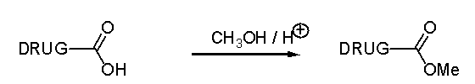
Feedback:
Page reference: 193-194
a. Amide
b. Ether
*c. Ester
d. Ketone

Type: multiple choice question
Title: Chapter 10 Question 103
103) A medicinal chemist carried out the following modification of a carboxylic acid group as part of an SAR study. The product showed a drastic drop in activity. What does this imply about the carboxylic acid group?

Feedback:
Page reference: 193-194
*a. It is an important binding group
b. It is not an important binding group
c. It stabilises the molecule
d. It destabilises the molecule

Type: multiple choice question
Title: Chapter 10 Question 104
104) A medicinal chemist carried out the following modification of a carboxylic acid group as part of an SAR study. The product showed a drastic drop in activity. Which of the following is an invalid hypothesis for the drop in activity observed?

Feedback: The ester cannot form ionic bonds and cannot act as a hydrogen bond donor. It is still capable of acting as a hydrogen bond acceptor, but the bulk of the new group that has been added may interfere with these interactions.
The ester cannot form van der Waals interactions, but neither can the carboxylic acid.
Page reference: 193-194
a. The product cannot ionise.
b. The product cannot act as a hydrogen bond donor.
c. The product is unlikely to act as a hydrogen bond acceptor due to the methyl group acting as a steric shield.
*d. The product cannot form van der Waals interactions.

Type: multiple choice question
Title: Chapter 10 Question 105
105) Which of the following reagents would react with the carboxylic acid to give another useful analogue for SAR studies?
Feedback: Lithium aluminium hydride would reduce the carboxylic acid to a primary alcohol. This would be a useful analogue to study since it cannot ionise but can still act as a hydrogen bond donor or hydrogen bond acceptor. If this reaction is to be carried out, it is important to ensure that the rest of the molecule is stable to lithium aluminium hydride since this is a strong reducing agent.
Hydrogen gas will not affect the carboxylic acid group, while sodium hydride and sodium hydroxide will act as bases and produce the carboxylate ion.
Page reference: 193-194
*a. LiAlH4
b. H2
c. NaH
d. NaOH

Type: multiple choice question
Title: Chapter 10 Question 106
106) A lead compound containing a methyl ester functional group was hydrolysed to give an analogue with a carboxylic acid functional group. An in vivo bioassay which involved oral administration suggested that the ester was active and that the acid was inactive. However, an in vitro bioassay suggested that the ester was inactive and that the acid was active.
What is the likely explanation for these results?
Feedback: The most likely explanation is that the lead compound acts as a prodrug and is metabolised to the active compound once it is absorbed. This implies that the carboxylic acid is an important binding group and that the ester is not. The in vivo bioassay for the carboxylic acid would be negative since the compound is too polar to get absorbed into the blood supply. The in vitro assay for the ester would be negative since it is not metabolised to the active carboxylic acid.
The carboxylic acid is more polar than the ester and should be less easily absorbed. Moreover, esters are more likely to be metabolised to carboxylic acids than the other way round.
There is no reason why a target should prefer one functional group under in vivo conditions and a different functional group under in vitro conditions.
It is a possibility that the ester and the carboxylic acid are both metabolised to the active compound in vivo but this is less likely than the ester acting as a prodrug in the in vivo studies.
Page reference: 194
a. The lead compound fails to get absorbed in the in vivo studies whereas the carboxylic acid is absorbed and is metabolised to the ester.
*b. The ester is acting as a prodrug in the in vivo studies.
c. The binding site of the target prefers to bind a carboxylic acid under in vitro conditions and an ester under in vivo conditions.
d. The ester and the carboxylic acid are both metabolised to the active compound in vivo.

Type: multiple choice question
Title: Chapter 10 Question 107
107) N-Phenethylmorphine was synthesised from morphine and found to have enhanced activity.

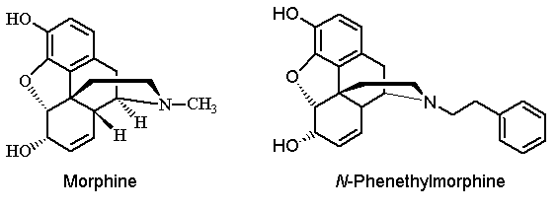

Why does N-phenethylmorphine have higher activity than morphine?
Feedback: The aromatic ring is binding to an extra hydrophobic binding region by van der Waals interactions.
Page reference: 202-204
*a. Increased binding to an extra binding region by van der Waals interactions.
b. Increased binding to an extra binding region by hydrogen bonding.
c. Increased binding to an extra binding region by dipole-dipole interactions.
d. Increased binding to an extra binding region by ionic bonding.

Type: multiple choice question
Title: Chapter 10 Question 108
108) In order to synthesise N-phenethylmorphine, morphine was converted to normorphine.

Which of the following reagents could be used to convert normorphine to N-phenethylmorphine?
Feedback: An alkylating agent with a good leaving group is required. Alkyl halides are better reagents for this than alcohols since a halide ion is a better leaving group than a hydroxide ion. The organometallic reagents Ph CH2CH2MgI and Ph CH2CH2Li are nucleophilic agents and are useless for this reaction since an electrophilic reagent is required.
Page reference: 201, 623
a. Ph CH2CH2MgI
b. Ph CH2CH2Li
*c. Ph CH2CH2I
d. Ph CH2CH2OH

Type: multiple choice question
Title: Chapter 10 Question 109
109) A lead compound has a methyl ether. You wish to produce a series of analogues from the lead compound by removing the methyl group and adding different alkyl groups.

What conditions would you use to convert the alcohol to different alkyl ethers?
Feedback: Sodium hydride removes the alcoholic hydrogen to produce an alkoxide ion which can then act as a nucleophile to react with the electrophilic alkyl halide in a nucleophilic substitution reaction. The other reagents are all nucleophilic and will remove the alcoholic hydrogen to produce the alkoxide ion, but nothing else will happen.
Page reference: 201
*a. NaH followed by RI
b. RMgI
c. RLi
d. R2CuLi

Type: multiple choice question
Title: Chapter 10 Question 110
110) A lead compound contains a tertiary amine. You wish to produce a series of analogues from the lead compound by removing the methyl group to form a secondary amine, then adding different alkyl groups.

What conditions would you use to convert the secondary amine to different tertiary amines?
Feedback: In order to add different alkyl groups, an electrophilic reagent has to be used since the amine acts as a nucleophile. Alkyl halides are electrophilic, whereas the organometallic reagents mentioned are all nucleophilic reagents.
Page reference: 201
a. R"2CuLi
b. R"MgI
c. R"Li
*d. R"I

Type: multiple choice question
Title: Chapter 10 Question 111
111) Structure I is an antihypertensive agent which acts by inhibiting the enzyme ACE. Structure II was designed to bind to the binding site more strongly and to have greater activity.

What effect does the extra aromatic ring have??
Feedback: The aromatic ring is a hydrophobic group and so it will interact by van der Waals interactions with a hydrophobic binding region.
Page reference: 203
*a. It interacts with an extra hydrophobic binding region through van der Waals interaction.
b. It interacts with an extra hydrophobic binding region through hydrogen bonding.
c. It interacts with an extra hydrophilic binding region through van der Waals interaction.
d. It interacts with an extra hydrophilic binding region through hydrogen bonding.

Type: multiple choice question
Title: Chapter 10 Question 112
112) Structure I is an antihypertensive agent which acts by inhibiting the enzyme ACE. Structure II was designed to bind to the binding site more strongly and to have greater activity.

The chain connecting the aromatic ring was varied in length to find the optimum chain length of 2 carbons. What is this strategy called?
Feedback: Chain contraction or extension can be used to place an important binding group at the optimum position for binding in the binding site.
Page reference: 203
a. Use of an isostere
b. Rigidification
c. Simplification
*d. Chain contraction/extension

Type: multiple choice question
Title: Chapter 10 Question 113
113) Structure I is an antihypertensive agent which acts by inhibiting the enzyme ACE. Structure II was designed to bind to the binding site more strongly and to have greater activity.

The chain connecting the aromatic ring was varied in length to find the optimum chain length of 2 carbons. Why is a 2-carbon chain length optimum for antihypertensive activity in this situation?
Feedback: The options 'it gives the molecule the optimum hydrophobic character for binding' and 'it gives sufficient flexibility to the arylalkyl chain to allow a full exploration of theavailable conformational space' and are not illogical, but are not the correct explanation.

The option 'it is the optimum length for molecular stability ' makes no sense. There is no reason why the stability of a molecule should be affected by the length of the carbon chain.
Page reference: 203
a. It gives the molecule the optimum hydrophobic character for binding.
b. It gives sufficient flexibility to the arylalkyl chain to allow a full exploration of theavailable conformational space.
*c. It places the aromatic ring in the optimum position to bind with the extra binding region.
d. It is the optimum length for molecular stability.

Type: multiple choice question
Title: Chapter 10 Question 114
114) Cilazaprilat is an antihypertensive agent derived from the lead compound (I) by a ring expansion strategy.

Why was this strategy successful in this situation?
Feedback: Increasing the size of the ring by a methylene unit would certainly be expected to increase hydrophobicity, but the increase is unlikely to be significant enough to explain the increased activity.
It is not very likely that it locked the molecule into the active conformation since this suggests that the molecule has become more rigid. If anything, it is more flexible although this, in itself, does not explain the success of the strategy.
Page reference: 204
a. It increased the hydrophobicity of the molecule.
b. It locked the molecule into the active conformation.
c. It increased the flexibility of the molecule.
*d. It placed important binding groups in the optimum position for binding to their respective binding regions.

Type: multiple choice question
Title: Chapter 10 Question 115
115) The following structures are various non steroidal anti-inflammatory agents developed by a ring variation strategy.

Which of the following terms has been used for drugs of this sort?
Feedback: 'Me too' drugs are often synthesised on a trial and error basis to find structures having similar biological activity which are not covered by patents. Occasionally, such drugs may have improved properties over the parent structure.
Page reference: 204
a. Family drugs
b. Analogue drugs
*c. Me too drugs
d. Isosteric drugs

Type: multiple choice question
Title: Chapter 10 Question 116
116) Cocaine was isolated as the active principle from coca leaves. Studies into structure activity relationships showed that the important functional groups for binding are those shown in blue.

What binding interactions are likely for the ester?
Feedback: The oxygen atoms of the ester can act as hydrogen bond acceptors. There is no hydrogen present in an ester to act as a hydrogen bond donor, and the functional group cannot ionise.
Page reference: 209
a. Hydrogen bonding as a hydrogen bond donor
*b. Hydrogen bonding as a hydrogen bond acceptor
c. Van der Waals interactions
d. Ionic bonding

Type: multiple choice question
Title: Chapter 10 Question 117
117) Cocaine was isolated as the active principle from coca leaves. Studies into structure activity relationships showed that the important functional groups for binding are those shown in blue.

What binding interactions are likely for the amine?
Feedback: The amine can act as a hydrogen bond acceptor as the free base. If it is protonated, it can act as a hydrogen bond donor or it can take part in an ionic bond.
Page reference: 209
a. Hydrogen bonding only
b. Ionic bonding only
c. Van der Waals interactions
*d. Ionic bonding and / or hydrogen bonding

Type: multiple choice question
Title: Chapter 10 Question 118
118) The following hypothetical structure has an asymmetric centre as shown by the asterisk.

Which of the following structures might be worth synthesising as an analogue of the above lead compound in order to achieve an active compound lacking an asymmetric centre?

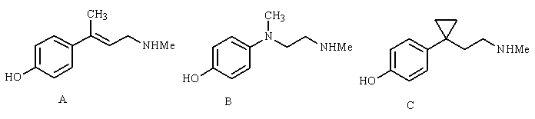

Feedback: All of the structures shown are achiral molecules and are all worth considering as analogues.
Page reference: 208-210
a. Structure A
b. Structure B
c. Structure C
*d. All of them

Type: multiple choice question
Title: Chapter 10 Question 119
119) Combretastatin is an anti cancer agent discovered from an African plant. Analogue (I) is more active than combretastatin whereas analogue II is less active.

Which of the following statements is most likely to explain the difference in activity between analogues I and II?
Feedback: The active conformation (I) has both alkene substituents cis with respect to each other. In the trans isomer, the substituents cannot bind to their corresponding binding regions simultaneously.

Page reference: 210-212, 525
*a. Rigidification has locked analogue I into the active conformation and locked analogue II into an inactive conformation.
b. Rigidification has locked analogue II into the active conformation and locked analogue I into the inactive conformation.
c. Rigidification has locked both analogues I and II into the active conformation.
d. Rigidification has locked both analogues I and II into the inactive conformation.

Type: multiple choice question
Title: Chapter 10 Question 120
120) Structure (III) is a serotonin antagonist. A methyl group has been introduced into analogue (IV) resulting in increased activity.

Which of the following statements is a reasonable explanation for the increase in activity observed for structure IV?
Feedback: The methyl group acts here as a conformational blocker to force the molecule into the active conformation. Activity should decrease if the molecule was prevented from adopting the active conformation.
The methyl group should interact with a hydrophobic pocket and not a hydrophilic pocket. This is certainly a possibility that would have to be considered.
Increasing the basicity of the ring nitrogen should make it a better hydrogen bond acceptor. This again would be a possibility worth considering.
Page reference: 212-213, 372
a. The methyl group interacts with an extra hydrophilic binding region through van der Waals interactions.
b. The methyl group increases the basicity of the ring nitrogen, making it a better hydrogen bond donor.
c. The methyl group prevents the pyridine rings from being coplanar and prevents the molecule adopting the active conformation.
*d. The methyl group prevents the pyridine rings from being coplanar and forces the molecule into the active conformation.

Type: multiple choice question
Title: Chapter 10 Question 121
121) Succinyl proline was the lead compound for captopril which acts as an inhibitor of the angiotensin converting enzyme.

What is the relevance of the thiol group?
Feedback: The carboxylic acid is a ligand for a zinc ion cofactor in the active site. The thiol group carries out the same function. It is a bio-isostere and not an isostere since isosteres should have the same valency.
Page reference: 216
a. It can form a covalent disulfide bond with cysteine thiol groups in the active site.
b. It acts as an isostere for the carboxylic acid.
*c. It acts as a bio-isostere for the carboxylic acid.
d. It is a smaller group than the carboxylic acid and fits the binding site more easily.

Type: multiple choice question
Title: Chapter 10 Question 122
122) The following diagram shows the significant stages in the development of oxamniquine from lucanthone.

Why does the introduction of a nitro group in step E improve activity?
Feedback: The correct option is that the nitro group is an electron withdrawing group which decreases the basicity of the cyclic amine. The options 'the nitro group can form an ionic interaction with the binding site' and 'the nitro group increases the water solubility of the compound resulting in increased bioavailability' might be worth considering, but the other option is totally wrong. A nitro group is a strong electron withdrawing group and not an electron donating group.
Page reference: 219-223
a. The nitro group can form an ionic interaction with the binding site.
b. The nitro group is an electron donating group which increases the basicity of the cyclic amine.
*c. The nitro group is an electron withdrawing group which decreases the basicity of the cyclic amine.
d. The nitro group increases the water solubility of the compound resulting in increased bioavailability.

