Chapter 07: Nucleic acids as drug targets

Type: matching question
Title: Chapter 07 - Question 01
01) Match the following structures to their names.
Feedback: The structures shown are nucleic acid bases
Page reference: 118
a. 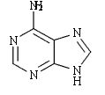 = Adenine
b. 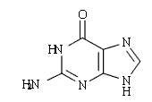 = Guanine
c. 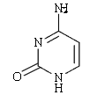 = Cytosine
d. 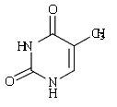 = Thymine

Type: multiple choice question
Title: Chapter 07 Question 02
02) What type of ring structure is present in structures C and D?

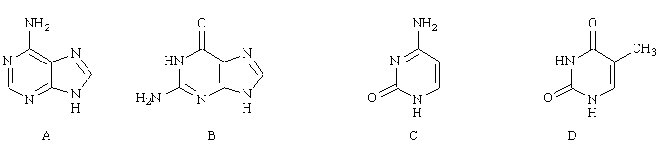

Feedback: The bicyclic nucleic acid base ring systems are purines and the monocyclic ring systems are pyrimidines. Quinoline and naphthalene ring systems are not present in nucleic acids.
Page reference: 118
a. Quinoline
b. Purine
c. Naphthalene
*d. Pyrimidine

Type: matching question
Title: Chapter 07 - Question 03
03) Name the following structures (i) – (iv)
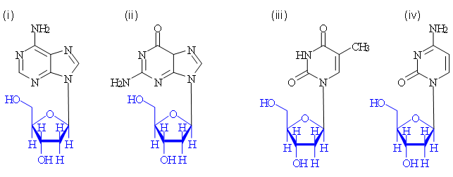

Feedback: The 'deoxy' portion of the name refers to the lack of a hydroxyl group at position 2 of the ribose ring.
Page reference: 117
a. (i) = Deoxyadenosine
b. (ii) = Deoxyguanosine
c. (iii) = Deoxythymidine
d. (iv) = Deoxycytidine

Type: multiple choice question
Title: Chapter 07 Question 04
04) Consider the following representation of DNA. What is the blue region called?

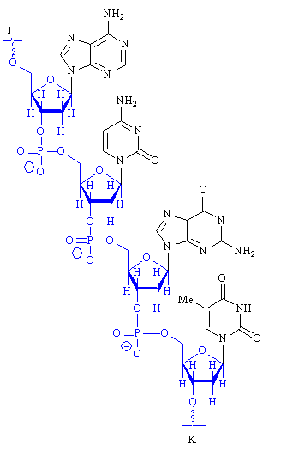

Feedback: The backbone consists of alternating deoxyribose sugars and phosphate groups. Therefore, it is the sugar phosphate backbone.
Page reference: 118
a. The carbohydrate backbone.
b. The phosphate backbone.
*c. The sugar phosphate backbone.
d. The nucleic acid base backbone.

Type: multiple choice question
Title: Chapter 07 Question 05
05) Consider the following representation of DNA. What are the groups shown in black?

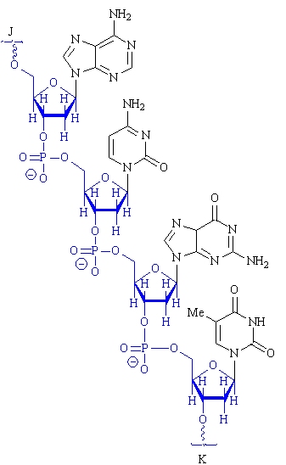
Feedback: The nucleic acid bases are linked to the sugar phosphate backbone. Deoxyribose is the sugar in DNA. A nucleoside is a nucleic acid base linked to a sugar moiety. A nucleotide is a nucleoside linked to one or more phosphate groups.
Page reference: 118
*a. Nucleic acid bases
b. Deoxyribose
c. Nucleosides
d. Nucleotides

Type: multiple choice question
Title: Chapter 07 Question 06
06) Consider the following representation of DNA. What is the term used to describe the end of the chain marked J?

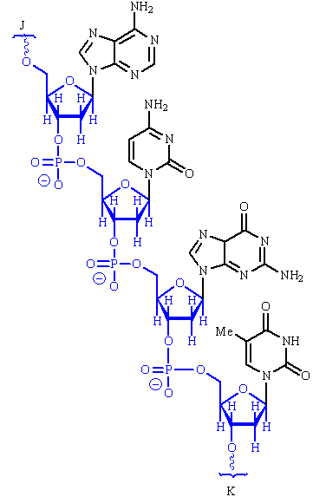
Feedback: The numbering relates to the numbering of the deoxyribose sugar moiety. The sugar-phosphate chain is extended from the 5' and 3' positions of each sugar moiety. The 5' end of the chain is closest to the 5' position of the final sugar moiety. The 3' end is closest to the 3' end of the final sugar moiety. The sugar phosphate backbone does not have a 2' end or a 4' end since the chain is not extended from those positions of the sugar ring.
Page reference: 118
a. The 2' end
b. The 3' end
c. The 4' end
*d. The 5' end

Type: multiple choice question
Title: Chapter 07 Question 07
07) Consider the following representation of DNA. What is the term used to describe the end of the chain marked K?

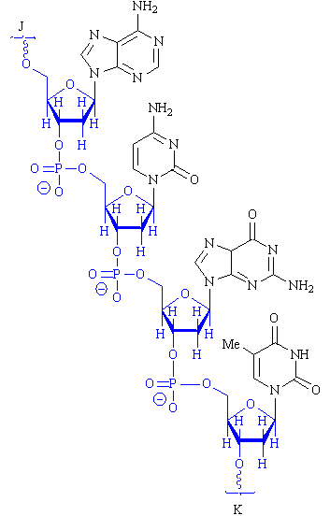

Feedback: The numbering relates to the numbering of the deoxyribose sugar moiety. The sugar-phosphate chain is extended from the 5' and 3' positions of each sugar moiety. The 5' end of the chain is closest to the 5' position of the final sugar moiety. The 3' end is closest to the 3' end of the final sugar moiety. The sugar phosphate backbone does not have a 2' end or a 4' end since the chain is not extended from those positions of the sugar ring.
Page reference: 118
a. The 2' end
*b. The 3' end
c. The 4' end
d. The 5' end

Type: multiple choice question
Title: Chapter 07 Question 08
08) Consider the following representation of DNA. What type of DNA structure is shown here?

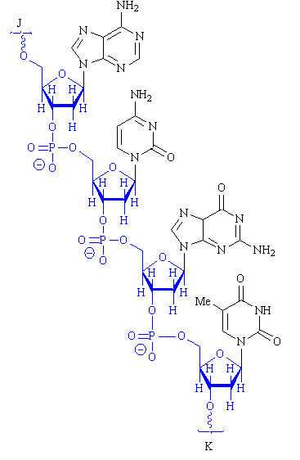

Feedback: The primary structure is the sequence in which the nucleotides are linked together in a DNA strand. The secondary structure refers to the double helix arrangement of two complementary DNA strands. The tertiary structure refers to the supercoiling of the DNA double helix into a more compact shape. There is no quaternary structure for DNA.
Page reference: 117-118
*a. Primary
b. Secondary
c. Tertiary
d. Quaternary

Type: multiple choice question
Title: Chapter 07 Question 09
09) What type of structure is the double helix of DNA?
Feedback: The primary structure is the sequence in which the nucleotides are linked together in a DNA strand. The secondary structure refers to the double helix arrangement of two complementary DNA strands. The tertiary structure refers to the supercoiling of the DNA double helix into a more compact shape. There is no quaternary structure for DNA.
Page reference: 118-119
a. Primary
*b. Secondary
c. Tertiary
d. Quaternary

Type: multiple choice question
Title: Chapter 07 Question 10
10) What does the following diagram demonstrate?

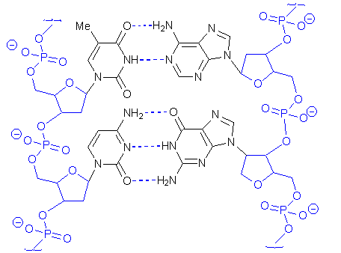

Feedback: The diagram shows base pairing between the nucleic acid bases adenine and thymine as well as between the nucleic acid bases guanine and cytosine. The interaction is through hydrogen bonding.
Page reference: 118-119
a. Dimerisation
b. Receptor binding
*c. Base pairing
d. Polymerisation

Type: multiple choice question
Title: Chapter 07 Question 11
11) Which of the following statements is not true about DNA secondary structure?
Feedback: The phosphate groups are ionised and are positioned to the outside of the structure such that they interact favourably with surrounding water molecules. The base pairs are hydrophobic and are stacked on top of each other in the centre of the structure such that they interact with each other and not with water.
Page reference: 118-119
a. There is a minor groove and a major groove.
b. A purine base pairs up with a pyrimidine base.
*c. The phosphate groups are positioned to the inside of the structure.
d. The base pairs are stacked.

Type: multiple choice question
Title: Chapter 07 Question 12
12) What non-covalent bonding interactions do the nucleic acid bases form in DNA secondary structure?
Feedback: Hydrogen bonds are involved in forming the base pairs. The base pairs are stacked and van der Waals interactions take place between the various stacks of base pairs. There are no ionic interactions involving nucleic acid bases. The phosphate groups on the outside of the double helix can form ionic interactions.
Page reference: 118-119
a. Ionic bonds only
b. Hydrogen bonds only
c. Van der Waals interactions only
*d. Hydrogen bonds and van der Waals interactions

Type: multiple choice question
Title: Chapter 07 Question 13
13) What is the significance of base pairing to the function of DNA?
Feedback: Base pairing results in two complementary chains. Each chain can be used as a template for a new chain allowing genetic information to be passed on from generation to generation.
There is an element of truth in the other statements but they serve no purpose in the function of DNA
Page reference: 119-120
a. It neutralises basic groups and controls the cell pH.
*b. It means that the chains of DNA are complementary allowing replication.
c. It stabilises the molecule such that cell lifetime is increased.
d. It prevents water interacting with the nucleic acid bases.

Type: multiple choice question
Title: Chapter 07 Question 14
14) Which of the following is not true when RNA is compared with DNA?
Feedback: RNA contains uracil, but it is in place of thymine and not adenine. Uracil can base pair with adenine in certain regions of RNA secondary structure.
Page reference: 122
a. RNA contains ribose and not deoxyribose.
*b. RNA contains uracil and not adenine.
c. RNA does not form a double helix.
d. RNA is smaller than DNA.

Type: multiple choice question
Title: Chapter 07 Question 15
15) What role does ribosomal RNA play in the synthesis of proteins?
Feedback: The process of protein synthesis is catalysed by ribosomal RNA. Messenger RNA provides the genetic blueprint for the protein. Transfer RNA is responsible for translating the triplet code into a specific amino acid. Messenger RNA molecules are modified prior to protein synthesis by small nuclear RNA.
Page reference: 122
*a. It catalyses the process.
b. It provides the genetic blueprint for the protein.
c. It translates the genetic code to a specific amino acid.
d. It modifies messenger RNA molecules prior to protein synthesis.

Type: multiple choice question
Title: Chapter 07 Question 16
16) What role does transfer RNA play in the synthesis of proteins?
Feedback: The process of protein synthesis is catalysed by ribosomal RNA. Messenger RNA provides the genetic blueprint for the protein. Transfer RNA is responsible for translating the triplet code into a specific amino acid. Messenger RNA molecules are modified prior to protein synthesis by small nuclear RNA.
Page reference: 124
a. It catalyses the process.
b. It provides the genetic blueprint for the protein.
*c. It translates the genetic code to a specific amino acid.
d. It modifies messenger RNA molecules prior to protein synthesis.

Type: multiple choice question
Title: Chapter 07 Question 17
17) Which of the following mutations is most likely to be disruptive to protein synthesis or function?
Feedback:
UAU to UAC results in tyrosine being coded in each case. There is no disruption to protein synthesis or function.
UAU to UUU results in a change from tyrosine to phenylalanine. This is a similar amino acid to tyrosine and so the chances of disruption are slight unless the tyrosine phenolic group is particularly important to function.
UAU to UAA results in a stop code which prevents further synthesis of the protein. This will be the most drastic effect and will lead to a non-functioning protein.
UAU to CAU results in a change from tyrosine to histidine. Only one amino acid is altered and the protein may still be functional if the tyrosine is not crucial to activity.
Page reference: 676
a. UAU to UAC
b. UAU to UUU
*c. UAU to UAA
d. UAU to CAU

Type: multiple choice question
Title: Chapter 07 Question 18
18) What is the name of the structure that is involved in protein synthesis and includes ribosomal RNA?
Feedback: Protein synthesis takes place on ribosomes which are located on the surface of an organelle called the endoplasmic reticulum within the cell's cytoplasm. Protein synthesis does not take place in the nucleus. Spliceosomes are located in the cell nucleus and are responsible for modifying newly transcribed mRNA molecules prior to translation.
Page reference: 122
a. Endoplasmic reticulum
b. Nucleus
*c. Ribosome
d. Spliceosome

Type: multiple choice question
Title: Chapter 07 Question 19
19) What is the name of the structure that is involved in modification of messenger RNA and includes small nuclear ribosomal RNA?
Feedback: Protein synthesis takes place on ribosomes which are located on the surface of an organelle called the endoplasmic reticulum within the cell's cytoplasm. Protein synthesis does not take place in the nucleus. Spliceosomes are located in the cell nucleus and are responsible for modifying newly transcribed mRNA molecules prior to translation.
Page reference: 126
a. Endoplasmic reticulum
b. Nucleus
c. Ribosome
*d. Spliceosome

Type: multiple choice question
Title: Chapter 07 Question 20
20) What is the term for the portion of messenger RNA that is excised when the molecule undergoes a splicing modification?
Feedback: The intron is the excised region. The exons are the regions that are spliced together. Exclusion and inclusion are terms that are not used in descriptions of the splicing mechanism.
Page reference: 126
*a. Intron
b. Exon
c. Exclusion
d. Inclusion

Type: multiple choice question
Title: Chapter 07 Question 21
21) Proflavine is an intercalating agent which was used to treat wounded soldiers in the Far East during the second world war. Which of the following statements is false regarding proflavine?

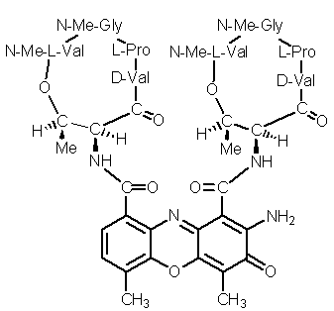

Feedback: Proflavine is too toxic to be used systemically since it does not distinguish between the DNA of host cells and those of an invading pathogen. It is used topically for the treatment of infected deep surface wounds. All the other statements are correct.
Page reference: 126, 431
*a. It a useful systemic antibacterial agent.
b. Its planar shape is important to intercalation.
c. The primary amine groups are protonated and interact with phosphate groups of the DNA backbone.
d. When inserted into DNA, the tricyclic system can form van der Waals interactions with base pairs above and below it.

Type: multiple choice question
Title: Chapter 07 Question 22
22) The following antibiotic structure is an intercalating agent. Which region of the molecule is chiefly responsible for its ability to intercalate into DNA?

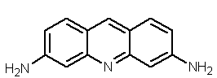

Feedback: The tricyclic system is planar and is the correct size to intercalate into the DNA double helix. The macrocyclic rings can interact with the sugar phosphate backbone through polar interactions.
Page reference: 126, 500-501
*a. The tricyclic system.
b. One of the macrocyclic rings.
c. Both of the macrocyclic rings.
d. The peptide bonds.

Type: multiple choice question
Title: Chapter 07 Question 23
23) Which of the following molecules is not a nucleotide?
Feedback: Adenosine is a nucleoside. All the others have phosphate groups linked to the nucleoside and are nucleotides.
Page reference: 117
*a. Adenosine
b. Adenosine monophosphate
c. Adenosine diphosphate
d. Adenosine triphosphate

Type: multiple choice question
Title: Chapter 07 Question 24
24) What term is used to describe the strategy where an oligonucleotide is designed such that it base pairs with a segment of messenger RNA and blocks protein translation?
Feedback: The other terms are not used. Anticodon therapy could have been a reasonable term to use for the therapy since the drugs used contain anticodons that can base pair with the codons present on messenger RNA. However, antisense therapy is the term that is used.
Page reference: 128
a. Sense therapy
b. Anticodon therapy
c. Codon therapy
*d. Antisense therapy

Type: multiple choice question
Title: Chapter 07 Question 25
25) What type of enzyme is used in recombinant DNA technology to reform sugar phosphate bonds after annealing?
Feedback: An esterase enzyme cleaves ester bonds. The restriction enzyme cleaves sugar phosphate bonds in DNA. The lipase enzyme breaks down fats. The ligase enzyme reforms sugar phosphate bonds after annealing.
Page reference: 129-130
a. Esterase
b. Restriction enzyme
c. Lipase
*d. Ligase

Type: multiple choice question
Title: Chapter 07- Question 26
26) Which of the following structures is thymine?

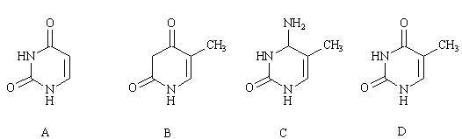

Feedback: Structure D is thymine. Structure A is uracil, but structures B and C are not present in DNA.
Page reference: 118
a. Structure A
b. Structure B
c. Structure C
*d. Structure D

Type: multiple choice question
Title: Chapter 07- Question 27
27) Which of the following structures is uracil?

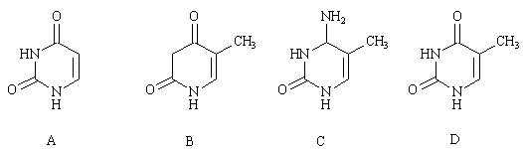

Feedback: Structure A is uracil. Structure D is thymine, but structures B and C are not present in DNA.
Page reference: 118
*a. Structure A
b. Structure B
c. Structure C
d. Structure D

Type: multiple choice question
Title: Chapter 07- Question 28
28) Which of the following structures is cytosine?

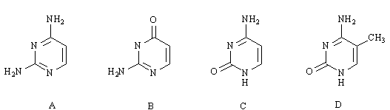
Feedback: Structure C is cytosine. The other structures are not present in DNA.
Page reference: 118
a. Structure A
b. Structure B
*c. Structure C
d. Structure D

Type: multiple choice question
Title: Chapter 07- Question 29
29) Which of the following structures is adenine?

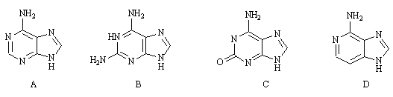
Feedback: Structure A is adenine. The other structures are not present in DNA.
Page reference: 118
*a. Structure A
b. Structure B
c. Structure C
d. Structure D

Type: multiple choice question
Title: Chapter 07- Question 30
30) Which of the following structures is guanine?

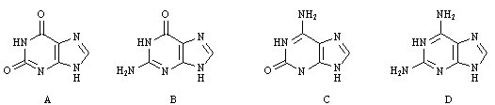
Feedback: Structure B is guanine. The other structures are not present in DNA.
Page reference: 118
a. Structure A
*b. Structure B
c. Structure C
d. Structure D

Type: multiple choice question
Title: Chapter 07- Question 31
31) Which of the following structures is a purine structure?

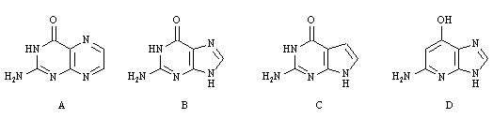
Feedback: Structure B is guanine which is a purine structure. Structure A is a pteridine. Structure C is a pyrrolopyrimidine. Structure D is an imidazopyridine.
Page reference: 118
a. Structure A
*b. Structure B
c. Structure C
d. Structure D

Type: multiple choice question
Title: Chapter 07- Question 32
32) Which of the following structures is a pyrimidine structure?

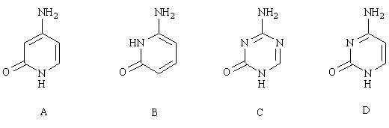
Feedback: Structure D is cytosine which is a pyrimidine structure. Structures A and B are pyridinones. Structure C is a triazinone.
Page reference: 118
a. Structure A
b. Structure B
c. Structure C
*d. Structure D

Type: multiple choice question
Title: Chapter 07- Question 33
33) Which of the following structures is deoxyadenosine?

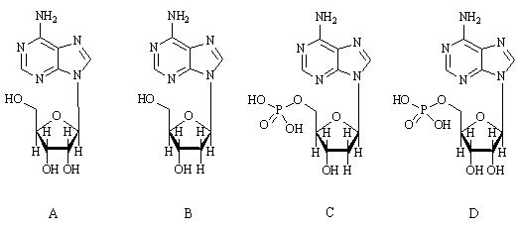
Feedback: Structure B is deoxyadenosine. Structure A is adenosine. Structure C is deoxyadenosine monophosphate. Structure D is adenosine monophosphate (AMP).
Page reference: 117
a. Structure A
*b. Structure B
c. Structure C
d. Structure D

Type: multiple choice question
Title: Chapter 07- Question 34
34) Which of the following structures is adenosine?

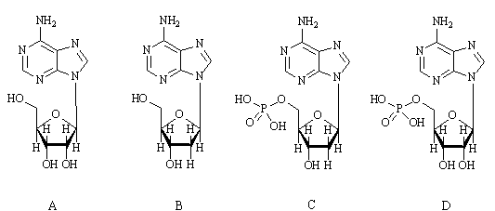
Feedback: Structure A is adenosine. Structure B is deoxyadenosine. Structure C is deoxyadenosine monophosphate. Structure D is adenosine monophosphate (AMP).
Page reference: 117, 122
*a. Structure A
b. Structure B
c. Structure C
d. Structure D

Type: multiple choice question
Title: Chapter 07- Question 35
35) Which of the following structures is a nucleotide building block for DNA?

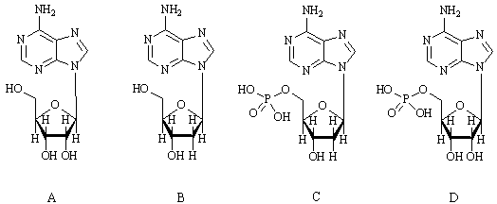
Feedback: Structure C is deoxyadenosine monophosphate and is a nucleotide building block for DNA. Structure D (adenosine monophosphate) is also a nucleotide but it is a building block for RNA. Structures A and B (adenosine and deoxyadenosine respectively) are nucleosides.
Page reference: 118
a. Structure A
b. Structure B
*c. Structure C
d. Structure D

Type: multiple choice question
Title: Chapter 07- Question 36
36) Which of the following structures is deoxyguanosine?

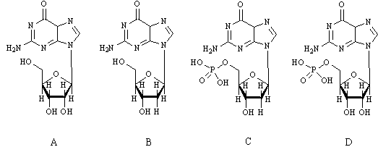
Feedback: Structure B is deoxyguanosine. Structure A is guanosine. Structure C is deoxyguanosine monophosphate. Structure D is guanosine monophosphate (GMP).
Page reference: 117
a. Structure A
*b. Structure B
c. Structure C
d. Structure D

Type: multiple choice question
Title: Chapter 07- Question 37
37) Which of the following structures is guanosine?

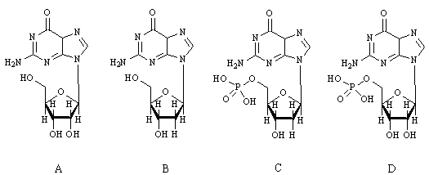
Feedback: Structure A is guanosine. Structure B is deoxyguanosine. Structure C is deoxyguanosine monophosphate. Structure D is guanosine monophosphate (GMP).
Page reference: 117, 122
*a. Structure A
b. Structure B
c. Structure C
d. Structure D

Type: multiple choice question
Title: Chapter 07- Question 38
38) Which of the following structures is a nucleotide building block for DNA?

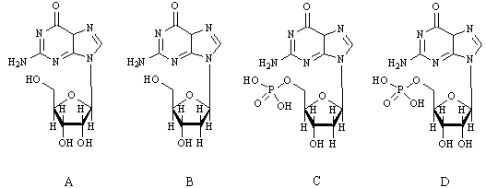

Feedback: Structure C is deoxyguanosine monophosphate and is a nucleotide building block for DNA. Structure D (guanosine monophosphate) is also a nucleotide but it is a building block for RNA. Structures A and B (guanosine and deoxyguanosine respectively) are nucleosides.
Page reference: 118
a. Structure A
b. Structure B
*c. Structure C
d. Structure D

Type: multiple choice question
Title: Chapter 07- Question 39
39) To which of the following does adenine form hydrogen bonds in DNA?
Feedback: Thymine base pairs with adenine. Guanine base pairs with cytosine.
Page reference: 118-119
a. Adenine
*b. Thymine
c. Cytosine
d. Guanine

Type: multiple choice question
Title: Chapter 07- Question 40
40) To which of the following does cytosine form hydrogen bonds in DNA?
Feedback: Thymine base pairs with adenine. Guanine base pairs with cytosine.
Page reference: 118-119
a. Adenine
b. Thymine
c. Cytosine
*d. Guanine

Type: multiple choice question
Title: Chapter 07- Question 41
41) Which of the following statements is not true about DNA secondary structure?
Feedback: A purine base always pairs up with a pyrimidine base.
Page reference: 118-120
a. There is a minor groove and a major groove.
*b. Purine bases pair up with each other.
c. The phosphate groups are positioned to the outside of the structure.
d. The base pairs are stacked.

Type: multiple choice question
Title: Chapter 07- Question 42
42) Which of the following is not true when RNA is compared with DNA?
Feedback: RNA molecules are smaller than DNA.
Page reference: 122
a. RNA contains ribose and not deoxyribose.
b. RNA contains uracil and not thymine.
c. RNA does not form a double helix.
*d. RNA is larger than DNA.

Type: multiple choice question
Title: Chapter 07- Question 43
43) Which of the following descriptions applies to the process of replication?
Feedback: Replication is the copying of DNA into two daughter DNA molecules. Translation is the process by which the genetic code for a specific protein (carried in messenger RNA) is used for the synthesis of a new protein. Transcription is the term used to describe how the genetic code relevant for the synthesis of one protein (a gene) is copied from DNA to form messenger RNA. Reproduction is the term used for the overall physiological process by which new progeny are produced in a particular species.
Page reference: 119-120
*a. The process by which DNA is copied to produce two daughter DNA molecules.
b. The process by which a segment of DNA is copied to produce a molecule of messenger RNA.
c. The process by which proteins are synthesised from a genetic code.
d. The overall physiological process by which new progeny are produced in a particular species.

Type: multiple choice question
Title: Chapter 07- Question 44
44) Which of the following descriptions applies to the process of transcription?
Feedback: Replication is the copying of DNA into two daughter DNA molecules. Translation is the process by which the genetic code for a specific protein (carried in messenger RNA) is used for the synthesis of a new protein. Transcription is the term used to describe how the genetic code relevant for the synthesis of one protein (a gene) is copied from DNA to form messenger RNA. Reproduction is the term used for the overall physiological process by which new progeny are produced in a particular species.
Page reference: 122
a. The process by which DNA is copied to produce two daughter DNA molecules.
*b. The process by which a segment of DNA is copied to produce a molecule of messenger RNA.
c. The process by which proteins are synthesised from a genetic code.
d. The overall physiological process by which new progeny are produced in a particular species.

Type: multiple choice question
Title: Chapter 07- Question 45
45) Which of the following descriptions applies to the process of translation?
Feedback: Replication is the copying of DNA into two daughter DNA molecules. Translation is the process by which the genetic code for a specific protein (carried in messenger RNA) is used for the synthesis of a new protein. Transcription is the term used to describe how the genetic code relevant for the synthesis of one protein (a gene) is copied from DNA to form messenger RNA. Reproduction is the term used for the overall physiological process by which new progeny are produced in a particular species.
Page reference: 122-125
a. The process by which DNA is copied to produce two daughter DNA molecules.
b. The process by which a segment of DNA is copied to produce a molecule of messenger RNA.
*c. The process by which proteins are synthesised from a genetic code.
d. The overall physiological process by which new progeny are produced in a particular species.

Type: multiple choice question
Title: Chapter 07- Question 46
46) Which of the following types of RNA provides the genetic blueprint for the synthesis of proteins?
Feedback: The process of protein synthesis is catalysed by ribosomal RNA (rRNA). Messenger RNA (mRNA) provides the genetic blueprint for the protein. Transfer RNA (tRNA) is responsible for translating the triplet code into a specific amino acid. Messenger RNA molecules are modified prior to protein synthesis by small nuclear RNA (snRNA).
Page reference: 122-125
a. rRNA
*b. mRNA
c. tRNA
d. snRNA

Type: multiple choice question
Title: Chapter 07- Question 47
47) Which of the following types of RNA helps to catalyse the synthesis of proteins?
Feedback: The process of protein synthesis is catalysed by ribosomal RNA (rRNA). Messenger RNA (mRNA) provides the genetic blueprint for the protein. Transfer RNA (tRNA) is responsible for translating the triplet code into a specific amino acid. Messenger RNA molecules are modified prior to protein synthesis by small nuclear RNA (snRNA).
Page reference: 122-125
*a. rRNA
b. mRNA
c. tRNA
d. snRNA

Type: multiple choice question
Title: Chapter 07- Question 48
48) Which of the following types of RNA translates the genetic code for the synthesis of proteins?
Feedback: The process of protein synthesis is catalysed by ribosomal RNA (rRNA). Messenger RNA (mRNA) provides the genetic blueprint for the protein. Transfer RNA (tRNA) is responsible for translating the triplet code into a specific amino acid. Messenger RNA molecules are modified prior to protein synthesis by small nuclear RNA (snRNA).
Page reference: 122-125
a. rRNA
b. mRNA
*c. tRNA
d. snRNA

Type: multiple choice question
Title: Chapter 07- Question 49
49) Which of the following types of RNA modifies messenger RNA molecules prior to the synthesis of proteins?
Feedback: The process of protein synthesis is catalysed by ribosomal RNA (rRNA). Messenger RNA (mRNA) provides the genetic blueprint for the protein. Transfer RNA (tRNA) is responsible for translating the triplet code into a specific amino acid. Messenger RNA molecules are modified prior to protein synthesis by small nuclear RNA (snRNA).
Page reference: 126
a. rRNA
b. mRNA
c. tRNA
*d. snRNA

Type: multiple choice question
Title: Chapter 07- Question 50
50) What expression is given for the three nucleic acid bases present on messenger RNA that code for a specific amino acid?
Feedback: The codon is a triplet of nucleic acid bases present on messenger RNA that will code for a specific amino acid. The anticodon is the complementary triplet of nucleic acid bases on transfer RNA that will link a specific transfer RNA to that codon. In doing so, a specific amino acid is carried to the site of protein synthesis by transfer RNA. There is no such thing as a translation factor.
Page reference: 124
a. Anticodon
b. Triplet
*c. Codon
d. Translation factor

Type: multiple choice question
Title: Chapter 07- Question 51
51) What expression is given for the three nucleic acid bases present on transfer RNA that base pair with a triplet of bases on messenger RNA?
Feedback: The codon is a triplet of nucleic acid bases present on messenger RNA that will code for a specific amino acid. The anticodon is the complementary triplet of nucleic acid bases on transfer RNA that will link a specific transfer RNA to that codon. In doing so, a specific amino acid is carried to the site of protein synthesis by transfer RNA. There is no such thing as a translation factor.
Page reference: 124
*a. Anticodon
b. Triplet
c. Codon
d. Translation factor

Type: multiple choice question
Title: Chapter 07- Question 52
52) How many nucleic acid bases on messenger RNA are responsible for the coding of one amino acid?
Feedback: Since three bases code for one amino acid, the genetic code is also called the triplet code.
Page reference: 124
a. 1
b. 2
*c. 3
d. 4

Type: multiple choice question
Title: Chapter 07- Question 53
53) What amino acid is coded by the triplet of bases UUU?
Feedback: The triplet code for phenylalanine can be UUU or UUC. For serine it can be UCU, UCC, AGU or AGC. For tyrosine, it is UAU or UAC. For cysteine it can be UGU or UGC.
Page reference: 676
*a. Phenylalanine
b. Serine
c. Tyrosine
d. Cysteine

Type: multiple choice question
Title: Chapter 07- Question 54
54) Which of the following mutations is most likely to be disruptive to protein synthesis or function?
Feedback: GAG to GAA results in glutamic acid being coded in each case. There is no disruption to protein synthesis or function.
GAG to GAC or GAU results in a change from glutamic acid to aspartic acid. This is a similar amino acid to glutamic acid and so the chances of disruption are slight.
GAG to UAG results in a stop code which prevents further synthesis of the protein. This will be the most drastic effect and will lead to a non-functioning protein.
Page reference: 676
a. GAG to GAA
b. GAG to GAC
c. GAG to GAU
*d. GAG to UAG

Type: multiple choice question
Title: Chapter 07- Question 55
55) Proflavine (I) is an intercalating agent which was used to treat wounded soldiers in the Far East during the second world war. Which of the following statements is false regarding proflavine?
Feedback: The tricyclic system forms van der Waals interactions with the base pairs above and below it.
Page reference: 431
a. It is a useful topical antibacterial agent.
b. Its planar shape is important to intercalation..
c. The primary amine groups are protonated and interact with phosphate groups of the DNA backbone.
*d. When inserted into DNA, the tricyclic system can form hydrogen bonds with base pairs above and below it.

Type: multiple choice question
Title: Chapter 07- Question 56
56) The following antibiotic structure is an intercalating agent. The tricyclic group in blue is the important feature that intercalates with the base pairs of DNA. Another group in the structure forms an interaction with the sugar phosphate chain of DNA. Which group?

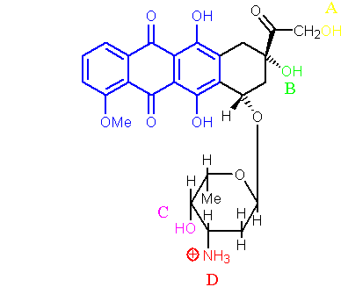

Feedback: An ionic interaction can be formed between the positively charged nitrogen of the antibiotic and the negatively charged phosphate groups of the DNA sugar phosphate backbone.
Page reference: 500
a. The alcohol group labelled A.
b. The alcohol group labelled B.
c. The alcohol group labelled C.
*d. The ammonium group labelled D.

Type: multiple choice question
Title: Chapter 07- Question 57
57) What sort of reaction is catalysed by a restriction enzyme in recombinant DNA technology?
Feedback: An esterase enzyme cleaves ester bonds. A restriction enzyme cleaves sugar phosphate bonds in DNA. A reductase enzyme reduces ketones. A ligase enzyme forms sugar phosphate bonds.
Page reference: 129-30
a. The hydrolysis of an ester group.
*b. The cleavage of a sugar phosphate bond.
c. The reduction of a ketone.
d. The formation of a sugar phosphate bond.

Type: multiple choice question
Title: Chapter 07- Question 58
58) What sort of reaction is catalysed by a ligase enzyme in recombinant DNA technology?
Feedback: An esterase enzyme cleaves ester bonds. A restriction enzyme cleaves sugar phosphate bonds in DNA. A reductase enzyme reduces ketones. A ligase enzyme forms sugar phosphate bonds.
Page reference: 129-130
a. The hydrolysis of an ester group.
b. The cleavage of a sugar phosphate bond.
c. The reduction of a ketone.
*d. The formation of a sugar phosphate bond.

Type: matching question
Title: Chapter 07 - Question 59
59) The following compounds (i), (ii) and (iii) are antiviral drugs which mimic natural nucleosides. What nucleosides do they mimic?

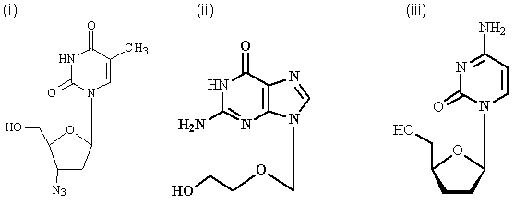

Feedback: The antiviral drugs contain the nucleic acid bases adenine, guanine and cytosine respectively. They all contain incomplete sugar moieties and if they are incorporated into a growing DNA chain, further chain growth is terminated.
Page reference: 117, 444-445, 452-453
a. (i) = Deoxythymidine
b. (ii) = Deoxyguanosine
c. (iii) = Deoxycytidine
d. None of the answers = Deoxyadenosine

