Answers
1) The pyrrole ring of DU 122290 serves to increase the rigidity of the side chain present in sultopride. The red coloured bond in sultopride is freely rotatable, but is locked within the pyrrole ring of DU 122290. This reduces the number of possible conformations that DU 122290 can adopt, and increases the chances of the active conformation being present when it enters the binding site, thus increasing activity.
Moreover, some of the conformations that are now disallowed may be those which are adopted when sultopride binds to the D₂-receptor, thus increasing selectivity for the D₃-receptor.

2) The binding interactions for methotrexate is shown below

It is tempting to try and fit the natural substrate in the same manner. However, only the primary amino group interacting with Asp26, and Leu114 & Thr116 (via a bridging water) can form the same interactions. Binding is much weaker as a result.

Comparing the two structures, there are important differences in the nature of the hydrogen bonding groups present.

This suggests that different binding modes may be occurring here. For example, the binding of the natural substrate is much stronger if it binds in the following manner. In this binding mode, five hydrogen bonds are possible instead of two in the above binding mode.
The ability of molecules to find alternative binding modes will be affected by their flexibility, the functional groups present and althernative binding modes result in bad steric interactions or not.
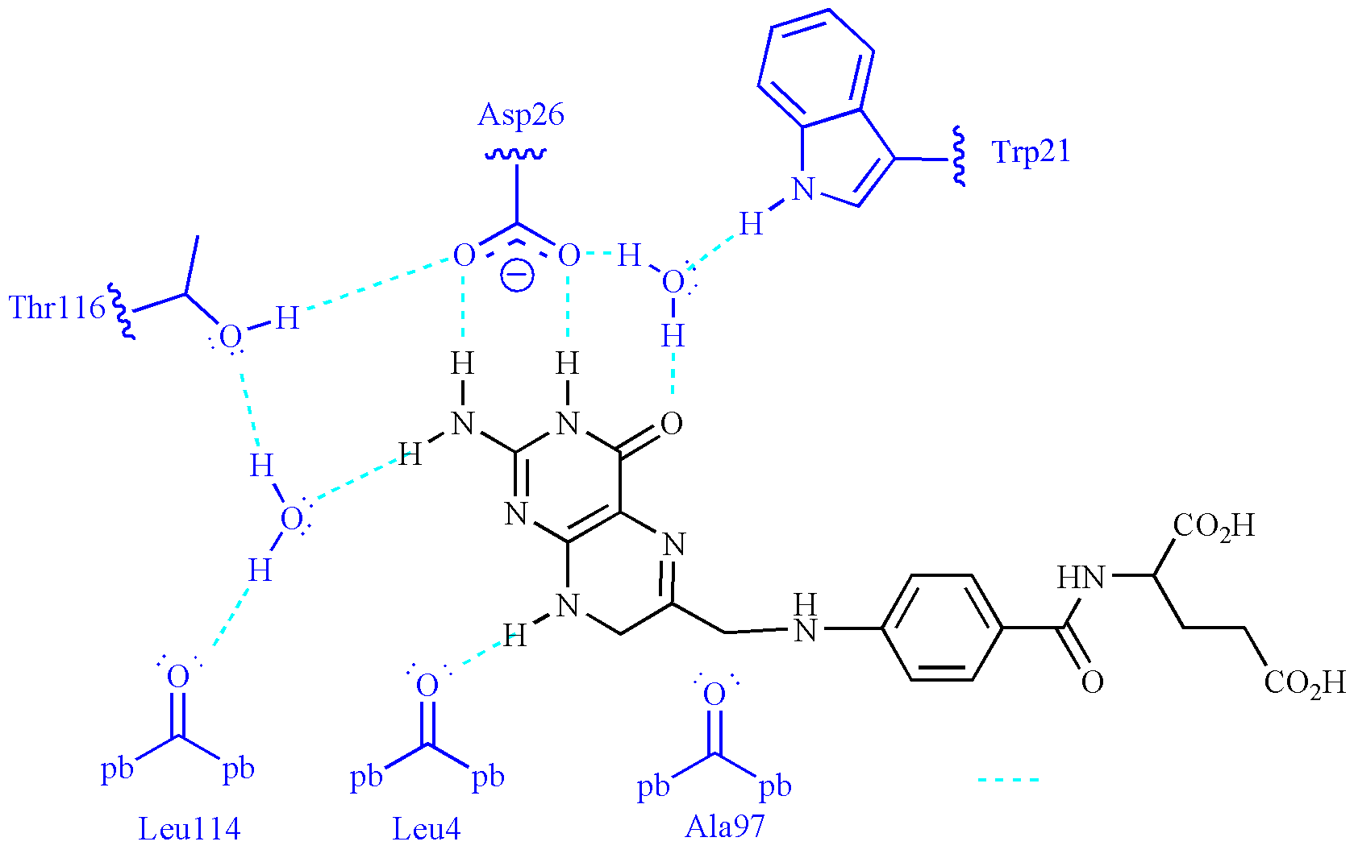
3) The results can be explained by proposing that the ester is acting as a prodrug. In the in vivo bioassays, the ester will be less polar than the carboxylic acid and so the prodrug will be able to cross fatty cell membranes such as those of the cells lining the gut wall. Once absorbed, esterases in the blood supply will hydrolyse the ester to reveal the carboxylic acid and generate the active drug. If the active drug is administered orally, the polar carboxylic acid hinders the drug crossing cell membranes and the drug fails to reach its target, accounting for the lack of activity.
In the in vitro bioassay, the drug interacts directly with its target and is active, whereas the ester prodrug is inactive since the ester masks the important carboxylic acid group. There are no esterases present in the in vitro bioassay to hydrolyse the ester.

4) Structures I and II are similar in activity to the lead compound which demonstrates that replacing the aromatic ring with a pyridine ring has no significant effect in itself. The aromatic and pyridine rings can both interact with a binding site by van der Waals interactions. The increased activity for structure III strongly suggests that there is an additional binding interaction taking place with the binding site, such as a hydrogen bond to a serine residue. The strategy used here is ring variation, but could also be described as extension since an extra binding interaction has been discovered.

5) There are several possibilities. The following are three examples, with the first of these being the most obvious. All the structures lack the methyl ester since this is not part of the pharmacophore.

6) Cocaine is quite a rigid structure whereas procaine has a flexible chain with several rotatable bonds. As a result it can adopt several conformations, one of which positions the important functional groups (amine, ester and aromatic ring) in the same relative position as in cocaine. This can be seen in the overlay below, where the alkyl chain of procaine bisects the ring of cocaine to place the amine group in the same position as that of cocaine.

This is an exercise which can be carried out using a molecular modelling programme such as Chem3D.

7) It could be interacting with an extra binding region in the binding site which is not used by cocaine. The interaction could be either hydrogen bonding (HBA or HBD) or ionic bonding (if the amine is protonated).
An alternative explanation is that the amine could have an electronic influence on the para ester carbonyl group as shown below and increase its strength as a hydrogen bond acceptor.
Finally, it might not have any binding role at all and is present to increase the water solubility of the drug.

8) The idea of rigidification is to restrict the number of possible conformations that a molecule can adopt whilst retaining the active conformation. This means that the molecule is more likely to be in its active conformation when it interacts with its target, resulting in greater activity. Restricting the number of conformations also reduces the chances of side effects if conformations recognised by different targets are prevented. In this example, an extra ring can be added to lock bonds in the side chain such that they can no longer rotate. The following are examples. Many more are possible with different ring sizes and positions.

9) Rigidification. Inclusion of the alkene restricts the number of conformations in each analogue since no rotation is allowed round the double bond. The differences in activity between structures V and VI can be explained by proposing that the active conformation has been retained in structure V, but not in structure VI.
Structure V would have greater activity than the lead compound since there is more chance of the active conformation being present when the drug reaches the binding site.
Structure VI might be expected to have no activity if the active conformation is disallowed. However, some activity may still be present if the molecule can fit the binding site in a different, but less efficient binding mode.

10) The methyl group in structure VIII is acting as a conformational blocker. It prevents the two pyridine rings becoming coplanar due to a bad steric interaction with a proton on the other ring.

If the activity increases it suggests that the rings are not coplanar in the active conformation. Preventing the coplanar conformation increases the chances of the molecule being in the active conformation and increases activity (see also section 15.18.10).

