Beginner’s Guide to Aqueous Protein NMR
Sample Preparation
- Start with a protein concentration of about 4-5 mg/mL. We will be making about 1 mL of sample to keep things simple, so weight out about 4-5 mg of protein.
NMR samples need to contain a deuterated (H’s have an extra neutron) solvent, which is will be necessary later to lock onto the sample. We will use D2O (heavy water) as our deuterated solvent. Important Note: deuterium H’s do not show up on ¹H NMR. Also, amide protons (NH’s) are easily exchanged with those in the solvent, so using 100% D₂O will cause the signals from amide protons to disappear. We want to see these amides, so the solution is only use a small amount of D₂O, 10% by volume. This provides a signal for locking and still allows the amide protons to be seen.
- Transfer your weighed sample to an Eppendorf tube, and add 100 μL of D₂O. Important: minimize the amount of time the bottle of D₂O is open to the atmosphere! Non-deutreated water in the air can exchange with the heavy water and pollute it, so don’t leave the cap off for long!
- Add another 900 μL of regular H₂O to bring the final volume up to 1 mL. These proteins should be fairly soluble, but if can’t get it to dissolve you can try vortexing it or using a sonic bath.
- Anything that isn’t in solution is bad for NMR (like dust or undissolved sample), so you may want to spin your samples for a minute in a microcentrifuge.
- Get a clean NMR tube. Be careful, NMR tubes are very thin and very expensive. Using a micropipette, slowly add 600 μL of sample to your tube. A good technique is to touch the tip of the pipette tip to the inside wall of the tube and slowly add your sample while holding the tube at an angle. Sometimes the surface tension of the liquid will trap the air in the bottom of the tube and your sample can back up near the top, so be mindful when adding your sample. If this happens, you can shake down the tube VERY CAREFULLY (like shaking down an old mercury thermometer).
- Gently press fit the cap onto the end of the tube. Label your sample with a marker or a removable tag.
- Clean off the outside of the tube with some alcohol to remove any fingerprints.
Magnet Safety
The NMR is built around an extremely powerful superconducting magnet, which requires caution. Remember the strength of magnetic fields is proportional to the inverse square of the distance, so the magnetic field will increase exponentially (not linearly) as you approach the magnet. The field is concentrated where the sample sits, but it still extends into the room. Therefore, you should not enter the room if you have any implanted medical devices.

You will notice a red circle taped out on the floor around the magnet that denotes the boundary of the magnetic safety zone. Do NOT bring any iron containing materials (tools, gas cylinders, etc..) inside this circle! Magnetic media such as floppy disks, tapes, and credit cards can be erased if brought close to the magnet. Mechanical watches (those with hands) can be damaged. Before you enter the red circle, remove any large watches, cell phones, or wallets from your person. Small objects like tooth fillings, glasses, and rings are usually okay (most of these items are nonmagnetic).
Sample Insertion
- Your sample needs to be in a spinner before it can go in the NMR. Take a blue spinner from the case. The NMR tube is inserted into the hole in the center. This is a tight fit, so cautiously insert the tube using gentle downward pressure and a slight twisting motion while avoiding any bending or shearing forces that may break tube. Insert until there is about 3 inches of tube protruding from the bottom of the spinner.
- Adjust the depth of the sample using the sample depth gauge. Do not skip this step! Place the spinner with your sample into the sample depth gauge, and carefully lower the tube until it just touches the bottom of the depth gauge. Do this carefully using the same techniques as above. Caution: Sometimes the tubes lose their friction with the spinner and will suddenly slip and hit the bottom of the depth gauge, which may break the tube. Be ready to remove pressure immediately. Your sample should now be ready to insert into the magnet.
- Log into the workstation using the following credentials:
Username: chem455_nmr
Password: methanobactin
- Several error messages will appear, just click OK for these. Double click the TopSpin icon (blue ball) on the desktop to open the NMR software.
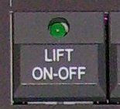
Samples are loaded and unloaded from the bore of the magnet using a pneumatic air lift system. The samples float on an air cushion that gently lowers the sample into the probe from the top of the magnet.
- Push the button on the BSMS panel to the right of the monitor to activate the lift. After a few seconds you should hear air rushing. Make sure you hear the air before proceeding to the next step.
- Hold the top of the NMR tube, approach the magnet, and insert your sample into the top of the magnet bore (remember to be aware of the magnetic field). Your tube and spinner should bob on top of the air cushion. **BE SURE THE LIFT AIR IS ON BEFORE INSERTING YOUR SAMPLE!!!** Without the air cushion, the sample will drop into the probe and break, causing thousands of dollars of damage.
- Once you have released the sample (it should be floating still) go back to the BSMS panel and hit the [LIFT ON-OFF] button again to shut off the lift air. The sample should slowly descend down into the magnet, and you should hear a click when it drops into the probe.
Using TopSpin
TopSpin is the name of the computer program used to run the NMR. As you can see, there are several menus, buttons, windows, and tabs similar to other computer programs you have used. In addition, there is a yellow command line that goes across the bottom of the screen with a blinking cursor. There are several ways to execute commands in TopSpin. The first way is to use the various buttons on the screen. To see what a button does, you can hover over it. A tooltip will appear with a description. This description may also appear at the bottom of the screen. The second way is to type commands directly into the command line at the bottom of the screen. This may seem archaic, but it is usually the fastest and simplest way to execute a command, provided you know what to type. Also, some functions do not have buttons, only text commands. For the purposes of this tutorial, it will be easiest to just give you the commands to type in the command line instead of describing the location and appearance of buttons. If you see a button for something and want to know the command for it, you can hover over it like before. The command is usually displayed in brackets. For example, if you hover over the zoom in spyglass, you see the command is [zi]. Typing zi in the command line will accomplish the same thing as clicking the button. Now let’s start a new experiment.
- To start a new experiment, type new in the command line (enter) or hit the button
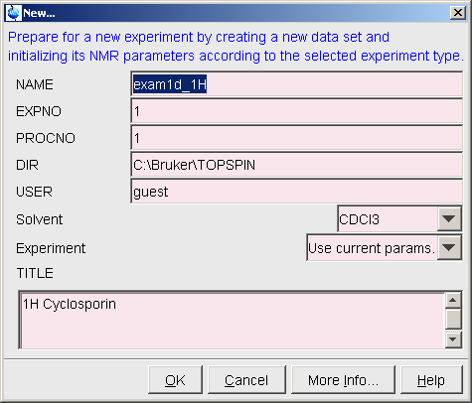
- You will get a window similar to this:
There are several fields here you want to change
Name: Type a name for you sample
User: Type a name for your group
Solvent: Select H2O+D2O
Experiment: Change to PROTON
Title: Type a description for your sample
(date, concentration, conditions, etc.)
The expno and procno are just experiment numbers that you will increment when you run another experiment (they should both say 1 for now). After you are done, hit OK to create the new experiment.

Locking, Tuning, and Shimming
Before actually running your experiment, there are a set of procedures that must be done to optimize certain parameters for your specific sample. Most of these functions are automatic, so I will just tell you what commands to type.
- First we need to lock our sample. This is where the deuterated solvent we added is utilized to maintain constant field strength. Type lock
- You will get a window with a list of solvents. Select H2O+D2O and hit OK. The locking process will now commence. You can watch the lock process in the small lock window in the lower right corner (has a red and green signal line going back and forth). In addition, there will be various status messages that appear in the lower left corner below the command bar. Wait until you see something that says “finished” or “complete” and you get a steady lock signal. This process usually takes about 30 seconds or so. If it doesn’t work properly, make sure you remembered to add D₂O to your sample, otherwise the sample won’t lock.
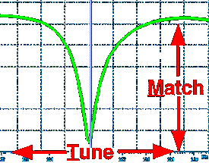
- Type atma to automatically tune and match the probe to your sample. This process automatically optimizes the tuning and matching potentiometers in the bottom of the probe with little servo motors. During the process, a graph with a pronounced dip will appear on the screen. As servos are adjusted, you can watch the dip move until it is tuned and matched properly. After the graph goes away, there are a few other things that have to finish before moving on. Again, wait until you get a “finished” or “complete” in the status area. This process will take several minutes.
- Type topshim to begin the shimming process. This optimizes that magnetic shim coils in the magnet to get a completely homogenous magnetic field throughout your sample. Each sample is slightly different, so shimming must be done with each new sample to optimize the field. During this process the lock signal will fluctuate. You can watch this in the lock window. Double click on the small lock window to bring up a full-size lock window if you want to see more detail. The experiment timer will erroneously indicate 45 minutes remaining, but in reality this process will never take more than a few minutes. The lock signal will stop fluctuating when the process is complete (also look for “finished” or “complete” in the status area). The improved shimming after the topshim process can sometimes cause the lock signal to increase to its limit in the lock window. To adjust the lock level, hit the [LOCK GAIN] button on the BSMS panel and use the wheel to adjust the lock until it is at about 60-70% of maximum.
- Type getprosol to load the predetermined probe and solvent dependant acquisition parameters into your experiment. This should finish almost instantaneously. This copies several default values into your experiment based on your solvent. This step is frequently forgotten, and subsequently the result is useless data.
- Type rga to optimize the receiver gain for optimal signal. This automatically adjusts the amount of signal fed into the receiver, analogous to adjusting the volume on your stereo to an optimal level.
- Type zg to start your experiment. If you click on the Fid tab you can watch the live collection of your data. When your experiment is running, the experiment timer in the lower part of the screen will indicative the time remaining. If you did everything right, you will have a finished proton spectra in a minute or two.
Note on Thread Errors
There is an unresolved issue with TopSpin that sporadically results in a thread error at the end of the acquisition period. When this happens, the experiment clock will continue to count down past zero (it will display negative seconds remaining), and “waiting for 1 thread to finish” will appear in the status area. Your spectrum is useless at this point, and you must wait a minute for the error to clear. To repeat the experiment, type the commands iexpno and then zg. This duplicates your experiment and reacquires your spectra. This somehow fixes the problem, and the second iteration will always work. When running longer 2D experiments, it is good practice to set up everything and type iexpno just before you begin acquiring to prevent this error from occurring.
Data Processing
After you are done acquiring you spectra, you need to process your data before you can extract a useful NMR spectrum. The PC’s in the 4th floor computer lab have TopSpin installed, so you can do processing on these computers if you wish.
- After acquisition is complete, type efp to exponentially multiply, Fourier transform, and automatically phase correct your spectrum. You should now see a spectrum with a large water peak at ~4.7 ppm.
- To manipulate the spectra, use the buttons on this toolbar. Trial and error works well here. (Don’t click the highlighted buttons.) In addition to the scroll wheel on the mouse, the buttons on the left change the scaling of the spectra. The spyglass buttons control zooming. Click and drag with the mouse to zoom in on a portion of the spectrum. The buttons on the right shift and scroll the spectrum around. Click and hold buttons with arrows and then drag the mouse around to adjust the display. To restore the original view, click the spyglass with the A in it (zoom all).
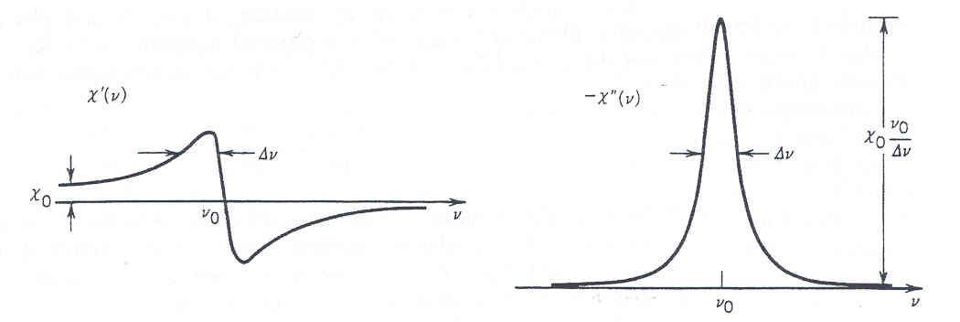
- You may need to rephrase the spectra if the water peak is not in phase (see right). This is done automatically as part of the efp command, but typing apk will automatically phase the spectrum again. You can also phase the spectrum manually. Click on the phase button to enter manual phase mode. A vertical red line should appear over the largest peak (the water peak). Now click and hold on the button and drag the mouse up and down until the water peak is completely absorptive. We will also use the button later to adjust the 1st order phasing correction. When you are done, click the button to save the phasing and exit phasing mode.
Dispersive (out of phase) peak
- Zoom in on the water peak and place the cursor at the very peak. Write down the Hz value of the peak displayed on the screen (ex. 1871.23 Hz). We will use this later for water suppression.
Water Suppression
As you may have noticed, the water peak is very large compared to the signals from your sample (you will have to scale up the spectrum using the scroll wheel to see sample signals). To get a useful spectrum, we want to do a water suppression experiment. This significantly reduces the intensity of the water peak so sample signals can be easily seen.
- Set up a new experiment by typing new or clicking the new experiment icon.
- Enter a new experiment number, and change the experiment to ZGPR.
- Type getprosol to load the default acquisition values.
- Type o1 and set the offset to the water frequency. A recommended starting value is 1878.53Hz.
- Type pl9 and change the power level to 64 dB.
- Type ns and change the number of scans to 16.
- Type rga to set the receiver gain.
- Start the experiment by typing zg.
- When the experiment is done, process your spectra by typing efp.
- Type apk to automatically correct the phasing, otherwise manually phase the spectrum.
2D NMR Experiments
Make sure your sample is locked, tuned, and properly shimmed before starting a 2D experiment. If you’ve just done a 1D experiment, your sample should still be ready to go.
COSY
COSY stands for COrrelation SpectroscopY. This experiment will show correlations between protons on adjacent carbons.
- Set up a new experiment by typing new or clicking the new experiment icon.
- Enter a new experiment number, and change the experiment to COSYPHPR.
- Type getprosol to load the default acquisition values.
- Type o1 and set the offset to the water frequency. A recommended starting value is 1878.53Hz.
- Type pl9 and change the power level to 64 dB.
- A standard COSY will take about an hour and twenty minutes. To reduce this time, you can reduce the number of scans if you have strong sample signal. To do this, type ns and reduce the number. Generally you want the number to be a multiple of 4.
- Type rga to set the receiver gain.
- If you are running another 2D experiment, skip this step, but otherwise you can start your COSY by typing zg.
TOCSY
TOCSY stands for TOtal Correlation SpectroscopY. This experiment will show correlations between all the protons in a spin system. A spin system consists of a chain of carbons that all have at least one proton attached. A spin system is terminated when there is not an adjacent carbon with protons attached. Examples of functional groups that terminate spin systems are ketones, esters, and amide groups. All peaks that show up on a COSY should also be present on the TOCSY.
- Set up a new experiment by typing new or clicking the new experiment icon.
- Enter a new experiment number, and change the experiment to MLEVPHPR.
- Type getprosol to load the default acquisition values.
- Type o1 and set the offset to the water frequency. A recommended starting value is 1878.53Hz.
- Type pl9 and change the power level to 64 dB.
- A standard TOCSY will take about an hour and twenty minutes. To reduce this time, you can reduce the number of scans if you have strong sample signal. To do this, type ns and reduce the number. Generally you want the number to be a multiple of 4.
- Type rga to set the receiver gain.
- If you are running another 2D experiment, skip this step, but otherwise you can start your TOCSY by typing zg.
Running your experiments
- To run your experiment, you first have to select it in the main window. If you set up both a COSY and a TOCSY, you need to go back and open the COSY in the main window. Expand the files in the left-hand pane and find the COSY. To select it in the main window, you can either double click on the file, or drag the file over into the main window.
- Type zg to start the experiment.
- If you have a second experiment to run, go back and select it in the main window (see above).
- Again, type zg to run the other experiment. If you are starting multiple experiments, they will queue up and run sequentially.
2D data processing
- Open your experiment in TopSpin.
- Type xfb to Fourier transform your data.
- You will need to manually phase your spectra. Click on the phase button .
- The phasing mode will open. You will need to select several peaks to phase them. To select a peak, right click on it and select add. Select about three peaks (don’t pick the water peak).
- Click on the row button to phase the rows. Click and hold on the and buttons to adjust the phasing. You usually shouldn’t have to adjust the 1st order phasing on the rows.
- Click on the button to exit row phasing. Wait a few seconds for the spectrum to update with the new phasing.
- Click on the button and do the same as above to phase the columns. Click the save button to exit column phasing.
- When you are completely done phasing, click on the button to completely exit phasing mode.
- The reference spectra displayed on the sides of the 2D plot are generated from the current experiment, but you may want to replace them with the higher quality 1D spectra you collected earlier. To change them, right click on the reference spectra and select “use external projection.”
- In the resulting window, change the experiment number to that of your 1D spectrum and click OK.
- Do the same for the second reference spectra.
Integration
It is important to integrate your spectra to find the number of hydrogens each peak represents.
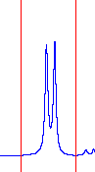
- First open up the 1D water suppressed spectra you collected in topspin.
- To enter integration mode, click on the button.
- In the spectrum window, you there will be a red vertical line that moves with the cursor. To integrate a peak, click and drag across the peak so that you start and stop equal distances from the center of the peak (see right). You also want to leave some space on either side of the peak, (see right). When you release the mouse button, the peak will be integrated. The first peak you select will be set to a default value of 1.000, and all the other peaks you select thereafter will be referenced to that value.
- Repeat the previous step until you have integrated all the individual peaks in the spectrum.
- When you are done, click the button to save and exit integration mode. The integration values will be displayed below the peaks near the axis in a red font.
How to interpret integration results
Unless you selected a 1H peak when you first integrated your spectrum, the integration values will not represent the true number of hydrogens for each peak. Instead, you should be looking for ratios between integrated peaks, like 2:1 or 3:1. For example, if you had two peaks that integrated for 1.77 and 5.31, you should notice the 1:3 ratio. In reality, you may have a CH and a CH₃, or you might have a CH₂ and a pair of equivalent CH₃’s. This is why the ratio is more important than the actual integration value. Another important note: you should only compare integration ratios within and not between the following groups: amide peaks, α-hydrogen peaks, and β-hydrogen peaks. The amide peak will always be smaller due to exchange, so it shouldn’t be compared to other aliphatic hydrogens. The α-hydrogen peaks are affected by the water suppression due to their close proximity to the water peak, so they should not be compared with the β-hydrogen peaks. Therefore, only compare α-hydrogens to α-hydrogens, and only compare β-hydrogens to β-hydrogens.

