How to Access NMR Data from Lab Computers
- First, you will need to map a network drive to the data directory on the chemserver. To do this, you can either right click on my computer and select “Map Network Drive” or you can click on Tools > Map Network Drive in any explorer window.

- After the Map Network Drive window appears, take note of the drive letter that will be used for the mapped drive. Usually it is Z: but you can change this to any other available letter from drop-down menu.

- In the folder textbox, type the name of the server and share you wish to connect to.
\\chemserver.chem.uwec.edu\chem455_nmr
Be sure to type it exactly as shown, otherwise it won’t work.

- Uncheck the reconnect at logon checkbox unless you want the drive to stay mapped the next time you use that particular computer. If you ever want to remove the mapped drive, simply right click on drive in my computer and select “Disconnect.”

- Click the connect using a different user name hyperlink. Put in these credentials.
Username: chem455_nmr
Password: methanobactin
- Click the Finish button to map the drive. If you are successful, a new window will appear with the NMR files.
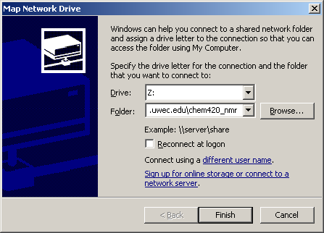
Type the chemserver directory here
Click Finish to map the drive
Map Network Drive Window
455
Click “different user name” and enter the username and password

- Next, start TopSpin (the NMR program). Click on the Start Menu, and select All Programs > Departmental > Chemistry > TOPSPIN 2.0.b (folder) > TOPSPIN 2.0.b (last item). TopSpin will start up in a minute, and it a license agreement will appear. Just click on “I Accept” to continue.

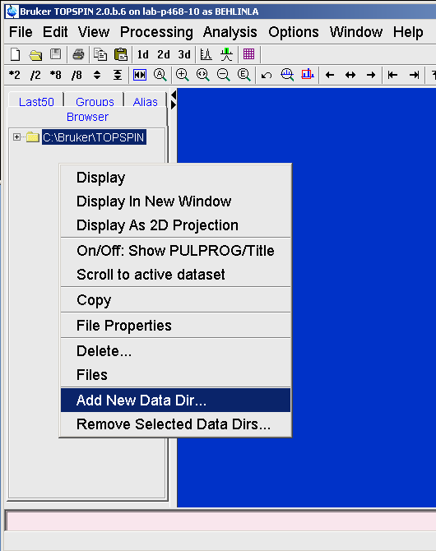
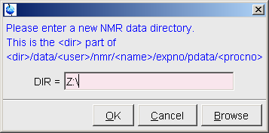
- Now we have to tell TopSpin where to look for the data. In the TopSpin window, right click in the grey area on the left. Select add data directory from the shortcut menu (2nd to last item). In the window that appears, type the directory that you just mapped (Z:\ unless you changed the drive letter to something else). Hit enter.
Opens
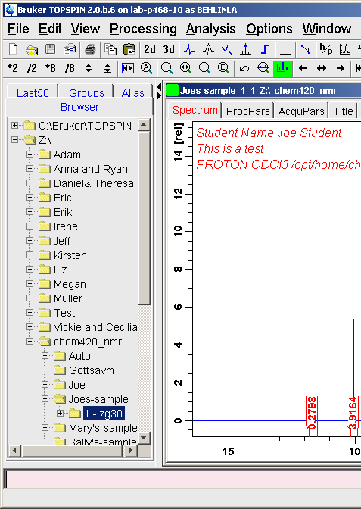
- You should now the Z:\ directory in the left window. Hit the + sign next to a directory to expand it and find your data. If your experiment was run under automation (IconNMR), the data will be one directory deeper, so expand the chem455_nmr folder and look for your username.

