Review Questions on Basic Pharmacology.

Make a list of your answers & then check them against the Answer Key

1. An antagonist is a type of drug that:

A.has maximal efficacy
B.has affinity for a receptor but little efficacy
C.binds to a receptor and activates it
D.has efficacy but low affinity
E.decreases the concentration of an agonist required to produce an effect

_____________________________

2. A partial agonist in Figure 1:

A.Drug A
B.Drug B
C.Drug C
D.Drug D (assuming that Drug D does not produce a measurable response)
E.None of the above
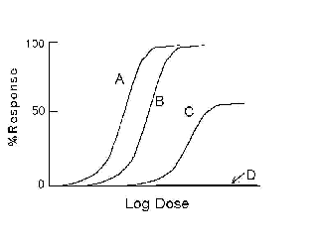
Figure 1:

3. Drug with the highest potency in Figure 1:

A.Drug A
B.Drug B
C.Drug C
D.Drug D
E.None of the above

_____________________________________
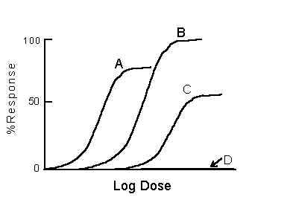
Figure 2:

4. Drug with highest efficacy in Figure 2:

A.Drug A
B.Drug B
C.Drug C
D.Drug D
E.None of the above

5. Drug with the greatest potency in Figure 2:

A.Drug A
B.Drug B
C.Drug C
D.Drug D
E.None of the above

6. An agonist is a type of drug that:

A.binds to a receptor without activating it
B.prevents the metabolism of other drugs
C.competes noncompetitively with antagonists
D.binds to a receptor and activates it
E.stimulates the metabolism of other drugs

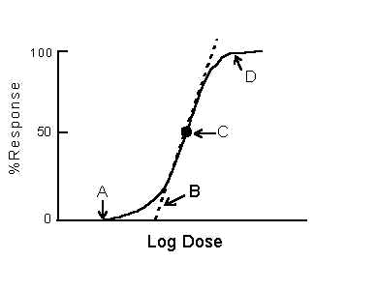
___________________________________________

Figure 3:

7. In Figure 3, the point or characteristic of the dose response curve that is used to define drug potency is:

A.Point A
B.Point B (slope)
C.Point C
D.Point D
E.None of the above

8. In Figure 3, the point or characteristic of the dose response curve that is used to define drug efficacy is:

A.Point A
B.Point B (slope)
C.Point C
D.Point D
E.None of the above

9. Drug affinity for a receptor is most closely associated with a drugs:

A.potency
B.efficacy
C.selectivity
D.toxicity
E.safety

