EXAM 1 Chem. 491/W-2009 85PTS. NAME .
In Class Part

Multiple Choice (2 pts each)

1 What role does ribosomal RNA play in the synthesis of proteins?
*a. It catalyses the process.
b. It provides the genetic blueprint for the protein.
c. It translates the genetic code to a specific amino acid.
d. It modifies messenger RNA molecules prior to protein synthesis.

2 .Tioconazole is a non polar antifungal agent which is used topically, whereas fluconazole is a polar drug which is used systemically. Which of the following statements is correct?

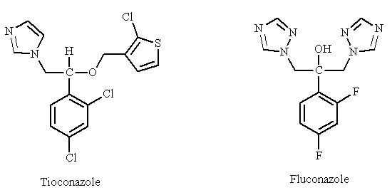

a. The heterocyclic groups in fluconazole contain more nitrogen atoms making the drug less polar.
b. Increased polarity decreases water solubility.
c. The fluorine substituents in fluconazole increase water solubility.
*d. The alcohol group in fluconazole increases polarity.

3.Methicillin was an important penicillin which was effective in the 1960's against penicillin G resistant strains of S. aureus. Although the drug is more effective than penicillin G against resistant strains, it is not as active against strains which are susceptible to penicillin G. The methyl substituents of the aromatic ring play an important role in the drug's effectiveness against penicillin G resistant strains. Which of the following statements is the most likely explanation?

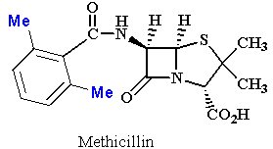
a. The methyl groups act as steric shields to protect the aromatic ring from oxidation by metabolic enzymes in the body.
*b. The methyl groups act as steric shields to protect the β-lactam ring from hydrolysis by enzymes produced by resistant bacteria.
c. The methyl groups act as conformational blockers to orientate the aromatic ring out of the plane of the side chain amide group, allowing better binding interactions with the target enzyme.
interactions with the target enzyme.

4. Why do many drugs containing ester functional groups have a limited duration of action?
a. The ester groups make the drug more polar and reduce absorption.
*b. The ester groups are susceptible to esterase enzymes.
c. The ester groups act as steric shields and prevent drugs entering binding sites.
d. Drugs with ester groups are rapidly excreted by the kidneys.

5.What is the most plausible explanation for the fact that some drugs containing an ester group are inactive in vitro, but are active once the drug has been absorbed in vivo?

a. The ester can only bind to its target when the target is present in the body. If the target is isolated for in vitro studies, the ester cannot bind to it since an important cofactor is missing.
*b. The ester group is hydrolysed by esterases in the body to produce the active drug.
c. The targets used for in vitro tests undergo conformational changes which disguise their binding sites and prevent the ester from binding in vitro. The ester binds to the target in vivo.
d. The ester forms a complex with an endogenous molecule before binding to the target binding site.

6.Levodopa is used as a pro-drug for dopamine since it enters the brain more efficiently than dopamine. Why?

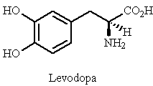

a. It is more polar and crosses the blood brain barrier more effectively.
b. It is less polar and crosses the blood brain barrier more effectively.
*c. brain barrier.
d. It is less susceptible to metabolism.

7. Which of the following strategies will not increase the polarity and water solubility of a drug?
*a. Removing polar functional groups.
b. Removing extra alkyl groups.
c. Replacing an aromatic ring with a nitrogen containing heterocyclic ring.
d. Replacing an alkyl group with a smaller alkyl group.

8.Which of the following structures is the most likely metabolite of tolbutamide?

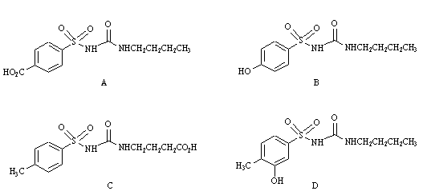
*a. Structure A
b. Structure B
c. Structure C
d. Structure D

_ 9. Lidocaine is a longer lasting local anaesthetic than procaine. Which of the following statements is true?

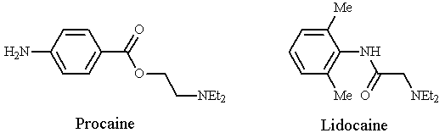
a. Lidocaine is less stable to hydrolysis.
b. The methyl substituents in lidocaine decrease stability.
*c. The amide group in lidocaine increases stability.
d. The NH2 group in procaine makes procaine less stable than lidocaine.

10.Which of the following definitions best describes a prodrug?
a. A drug that activates a receptor rather than deactivating it.
b. A naturally occurring compound that can be converted synthetically into an active compound.
*c. A compound that is inactive, but which is converted to an active compound in the body.
d. A drug which has been approved for clinical purposes by a regulatory authority.

11.Some peptides and proteins have been used as drugs. Which of the following statements is untrue?
a. Protein drugs suffer a disadvantage in that they could produce an immune response.
*b. Peptides and proteins generally show good bioavailability.
c. Peptide drugs are susceptible to peptidase enzymes.
d. Peptide drugs are susceptible to metabolic and digestive enzymes.

12. Which of the following statements best describes an induced fit?
messenger into the binding conformation before binding is wrong.

a. The process by which a binding site alters shape such that it is ready to accept a chemical messenger.
b. The process by which a chemical messenger adopts the correct binding conformation before entering a binding site.
*c. The process by which binding of a chemical messenger to a binding site alters the shape of the binding site.
d. The process by which a binding site alters the shape of the chemical messenger into the binding conformation before binding.

13. When a membrane bound receptor binds its chemical messenger, an induced fit takes place which leads to secondary effects allowing a chemical message to be received within the cell. Which of the following mechanisms is not involved in this process?

*a. The transport of the chemical messenger into the cell.
b. The opening or closing of an ion channel.
c. The activation of a signal protein.
d. The activation of a membrane bound enzyme.

14. What sort of agent binds to a receptor using a different binding site from that used by the endogenous chemical messenger? Binding results in an induced fit which distorts the binding site for the endogenous messenger such that the chemical messenger fails to bind.
a. An agonist
*b. An allosteric antagonist
c. An antagonist acting by the 'umbrella' effect
d. An inverse agonist

15.Which of the following definitions applies to the term EC50?
a. The concentration of antagonist required to inhibit the binding of an agonist by 50%.
b. The inhibitory or affinity constant.
c. The dissociation binding constant.
*d. The concentration of a drug required to produce 50% of a maximum possible effect.

16.Which of the following definitions applies to the term IC50?

*a. The concentration of antagonist required to inhibit the binding of an agonist by 50%.
b. The inhibitory or affinity constant.
c. The dissociation binding constant.
d. The concentration of a drug required to produce 50% of a maximum possible effect.

17.What is meant by a double blind clinical trial?

a. Two patients in a control study are given a placebo rather than the active drug.
b. One batch of patients receives the drug while two batches of patients receive the placebo.
c. One batch of patients receives the drug and one batch receives the placebo. The doctors determine which patients should have priority in receiving the experimental drug.
*d. One batch of patients receives the drug and one batch receives the placebo. Neither the patient nor the doctor knows whether the drug or the placebo is being administered.

18.Which of the following definitions best describes the LD50 of a drug?

a. The dose of a drug required to produce 50% of a maximum effect.
b. The dose of a drug required to produce a measurable effect in 50% of the animals tested.
c. The ratio of LD50 to ED50.
*d. The dose of a drug required to kill 50% of a group of animals.

19.What is the pharmacokinetic advantage of drugs having amine functional groups?

a. They are strong bases and are fully ionised.
b. They are very weak bases and are fully unionised.
*c. They are weak bases and are in equilibrium between the ionised and free base forms.
d. They are able to form hydrogen bonds.

20.What sort of reactions do cytochrome P450 enzymes catalyse?

a. Phosphate hydrolysis
b. Ester hydrolysis
c. Conjugations
*d. Oxidations

21.The quaternary salt of morphine binds strongly to opiate receptors in vitro. However, the compound is inactive in vivo when injected into the blood supply. Explain this apparent contradiction.

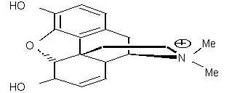

a. The drug is rapidly metabolised.
b. The drug is rapidly excreted.
*c. The drug fails to cross the blood brain barrier.
d. The drug is bound strongly to plasma proteins.

22.Where is the major site for drug metabolism?

a. Brain
*b. Liver
c. Gut wall
d. Kidneys

23.Which type of functional group would be useful to have in a drug designed to treat a gut infection?
a. An aromatic ring
b. An alcohol group
*c. A carboxylate group
d. A ketone

24.Which of the following is the general mechanism of action for β-lactams?
a. Inhibition of a metabolic enzyme.
*b. Inhibition of cell wall synthesis.
c. Disruption of protein synthesis.
d. Inhibition of nucleic acid transcription and replication.

25.Which of the following is the general mechanism of action for tetracyclines?

a. Inhibition of a metabolic enzyme.
b. Inhibition of cell wall synthesis.
*c. Disruption of protein synthesis.
d. Inhibition of nucleic acid transcription and replication.

26.The following diagram represents the general formula for a penicillin.

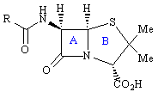
What type of ring is ring A?
a. Thiazole
b. Thiazolidine
*c. β -lactam
d. β -lactone

27.Penicillins act on an important bacterial enzyme called transpeptidase. What role does this play?
a. It racemises L-alanine to D-alanine prior to its incorporation into the bacterial cell wall.
b. It acylates amino acid residues in the bacterial cell wall.
*c. It catalyses the final crosslinking stage in cell wall synthesis.
d. It catalyses the transport of the building blocks for cell wall synthesis across the cell membrane.

28.Which of the following statements best describes the mechanism of action of penicillins?

a. A serine residue in the active site of the enzyme acts as a nucleophile and reacts with the carboxylate group of penicillin to form an ester.
b. A lysine residue in the active site of the enzyme acts as a nucleophile and reacts with the carboxylate group of penicillin to form an ester.
*c. A serine residue in the active site of the enzyme acts as a nucleophile and reacts with the β -lactam ring.
d. A lysine residue in the active site of the enzyme acts as a nucleophile and reacts with the β-lactam ring.

29.What molecular feature is penicillin G said to mimic?

a. N-acetylmuramic acid
b. N-acetylglucosamine
c. The pentapeptide moiety Gly-Gly-Gly-Gly-Gly
*d. The dipeptide moiety D-Ala-D-Ala

30.What feature of ampicillin is important in its acid stability?

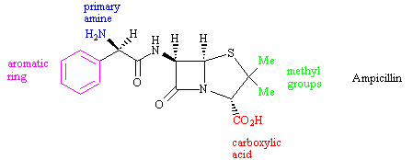

a. The carboxylic acid
b. The aromatic ring
*c. The primary amine
d. The methyl groups

31.What is the relevance of β-lactamase enzymes to penicillins?

a. Fungi containing β-lactamase enzymes can synthesise penicillins.
*b. Bacteria containing β-lactamase enzymes show resistance to penicillins.
c. Mammalian cells are unaffected by penicillins because they contain β-lactamase enzymes.
d. Only bacteria containing β-lactamase enzymes are susceptible to penicillins.

32.What modification could you reasonably carry out on an alcohol to assess whether the group is important to target binding?
a. Convert it to an amine
b. Convert it to an amide
c. Convert it to an alkane
*d. Convert it to an ester

33.Which of the following statements is true regarding an alcohol?
a. It can only participate in hydrogen bonding as a hydrogen bond donor.
b. It can only participate in hydrogen bonding as a hydrogen bond acceptor.
*c. It can participate in hydrogen bonding both as a hydrogen bond donor and a hydrogen bond acceptor.
d. It cannot participate in hydrogen bonding at all.

34.Which of the following statements is true regarding a ketone?

a. It can only participate in hydrogen bonding as a hydrogen bond donor.
*b. It can only participate in hydrogen bonding as a hydrogen bond acceptor.
c. It can participate in hydrogen bonding both as a hydrogen bond donor and a hydrogen bond acceptor.
d. It cannot participate in hydrogen bonding at all.

35.What strategy of drug design is frequently used on complex lead compounds derived from natural products?

a. Extension
*b. Simplification
c. Rigidification
d. Conformational blocking

36.Cilazaprilat is an antihypertensive agent derived from the lead compound (I).

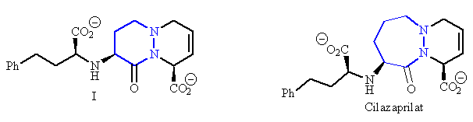

37.Which of the following is not classed as an in vitro test?

a. Receptor binding studies on tissue preparations.
b. Testing inhibitors on isolated enzymes.
c. Testing anticancer drugs by measuring the rate of growth of whole cells.
*d. Testing antibacterial agents in infected rats.

38.What is meant when a lead compound is found by serendipity?

a. It was found by a pharmaceutical company by the name of Serendipity.
b. It was found in the Serendipity region of the African Veldt.
*c. It was discovered by chance.
d. It was found by an experimental procedure known as serendipity.

39. Which of the following reflects the order in which various stages of the drug discovery and development take place?

*a. Determining a target, establishing a bioassay, finding a lead compound, structure activity relationships
b. Establishing a bioassay, determining a target, finding a lead compound, structure activity relationships
c. Determining a target, establishing a bioassay, structure activity relationships, finding a lead compound,
d. Determining a target, finding a lead compound, structure activity relationships, establishing a bioassay,

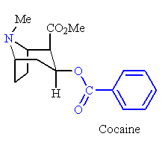

40.Procaine has been a highly successful local anaesthetic that was ultimately developed from cocaine. What strategy was used in its design?

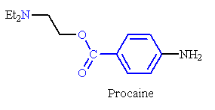
a. Rigidification
b. Extension
*c. Simplification
d. Chain contraction

41.What is meant by ADME in pharmacokinetics?

a. Affinity, dosage, marketing, efficacy
*b. Absorption, distribution, metabolism, excretion
c. Agonism, dependence, mobility, efficiency
d. Antagonism, deficiency, mean, efflux

Miscellaneous Questions:

The following structure (III) is used as a prodrug for estrone.
Draw a line where it is likely that the prodrug will be cleaved to form the actual drug structure.(1)

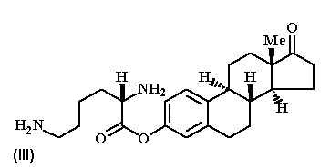

Match the following targets with their signaling molecules. Write in names . (4)

a. camp Activation of protein kinase A
b. ip3 Activation of calcium ion releasein the cell
c. dag Activation of protein kinase C
d. cgmp Activation of protein kinase G

Cyclic AMP, Inositol triphosphate, Diacylglycerol, Cyclic GMP

