quiz 1 Chem. 491-2009, 20- PTS. NAME KEY .

1. On a single graph, draw a typical dose/response curve for the new natural product drug, hartseloic acid. Also draw dose/response curve for the drug in the presence of (A) , a competitive antagonist and (B) a non-competitive antagonist. In addition, include a curve for a newly discovered similar drug, wiegelnoic acid, which is less potent but more efficacious than hartseloic acid. Be sure to label your axes clearly in a reasonable manner. (4)

100
hartseloic acid
A
wiegelnoic acid

% maximum effect

B

0
[DRUG]

D 2) The following antibiotic structure is an intercalating agent. The tricyclic group in blue is the important feature that intercalates with the base pairs of DNA. Another group in the structure forms an interaction with the sugar phosphate chain of DNA. Which group?

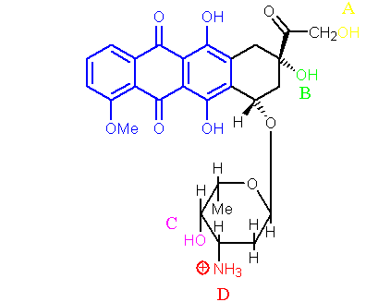

a. The alcohol group labelled A.
b. The alcohol group labelled B.
c. The alcohol group labelled C.
*d. The ammonium group labelled D.

D 3) Which of the following descriptions best describes an allosteric inhibitor?

a. A drug that binds to an active site and undergoes a reaction.
b. A drug that binds to an active site and inhibits the enzyme, but which is displaced by increasing the concentration of substrate.
c. A drug that binds to an active site and inhibits the enzyme, but which is not displaced by increasing the concentration of substrate.
d. A drug that binds to a different binding site from the active site and affects the activity of the enzyme.

B 4) What structure activates the enzyme that catalyses the following reaction?

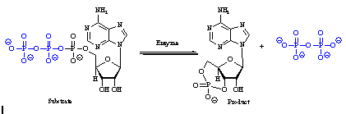
a. The β,γ dimer of a Gs-protein
*b. The αs subunit of a Gs-protein
c. A Gs-protein
d. The β-subunit of a Gs-protein

B 5) What structure deactivates the enzyme that catalyses the following reaction?

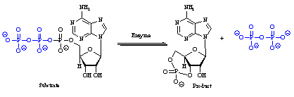

a. The β,γ dimer of a Gi-protein
*b. The αi subunit of a Gi-protein
c. A Gi-protein
d. The β-subunit of a Gi-protein

A 6) Which of the following enzymes catalyses a phosphorylation reaction?

*a. Protein kinases
b. Phosphorylases
c. Esterases
d. Ligases

A 7) Which of the following amino acids is phosphorylated by a protein kinase?
*a. Tyrosine
b. Cysteine
c. Phenylalanine
d. Lysine

D 8) Which of the following statements is true about a tyrosine kinase linked receptor?

a. it is situated in the cytoplasm
b. the N-terminal chain is intracellular
c. the ligand binding site is in the C-terminal chain
*d. it has one hydrophobic transmembrane region

C 9) Which of the following is a messenger for a tyrosine kinase linked receptor?

a. Adrenaline
b. Dopamine
*c. Epidermal growth factor
d. Histidine

C 10) Which of the following statements is not true regarding the actions of the estrogen receptor?

a. Binding of estradiol causes dimerization of the receptor.
b. Binding of estradiol causes a conformational change in the receptor.
c. Is membrane bound and interacts with Gs

D 11) Which of the following events will eventually result in the termination of adenylate cyclase activation?

a. Departure of GTP from the αs-subunit.
b. Departure of GTP from the αs-subunit and replacement with GDP.
c. Hydrolysis of bound GTP on the αs-subunit to GMP.
*d. Hydrolysis of bound GTP on the αs-subunit to GDP.

A 12) Which of the following descriptions best fits an agonist?

*a. A compound that has the same effect on a receptor as the endogenous chemical messenger.
b. A compound that binds to a receptor, and activates it, but to a lesser extent than the endogenous chemical messenger.
c. A compound that binds to a receptor fails to activate it and prevents the endogenous chemical messenger from binding.
d. A compound that binds to a receptor fails to activate it and leads to a drop in inherent biological activity.

C 13) Which of the following descriptions best fits an antagonist?

a. A compound that has the same effect on a receptor as the endogenous chemical messenger
b. A compound that binds to a receptor, and activates it, but to a lesser extent than the endogenous chemical messenger.
*c. A compound that binds to a receptor fails to activate it and prevents the endogenous chemical messenger from binding.
d. A compound that binds to a receptor fails to activate it and leads to a drop in inherent biological activity.

A 14) Which of the following statements best describes the efficacy of a drug?

*a. The maximum biological effect resulting from a drug binding to its target.
b. The measure of how strongly a drug binds to a receptor.
c. The amount of drug required to produce a defined biological effect.
d. The lifetime of the drug in the body.

B 15) Which of the following statements best describes the affinity of a drug?

a. The maximum biological effect resulting from a drug binding to its target.
*b. The measure of how strongly a drug binds to a receptor.
c. The amount of drug required to produce a defined biological effect.
d. The lifetime of the drug in the body.

C 16) Which of the following symbols represents the dissociation binding constant?

a. IC50
b. Ki
*c. Kd
d. EC50

