PRACTICE FOR EXAM 2
1. There is a cis-Δ⁹ 17 carbon fatty acid (a 17:1 heptadecenoic acid) found in the fish and blubber eaten by Inuit people.
a. Estimate how many ATPs could be obtained from this fatty acid. Show/explain your reasoning.

- The fatty acid above is an exception to the rule that glucose cannot be made from fatty acids. EXPLAIN WHY.

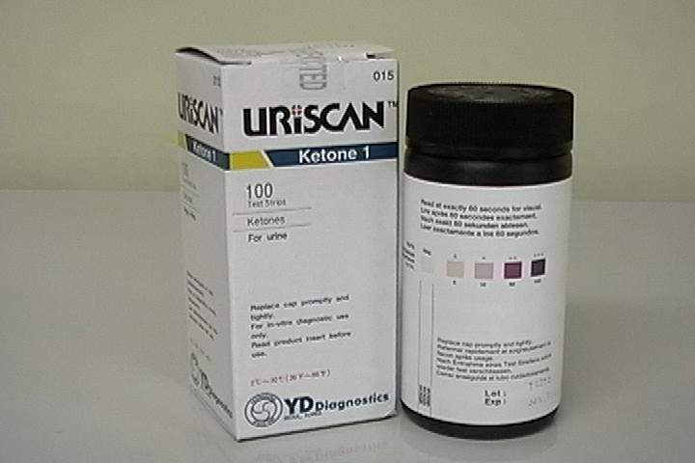
Ketone strips
Large 100 Ct Size
Check your ketone levels while on your Dr. Atkins low carb diet.
Especially helpful during the Dr. Atkins Diet two week induction phase. A must for any low carber!

2. Above is a web ad for Uriscan strips ($11.95) to detect ketones in one’s urine.

a. Explain in as much detail as you can why the presence of ketones signals the “success” of Atkins low carb diets.

What effect on urine ketones in an Atkins dieter would you expect from the following:

b. Eating a big beef jerky (all protein essentially). Explain your answer.

c. Eating a big chunk of butter (yechh!). Explain your answer.

d. Eating a bag of candy. Explain your answer

3. PGI2 , a prostaglandin , is an inhibitor of blood clotting which is secreted by endothelial cells while thromboxane TXA2 produced by blood platelets is a strong promotor of blood clotting. (12)

a. Explain why aspirin in small doses taken every few days inhibits TXA2 production while the concentration of PGI2 does not change too much.

b. Explain how EPA (eicosapentaenoic acid) from fish oil might have the same overall effect as a “blood thinner” as aspirin . Do you think that high doses would reverse the anticoagulant properties as in aspirin? Explain why or why not.

4. Type VIII glycogen storage disease is caused by a deficiency in phosphorylase kinase in the liver. Explain these clinical symptoms. Don’t forget to describe what the enzyme does!: (8)

- “increased amount and normal glycogen structure in the liver”
- “hypoglycemia

5.a. Why is water excluded from the active site of the phosphorylase enzyme? (8)

b. Predict the effect of a mutation exspressed in the protein that allows a water molecule to occasionally enter. Would this have a bigger effect on the liver or muscle phosphorylase ? Explain.

6. a. Dichlorophenyldimethylurea (DCMU), a herbicide, interferes with photophosphorylation and O₂ evolution. However, it does not block O₂ evolution in the presence of an artificial electron acceptor such as ferricyanide. Propose a site for the inhibitory action of DCMU. Draw a schematic diagram of PS I and II to help.

- In light of the previous answer, predict the effect of DCMU on a plants ability to perform cyclic photophosphorylation.

7. a) Glycogen Storage Disease 0 involves a deficiency of liver glycogen synthase. Describe the symptoms you might expect (specifically what would blood sugar levels be like under conditions of fasting and feeding). How could this disease be treated (assume that a large enzyme like glycogen synthase could not be injected and taken up by the liver)?

b) Glycogen Storage Disease I (Von Gierke Disease) involves a deficiency of liver and kidney glucose-6-phosphatase. Describe the symptoms you might expect (specifically what would blood sugar levels be like under conditions of fasting and feeding). How could this disease be treated?

