Exam 2 454-85 pts Name KEY .

- a. Dichlorophenyldimethylurea (DCMU), a herbicide, interferes with photophosphorylation and O₂ evolution. However, it does not block O₂ evolution in the presence of an artificial electron acceptor such as ferricyanide. Propose a site for the inhibitory action of DCMU. Draw a schematic diagram of PS I and II to help.
DCMU blocks O₂ production, so it must somehow interfere with PSII and electron transfer. It seems most likely that it would inhibit transfer to plastoquinone, Q. This would block any further oxidation of water and hence, no oxygen. When a route is supplied for electrons to be passed on (like ferricyanide) oxygen production can continue. It is also possible that DCMU could block at the level of electron transfer to cyt bf and QH₂ could get “backed-up” and stop water oxidation.
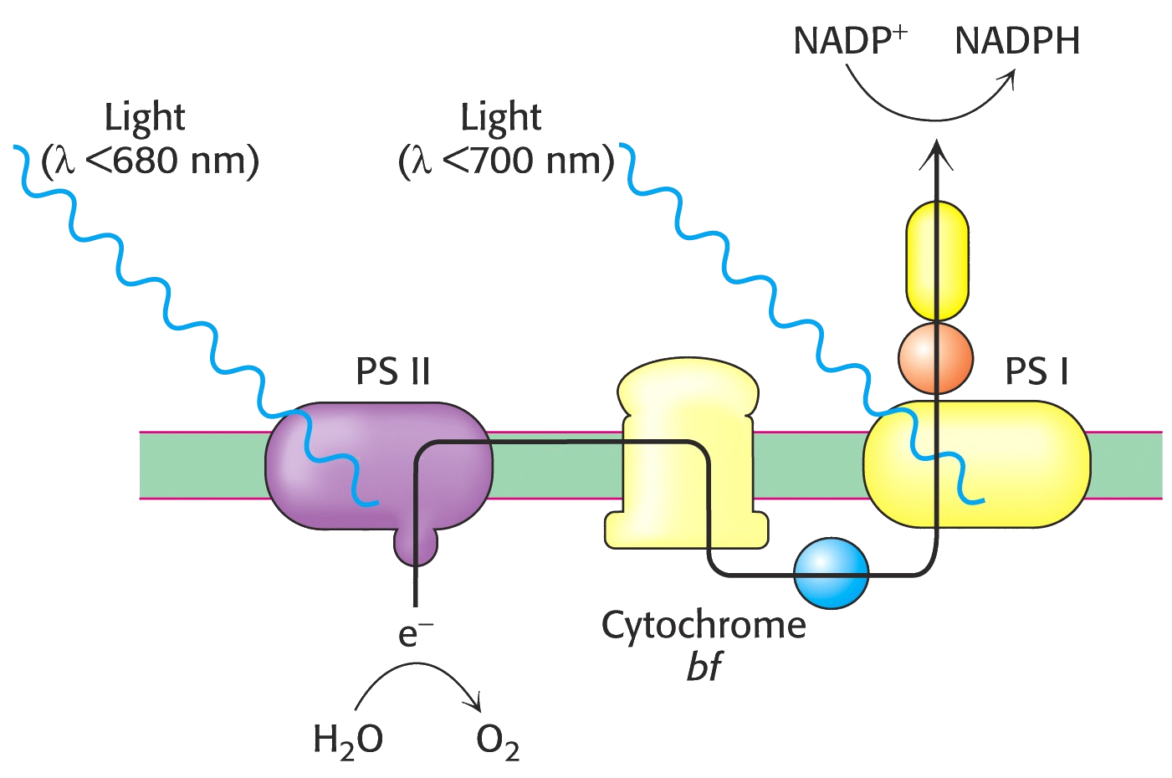

b. In light of the previous answer, predict the effect of DCMU on a plants ability to perform cyclic photophosphorylation.
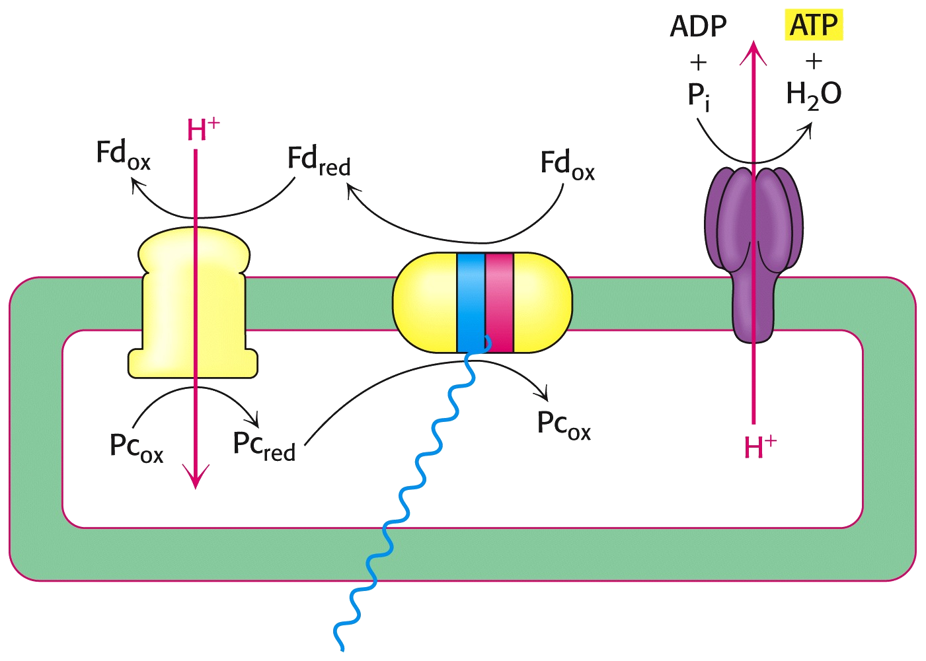
If a site on PSII is blocked, then cyclic phosphorylation, which does not depend on water electrons, should not be affected. If you proposed that a site in cyt bf or PSI is blocked (causeing electron back-up) then cyclic photophosphorylation would be inhibited. Yopur answers should be consistent

2. Cytochrome c oxidase in mitochondria catalyzes the reduction of O₂ to H₂O. In chloroplasts, photosystem II catalyze the “reverse” reaction, oxidizing 2 H₂O molecules to form O₂. Both systems, the electron transfer reactions occur sequentially, 1 electron at a time.
a. Show the stepwise reduction of O₂ to water, showing the lewis dot structure of each oxygen intermediate as electrons and H⁺ ions are added. To simplify matters, the singlet lewis dot structure of O₂ is provided.
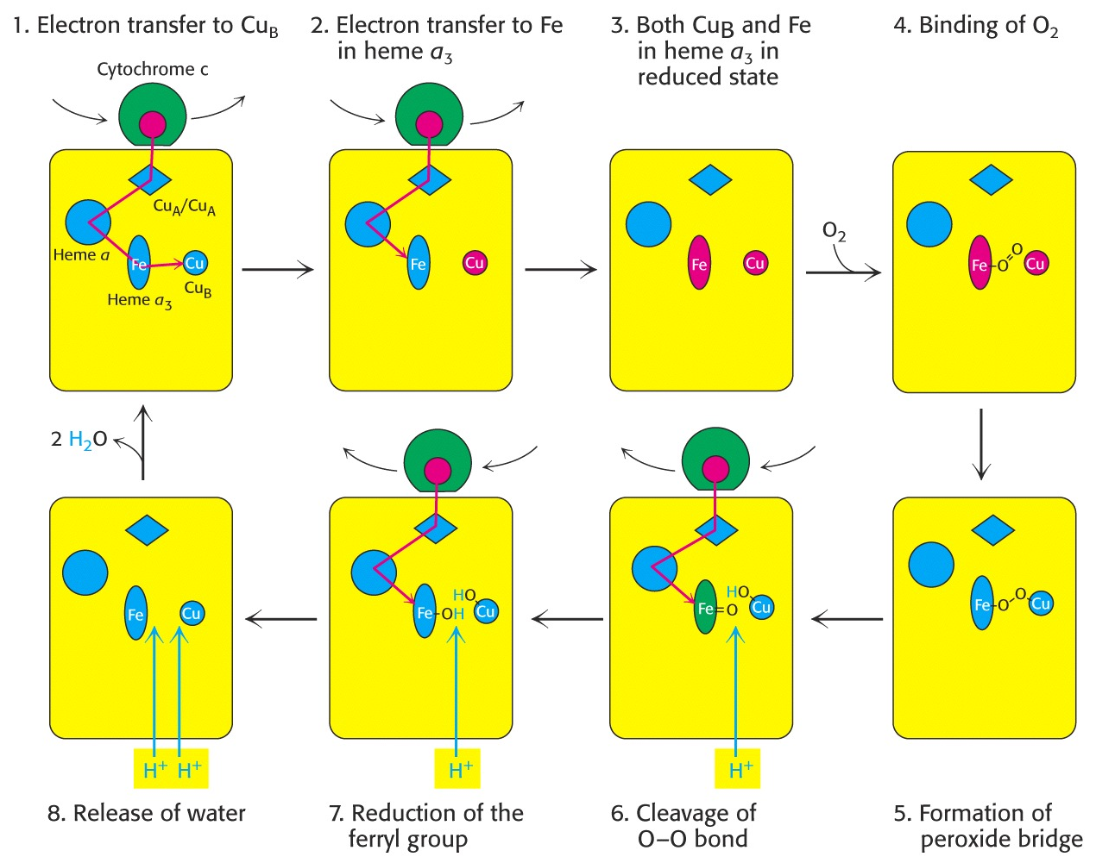

Some diagrams such as those at right showing

sequential reduction of bound O₂ would be is reasonable .
Alternately, the “bare” Lewis structures of sequential conversion
to superoxide, then (hydrogen) peroxide, water #1 + hydroxyl radical followed by water #2 would be OK . Of course, structures should have the right number of electrons in them!!!

b. In both photosystem II and cytochrome c oxidase , metal ions are found at the active site. Photosystem II has 4 Mn ions; cytochrome c oxidase has a heme group (a₃ and a copper ion (Cu_{B}). Using either photosystem II or cytochrome c oxidase as a model, describe two roles for the metal ions during catalysis.

Some description and /or diagram of one of the following would be appropriate:

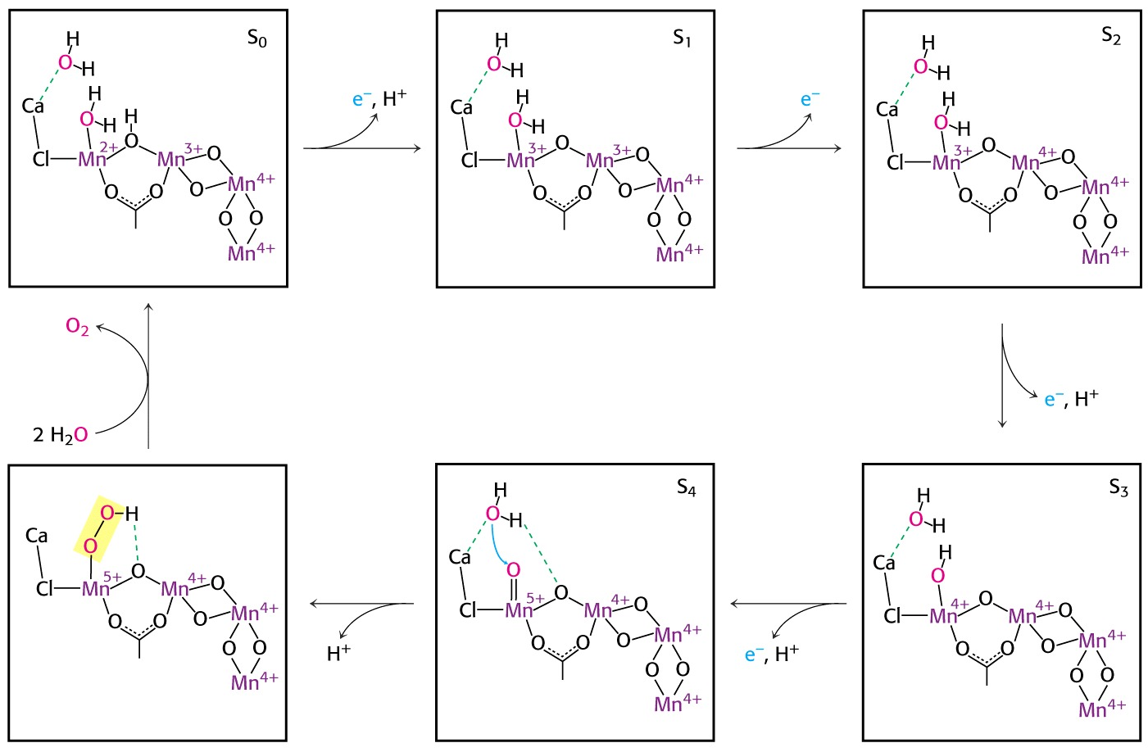

Your description should explain the purpose of the metal in catalysis and stabilization during the process. For example, the Cu and Heme centers in Cyt Oxidase receiving electrons and liganding intermediate oxygen species or the fact that Mn can exist in may oxidation states in the O₂ evolving center allowing sequential removal of electrons from H₂O.
3. A graduate student is studying carbohydrate metabolism in tropical plants. In an in vitro system, she has found that when she mixes DHAP, ribose 5-phosphate, and erythrose 4-phosphate with plant cellular extract, two 6 carbon compounds, fructose 6-phosphate and allose 6-phosphate and a phosphate moeity are generated, according to the following reaction:

Enzyme assays show that the enzymes aldolase, transketolase and an 8C phosphatase are present in the cell extract.

Derive a plausible pathway for this reaction. Please draw structures of substrates and products and include the enzyme used over the reaction arrow.
Here, I’m looking for the right enzyme and right structures.

CH2OH
CH2 OPO3
OPO3

TK

DHAP
O
O
OH
OH
OH
OH
OH
8C Phosphatase
Aldolase
Allose-6-P (bottom piece)
and Fructose-6-P (top 2 carbons + E-4-P)

+ R-5-P --------→ --------------→ + E-4-P --------------→
OH

OH
OH
OH
OH
CH2 OPO3
OPO3

CH2 OPO3
OPO3

Some 8 C sugar
bisphosphate
Some 8 C sugar
phosphate
4. a) Glycogen Storage Disease 0 involves a deficiency of liver glycogen synthase. Describe the symptoms you might expect (specifically what would blood sugar levels be like under conditions of fasting and feeding). How could this disease be treated (assume that a large enzyme like glycogen synthase could not be injected and taken up by the liver)?

Since the liver controls blood glucose levels to a large extent, this could be serious. One would expect since less glycogen synthesis would occur, that after fasting (or sleeping) that blood glucose levels would drop (hypoglycemia). The could only be maintained by gluconeogenesis. One would also expect that liver glycogen levels would also be reduced. On the other hand after a carb-rich meal one would expect hyperglycemia (high blood glucose), since blood glucose could not be stored efficiently as liver glycogen. Treatment could possibly be through diet, eating a little bit very often to keep blood sugar steady (no fasting and no big pasta meals). Maybe insulin and glucagon when needed could keep blood sugar regulated.

Find out real details here: http://www.ncbi.nlm.nih.gov/entrez/dispomim.cgi?id=240600

b) Glycogen Storage Disease I (Von Gierke Disease) involves a deficiency of liver and kidney glucose-6-phosphatase. Describe the symptoms you might expect (specifically what would blood sugar levels be like under conditions of fasting and feeding). How could this disease be treated?

Once again, since the liver controls blood glucose levels to a large extent, this could be serious. Glucose 6-phosphatase is that last step in releasing glucose into the blood. Without it neither glucose from gluconeogenesis or glycogen breakdown could be released. This would severely alter the liver’s ability to regulate glucose and hypoglycemia would big a BIG problem. One might expect high concentrations of glycogen in the liver due to excess G-6-P→ G-1-P. The only possible treatment other than gene therapy would be to eat constant small meals of glucose to keep blood sugar up (but not too high!!). One might expect rapid exhaustion, like the first case study problem due to inability to maintain blood glucose high enough.

Find out real details here: http://www.ncbi.nlm.nih.gov/entrez/dispomim.cgi?id=232200
5. Some people have proposed bringing back an old weight loss remedy from the 1930’s as a preventative treatment for the side effects of diabetes. This molecule is DNP, which is a weak acid than can transport protons across membranes. It worked for weight loss, but was deadly in an overdose and was banned. Propose using modern ideas of high glucose consequences on cell metabolism, how this treatment might work. Predict what side effects (good or bad) might occur upon taking this drug.

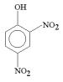
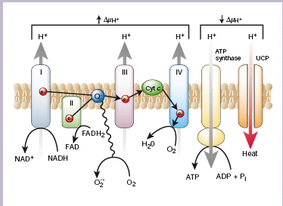

Since DNP conducts protons it would be an uncoupler, uncoupling oxidation from phosphorylation in the mitochondria. As seen above, it would reduce protonmotive force (pmf, Δµ_{H+}) in the mitochondria depleting NADH and creating heat and inefficient ATP synthesis. How would this help diabetes? Remember the hypothesis of Brownlee (Nature, 2001), that the four main problems caused by high glucose, increased polyol flux, AGES, increased PKC activity and increased hexosamine products all could be caused by the effects of an overactive electron transport chain caused by too much glucose and hence too much NADH. Under these conditions the high Δµ_{H+} opposes electron transport and QH₂ and Q. builds up. This build up increases O₂- production which leads to all of the metabolic conditions above by blocking GAPDH in glycolysis. If this hypothesis is true, then reducing Δµ_{H+} artificially will relieve this problem. One way to do it is to poison mitochondria with DNP!!

Problems, side effects? It would cause fever and high body temperature (like brown fat), and a little too much might inhibit ATP synthesis to the point where you die. You might also lose weight which would be good for type II diabetics (see next chapter and next article).

