Chem 352 - Spring 2018

Problem Set 1 (Due 2. March, 2018)

1. On the last page you will find a table containing the sequence of a dipeptide that has been personally assigned to you. Each student in the class has been assigned a different sequence.
   1. The sequences were assigned using the one-character symbols for the amino acid residues. Using the three-letter symbols, enter the sequence for your dipeptide here,
   2. If I wanted to do this with a larger class. How many students could I accommodate in the class and still give each student a unique dipeptide sequence? (Show your work, note, the sequence AA ≡ AA.)
   3. Use [MarvinSketch](https://www.chem.uwec.edu/Chem352_S18/pages/resources/resources.html#marvin) to predict the *pKa* values for each of the ionizable groups that exist between 0 and 12 for your dipeptide. You can do this by selecting “Calculations→Protonation→*pK*a” after drawing your structure and setting the min and max *pK*a to 0 and 12, respectively, before clicking “OK”.
      1. List the *pKa*’s here in order from lowest to highest:
   4. Use [MarvinSketch](https://www.chem.uwec.edu/Chem352_S18/pages/resources/resources.html#marvin) to draw the structure of your assigned dipeptide in the predominate form that exists at its *isoelectric* *pH*. You can determine the *isoelectric* *pH* by selecting “Calculations→Protonation→Isoelectric Point”. Then go back to Microspecies Distribution plot that was generated in part c. and select the highest peak that is centered at the isoelectric *pH*. Copy and paste this structure from MarvinSketch and place in the space below. Enter the isoelectric *pH* here, *pI* = ________________

a. In the space below, draw, *in order*, the chemical structures for the major ionic species that will be present as your dipeptide is titrated from *pH* 0.0 to *pH* 14. You may do this by hand or by using [MarvinSketch](https://www.chem.uwec.edu/Chem352_S18/pages/resources/resources.html#marvin). (Take *major* to mean that there exists a *pH* at which that species represents > 50% of all the species present at that *pH*.) Analyze the Microspecies Distribution plot that was produced in part c. to determine the major ionic species.

* 1. What is the expected *pH* of a 125 mM solution of the fully protonated form of your assigned dipeptide? (Show your calculations) *pH =* ____________________
  2. Sketch by hand a titration curve for a 125 mM solution of your assigned dipeptide as *pH vs. equivalents of base added*. Be sure to label both axes. (You can check your work by selecting “Calculations->Protonation->Isoelectric point” in [MarvinSketch](https://www.chem.uwec.edu/Chem352_S18/pages/resources/resources.html#marvin), which will create a plot of *net charge vs pH*. This plot is essentially the *x* ↔︎ *y* transpose of the 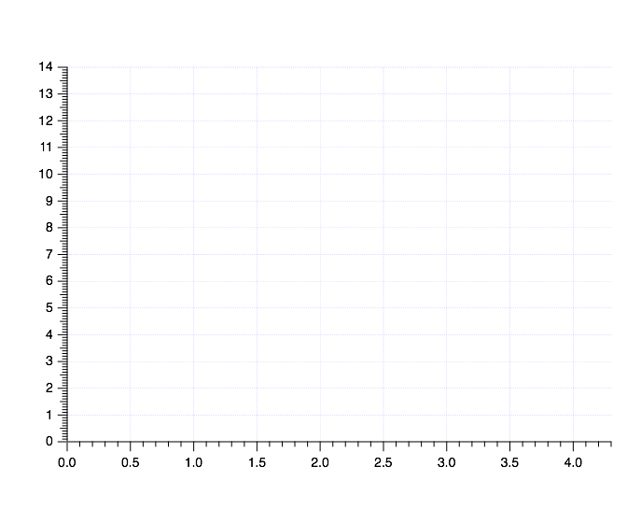titration curve you drew below.)
  3. Focusing on the side chains, classify each amino acid residue for your assigned dipeptide as *aliphatic, aromatic, sulfur containing, alcohol containing, amide containing, acidic or basic*. Also characterize each side chain’s interactions with water as either *hydrophilic* or *hydrophobic*.

|  | **Residue 1** | **Residue 2** |
| --- | --- | --- |
| **Classification** |  |  |
| **Interactions with water** |  |  |

| Name | | Sequence | |
| --- | --- | --- | --- |
| Rachel | Bayer | D | G |
| Kendra | Berry | E | A |
| Gina | Bierman | R | L |
| Matt | Breuer | K | T |
| Lucas | Brunner | H | I |
| Corey | Cantu | C | P |
| Michael | Chernyaev | Y | M |
| Miranda | Close | F | D |
| Abe | Dickenson | W | E |
| Kelsey | Egbert | G | R |
| John | Egdorf | A | K |
| Kourtney | Fischer | S | H |
| Rachel | Flanagan | V | C |
| Kaci | Gorres | I | Y |
| Keelie | Heck | D | P |
| Matthew | Hicks | E | M |
| Mark | Kompsie | R | F |
| Maranda | Kurth | K | W |
| Alana | Lemke | H | G |
| Katie | Marcus | C | N |
| Victoria | Neuman | Y | L |
| Tessa | Plautz | V | D |
| Isabella | Puls | I | E |
| Eric | Reetz | P | R |
| Weston | Reffke | M | K |
| Breanna | Schara | F | H |
| Dan | Schroeder | W | C |
| Guenter | Schwoerer | Q | Y |
| Jenna | Smith | D | A |
| Marissa | Spatz | E | L |
| Bobbie | Stratman | R | V |
| Chris | Thompson | K | I |
| Patrick | Treacy | H | P |
| David | Tsolak | C | M |
| Max | Voss | Y | T |
| Michael | Wenzel | W | D |
| Alex | Zedler | G | H |

**Problem Set 1  
Dipeptide Assignments**