Chapter 22: Antiulcer agents

Type: multiple choice question
Title: Chapter 22 Question 01
01) Which of the following agents does not affect the release of gastric acid from parietal cells?
Feedback: Acetylcholine, gastrin and histamine bind to their respective receptors on parietal cells to induce the release of gastric acid. Noradrenaline does not do this.
Page reference: 642-643
a. Acetylcholine
*b. Noradrenaline
c. Gastrin
d. Histamine

Type: matching question
Title: Chapter 22 - Question 02
02) The structure of histamine is shown below. What labels are used to distinguish the nitrogens at positions A, B and C?

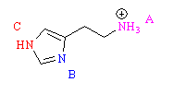
Feedback: The α-nitrogen is the one at the end of the side chain on histamine. The  nitrogen is the one in the imidazole ring closest to the side chain. The  nitrogen is the imidazole nitrogen furthest away from the side chain.
Page reference: 644
a. A = α
b. B = π
c. C = τ

Type: multiple choice question
Title: Chapter 22 Question 03
03) What sort of heterocyclic ring is present in histamine?
Feedback: The ring systems given are as follows

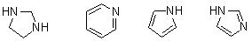
Page reference: 644
a. Imidazolidine
b. Pyridine
c. Pyrrole
*d. Imidazole

Type: multiple choice question
Title: Chapter 22 Question 04
04) What type of histamine receptor is associated with the dilation of blood vessels?
Feedback: There are two main types of histamine receptor, H1 and H2. H3 and H4 receptors do not exist. The H1 receptor is targeted by traditional antihistamines while the H2 receptor is targeted by histamine antagonists used in anti-ulcer therapy.
Page reference: 644-645
*a. H1
b. H2
c. H3
d. H4

Type: multiple choice question
Title: Chapter 22 Question 05
05) Which ailment is not treated by conventional histamine antagonists acting on the H1 receptor?
Feedback: Anti-ulcer agents acting as histamine antagonists target H2-receptors on parietal cells.
Page reference: 644-645
a. Hay fever
b. Insect bites
*c. Ulcers
d. Asthma

Type: multiple choice question
Title: Chapter 22 Question 06
06) There are two possible tautomers for histamine.

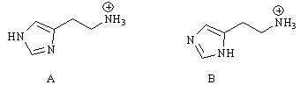
Tautomer A is more stable than tautomer B. Why?
Feedback: The side chain is electron withdrawing due to the positively charged ammonium group at the end of the chain. Since this is an inductive effect, it is felt more at the π nitrogen than the τ nitrogen since the former is nearer the side chain. Inductive effects decrease with the number of bonds involved. This means that the π nitrogen is going to be less basic and less likely to use its lone pair of electrons to form a bond to hydrogen.
Page reference: 652-653
*a. The side chain has an inductive electron withdrawing effect on the ring making the π nitrogen less basic than the τ nitrogen.
b. The side chain has an inductive electron donating effect on the ring making the π nitrogen less basic than the τ nitrogen.
c. The side chain has an inductive electron withdrawing effect on the ring making the τ nitrogen less basic than the π nitrogen.
d. The side chain has an inductive electron donating effect on the ring making the τ nitrogen less basic than the π nitrogen.

Type: multiple choice question
Title: Chapter 22 Question 07
07) There are two possible tautomers for histamine.

What would be the effect on the tautomer population if a methyl group were to be placed at position 4 of the ring?
Feedback: The methyl group has an inductive effect which is electron donating. The τ nitrogen is closer to this substituent than the π nitrogen and so the τ nitrogen experiences this inductive effect to a greater extent. This makes the τ nitrogen more basic and more likely to use its lone pair of electrons to bond to hydrogen.
Page reference: 653
a. The relative population of B would increase.
b. There would be no difference.
*c. The relative population of A would increase.
d. It is not possible to predict the effect.

Type: multiple choice question
Title: Chapter 22 Question 08
08) There are two possible tautomers for histamine. A methyl group at position 4 plays an important role in favouring tautomer A through an inductive effect.

What other important effect arises from the presence of a methyl group at position 4?
Feedback: It introduces selectivity for the H2 receptor and is present in anti-ulcer drugs such as cimetidine.
Page reference: 653
a. It introduces selectivity for the H1 receptor.
*b. It introduces selectivity for the H2 receptor.
c. It protects the molecule from metabolism.
d. It increases the ability of the compound to cross cell membranes.

Type: multiple choice question
Title: Chapter 22 Question 09
09) What effect does histamine have on the release of gastric acid?
Feedback: Histamine interacts with histamine H2 receptors to increase gastric acid secretion.
Page reference: 643
*a. It increases secretion
b. It decreases secretion
c. It has no effect
d. It completely switches off secretion

Type: multiple choice question
Title: Chapter 22 Question 10
10) What effect would a histamine H2 antagonist have on the release of gastric acid?
Feedback: An H2 antagonist would prevent histamine activating the H2 receptor and so gastric acid secretion would decrease. It would not be stopped completely since gastric acid and acetylcholine are still able to stimulate gastric acid secretion.
Page reference: 643-644
a. It would increase secretion
*b. It would decrease secretion
c. It would have no effect
d. It would stop secretion completely

Type: multiple choice question
Title: Chapter 22 - Question 11
11) N-Guanylhistamine is a partial agonist at the H2 receptor. What is meant by a partial agonist?

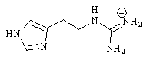

a. The structure is weakly bound to the receptor binding site.
Feedback: incorrect. This only states that the structure is binding to the receptor and does not identify whether this binding is associated with agonist or antagonist activity.
Page reference: 646-648
b. The structure only occupies a portion of the receptor binding site.
Feedback: incorrect. This only states that the structure is binding to the receptor and does not identify whether this binding is associated with agonist or antagonist activity.
Page reference: 646-648
*c. The structure is bound to the receptor binding site but does not fully activate the receptor.
Feedback: Correct. This is the most accurate description of the four.
Page reference: 646-648
d. The structure binds to the receptor, prevents the natural messenger from binding and eliminates any inherent activity associated with the receptor.
Feedback: incorrect. This describes an inverse agonist which binds to stabilise an inactive conformation of the receptor.
Page reference: 646-648

Type: multiple choice question
Title: Chapter 22 Question 12
12) Nα-Guanylhistamine was the first lead compound for the development of H2-antagonists.

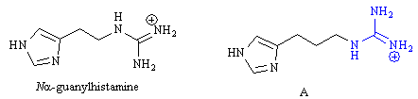
What strategy was used in developing the guanidine structure (A)?
Feedback: Extension indicates the addition of a new functional group to find an extra binding region. Here, the functional group is already present and has been moved further away from the imidazole ring by chain extension. Substituent variation and isosteric replacement indicate the replacement of a group with another group which has not occurred here.
Page reference: 649
a. Extension
*b. Chain extension
c. Substituent variation
d. Isosteric replacement

Type: multiple choice question
Title: Chapter 22 Question 13
13) Nα-Guanylhistamine was the first lead compound for the development of H2-antagonists.

What was the rationale for the strategy used in developing the guanidine structure (A)?
Feedback: The antagonist binding region is further away from the imidazole binding region than the agonist binding region. Therefore, extending the distance between the guanyl group and the imidazole ring increases the chances that the molecule will bind as an antagonist rather than as an agonist.
Page reference: 649
a. To reduce the inductive effect of the guanidine unit on the imidazole ring.
b. To increase the flexibility of the chain by allowing more single bond rotations.
c. To move the binding group closer to the agonist binding region and away from the antagonist binding region.
*d. To move the binding group closer to the antagonist binding region and away from the agonist binding region.

Type: multiple choice question
Title: Chapter 22 Question 14
14) During the search for H2 antagonists, the following binding theory was proposed between a guanidine unit and a carboxylate unit in the binding site. What was it called?

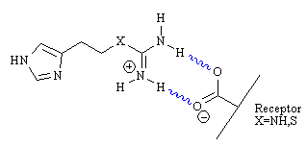
Feedback: The binding theory was called the chelation binding theory and involves the guanidine and carboxylate ion interacting through ionic and hydrogen bonding interactions.
Page reference: 648-649
a. Ionic binding theory
b. Hydrogen bonding theory
*c. Chelation binding theory
d. Complexation binding theory

Type: multiple choice question
Title: Chapter 22 Question 15
15) The following structures show some of the important molecules leading to the discovery of structure B.

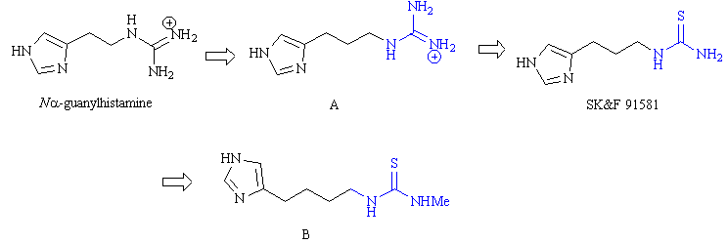
What sort of functional group has been introduced in SK&F 91581?
Feedback: The functional groups described in the options are as shown below:

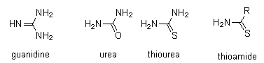
Page reference: 650-651
a. Guanidine
b. Urea
*c. Thiourea
d. Thioamide

Type: multiple choice question
Title: Chapter 22 Question 16
16) The following structures show some of the important molecules leading to the discovery of structure B.

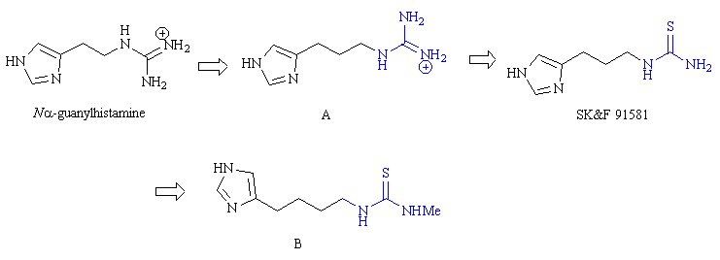
A functional group has been introduced in SK&F 91581. What was the rationale for introducing this functional group?
Feedback: Structure B is burimamide. The rationale was to replace the basic guanyl group with a neutral group such that it would interact by hydrogen bonding rather than ionic bonding. A neutral group was chosen that was as similar as possible to the guanyl group in terms of size and shape.
Page reference: 650-651
a. To reduce the number of possible hydrogen bond donors present.
*b. To replace an ionic group with a neutral group.
c. To change the shape of the terminal functional group.
d. To change the size of the terminal functional group.

Type: multiple choice question
Title: Chapter 22 Question 17
17) The following structures show some of the important molecules leading to the discovery of structure B.

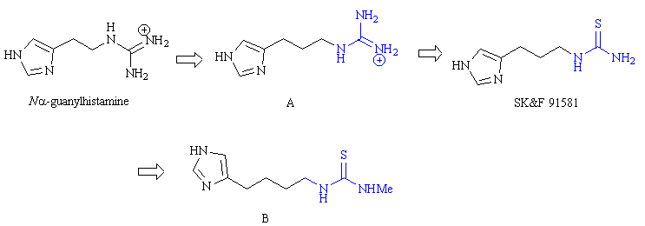
What was the rationale for the strategy used in developing structure B from SK&F 91581?
Feedback: Structure B is burimamide. The antagonist binding region is further away from the imidazole binding region than the agonist binding region. Therefore, extending the distance between the thiourea group and the imidazole ring increases the chances that the molecule will bind as an antagonist rather than an agonist.
Page reference: 651
a. To reduce the inductive effect of the terminal functional group on the imidazole ring.
b. To increase the flexibility of the chain by allowing more single bond rotations.
c. To move the terminal functional group closer to the agonist binding region and away from the antagonist binding region.
*d. To move the terminal functional group closer to the antagonist binding region and away from the agonist binding region.

Type: multiple choice question
Title: Chapter 22 Question 18
18) The following diagram shows the various tautomers of the terminal functional group in structure cimetidine. Which is considered to be the most stable tautomer?

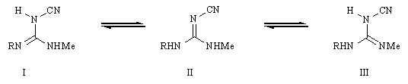

Feedback: Since the electron withdrawing effect of the cyanide group is inductive, it is experienced most by the nitrogen directly attached to cyanide. As a result, this nitrogen will be the least basic of the three nitrogens present in the guanidine moiety and the least likely to bond to hydrogen.
Page reference: 656
a. Tautomer I
*b. Tautomer II
c. Tautomer III
d. They are all equal in stability

Type: matching question
Title: Chapter 22 - Question 19
19) The following synthetic route has been used to produce cimetidine.

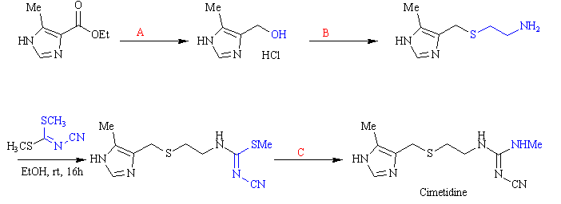
What reagents were used in steps A, B and C?
Feedback: Lithium aluminium hydride is a powerful reducing agent capable of reducing carbonyl groups such as esters. Esters are reduced to primary alcohols.
Hydrogen bromide is used to convert an alcohol to an alkyl bromide which can then undergo nucleophilic substitution with 2-aminoethanethiol.
Methylamine in ethanol is used to substitute the methylthio group in the penultimate structure with a methylamino group.
Page reference: 657
a. Step A = Lithium aluminium hydride
b. Step B = 48% hydrogen bromide and 2-aminoethanethiol
c. Step C = Methylamine in ethanol

Type: multiple choice question
Title: Chapter 22 Question 20
20) The following graph measures log(activity) versus log P.

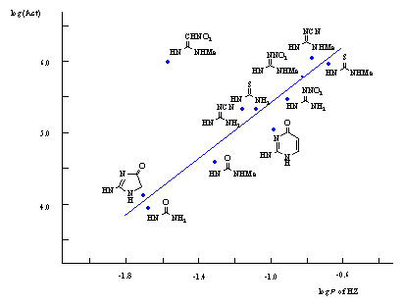
What is measured by log P?
Feedback: Log P measures the overall hydrophobicity of a molecule.
Page reference: 658-659
a. Size
*b. Hydrophobicity
c. Basicity
d. Dipole moment

Type: multiple choice question
Title: Chapter 22 Question 21
21) The following graph measures log(activity) versus log P.

What does the graph indicate about a urea group in comparison to an N-methyl urea group?
Feedback: Log P is a measure of a drug’s hydrophobicity. Increasing values of logP indicate increasing hydrophobicity and so the urea group is more hydrophobic than an N-methyl urea group.
Page reference: 658-659
a. The urea group is smaller
b. The urea group is less basic
c. The urea group is more hydrophobic
*d. The urea group is less hydrophobic

Type: multiple choice question
Title: Chapter 22 Question 22
22) The following graph measures log(activity) versus log P.

What does the graph show about activity?
Feedback: As logP increases, activity increases. LogP is a measure of hydrophobicity and so increased activity is associated with increasing hydrophobicity.
Page reference: 658-659
*a. Activity increases with hydrophobic character
b. Activity decreases with hydrophobic character
c. Activity increases with basicity
d. Activity increases with the size of the group

Type: multiple choice question
Title: Chapter 22 Question 23
23) The following graph measures log(activity) versus log P.

The nitroketeneaminal group does not fit the straight line. Which of the following statements is true?
Feedback: The log P value for this group is relatively low and the compound should have a lower activity than it actually has.
Page reference: 659-660
*a. The activity is too great for the hydrophobicity of the group.
b. The activity is too great for the size of the group.
c. The activity is too great for the basicity of the group.
d. The activity is too small for the hydrophobicity of the group.

Type: multiple choice question
Title: Chapter 22 Question 24
24) The following graph measures log(activity) versus log P.

What physical feature other than logP is important to the activity of cimetidine analogues?
Feedback: To be precise, the orientation of the dipole moment is important to the activity rather than the size of the dipole moment.
Page reference: 660
a. Hydrophobicity
b. Basicity
c. Molecular weight
*d. Dipole moment

Type: multiple choice question
Title: Chapter 22 Question 25
25) The following graph measures log(activity) versus log P.

The nitroketeneaminal group does not fit the line of the graph. This group is present in a clinically important anti-ulcer drug. Identify the drug.
Feedback: Ranitidine has the following structure

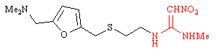
Page reference: 662
*a. Ranitidine
b. Famotidine
c. Lamitidine
d. Loxtidine

Type: multiple choice question
Title: Chapter 22 Question 26
26) A QSAR study of cimetidine analogues with different planar groups produced the following equation;

log (Activity) = 9.12 cosθ + 0.6logP -2.71.

What is the relevance of the cos entry?
Feedback: The cosθ entry quantifies the orientation of a dipole moment. θ is the deviation in angle of the dipole moment from the ideal orientation of 30º.
Page reference: 660-661
*a. It quantifies the orientation of a dipole moment
b. It quantifies the magnitude of a dipole moment
c. It quantifies the orientation of hydrogen bonds
d. It quantifies the strength of hydrogen bonding

Type: multiple choice question
Title: Chapter 22 Question 27
27) A QSAR study of cimetidine analogues with different planar groups produced the following equation;

log (Activity) = 9.12 cosθ + 0.6logP -2.71.

What is the ideal value of θ?
Feedback: At 0o, cosθ is equal to a maximum value of 1. At any other value, the cosθ value will be a fraction. This means that the calculated activity will be smaller.
Page reference: 660-661
*a. 0o
b. 45o
c. 60o
d. 90o

Type: multiple choice question
Title: Chapter 22 Question 28
28) What enzyme catalyses the following reaction?

Feedback: Carbonic anhydrase catalyses the formation of carbonic acid from water and carbon dioxide. The acid dissociates to give a proton and a hydrogen carbonate ion.
Page reference: 665
a. Carbonic synthase
b. Carbonic ligase
*c. Carbonic anhydrase
d. Carbonic hydrolase

Type: multiple choice question
Title: Chapter 22 Question 29
29) What reaction is catalysed to power the proton pump?
Feedback: Hydrolysis of ATP to ADP involves the splitting of the terminal phosphate group from the triphosphate chain of ATP, generating energy which can be used to power the proton pump.
Page reference: 665
*a. ATP to ADP
b. ATP to AMP
c. ATP to cyclic AMP
d. ATP to adenosine

Type: multiple choice question
Title: Chapter 22 Question 30
30) The proton pump inhibitors are prodrugs. Where do they get activated?
Feedback: The proton pump inhibitors are activated by strong acidic conditions found only in the canaliculae of parietal cells.
Page reference: 666
a. In the liver
b. In the blood supply
c. In parietal cells
*d. In the canaliculae of parietal cells

Type: multiple choice question
Title: Chapter 22 Question 31
31) What is the typical pKa for proton pump inhibitors?
Feedback: The proton pump inhibitors are weak bases and require strong acidic conditions before they protonate and become activated.
Page reference: 666
*a. 4
b. 6
c. 7.4
d. 9

Type: multiple choice question
Title: Chapter 22 Question 32
32) What conditions are required to activate proton pump inhibitors?
Feedback: The proton pump inhibitors are weak bases and require strong acidic conditions before they protonate and become activated.
Page reference: 666
*a. Strongly acidic conditions
b. Weakly acidic conditions
c. Neutral conditions
d. Slightly basic conditions

Type: multiple choice question
Title: Chapter 22 Question 33
33) The following diagram shows the development of the first commercially available proton pump inhibitor omeprazole (A)

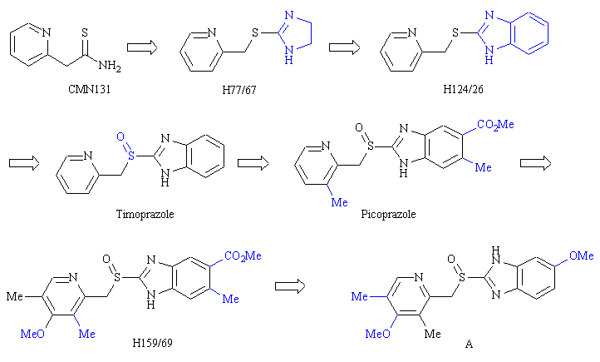

What sort of heterocyclic ring was introduced in H124/6?
Feedback: The various rings described are shown below. The term imidazobenzene is incorrect and is not a recognised term.

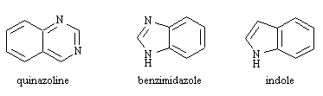
Page reference: 667
a. Quinazoline
b. Imidazobenzene
*c. Benzimidazole
d. Indole

Type: multiple choice question
Title: Chapter 22 Question 34
34) The following diagram shows the development of the first commercially available proton pump inhibitor omeprazole (A). During this study, timoprazole was found to be a promising looking candidate. Addition of methyl and methoxy substituents to the pyridine ring increases the activity of timoprazole. What effect do these groups have?

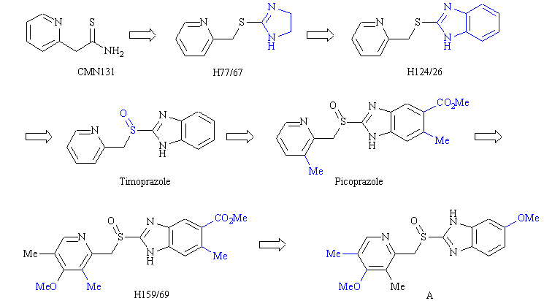
Feedback: The activation of the drug under acidic conditions requires the pyridine nitrogen to act as a base. The addition of electron donating substituents increases the basicity of the pyridine nitrogen.
Page reference: 668
a. They fit into hydrophobic binding pockets in the active site and increase binding strength.
*b. They are electron donating groups and increase the basicity of the pyridine ring.
c. They act as steric shields to prevent metabolism at exposed regions of the pyridine ring.
d. They block the drug binding to alternative targets.

Type: multiple choice question
Title: Chapter 22 Question 35
35) The following diagram shows the development of the first commercially available proton pump inhibitor omeprazole (A). During this study, it was found that the methyl and methoxy substituents on the pyridine ring had an important role in increasing activity. What effect would you predict if the pyridine substituents in omeprazole (A) were placed as shown below?

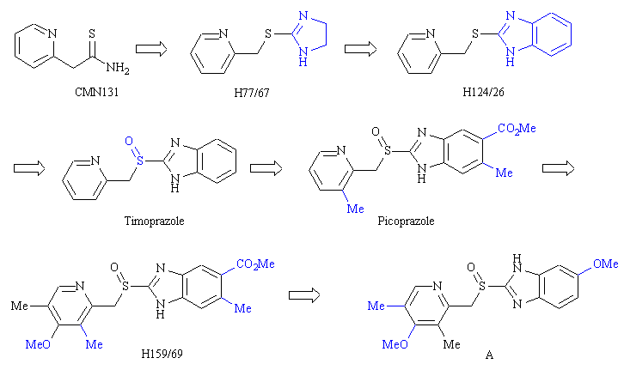
Feedback: The methoxy substituent can interact with the pyridine ring by resonance. When the substituent is located at the para position, a resonance structure can be drawn where a negative charge is placed on the pyridine nitrogen, thus increasing its basic character and the activity of the compound. If the substituent is at the meta position, this resonance structure is no longer possible. This means that the pyridine ring will be less basic and the structure will be less active.
Page reference: 668-669
a. Activity would be unaffected
b. Activity would increase
*c. Activity would decrease
d. It is impossible to predict what would happen

Type: multiple choice question
Title: Chapter 22 Question 36
36) The following structure has been marketed as the more active enantiomer of a proton pump inhibitor.

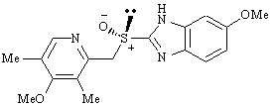

What is the name of this structure?
Feedback: The structure shown is the S-enantiomer of omeprazole and this was what led to the structure being called esomeprazole.
Page reference: 669
a. Espantoprazole
b. Eslansoprazole
*c. Esomeprazole
d. Esrabeprazole

Type: multiple choice question
Title: Chapter 22 Question 37
37) The following structure (esomeprazole) has been marketed as the more active enantiomer of omeprazole.

What is the name of the strategy where a clinically important racemic drug is replaced with the active enantiomer of the drug?
Feedback: Chiral switching has been used on several drugs which were previously marketed as racemates.
Page reference: 669
a. Patent switching
b. Enantiomeric switching
c. Asymmetric switching
*d. Chiral switching

Type: matching question
Title: Chapter 22 - Question 38
38) The following diagram shows the synthetic route to an important proton pump inhibitor.

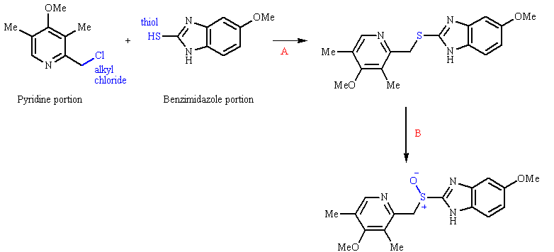
What were the reagents used for step A and step B

Feedback: Sodium hydroxide converts the thiol to a thiolate which can then displace the chloride from the alkyl chloride via a nucleophilic substitution reaction. The meta-chloroperbenzoic acid is an oxidising agent which is often used as an epoxidising agent, but which in this case is used to oxidise the sulphur atom of the penultimate compound.
Page reference: 670
a. Step A = Sodium hydroxide
b. Step B = Meta-chloroperbenzoic acid

Type: multiple choice question
Title: Chapter 22 Question 39
39) What type of triple therapy is most commonly used to treat ulcers caused by Helicobacter pylori?
Feedback: The proton pump inhibitor serves to reduce the quantity of hydrochloric acid released into the stomach by parietal cells. The antibacterial agents are used to combat the bacterium Helicobacter pylori which is known to cause inflammation and cell damage in the stomach.
Page reference: 672
a. An H2 antagonist, proton pump inhibitor and an antibacterial agent
b. An H2 antagonist, and two antibacterial agents
*c. A proton pump inhibitor and two antibacterial agents
d. Two proton pump inhibitors and an antibacterial agent

Type: multiple choice question
Title: Chapter 22 - Question 40
40) Which of the following structures represents histamine at physiological pH?

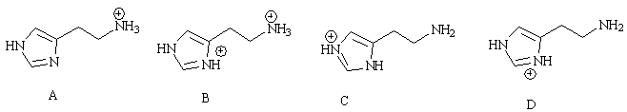

Feedback: The side chain nitrogen is fully ionised and the heterocyclic nitrogens are not ionised.
Page reference: 644-645
*a. Structure A
b. Structure B
c. Structure C
d. Structure D

Type: multiple choice question
Title: Chapter 22 - Question 41
41) Which nitrogen atom (or atoms) in histamine is / are considered important for H2-agonist activity but not H1 activity?

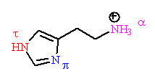
Feedback: The τ nitrogen atom is involved in a hydrogen bonding interaction with the H2 receptor but not the H1 receptor. The π nitrogen atom is involved in hydrogen bonding interactions with both the H1 and H2 receptor binding sites, while the ionised ammonium group at the end of the alkyl chain is involved in an ionic interaction with both bindng sites.
Page reference: 645-646
a. The π nitrogen atom and the α nitrogen atom
b. The π nitrogen atom
*c. The τ nitrogen atom
d. The α nitrogen atom

Type: multiple choice question
Title: Chapter 22 - Question 42
42) Several binding regions were proposed to be present in the binding site of the H2 receptor. Which of the following statements is incorrect?
Feedback: The imidazole binding region is the same for agonists and antagonists.
Page reference: 645-646
*a. There are two binding regions for the imidazole ring of histamine analogues, one which is occupied by agonists and one which is occupied by antagonists.
b. There is a binding region which interacts ionically with the α-nitrogen of histamine and results in agonist activity.
c. There is a binding region further away from the imidazole ring that produces an antagonist effect if occupied.
d. The α-nitrogen of histamine can only bind to the agonist binding region while the guanyl group of Nα-guanylhistamine can bind either to the antagonist binding region or the agonist binding region.

Type: multiple choice question
Title: Chapter 22 - Question 43
43) The following structures are some of the important molecules leading to the discovery of cimetidine.

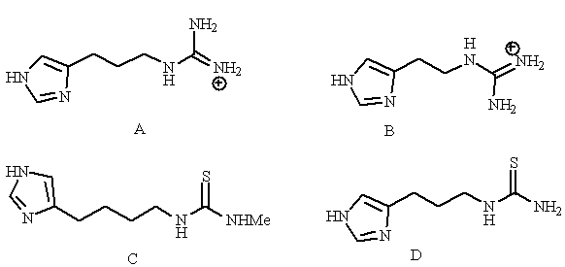
In what order were these compounds developed?

Feedback: Structure C is burimamide. Structure B is N-guanylhistamine. Structures A and D are compounds that were developed from N-guanylhistamine and which led to the discovery of burimamide.
Page reference: 646-654
a. A, B, D, C
b. B, A, C, D
*c. B, A, D, C
d. B, D, A, C

Type: multiple choice question
Title: Chapter 22 - Question 44
44) The following structures are some of the important molecules leading to the discovery of cimetidine.

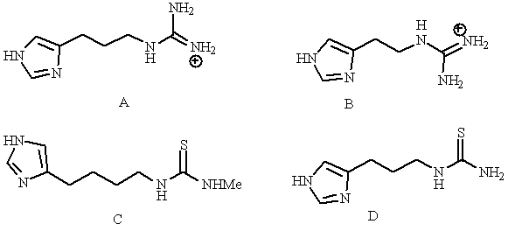
Which of the structures shown is burimamide?
Feedback: Structure C is burimamide. Structure B is N-guanylhistamine. Structures A and D are compounds that were developed from N-guanylhistamine and which led to the discovery of burimamide.
Page reference: 646-654
a. Structure A
b. Structure B
*c. Structure C
d. Structure D

Type: multiple choice question
Title: Chapter 22 - Question 45
45) The following structures are some of the important molecules leading to the discovery of cimetidine.

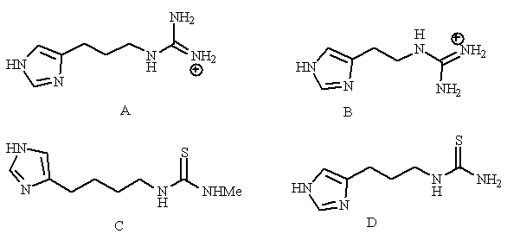
Which of the structures shown is N-guanylhistamine?

Feedback: Structure B is Nα-guanylhistamine. Structure C is burimamide. Structures A and D are compounds that were developed from Nα-guanylhistamine and which led to the discovery of burimamide
Page reference: 646-654
a. Structure A
*b. Structure B
c. Structure C
d. Structure D

Type: multiple choice question
Title: Chapter 22 - Question 46
46) The following structures are some of the important molecules leading to the discovery of cimetidine.

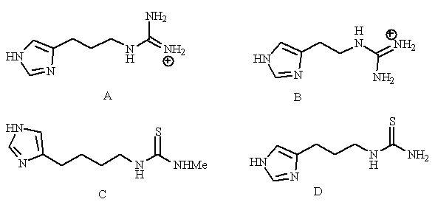
Which of the following statements is true?
Feedback: Structure B is N-guanylhistamine. Structure C is burimamide. Structures A and D are compounds that were developed from Nα-guanylhistamine and which led to the discovery of burimamide.
Page reference: 646-654
a. Structure B was developed from structure A using a chain extension strategy.
b. Structure C was developed from structure D using a bio-isostere strategy.
c. Structure D was developed from structure A using a chain extension strategy.
*d. Structure C was developed from structure D using a chain extension strategy.

Type: multiple choice question
Title: Chapter 22 - Question 47
47) The following structures show some of the important molecules leading to the discovery of structure B.

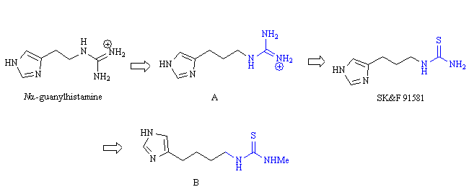
Which of the following statements concerning structure B is untrue?
Feedback: It established that binding to the antagonist binding region involved hydrogen bonding and not ionic bonding.
Page reference: 650-651
a. It established the existence of H2-receptors.
b. It was a good antagonist at H2 receptors with no agonist activity.
c. It inhibited gastric acid release from parietal cells.
*d. It indicated that binding to the antagonist binding region involved ionic bonding and not hydrogen bonding.

Type: matching question
Title: Chapter 22 - Question 48
48) Identify the following structures

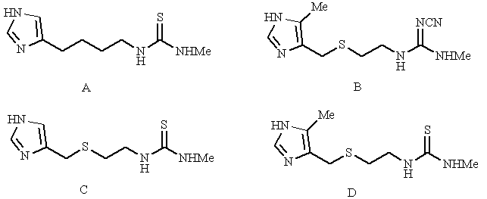
Feedback: Burimamide was the first of the four compounds named to be developed and established the existence of H2 receptors. Thiaburimamide was developed by introducing a sulphur atom into the side chain of burimamide. Metiamide involved the further addition of a methyl substituent to the imidazole ring and cimetidine involved replacement of the thiourea group with cyanoguanidine group.
Page reference: 650-655
a. Cimetidine = Structure B
b. Thiaburimamide = Structure C
c. Metiamide = Structure D
d. Burimamide = Structure A

Type: multiple choice question
Title: Chapter 22 – Question 49
49) Which of the following structures has an electron donating side chain attached to the imidazole ring?

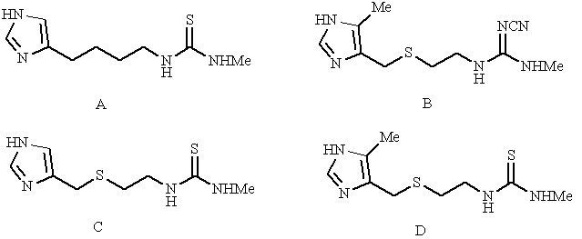
Feedback: The structures shown (A-D) are burimamide, cimetidine, thiaburimamide and metiamide respectively. Burimamide has an electron donating side chain. The other structures contain sulfur in the side chain, making the substituent electron withdrawing.
Page reference: 650-655
*a. Structure A
b. Structure B
c. Structure C
d. Structure D

Type: multiple choice question
Title: Chapter 22 – Question 50
50) The following structures were part of a study aimed at finding anti-ulcer agents. What sort of mode of action do they have?

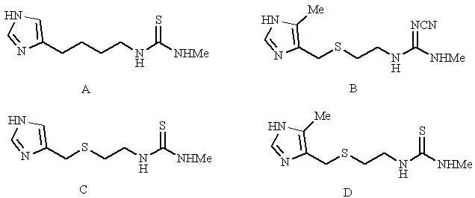
Feedback: The structures shown (A-D) are burimamide, cimetidine, thiaburimamide and metiamide respectively. They all act as antagonists at the H2 receptor.
Page reference: 650-655
a. They are receptor agonists
*b. They are receptor antagonists
c. They are enzyme inhibitors
d. They block carrier proteins

Type: multiple choice question
Title: Chapter 22 – Question 51
51) The following structures were part of a study aimed at finding anti-ulcer agents. What is their target?

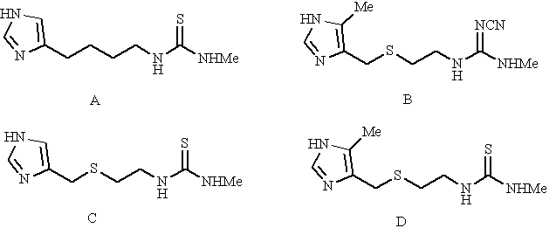
Feedback: The structures shown (A-D) are burimamide, cimetidine, thiaburimamide and metiamide respectively. They all act as antagonists at the H2 receptor.
Page reference: 650-655
a. The proton pump
b. The H1 receptor
*c. The H2 receptor
d. The gastrin receptor

Type: multiple choice question
Title: Chapter 22 - Question 52
52) The following structures were part of a study aimed at finding anti-ulcer agents. Which of the structures has the pKa for the imidazole ring?

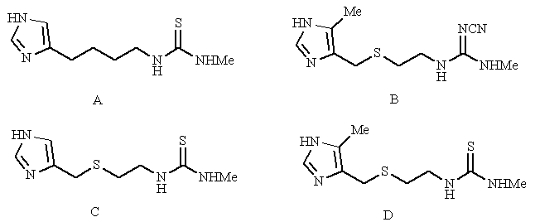
Feedback: The structures shown (A-D) are burimamide, cimetidine, thiaburimamide and metiamide respectively. Burimamide has an electron donating side chain giving it a pKa of 7.25. The other structures contain sulfur in the side chain, making the substituent electron withdrawing. Thiaburimamide has a pKa of 6.25. Metiamide has an electron donating methyl group which counteracts the electron withdrawing influence of the side chain giving it a pKa of 6.80. For the same reson, the pKa for the imidazole ring of cimetidine is also higher than the pKa for thiaburimamide
Page reference: 650-655
a. Structure A
b. Structure B
*c. Structure C
d. Structure D

Type: multiple choice question
Title: Chapter 22 - Question 53
53) The following structures were part of a study aimed at finding anti-ulcer agents. In what order were the structures developed?

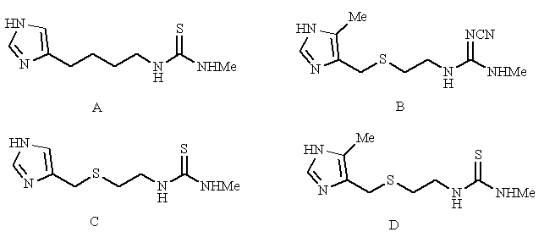
Feedback: The structures shown (A-D) are burimamide, cimetidine, thiaburimamide and metiamide respectively.
Page reference: 650-655
a. C, A, B, D
b. B, D, C. A
*c. A, C, D, B
d. D, B, C, A

Type: multiple choice question
Title: Chapter 22 - Question 54
54) The following structure is cimetidine. Which electron donating group is present to favour the active tautomeric form of the imidazole ring shown?

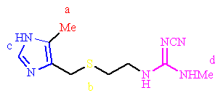
Feedback: The methyl group has an inductive electron donating effect on the imidazole ring. This inductive effect is more pronounced at the τ-nitrogen than the π-nitrogen since the former is closer to the substituent. The inductive effect makes the τ-nitrogen more basic and favours the tautomer where this nitrogen is bonded to a hydrogen.
Page reference: 651-655
*a. Group a
b. Group b
c. Group c
d. Group d

Type: multiple choice question
Title: Chapter 22 - Question 55
55) The following structure is cimetidine. Which electron withdrawing group is present to favour the active tautomeric form of the imidazole ring shown?

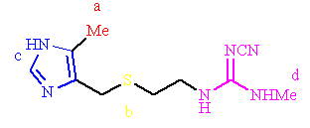
Feedback: The sulfur has an inductive electron withdrawing effect on the imidazole ring. This inductive effect is more pronounced at the π-nitrogen than the τ-nitrogen since the former is closer to the substituent. The inductive effect makes the τ-nitrogen more basic and favours the tautomer where this nitrogen is bonded to a hydrogen.
Page reference: 651-655
a. Group a
*b. Group b
c. Group c
d. Group d

Type: multiple choice question
Title: Chapter 22 - Question 56
56) The following structure is cimetidine. Which group is present to interact with a hydrogen bonding region not used by histamine?

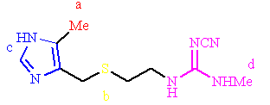
Feedback: Group d is a naturally occurring moiety which is neutral and interacts with a binding region through hydrogen bonding. It was used to replace a thiourea group in previous structures since the latter was responsible for toxic side effects.
Page reference: 651-655
a. Group a
b. Group b
c. Group c
*d. Group d

Type: multiple choice question
Title: Chapter 22 - Question 57
57) The following structure is cimetidine. The guanidine moiety at the end of the side chain is neutral which is unusual since guanidine moieties are usually basic. Which one of the coloured groups shown is responsible for this?

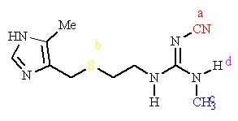

Feedback: The cyanide group has a strong inductive effect which is electron withdrawing. As a result the basicity of the guanidine group is reduced and it is less likely to ionise.
Page reference: 654-655
*a. Group a
b. Group b
c. Group c
d. Group d

Type: multiple choice question
Title: Chapter 22 - Question 58
58) Which of the following structures is a metabolite of cimetidine?

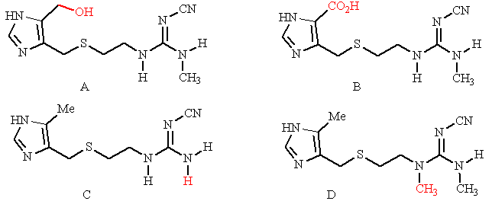
Feedback: The metabolites of cimetidine are shown below.

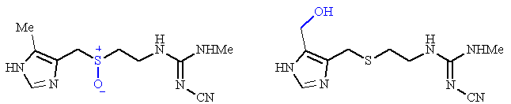
Page reference: 656
*a. Structure A
b. Structure B
c. Structure C
d. Structure D

Type: multiple choice question
Title: Chapter 22 - Question 59
59) Which of the following structures is a metabolite of cimetidine?

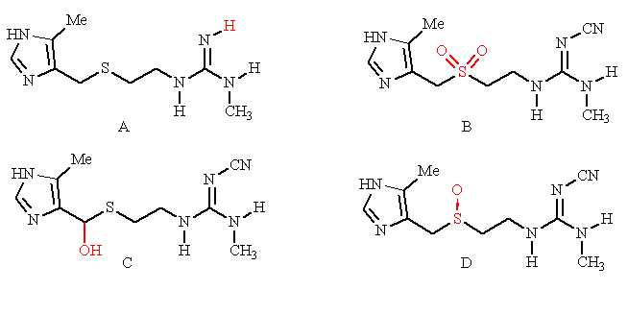
Feedback: The metabolites of cimetidine are shown below.

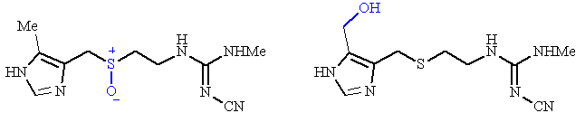
Page reference: 656
a. Structure A
b. Structure B
c. Structure C
*d. Structure D

Type: matching question
Title: Chapter 22 - Question 60
60) The synthetic route to cimetidine is shown below:

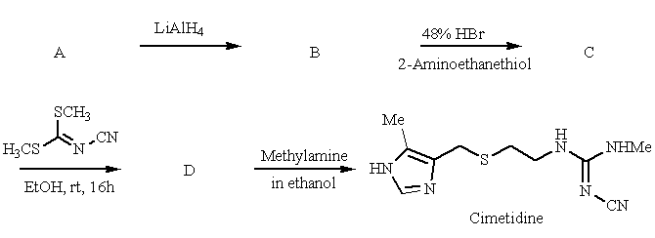

Match the structures shown below to the above synthetic route.

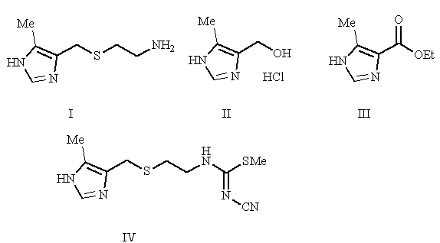
Feedback: The synthesis of cimetidine is a 4 stage process involving the construction of cimetidine’s side chain on a starting material already containing the required imidazole ring.
Page reference: 657
a. A = Structure III
b. B = Structure II
c. C = Structure I
d. D = Structure IV

Type: multiple choice question
Title: Chapter 22 - Question 61
61) The following conformation for the cyanoguanidine group of cimetidine is not favoured due to a bad steric interaction. Which of the following diagrams illustrates this?

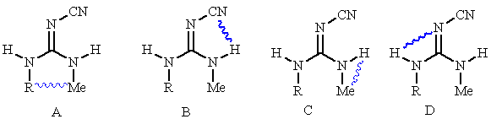
Feedback: In diagram A, the methyl group is too close to the side chain. In the other diagrams, there is very little steric interaction since one of the groups involved is a small hydrogen.
Page reference: 656-658
*a. Diagram A
b. Diagram B
c. Diagram C
d. Diagram D

Type: multiple choice question
Title: Chapter 22 - Question 62
62) The following diagram shows the synthetic route to omeprazole. What were the functional groups X and Y?

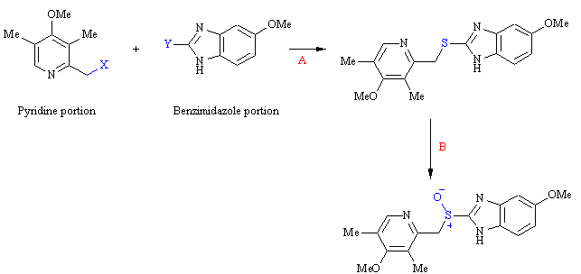
Feedback: The thiol group is converted to a thiolate ion in the presence of sodium hydroxide and acts as a nucleophile to displace a chloride ion from the alkyl chloride.
Page reference: 670
a. X=SH, Y=Cl
*b. X=Cl, Y=SH
c. X=SCl, Y=Li
d. X=Li, Y=SCl

Type: multiple choice question
Title: Chapter 22 - Question 63
63) The following diagram shows various conformations for the cyanoguanidine group of cimetidine. A study was carried out to find out the most stable conformations.

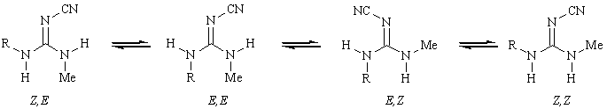
Which of the following statements is true?

Feedback: The study showed that the EZ and ZE tautomers were favoured and that the ZZ and EE tautomers were not. This demonstrated that two hydrogen bonding interactions were taking place to two different hydrogen bonding groups in the binding site, thus disproving the chelation bonding theory.
Page reference: 656-658
a. The study showed that only the Z,E tautomer is favoured.
b. The study established that there is only one hydrogen bonding interaction between the guanidine unit and the binding region.
c. The study showed that only the E,Z tautomer is favoured.
*d. The study disproved the chelation theory of hydrogen bonding.

Type: matching question
Title: Chapter 22 – Question 64
64) The following diagram shows a parietal cell releasing HCl into the stomach. Identify A-D.

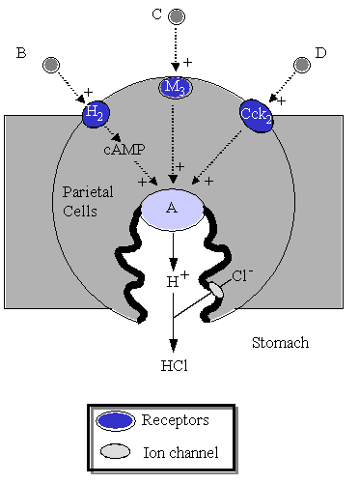
Feedback: The proton pump is responsible for pumping protons out of the parietal cell and potassium ions into the parietal cell. Acetylcholine is a neurotransmitter that interacts with cholinergic receptors on parietal cells to increase the release of hydrochloric acid into the stomach. The hormone gastrin and the local hormone histamine have the same effect when they interact with their corresponding receptors.
Page reference: 664-665
a. Gastrin = D
b. Histamine = B
c. Proton pump = A
d. Acetylcholine = C

Type: multiple choice question
Title: Chapter 22 - Question 65
65) The following diagram illustrates a parietal cell. What is the feature labelled F?

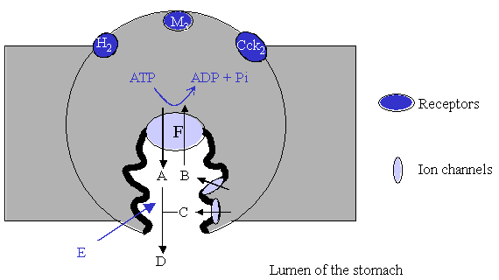
Feedback: Feature F is the proton pump responsible for pumping protons into the lumen of the stomach. Potassium ions are brought into the parietal cell in exchange and the process is powered by the hydrolysis of ATP.
Page reference: 664-665
a. The histamine receptor
b. Adenylate cyclase
c. An ion channel for chloride ions
*d. The proton pump

Type: matching question
Title: Chapter 22 - Question 66
66) The following diagram illustrates a parietal cell where feature F is the proton pump. What are the species labelled A-D?

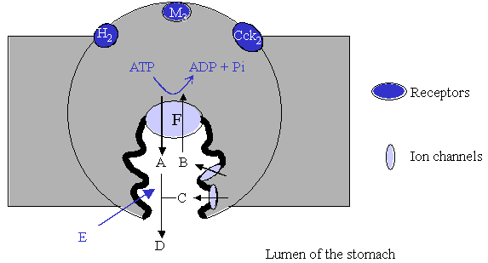
Feedback: Feature F is the proton pump responsible for pumping protons into the lumen of the stomach. Potassium ions are brought into the parietal cell in exchange and the process is powered by the hydrolysis of ATP. Chloride and potassium ions depart the parietal cells through ion channels which are separate from the proton pump.
Page reference: 664-665
a. Hydrochloric acid = D
b. Chloride ions = C
c. Potassium ions = B
d. Protons = A

Type: multiple choice question
Title: Chapter 22 - Question 67
67) The following diagram illustrates a parietal cell where feature F is the proton pump. What is the space indicated by the label E?

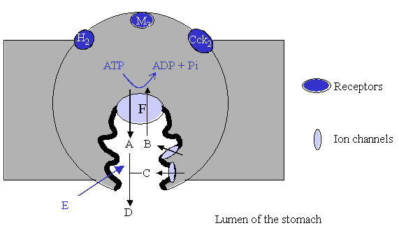
Feedback: Feature F is the proton pump responsible for pumping protons into the lumen of the stomach. Potassium ions are brought into the parietal cell in exchange and the process is powered by the hydrolysis of ATP. Chloride and potassium ions depart the parietal cells through ion channels which are separate from the proton pump. The canaliculus is the channel into which these ions enter and leave. HCl is released from the canaliculus into the stomach lumen.
Page reference: 664-665
a. Stomach lumen
b. Parietal channel
*c. Canaliculus
d. Parietal outlet

Type: multiple choice question
Title: Chapter 22 - Question 68
68) The following structure is the proton pump inhibitor omeprazole

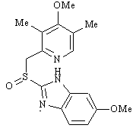
Omeprazole undergoes a series of arrangements in the acid conditions of the canaliculus before reacting with cysteine residues of the the proton pump. Which of the following structures is the structure responsible for that alkyation?

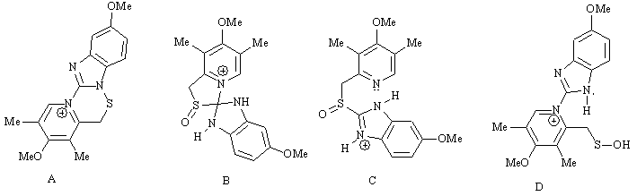
Feedback: The thiol group of cysteine acts as a nucleophile and reacts with structure A to produce a disulfide covalent bond between the amino acid and the drug. The other structures shown are formed in the mechanism by which omeprazole is converted to structure A.
Page reference: 666-667
*a. Structure A
b. Structure B
c. Structure C
d. Structure D

Type: multiple choice question
Title: Chapter 22 - Question 69
69) The following mechanism shows how proton pump inhibitors are activated. Which arrow is incorrect?

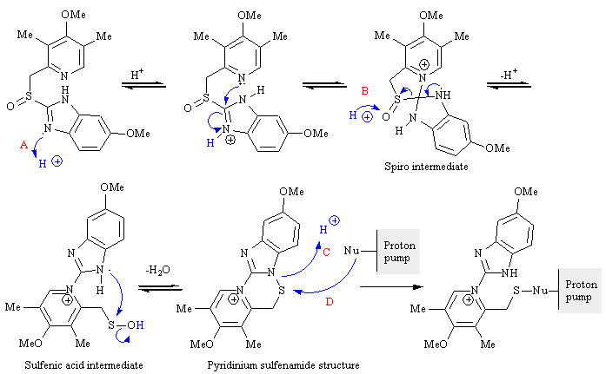
Feedback: Arrow B is pointing the wrong way. Curly arrows represent the movement of electrons. A proton has no electrons and so it never makes sense to draw an arrow from a proton.
Page reference: 666-667
a. A
*b. B
c. C
d. D

Type: matching question
Title: Chapter 22 - Question 70
70) Match the following structures with the named drugs:

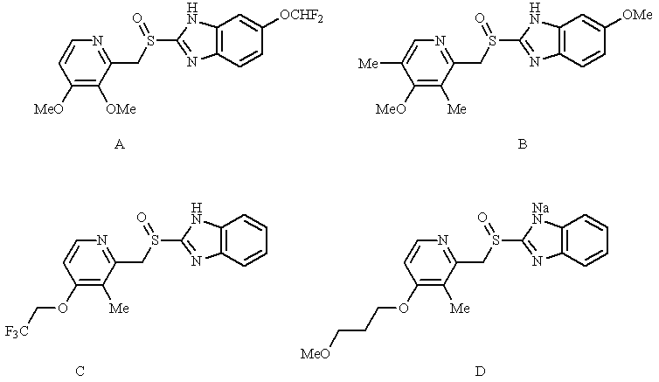
Feedback: All the examples given are proton pump inhibitors.
Page reference: 665
a. Rabeprazole = Structure D
b. Lansoprazole = Structure C
c. Omeprazole = Structure B
d. Pantoprazole = Structure A

Type: matching question
Title: Chapter 22 Question 71
71) The following diagram shows some of the structures that were relevant to the development of an important antiulcer drug. Match the structures to the following names:

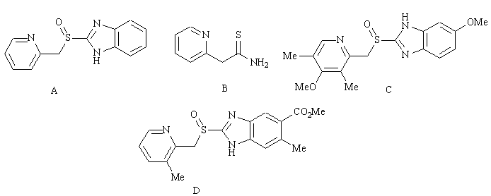
Feedback: All the examples given are proton pump inhibitors.
Page reference: 667-669
a. CMN131 = Structure B
b. Timoprazole = Structure A
c. Picoprazole = Structure D
d. Omeprazole = Structure C

Type: multiple choice question
Title: Chapter 22 - Question 72
72) The following diagram shows some of the structures that were relevant to the development of an important antiulcer drug. Which of these structures was the lead compound?

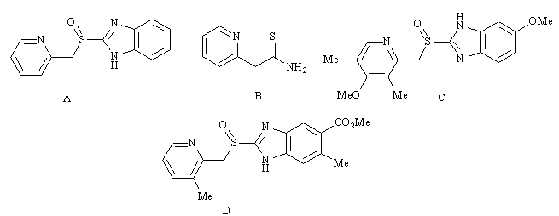
Feedback: Structure B is CMN131 which was the lead compound, but suffered from liver toxicity.
Page reference: 667-669
a. Structure A
*b. Structure B
c. Structure C
d. Structure D

Type: multiple choice question
Title: Chapter 22 – Question 73
73) The following diagram shows some of the structures that were relevant to the development of an important antiulcer drug. In what order were they discovered?

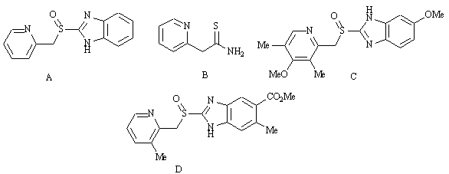
Feedback: Structure B is CMN131 which was the lead compound for the study. Structures A, C and D are timoprazole, omeprazole and picoprazole respectively
Page reference: 667-669
a. A, B, C, D
*b. B, A, D, C
c. B, D, A, C
d. C, D, A, B

Type: multiple choice question
Title: Chapter 22 - Question 74
74) The following diagram shows some of the structures that were relevant to the development of an important antiulcer drug. Which of these structures was discovered following drug metabolism studies?

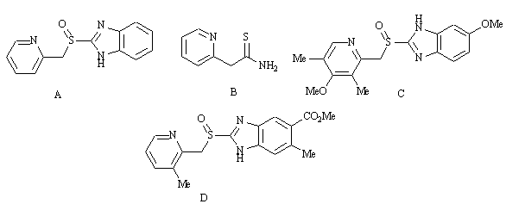
Feedback: Structure B is CMN131 which was the lead compound for the study. Structures A, C and D are timoprazole, omeprazole and picoprazole respectively.
Drug metabolism studies led to the recognition that the sulfur atom in timoprazole underwent metabolic oxidation to produce an active metabolite.
Page reference: 667-669
*a. Structure A
b. Structure B
c. Structure C
d. Structure D

Type: multiple choice question
Title: Chapter 22 - Question 75
75) The following diagram shows some of the structures that were relevant to the development of an important antiulcer drug. Which of these structures was found to have a side effect which involved inhibition of iodine uptake by the thyroid gland?

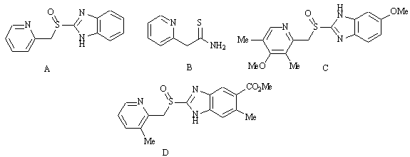
Feedback: Structure B is CMN131 which was the lead compound for the study. Structures A, C and D are timoprazole, omeprazole and picoprazole respectively.
Page reference: 667-669
*a. Structure A
b. Structure B
c. Structure C
d. Structure D

Type: multiple choice question
Title: Chapter 22 - Question 76
76) The following molecule is omeprazole, an important proton pump inhibitor.
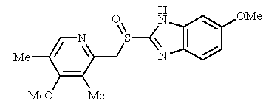
Which of the following structures is a metabolite?

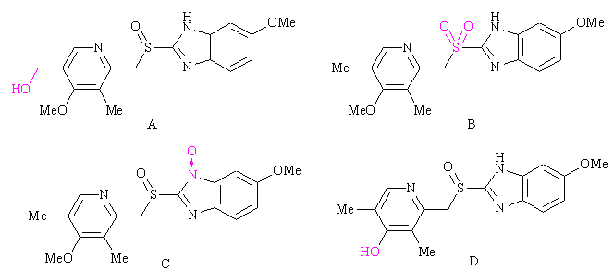

Feedback: The two major metabolites of omeprazole are shown below.

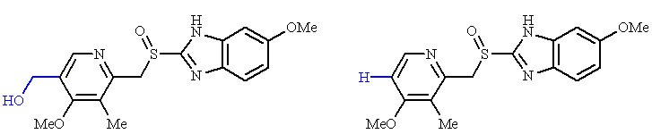
Page reference: 669
*a. Structure A
b. Structure B
c. Structure C
d. Structure D

Type: multiple choice question
Title: Chapter 22 - Question 77
77) The following molecule is omeprazole, an important proton pump inhibitor.

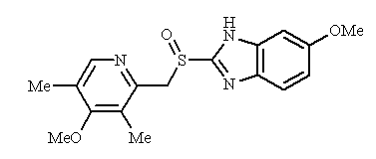
Which of the following structures is a metabolite?

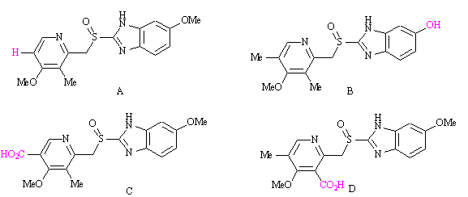
Feedback: The two major metabolites of omeprazole are shown below.

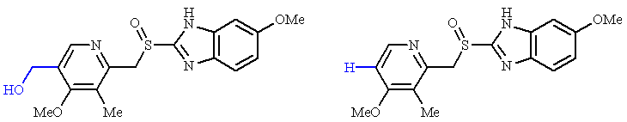

Page reference: 669
*a. Structure A
b. Structure B
c. Structure C
d. Structure D

