Lipids and Membranes
I.Glycerol-based lipids

A. Fatty Acids
Know the common names and structures for fatty acids up to 20 carbons long
- Saturated
- Lauric acid (12 C)
- Myristic acid (14 C)
- Palmitic acid (16 C)
- Stearic acid (18 C)
- Arachidic acid (20 C)
- Unsaturated fatty acids
- Palmitoleic acid (16:1)
- Oleic acid (18:1)
- Linoleic acid (18:2)
- α-Linolenic acid (18:3)
- γ-Linolenic acid (18:3)
- Arachidonic acid (20:4)
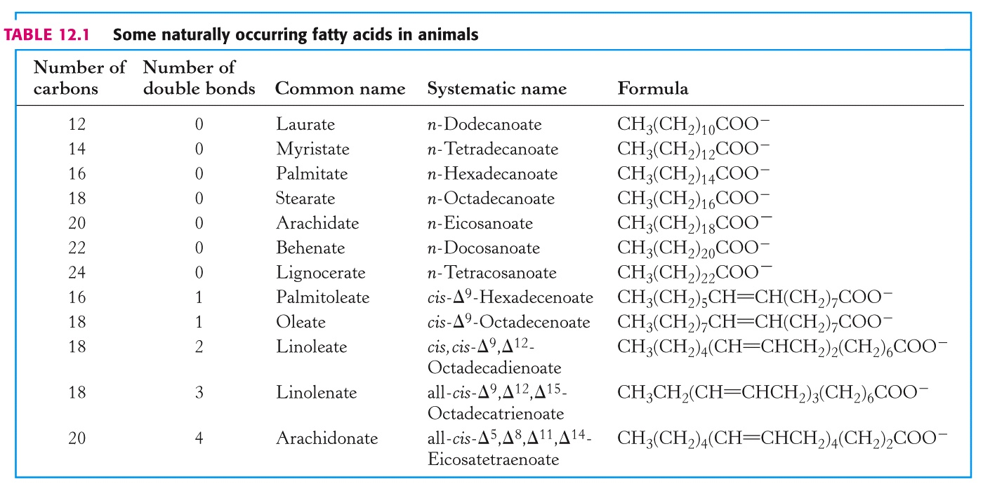
Saturation versus unsaturation

B. Triacylglycerols

C. Phosphoacylglycerols

ROOT STRUCTURE:
phosphatidylglycerol

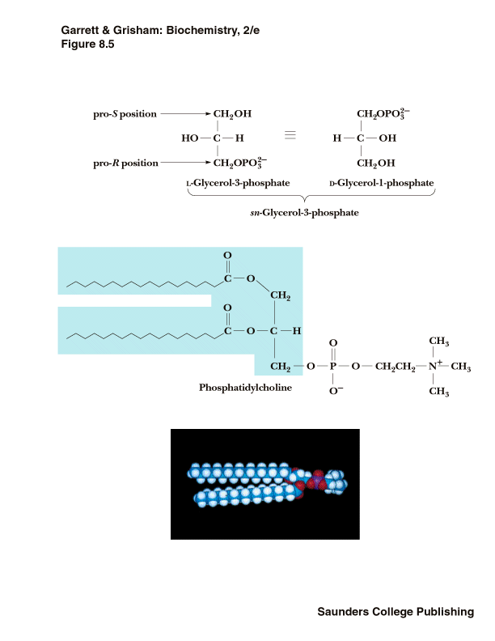
Phosphatidylcholine
Other glycerolipids and their charges:
II. Sphingolipids
- Sphingosine is an 18-carbon amino alcohol
- Ceramides are amide linkages of fatty acids to the nitrogen of sphingosine
- Glycosphingolipids are ceramides with one or more sugars in beta-glycosidic linkage at the 1-hydroxyl group

III. Glycolipids
- Glycosphingolipids with one sugar are cerebrosides
- Gangliosides - ceramides with 3 or more sugars, one of which is a sialic acid
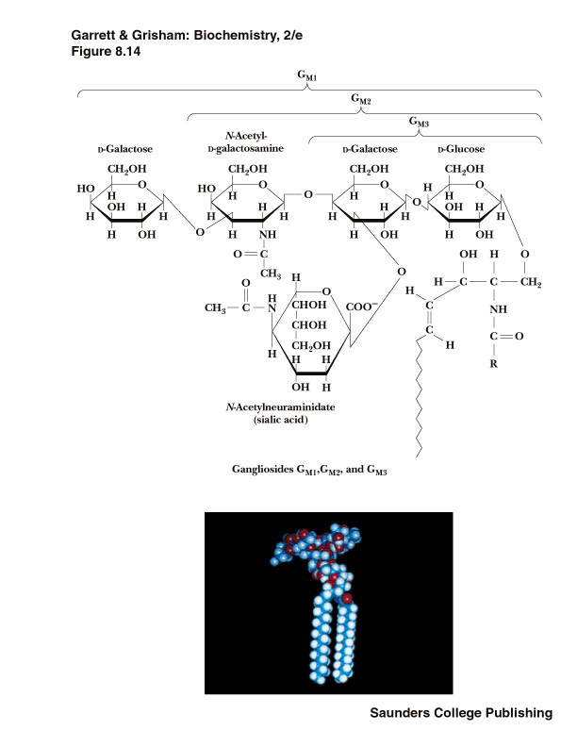

IV. Isoprenoids:

Steroids
- Based on a core structure consisting of three 6-membered rings and one 5-membered ring, all fused together
- Cholesterol is the most common steroid in animals and precursor for all other steroids in animals
- Steroid hormones serve many functions in animals - including salt balance, metabolic function and sexual function

Membranes
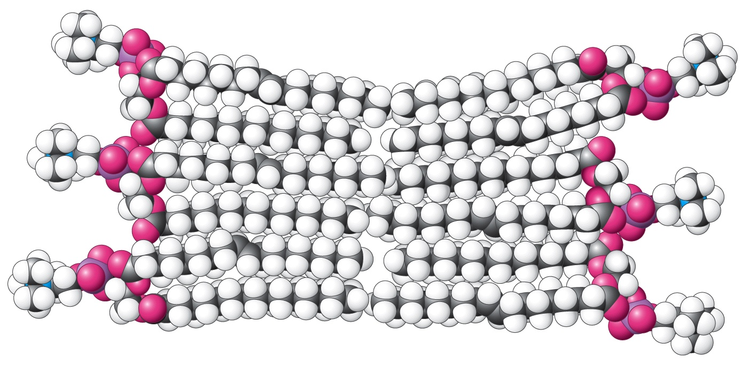

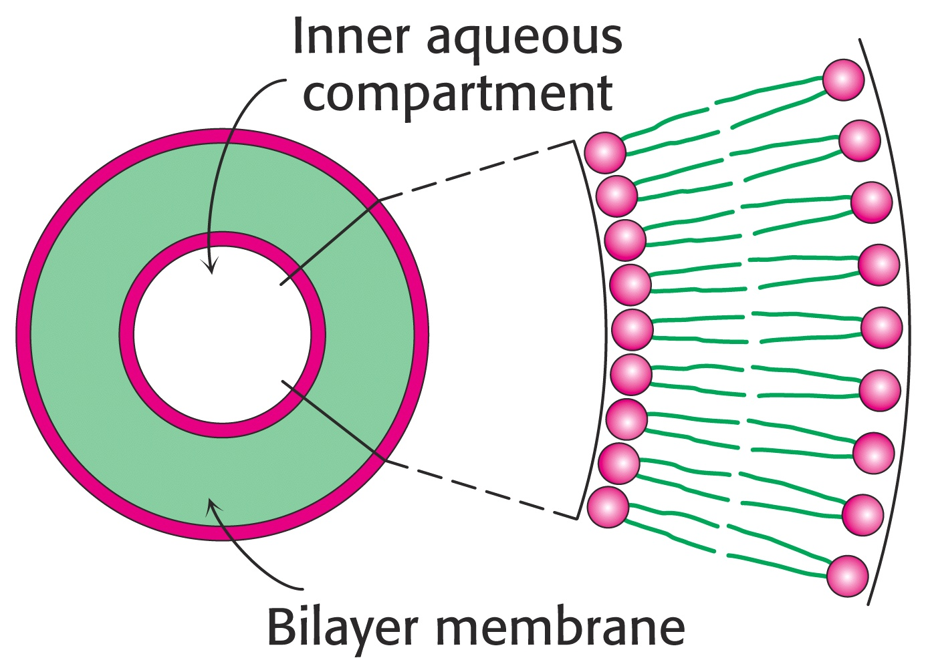

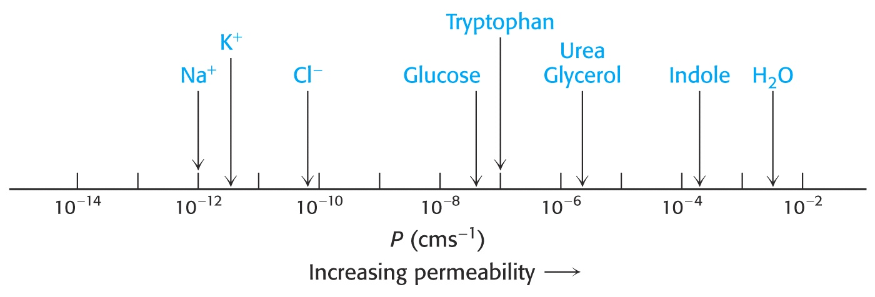
12.6 Membrane properties/models:

Davson-Danielli Butter sandwich

Benson-Green

Singer-Nicolson Fluid Mosaic Model

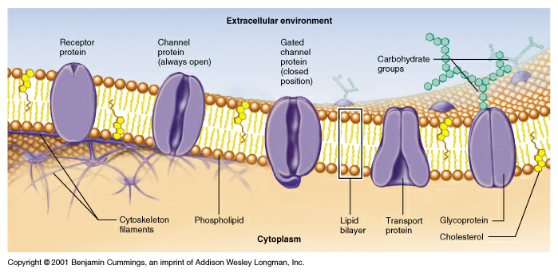
Membrane Fluidity/Phase Transitions

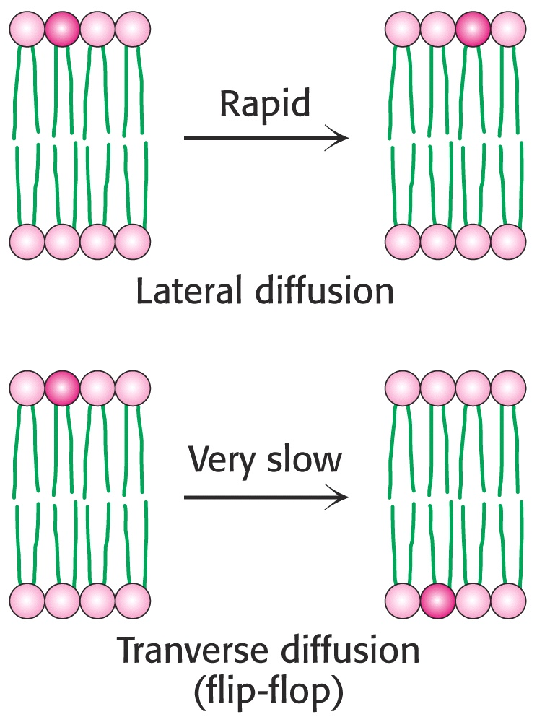
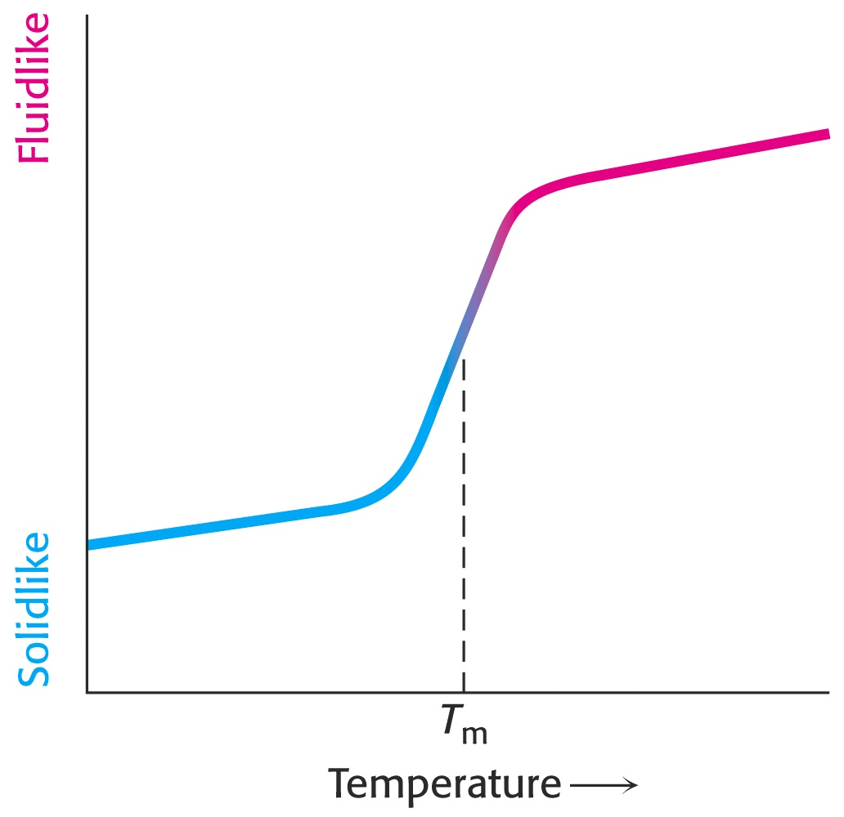
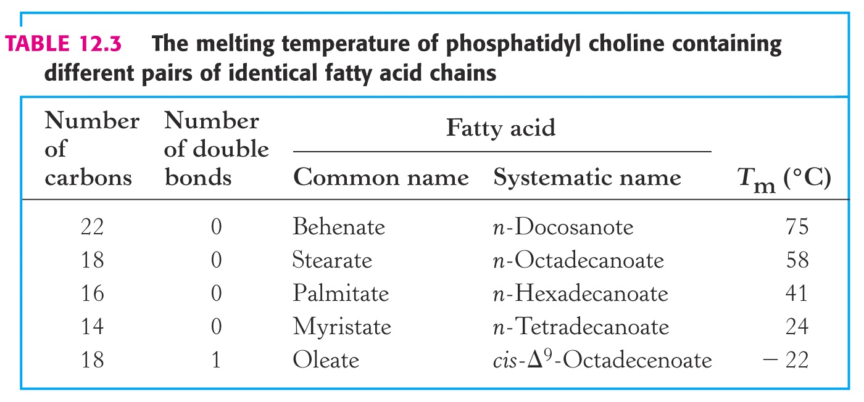
T_{m}

Membrane Transport and Channels
13.1-Transport of Uncharged Species
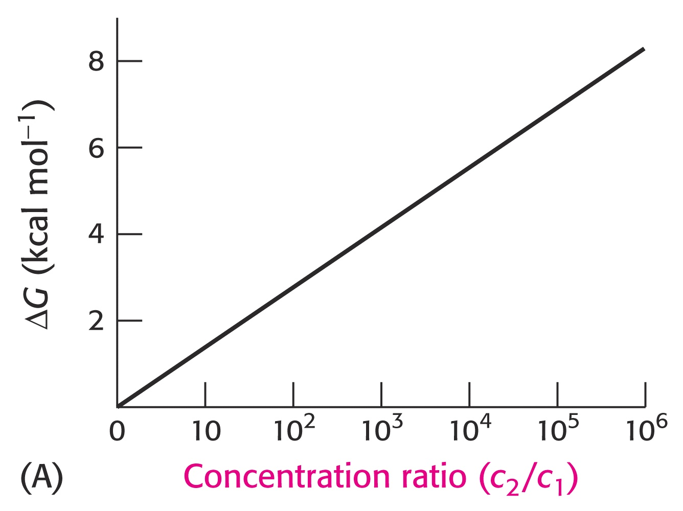
13.1-Transport of Charged Species

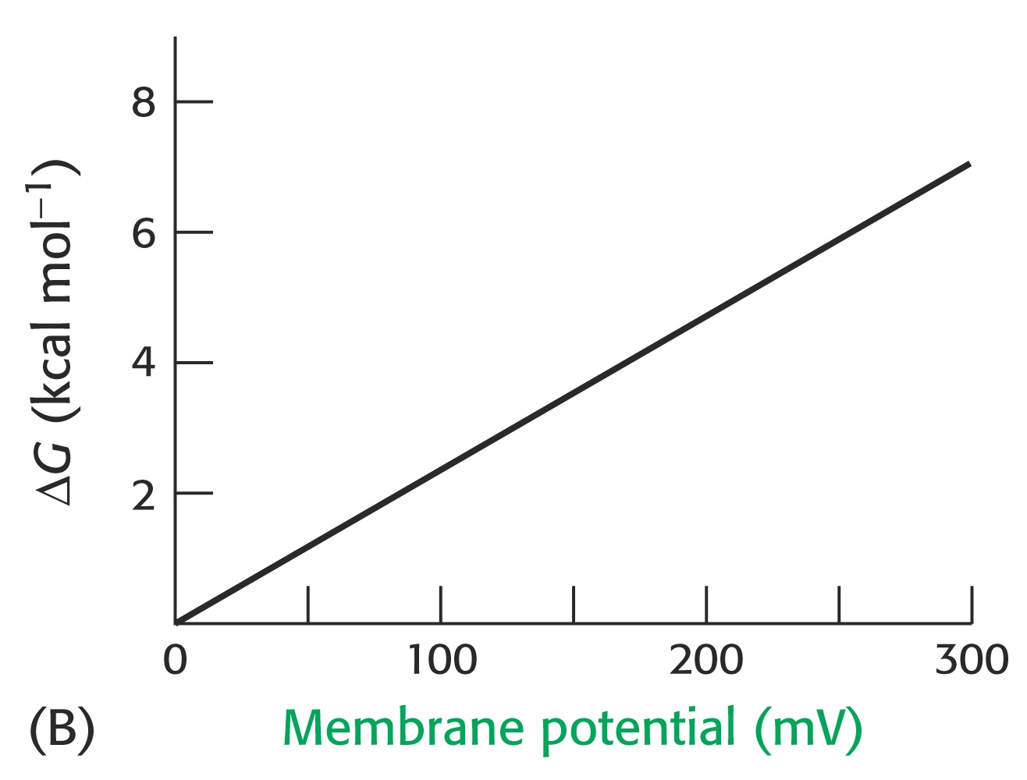
The Nernst Potential

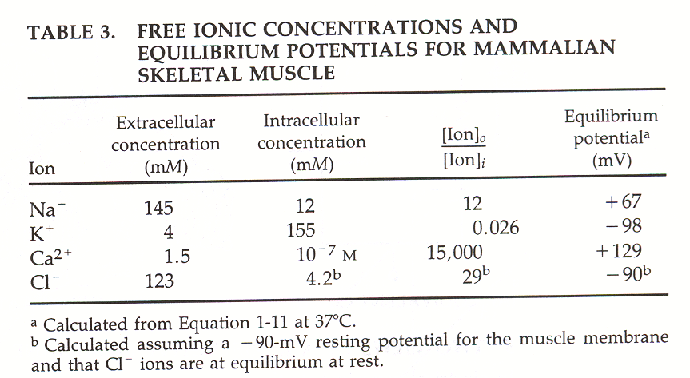
The membrane is a capacitor:

V=q/c
q=charge (in Coulombs, 1e⁻=1.6 x 10⁻¹⁹ C/electron charge)
V=voltage in Volts
c=capacitance (F,Farads)

Q: How many H⁺’s need to be pumped by an ATP’ase across a spherical bacterium (r=1.0 µm) to get a transmembrane voltage of –60. mV? Bilayer capacitance = 1.0 x 10⁻⁶ F/cm². Area of a sphere=4πr² Volume of a sphere=4/3πr³
H+

H+

Example: Calculations on a neuron
.For the Torpedo ray neuron below :

a. Give the expected equilibrium membrane potential which would be achieved by opening ion channels specific for K⁺, Na⁺, or Ca⁺⁺ and Cl⁻ one at a time and allowing the system to come to equilibrium. Temperature = 37º C.

b. A typical neuron can be approximated as a cylinder with a volume of 6300 μm³ and a surface area of 2700 μm². How many Na⁺ ions are required to charge the above neuron membrane from 0.0 mV to the equilibrium Na⁺ voltage (see above)? assume 1.0 µF/cm² capacitance.

c. Will the internal [Na⁺] change significantly in response to this flux of sodium ions ? Calculate the final [Na⁺]_{in}.

Cl⁻ =100. mM
Ca²⁺ = 2.0 µM mM
Na⁺ =20. mM
K⁺ =200. mM

Cl⁻ =5.0 mM
Ca²⁺ = 2000 µM mM
Na⁺ =200. mM
K⁺ =7.0 mM

Ion Channels:
Permeability and Patch Clamping
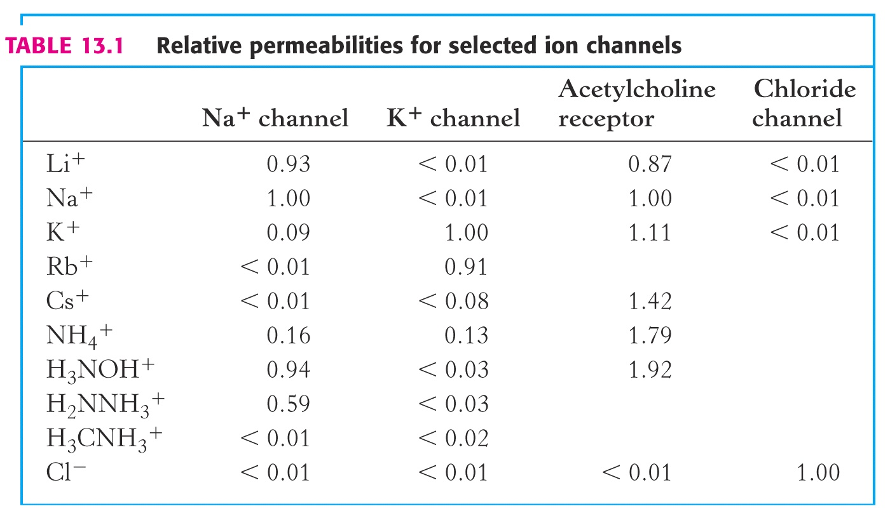
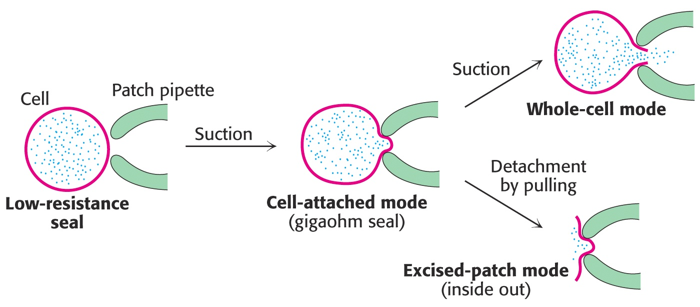
The Structure of Ion channels-Potassium Channel
( see http://blanco.biomol.uci.edu/Membrane_Proteins_xtal.html for all membrane protein structures)
See Powerpoint Presentation

IonChannel.pdf

